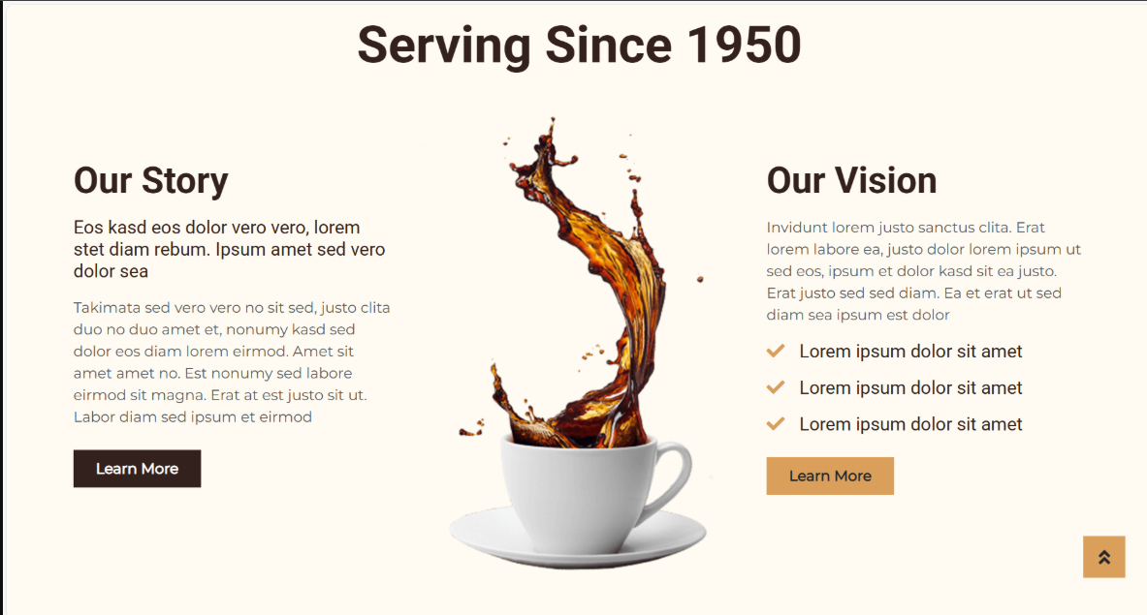
H1
button
button
ul
p
H2
img
button
p
P
H2

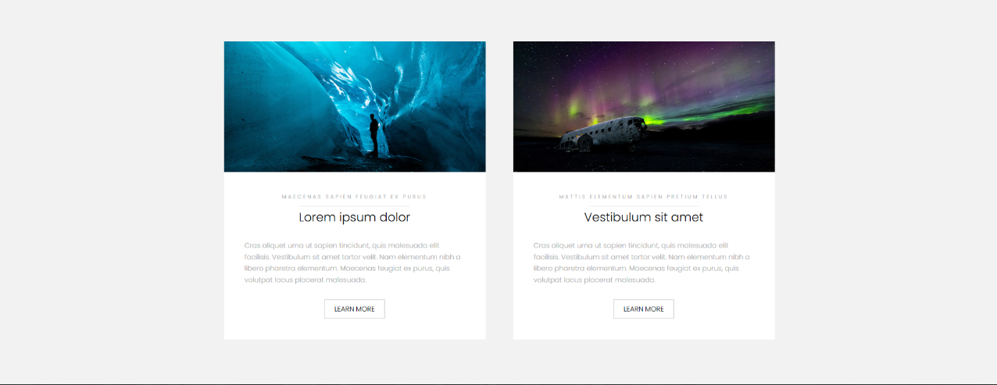
button
p
span
H3
span
button
p
H3
img
img


radio
button
button
icon
icon
img
ul
H1
icon
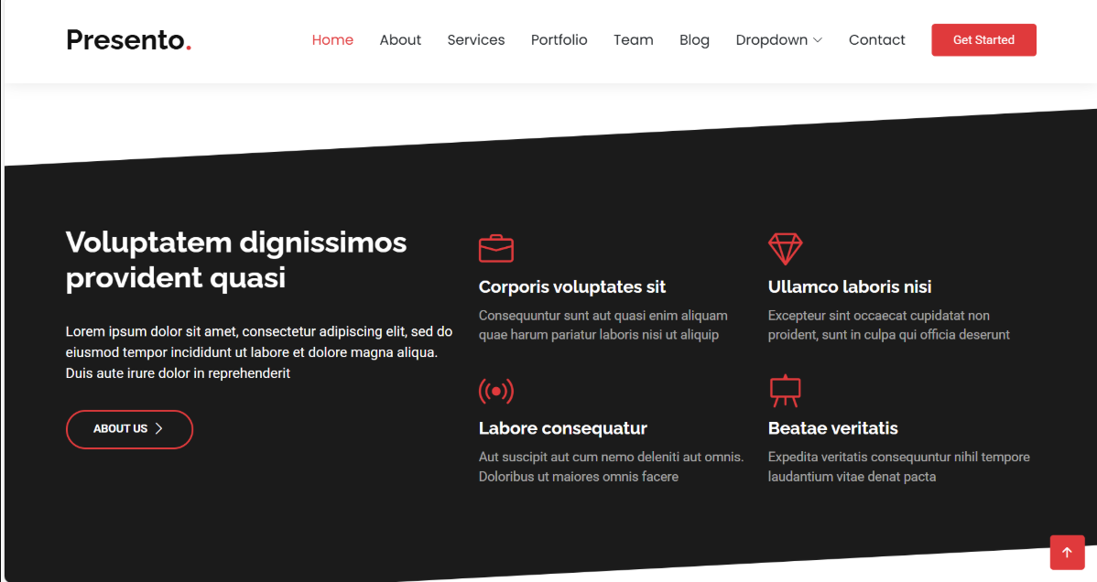
button
p
H2
img
button
p
H1
button
ul
H1


ul
button
button
p
H2
button
ul
H1
img

