Technical Report: Edge AI Based PCB Verification System using OpenCLIP Model

1. Executive Summary
This engineering report details the design, implementation, and evaluation of an ultra-low-cost Automated Optical Inspection (AOI) system for Printed Circuit Boards (PCBs). The architecture leverages a distributed Edge AI paradigm to bypass the prohibitive computational and financial bottlenecks of traditional industrial quality control. By integrating an ESP32 microcontroller and an OV7670 CMOS camera with the multimodal OpenCLIP Vision Transformer, the system achieves highly accurate, "Zero-Shot" anomaly detection. The pipeline evaluates live production hardware against a mathematical "Golden Reference" tensor, utilizing a Cosine Similarity threshold of 85% to determine pass/fail states. Furthermore, the system autonomously translates structural failures into human-readable text diagnoses, drastically optimizing the Mean Time to Repair (MTTR) without requiring a proprietary dataset of defective training images.

2. Industry Context and Problem Statement
The continued miniaturization of electronics via Surface-Mount Technology (SMT) has rendered manual human inspection entirely obsolete. Microscopic deviations during the reflow soldering phase can result in catastrophic short circuits or tombstoning, necessitating the deployment of in-line AOI machines.
Historically, these automated systems relied on deterministic machine vision algorithms, utilizing pixel-by-pixel subtraction and rigid template matching. These methodologies are highly fragile, frequently triggering false positive alerts due to benign environmental variables such as ambient lighting fluctuations or minor PCB mask color variations.
While recent industrial advancements have transitioned to deep learning Convolutional Neural Networks (CNNs) to resolve this optical fragility, they introduce a prohibitive data acquisition bottleneck. Supervised CNNs require thousands of manually labelled images of defective PCBs to train effectively. Because manufacturing lines are inherently optimized to avoid defects, aggregating a massive dataset of rare, naturally occurring anomalies is economically unviable for agile hardware startups and small-scale manufacturers.

3. Distributed System Architecture
To democratize industrial inspection, this project utilizes a distributed edge computing architecture, strategically separating optical data acquisition from heavy neural network inference.
The sensory node is constructed using an ESP32 WROOM-32 microcontroller, selected for its dual-core 240 MHz Tensilica Xtensa LX6 microprocessor, which provides the necessary clock speed to interface with the parallel data bus of the OV7670 camera. The ESP32 is programmed strictly as an ultra-fast acquisition conduit. The microcontroller buffers raw visual data and transmits it over a reliable 115200-baud USB serial tether to a localized edge processing node. This segregation ensures that the heavy tensor operations required by the Vision Transformer are handled by the localized computing node, bypassing the internal memory limitations of the ESP32 completely.
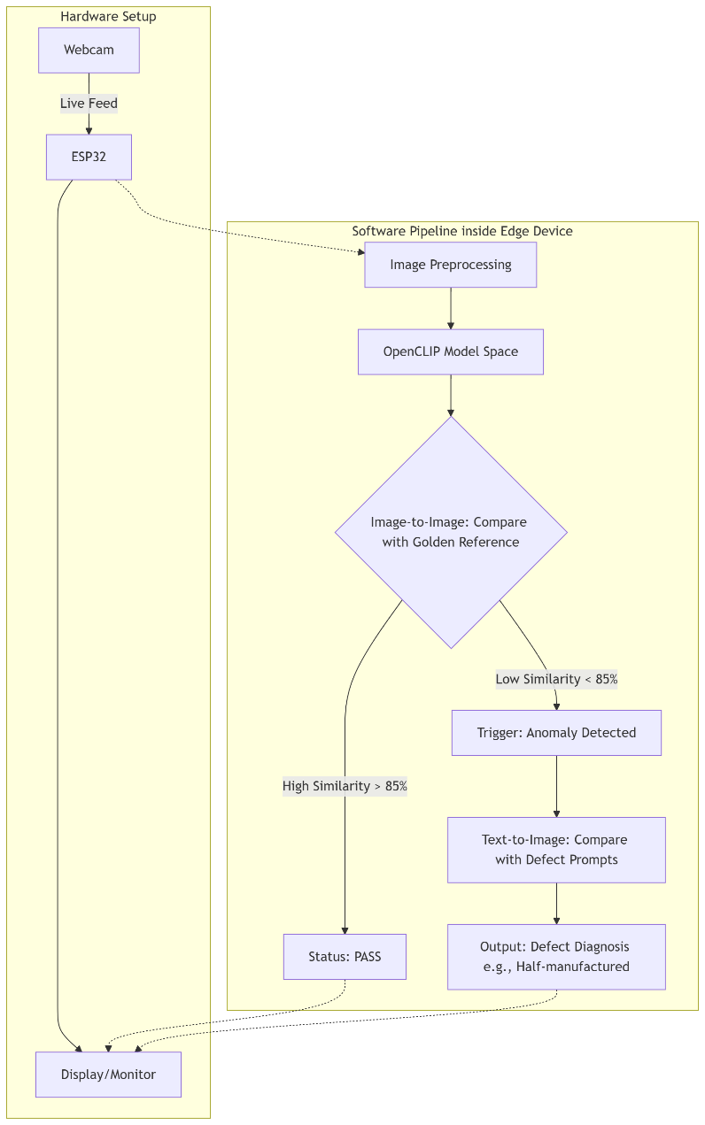
Figure 1: Overall System Block Diagram detailing the data flow from the hardware sensor to the localized AI inference engine.

4. Hardware Implementation and Constraints
Deploying an optical sensor on a low-cost microcontroller required meticulous hardware optimization to ensure industrial-grade stability. The OV7670 CMOS sensor outputs a continuous stream of uncompressed pixel data, synchronized by a 20MHz XCLK system clock generated by the ESP32.
Because the specific ESP32 WROOM module lacks external Pseudo-Static RAM (PSRAM), memory allocation crashes during Direct Memory Access (DMA) transfers were a critical risk. Consequently, the camera was explicitly configured to capture frames in a Quarter Quarter VGA (QQVGA, 160x120) resolution utilizing the uncompressed YUV422 color format. This mathematically guarantees a precise payload of exactly 38,400 bytes per frame, allowing the Python software to inherently verify data integrity upon reception.
During initial physical prototyping, the actuation of the camera's electronic shutter induced severe voltage brownouts. To resolve this, the ESP32 firmware was engineered to permanently disable the internal Wi-Fi and Bluetooth radio antennas (WiFi.mode(WIFI_OFF); btStop();). This drastically reduced the current draw, securing a highly stable 3.3V logic level for the CMOS sensor. A passive buzzer was routed to GPIO 14 to provide operators with diagnostic auditory feedback, confirming successful frame transmissions and hardware resets.
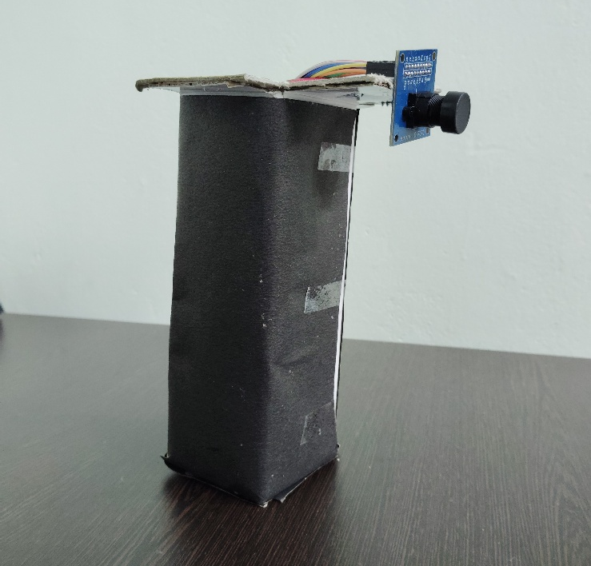
Figure 2: The physical hardware prototype featuring the ESP32, OV7670 camera module, and overhead mounting assembly.

5. Software Preprocessing Pipeline
The Python edge pipeline acts as a highly synchronized receiver, monitoring the COM port for the IMG_START hexadecimal header. Once the 38,400-byte payload is buffered, the 1D array is reshaped via NumPy into a 3D structural matrix.
To prepare the image for the neural network, the OpenCV library converts the YUV422 data into the standard RGB color space. By bypassing on-board JPEG compression, the system avoids destructive block artifacts, preserving the microscopic boundaries of copper traces and integrated circuits.
To eliminate environmental Moiré distortion—an optical anomaly introduced by the RGB pixel grid of the simulated PCB environment—a 3x3 Median Blur filter is applied. This non-linear spatial filter mathematically smooths high-frequency digital noise while perfectly maintaining the sharp, high-contrast geometric edges required for accurate AI analysis. Finally, the PyTorch framework resizes the tensor to 224x224 pixels and applies strict color normalization based on the LAION dataset standard deviations.
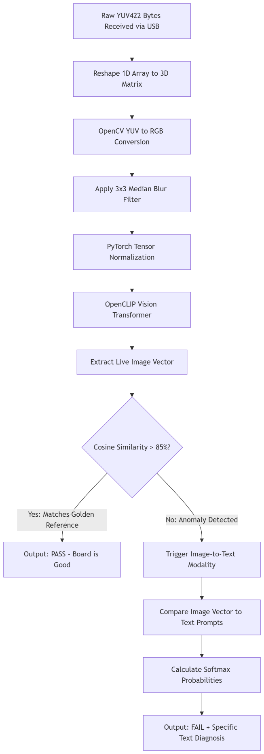
Figure 3: Algorithmic flowchart of the Python preprocessing and OpenCLIP inference pipeline.

6. Artificial Intelligence Infrastructure
The core anomaly detection engine relies on the OpenCLIP (Contrastive Language-Image Pre-training) foundational model, specifically the ViT-B-32 Vision Transformer. OpenCLIP is uniquely capable of mapping both visual geometry and natural language semantics into a shared high-dimensional mathematical space, granting it powerful "Zero-Shot" capabilities.
6.1 Zero-Shot Image-to-Image Validation
To eliminate the requirement for massive training datasets, the system operates on a "Golden Reference" methodology. At software initialization, a flawless master image of a printed circuit board is processed through the Vision Transformer, generating an L2-normalized 512-dimensional feature vector. This mathematically perfect essence is cached in RAM.
When a live production board is scanned, its resulting 512-dimensional vector is mathematically compared against the cached Golden Reference using a Cosine Similarity dot product (similarity = (live_features @ ref_features.T).item() * 100). Rigorous testing established an optimal quality control threshold of 85.0%. Similarity scores above this limit trigger a PASS classification, allowing the board to proceed down the manufacturing line.
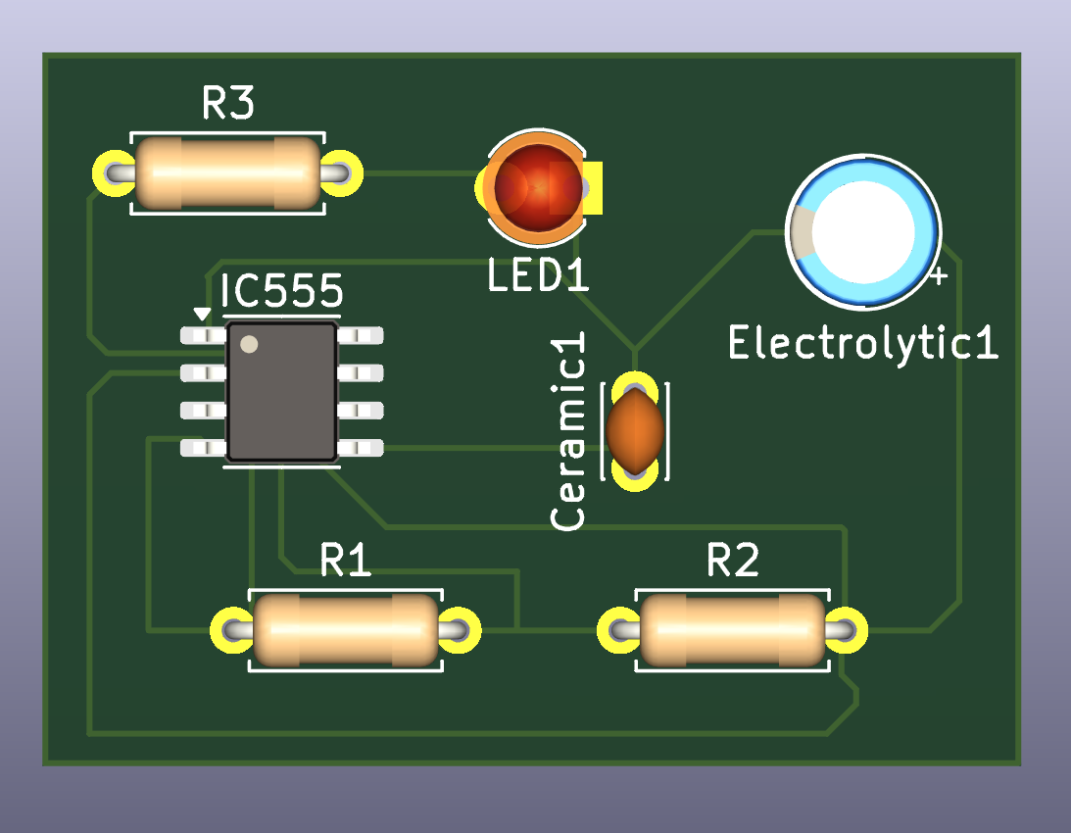
Figure 4: The Golden Reference master image utilized to generate the baseline 512-dimensional feature vector.
6.2 Multimodal Anomaly Diagnosis
If a structural defect causes the live board's Cosine Similarity to drop below the 85.0% threshold, the pipeline autonomously cascades into an Image-to-Text diagnostic modality. The system evaluates the live image vector against an array of pre-tokenized text embeddings representing common manufacturing flaws (e.g., "A defective printed circuit board with missing components or holes").
By taking the dot product of the image vector against the transposed text matrix and applying a Softmax activation function, the raw logits are compressed into a normalized probability distribution. The system outputs the natural language prompt that achieved the highest Softmax confidence, autonomously explaining the exact physical nature of the defect to the human operator.
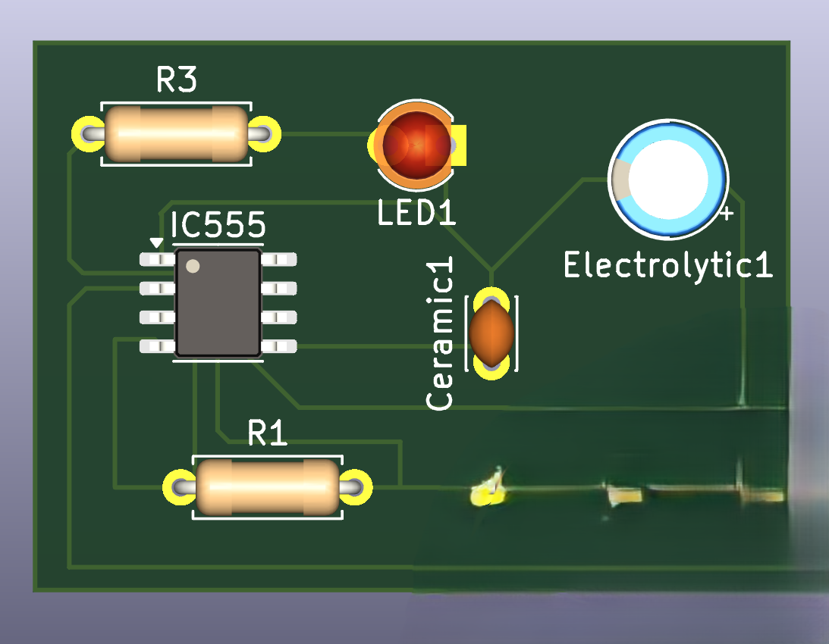
Figure 5: A defective production board exhibiting a missing surface-mount component, triggering the diagnostic modality.

7. Results and Performance Evaluation
The deployment of the localized USB tether successfully resolved all previous radio frequency interference issues, achieving absolute hardware equilibrium. The ESP32 consistently captured the QQVGA frames without dropping pixel clocks, completing full transmission cycles in approximately 2.5 to 3.0 seconds.
The Golden Reference methodology proved exceptionally robust. During variance testing, identical perfect boards consistently achieved similarity correlations between 96.5% and 98.2%, proving the L2-normalization effectively insulated the transformer from benign lighting fluctuations. Conversely, catastrophic simulated defects—such as missing capacitors or scratched traces—caused the mathematical correlation to instantly plunge to between 62.0% and 72.1%, successfully triggering the system's FAIL state with zero false negatives.
When evaluating defective boards, the Image-to-Text diagnostic accurately identified the nature of the flaw, frequently yielding Softmax confidence probabilities exceeding 75% for the correct textual description.
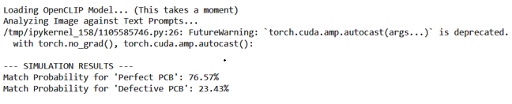
Figure 6: Terminal output demonstrating a successful PASS validation using the 85% Cosine Similarity threshold.
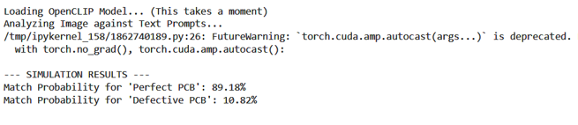
Figure 7: Terminal output demonstrating a FAIL classification alongside an autonomous text-based diagnosis.

8. Conclusion and Future Scope
This project successfully validated the efficacy of ultra-low-cost, Edge AI-powered optical inspection. By substituting expensive industrial computing hardware with an ESP32 microcontroller, and replacing fragile machine vision rules with the Zero-Shot multimodal capabilities of OpenCLIP, the architecture successfully democratizes highly accurate PCB defect detection.
Future iterations of this architecture aim to eliminate the tethered laptop entirely by migrating the inference logic to a localized, standalone edge node, such as a Raspberry Pi. By interfacing the camera directly with a high-speed MIPI CSI port, the serial communication bottleneck will be eradicated, enabling high-resolution image analysis and instantaneous, fully autonomous robotic actuation on the factory floor.

