237.75

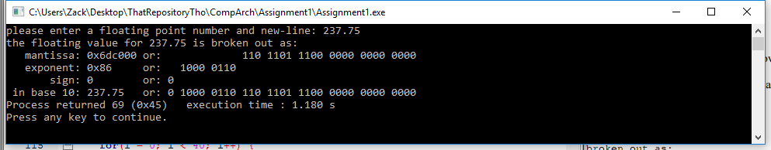

-.0000005126

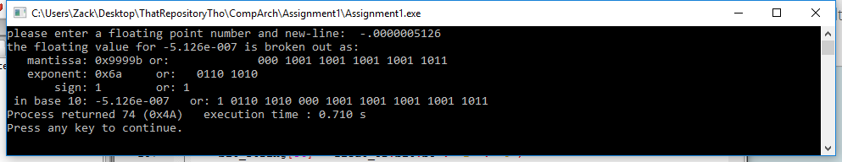

-92,457,321.670245

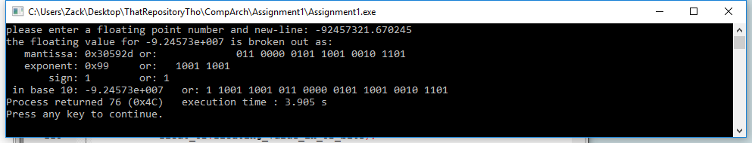

6.023E+23

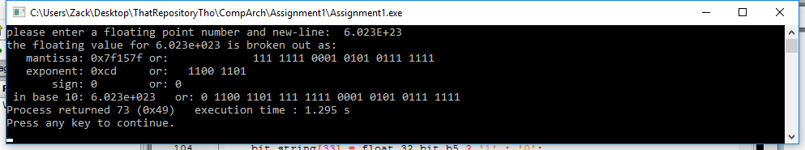

1.67339E-40

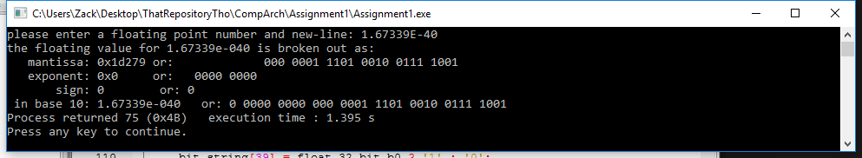

0

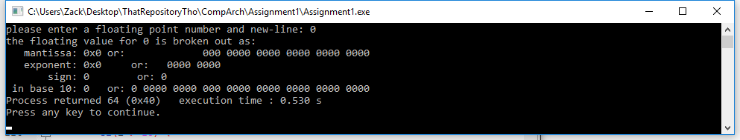

0.5

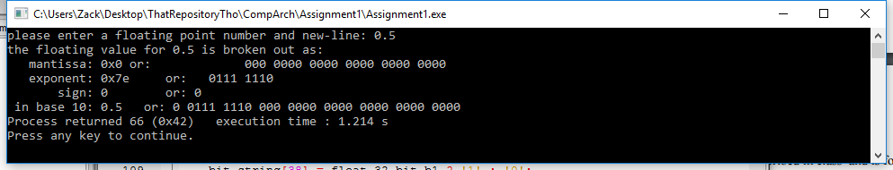

1,000,000

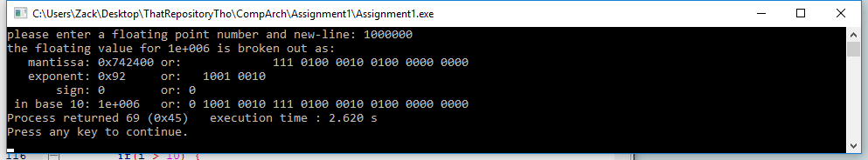

-55.5

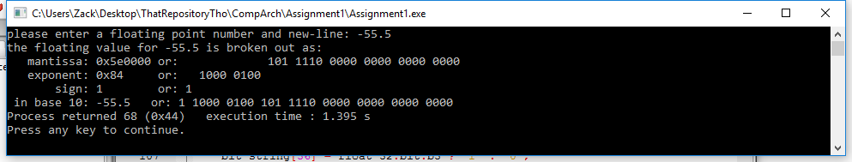

123456789

