Showing capital:

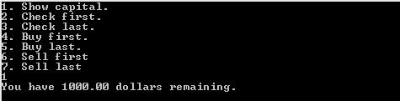

Checking information at the top of ledger:

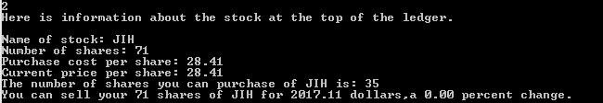

Buying the stock at the top of the ledger then updating the stock prices and then checking the first stock purchase in the ledger:

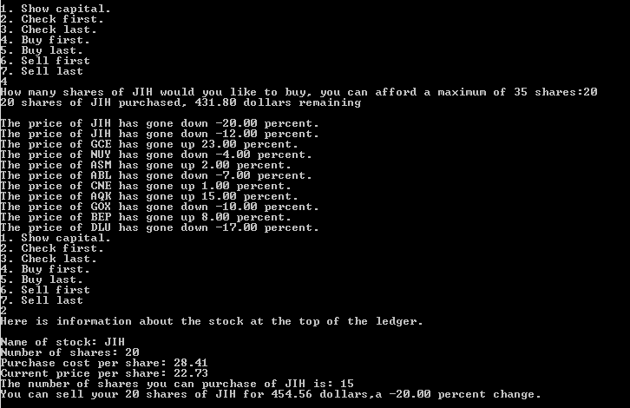

Checking information about the bottom of the ledger:

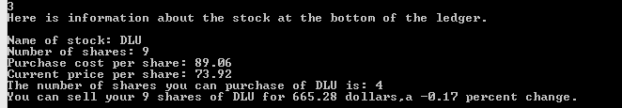

Buying the stock at the bottom of the ledger then updating the stock prices and then checking the first stock purchase in the ledger:

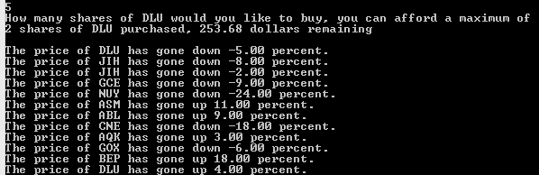

Checking and then selling the first stock:

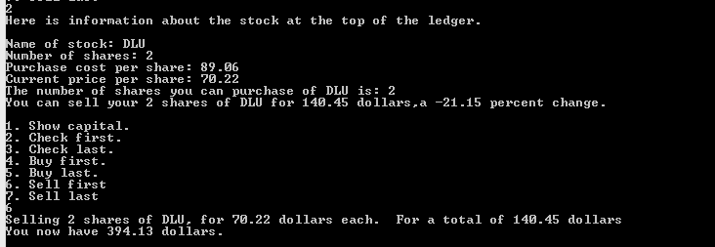

Checking and then selling the last stock:

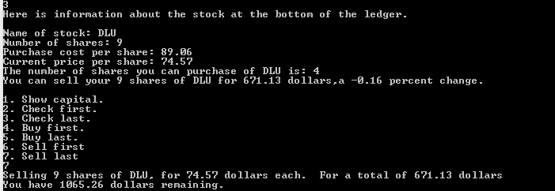

At the end of 10 iterations:

