1. Create a Database.
2. Add one column as primary key

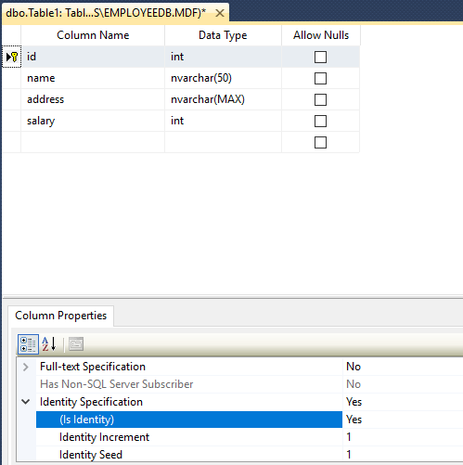

1. Create a Web Application
2. Then drag and drop the **Form View** from Toolbox.
3. Then select **Choose Data Source** Option and set As **New Data Source.**
4. Then choose the **Data Source Type** setAs **Sql Database.**
5. Then choose your data Connection (By selecting your created database).

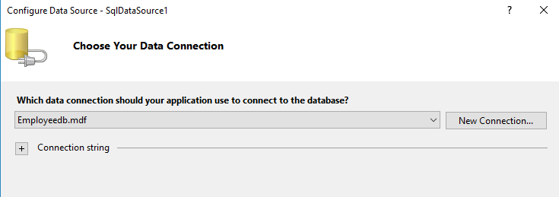

1. Then chick Next.
2. Once you see the **Configure your select statement** then choose **Advanced option** and Click on **Generate insert, update, delete statement** then click **Ok.**
3. Then Click on Finish.
4. Then Click on **Form View Properties** and Set **Default Mode** to **Insert**
5. After Done Above Things Its Look as Follow

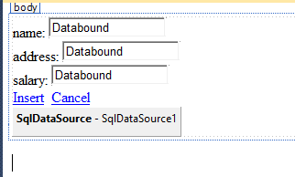

1. Then drag and drop the **Gridview**.
2. Then select **Choose Data Source** as Created Data Source which will listed (ex SqlDataSource1).
3. Once Your Selected Data Source it will show some options like **Enable Editing**, **Enable Deleting** etc.
4. Enable options as per your requirements.

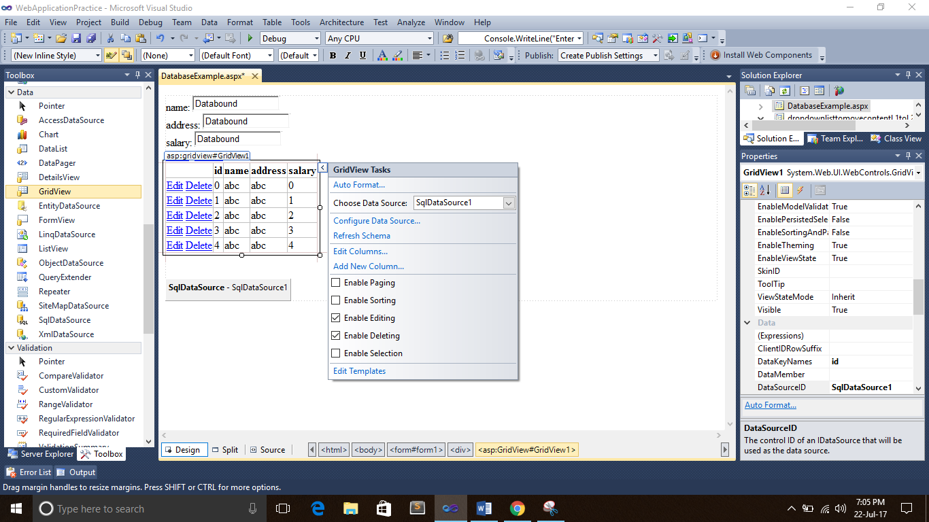

1. Then Save it.

