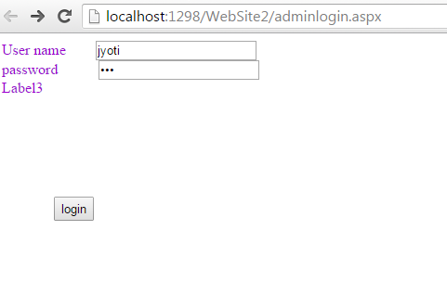

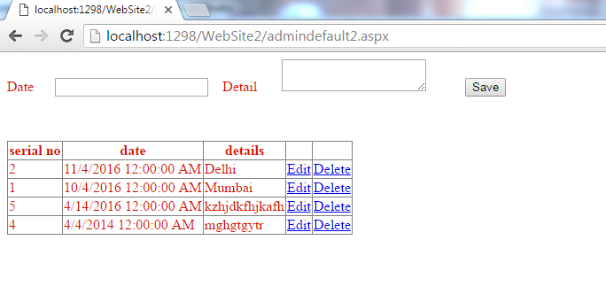

<?xml version="1.0"?>

<!--

For more information on how to configure your ASP.NET application, please visit

http://go.microsoft.com/fwlink/?LinkId=169433

-->

<configuration>

<connectionStrings>

<add name="NewsConstring"

connectionString="Data Source=.\SQLEXPRESS;AttachDbFilename=|DataDirectory|\newspaperdb.mdf;Integrated Security=True;Connect Timeout=30;User Instance=True"

providerName="System.Data.SqlClient"/>

</connectionStrings>

<system.web>

<compilation debug="true" targetFramework="4.0"/>

</system.web>

</configuration>

<%@ Page Language="C#" AutoEventWireup="true" CodeFile="adminlogin.aspx.cs" Inherits="adminlogin" %>

<!DOCTYPE html PUBLIC "-//W3C//DTD XHTML 1.0 Transitional//EN" "http://www.w3.org/TR/xhtml1/DTD/xhtml1-transitional.dtd">

<html xmlns="http://www.w3.org/1999/xhtml">

<head runat="server">

<title></title>

</head>

<body text="password">

<form id="form1" runat="server">

<div>

</div>

<asp:Label ID="Label1" runat="server" Text="User name"></asp:Label> &nbsp; &nbsp;

&nbsp;&nbsp;

<asp:TextBox ID="TextBox1" runat="server"></asp:TextBox><br />

<asp:Label ID="Label2" runat="server" Text="password"></asp:Label>

&nbsp;&nbsp;&nbsp;&nbsp;&nbsp;&nbsp;&nbsp;&nbsp;&nbsp;

<asp:TextBox ID="TextBox2" runat="server" TextMode="Password"></asp:TextBox>

<br />

<asp:Label ID="Label3" runat="server" Text="Label3"></asp:Label>

<br />

<br />

&nbsp;&nbsp;&nbsp;&nbsp;&nbsp;&nbsp;&nbsp;&nbsp;&nbsp;&nbsp;&nbsp;&nbsp;&nbsp;

<asp:Button ID="Button1" runat="server" Text="login" onclick="Button1_Click"

style="height: 26px"/>

</form>

</body>

</html>

using System;

using System.Configuration;

using System.Data.SqlClient;

using System.Drawing;

public partial class adminlogin : System.Web.UI.Page

{

protected void Button1_Click(object sender, EventArgs e)

{

String tUser = TextBox1.Text;

String tPass = TextBox2.Text;

String strcon = ConfigurationManager.ConnectionStrings["NewsConstring"].ConnectionString;

SqlConnection con = new SqlConnection(strcon);

string cmdstr = "select count (*) from usertable where user_name = '" + tUser + "'and user_pass = '" + tPass + "'";

con.Open();

SqlCommand check = new SqlCommand(cmdstr, con);

int n = Convert.ToInt16(check.ExecuteScalar().ToString());

if (n == 1)

{

Session["Adminauth"] = true;

Response.Redirect("~/admindefault2.aspx");

}

else

{

Label3.ForeColor = Color.Red;

Label3.Text = "Invalid credintials!!";

}

}

}

<%@ Page Language="C#" AutoEventWireup="true" CodeFile="admindefault2.aspx.cs" Inherits="admindefault2" %>

<!DOCTYPE html PUBLIC "-//W3C//DTD XHTML 1.0 Transitional//EN" "http://www.w3.org/TR/xhtml1/DTD/xhtml1-transitional.dtd">

<html xmlns="http://www.w3.org/1999/xhtml">

<head runat="server">

<title></title>

</head>

<body text="Date">

<form id="form1" runat="server">

<div>

</div>

<asp:Label ID="Label1" runat="server" Text="Date"></asp:Label>

&nbsp;&nbsp;&nbsp;&nbsp;

<asp:TextBox ID="TextBox1" runat="server"></asp:TextBox>

&nbsp;&nbsp;

<asp:Label ID="Label3" runat="server" Text="Detail"></asp:Label>

&nbsp;&nbsp;&nbsp;&nbsp;&nbsp;

<asp:TextBox ID="TextBox3" runat="server" TextMode="MultiLine"></asp:TextBox>

&nbsp;&nbsp;&nbsp;&nbsp;&nbsp;&nbsp;&nbsp;&nbsp;&nbsp;

<asp:Button ID="Button1" runat="server" Text="Save" onclick="Button1_Click" />

&nbsp;&nbsp;&nbsp;&nbsp;&nbsp;&nbsp;

<asp:Label ID="Label4" runat="server"></asp:Label>

<p>

&nbsp;</p>

<p>

<asp:GridView ID="GridView1" runat="server"

AutoGenerateColumns = "False" DataKeyNames = "news_id"

OnRowDeleting = "GridView1_Rowdeleting"

OnRowUpdating = "GridView1_Rowupdating"

DataSourceID="SqlDataSource1">

<Columns>

<asp:BoundField DataField = "news_id" HeaderText = "serial no" />

<asp:BoundField DataField = "news_date" HeaderText = "date" />

<asp:BoundField DataField = "news_content" HeaderText = "details" />

<asp:Commandfield ShowEditButton = "true" />

<asp:Commandfield ShowDeleteButton = "true" />

</Columns>

</asp:GridView>

<asp:SqlDataSource ID="SqlDataSource1" runat="server"

ConnectionString="<%$ ConnectionStrings:NewsConstring %>"

SelectCommand="SELECT * FROM [newstable] ORDER BY [news_date] DESC">

</asp:SqlDataSource>

</p>

</form>

</body>

</html>

using System;

using System.Data.SqlClient;

using System.Data;

using System.Configuration;

using System.Web.UI.WebControls;

public partial class admindefault2 : System.Web.UI.Page

{

private SqlConnection conn = new SqlConnection(ConfigurationManager.ConnectionStrings["NewsConstring"].ConnectionString);

protected void Page_Load(object sender, EventArgs e)

{

if (Session["Adminauth"] == null)

{

Response.Redirect("~/adminlogin.aspx");

}

}

protected void GridView1_Rowdeleting(object sender, GridViewDeleteEventArgs e)

{

int id = Convert.ToInt32(GridView1.DataKeys[e.RowIndex].Value.ToString());

GridViewRow row = (GridViewRow)GridView1.Rows[e.RowIndex];

SqlDataSource1.DeleteCommand = "delete from newstable where news_id=" + id ;

GridView1.DataBind();

}

protected void GridView1_Rowupdating(object sender, GridViewUpdateEventArgs e)

{

int id = Convert.ToInt32(GridView1.DataKeys[e.RowIndex].Value.ToString());

GridViewRow row = (GridViewRow)GridView1.Rows[e.RowIndex];

TextBox textcontent = (TextBox)row.Cells[2].Controls[0];

GridView1.EditIndex = -1;

SqlDataSource1.UpdateCommand = "update newstable set news_content= '" + textcontent.Text + "' where news_id =" + id;

GridView1.DataBind();

}

protected void Button1_Click(object sender, EventArgs e)

{

string tdate = TextBox1.Text;

string tdetail = TextBox3.Text;

string sql = "Insert into newstable(news_date, news_content) values(@news_date, @news_content)";

SqlCommand inCmd = new SqlCommand();

inCmd.Connection = conn;

inCmd.CommandText = sql;

inCmd.CommandType = CommandType.Text;

inCmd.Parameters.AddWithValue("@news_date", tdate);

inCmd.Parameters.AddWithValue("@news_content", tdetail);

conn.Open();

int rowsAffected = inCmd.ExecuteNonQuery();

Label4.Text = rowsAffected + "Record inserted";

TextBox1.Text = "";

TextBox3.Text = "";

conn.Close();

GridView1.DataBind();

}

}