***Software Requirements***

***Specification***

**For**

***< Project: E-HEALTH CARE SYSTEM >***

***GROUP: THE STROM BREAKER***

1 Introduction

This document goes over the requirements that must be fulfilled before e-health care system can be delivered to the customer. In section one it discusses the scope of the application, any definitions or acronyms used, along with the organization of the SRS document.

1.1 Purpose

The purpose of this document is to present a detailed description of a Personal Medical Record application for both web and android application. It explains the purpose and features of the application itself, the web interface through which a user can access a personal account, the server that hosts the user accounts, and the constraints that must be satisfied for security purposes. This document is intended for both the customer and the project development team.

1.2 Scope

This E- Health Care system, is used to capture personal medical history. This application will be designed to provide a simple and reliable way to store and convey one’s medical history. Upon the event of an emergency, medical information would have to be acquired from the patient’s current doctor or family for any informed, safe procedure. E-Health Care system would alleviate the need to track down this medical history because it would be readily available. Doctors would be able to add information to the patient’s E-Health Care system account at anytime, including at an appointment, with the patient’s consent.

More specifically, E-Health Care system will contain extensive documentation of the patient’s medical records, which can be authored by the owner or the owner’s healthcare provider(s). This includes diagnoses, treatments, medications, allergies, and medical procedures. E-Health Care system would allow for uniform communication of information between the patient and their respective doctor(s). The web application would label and organize information authored by health care providers separately from information authored by the patient to maintain authenticity.

1.3 Definitions, acronyms, and abbreviations

Define all terns, acronyms, and abbreviations need to understand the SRS. If this section is extensive, then move to an appendix.

|  |  |
| --- | --- |
| **Term** | **Definition** |
| SRS | Software Requirements Specification |
| Iteration | One execution of a sequence of operations or instructions |
| Actors | Entities that provide input data or receive the output result |
| Wi-Fi | Wireless networking technology that uses radio waves to provide high speed internet as well as a local area network |
| Operating system | Interface between hardware and applications and is responsible for managing, sharing and coordination of resources |
| Secure account | A web based account in which some form of encryption is in place |
| User | An instance of the User class for someone accessing their own medical records with the web application |
| Android User | An instance of the User class for someone accessing their own medical records in the e-health care System with an android phone. |
| Healthcare Provider | An instance of the User class, specifically a healthcare professional (e.g., doctor) |
| MedRecord | An instance of one person’s medical record |
| Local | Refers to a MedRecord that is stored on the user’s android phone. |

1.4Organization

The remaining sections of the SRS document contains detailed information regarding the requirements of E-Health Care system. In section 2 the document covers the product overall description, product functions, user expectations, constraints, any assumptions or dependencies, and anything that is beyond the scope of the application. In section 3 it lists any specific requirements that must be met before the application can be delivered. In section 4 the document gives graphical models which specify the bridge between the application domain and the machine domain. In section 5 the details of the project safety,security, business rule, software quality attribute are described. Section 6 contains ER diagram, schema diagram,project summery in this SRS document. Section 7 gives a sample case studies that gives the reader a short description for any inquiries about the application.

**2. Overall Description**

**2.1 Product Perspective**

**“E-Healthcare”** is an online system which is intended for a person who can get online consultancy service by sitting at home.

This system will consist of two parts: one web portal and one mobile application and. The mobile application will be used to view doctor profile and view information about them while the web portal will be used for managing all the information and the system as a whole.

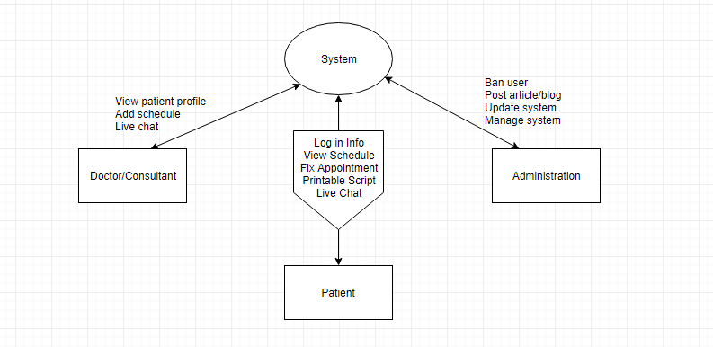

**2.2 Product Functions**

The E consultation system is an end user support and online consultation project. Here we propose a system that connects patients to available doctors for online consultation and also allows doctors to email subscriptions in printable format .In this system patient can chat live with doctor and discuss their problems and can get solution. Also by paying extra credit they can get emergency services.

**2.3 User Classes and Characteristics**

|  |  |
| --- | --- |
| **Class** | **Characteristics** |
| **Administrators** | **Modify post, Add article/blog , Ban user, Manage whole system** |
| **Doctor/Consultant** | **Check client report, Post schedule, Live chat** |
| **Patient** | **View doctor/consultant profile , View/book appointment , Live chat, Get printable report/prescription,** |
| **Visitor** | **Read blogs/articles, Post articles** |

**2.4 Operating Environment**

**“E-Healthcare”** can be accessed using any Internet browsing application like Google Chrome, Internet Explorer and Mozilla Firefox. It will open on Windows 7 or above. The processor should be Intel Core Duo or above with a processor speed of 1GHz or above. The latest version of Flash Player should be installed in order to get latest video update/tutorials. We will also integrate an android application that will directly let all users to access our system.

**2.5 Design and Implementation Constraints**

•The website is designed in English.   
•We maintained the IEEE standards.   
•Android studio is used to design the Application.

**2.6 User Documentation**

We will provide a user guideline with the website and the android application, from where the users can easily find out how to use it. They will also find help button that will directly take them to the guideline.

**2.7 Assumptions and Dependencies**

•The user should have a computer and internet access if he/she wants to access our system

•The user also needs to have an android phone if he/she wants access our system by using mobile phone.

•The user needs to have some basic knowledge on how to operate internet

**3 User Interfaces**

Here we propose a system that connects patients to consultant for online consultation though live-chat system and also allows refer to doctor for online consultation.

There will be a page for doctors directory where patient and visitor will be able to see the list. There will be a blog, where visitor will read health related articles. An Emergency button will be there for emergency service. A consultant list or information page will be there also. In the Home page an update Ticker will always give user announcement or important news. There will be a page for Hospital directory, about us, symptom checker, subscription. There will be a area for downloading our app from Google-Play-Store. A search bar will be preserve for search and login and registration area for users.

**Software Interfaces**

A user can get appointment though live-chat where a consultant or doctor will be able to send files and get images or files from user. Consultant will accept user livechat request. And every single log will be save in the database and history or record of a user will also be there for future purpose. Doctors will be able to view those record and other files. Symptom checker will check the symptom of a user, which is a built-In application of our web application. User or doctor can post articles but moderator will approve those post and they can also delete those post from database. A user can also subscribe feeds via email or social media. In our android app, there will be the almost same userinterface like our web and everything will be connected though our one database. Login logs,cookies,cache will be also saved in the database.

**Communications Interfaces**

Our communication standards are HTTP,HTTPS. There will be a secure and synchronized mechanism for our system. There will be a WAF(windows application firewall) for our web security and encryption system for our livechat. Communication protocols will be IMAP/POP3. Server will be Apache(dedicated). Consultant only will be have access for refer doctor to a user. RSS feed and email subscription will reach every updates to user. User can also submit query to system via E-form and so on.

**4.System Features:**

**4.1 Patient’s Panel  
  
 4.1.1 Description and priority**

User who has a account in this system is counted as a patient. Every patient must has a unique account in the system so that he/she can log in to their own account to get services .A patient’s account has his/her name, phone number, email address, residential address, date of birth, etc. This feature has a higher priority in the system.

**4.1.2 Functional Requirements** A. Each account must securely store all of its data.

Basic information that must be stored

* Username
* Password
* Address
* Phone Number
* First Name
* Last Name
* Middle Name
* Date of Birth
* Sex
* Hair Color
* Eye Color
* Ethnicity
* Height
* Weight
* Blood Type
* Allergies

B. Each account must have a separate identifying account number.

C. Data must always be related to an account, and a user cannot view data if

he/she is not the owner of the account.

D. Patient can consult doctors.

E. Patient can chat with avaiable doctors and tell them their issues and discuss

remedies.

F. Patient can send their images (for skin diseases/beauty related issues) to the

avaiable doctor so that they can prescribe.

**4.2 Healthy Lifestyle(blog):**

**4.2.1 Description and priority**

The concept of healthy living has evolved from a laser focus on fitness and nutrition into a mentality about holistic health. Healthy lifestyle blogs help users to get conscious about their health.Users can read these blogs to get health conscious..This Feature has a low priority in the system.  
   
 **4.2.2Functional Requirements**

A. Admin panel and doctors both can upload healthy lifestyle blogs..

B. Users can read these blogs.

**4.3 Doctor's Panel:**

**4.3.1 Description and priority**

Doctors are registered by admin panel. Every doctor must has a unique account in the system so that he/she can log in to their own account to give services .A doctor’s account has his/her name, phone number, email address, residential address, date of birth, etc. This feature has a higher priority in the system.  
  
 **4.3.2Functional Requirements**

A. Each account must securely store all of its data.

Basic information that must be stored

* Username
* Password
* Address
* Phone Number
* First Name
* Last Name
* Middle Name
* Date of Birth
* Sex
* Hair Color
* Eye Color
* Ethnicity
* Height
* Weight
* Blood Type
* Allergies

B. Each account must have a separate identifying account number.

C. Data must always be related to an account, and a user cannot view data if

he/she is not the owner of the account.

D. Doctors can see patient through vedio chat.

E. Doctors can prescribe for patient's present condition.

**4.4 Printable medical subscription(prescription)**

**4.4.1 Description and priority**

When a patient and a doctor are in the vedio chat,patient can give the description about their present situation to the doctor.By seeing the description or photos those are send by the patient,the doctor may send them an online subscription in a printable word format so that they may directly print it and get medicines based on that prescription.This feature has a medium priority in the system.

**4.4.2 Functional Requirements**

A. Doctor can send printable medical subscription(pescription) .

B. Patient can download and print that printable medical subscription(prescription).

**4.5 Email Subscriptions**

**4.5.1 Description and priority**

Email subscription means that people subscribe to a website via email, i.e they get notifications and they do not need to visit the website or a blog. Doctors and patients both can get this facility in the system.This feature has a higher priority in the system.

**4.5.3 Functional Requirements**

A. Doctors should log in to their account through email.

B. Patients should log in to their account through email.

C.Doctors can give printable prescription through email subscription so that

patients can download.

**4.6 Live Chat**

**4.6.1 Description and priority**

Live chat is a fast, easy and stylish way to connect with our website

Visitors . Patients and doctors can connect to each other through live chat so that

doctors can prescribe patient for their problem. This has a higher priority in the

system.

**4.6.2 Functional Requirements**

**A.** Doctors would connect to the patients through live chat in the system.

**B.** Patients can get solution for their problem by chatting with doctors.

**4.7 Emergency Care**

**4.7.1 Description and priority**

All around the world, acutely ill and injured people seek care every day.Patient who need a emergency care,the system has a option for this.Due to the unplanned nature of patient attendance, the emergency care unit must provide initial treatment or prescription for a broad spectrum of illnesses and injuries, some of which may be life-threatening and require immediate attention.This has a medium priority in the system.

**4.7.2 Functional Requirements**

A.Patients can get initial treatment at their critical situation.

B. Doctors can give initial treatment to the emergency patients.

**System Features:**

**4.8 Android**

**4.8.1 Description and priority**

An Android application component which will have stopwatch capability and allow users to manage time from their mobile devices. This feature has a higher priority in the system.

### 4.8.2 Functional Requirements

1. The system shall allow a user who is logged in to review their time.

2. The system shall allow a user who is logged in to log time

3. The system shall allow a user who is logged in to submit time.

4. The system shall check to see if all required information is present, and prompt the user to fill out missing data and resubmit.

5. The system shall copy selected time.

**4.9 Administration**

**4.9.1 Description and priority**

 Admin has the authority to add/delete users, grant permission to doctors and kiosk manager, to generate and view reports. He also views the complaints of patients and takes necessary actions. This feature has a higher priority in the system.

### Functional Requirements

1. Sign in

2. View profile

3. Update profile

4. View reports

5. Generate reports

6. View complaint

7. Take action

8. Take backup

9. Delete users

10. Send mail

11. Receive message

13. View thread

14. Create thread

15. Post thread.

16. Search

**4.10 Live Appointment**

**4.10.1 Description and priority**

Live appointment is a fast, easy and stylish way to connect with your website

Visitors. Patients and doctors can connect to each other through live appointment. So that

Doctor’s can prescribe patient for their problem. This has a higher priority in the

system. This feature has a higher priority in the system.

# 4.10.2 Stimulus/Response Sequences

4.10.3Functional Requirements

A. Doctors would connect to the patients through live appointment in the system.

B. Patients can get solution for fast their problem by live appointment with doctors.

**4.11 Notification System**

**4.11.1 Description and priority**

There are many situations when you urgently need to alert a group of people of information. This can include dangerous weather, a security situation they should be aware of, or perhaps it’s an influx of patients. Your staff depends on fast, accurate notification of critical information on the right communications device to prepare them and to ensure their safety in the event of an emergency. This feature has a higher priority in the system.

**5.1 Performance requirements:**

To satisfy a set of users, in the system’s the operations can respond within minimum time to user.

The operations won’t make wasteful use of system resources. Some of performance requirements are given below:

-> Takes responsibility

-> User doesn’t blame or make excuses when things go wrong by their fault

-> Self-starter

-> Displays a sense of urgency

-> Follows through on projects and commitments

-> Pays attention to details

**5.2 Safety requirements:**

Harm protection, hazard protection, safety incident identification, Safety incident reporting these are much important for our system so that a user can be much reliable on our system. Besides, the system contains all the requirements of safety instrumental functions that helps user to be dependable. Since lots of software hazards are caused by incompleteness or omissions of requirements, safety analysis of software requirements are important. In our system, the function of every process is safe to user. It might have technical faults. But the system can control the health care system.

**5.3Security requirements:**

It is not a feature but for avoiding abuse, misuse of system the security requirements are required.

So some properties of the security requirements are given below:

-> Confidentiality:

(1) Access control: System will require password.

(2) Privacy: System will only show documents to authorized users

**-> Integrity:**

(1) Anti-corruption

(2) Origin authenticity

-> Availability

-> Accountability

**Software Quality Attributes:**

In particular, in our online E Health care System the quality model has been defined from the specific

requirements is summarized as:

-> Functionality: suitability, accuracy, security and interoperability.

-> Reliability: security, & safety, maturity, fault tolerance (availability).

-> Usability: understandability, operability, attractiveness.

-> Efficiency: time behavior, resource utilization.

-> Portability: adaptability.

**Business rules:**

Some business rules to the E Health Care Systems are presented as follows.

-> A user must create an account to accessing in system, consulting with doctor e.t.c online.

-> A user must have access from an arbitrary web browser or have an application.

-> Payments with credit card, Bkash will be accepted.

-> Credit card approval time must be less than 2 minutes.

**ER Diagram: E-health Care System**

Cost

payment

Treatment

Consultant

Login

Book Appointment

Doctors

Bill-n-Report

Test

**Schema Diagram: Hospital Management System**

|  |
| --- |
| Book appointment |
| PID  Fname  Lname  Age  Weight  Gender  Address  Phone  Diseases  Docid |

|  |
| --- |
| login |
| Username  Password  Status |

|  |
| --- |
| Hospital Management System |

|  |
| --- |
| Test |
| IID  Test name  Conductor  Fee |

|  |
| --- |
| Bill-n-Report |
| PID  Report  All test  Due  Status |

|  |
| --- |
| Doctors |
| Docid  Doc_name  Dept  Fee  Start |

**Attribute Description:**

In our E-Health Care system we use many attributes. Their description is given below.

PID: By this attribute we indicate patient id.

FName: Patient’s first name

LName: Patient’s last name

Age: Patient’s age

Weight: Patient’s weight

Gender: Patient’s gender

Address: Patient’s address

Phone: Patient’s contact number

Diseases: Patient’s suffering diseases

Docid: Doctor’s ID.

Username: Administrator’s login code.

Password: Administrator’s password.

Doc_name: Doctor’s name.

Dept: Department.

Fee: Medical cost.

Start: Doctor’s appointment date.

TID: Test Id.

Test name: Test type.

Conductor: Under whom the test conduct.

Report: Result.

Status: Patient Condition.

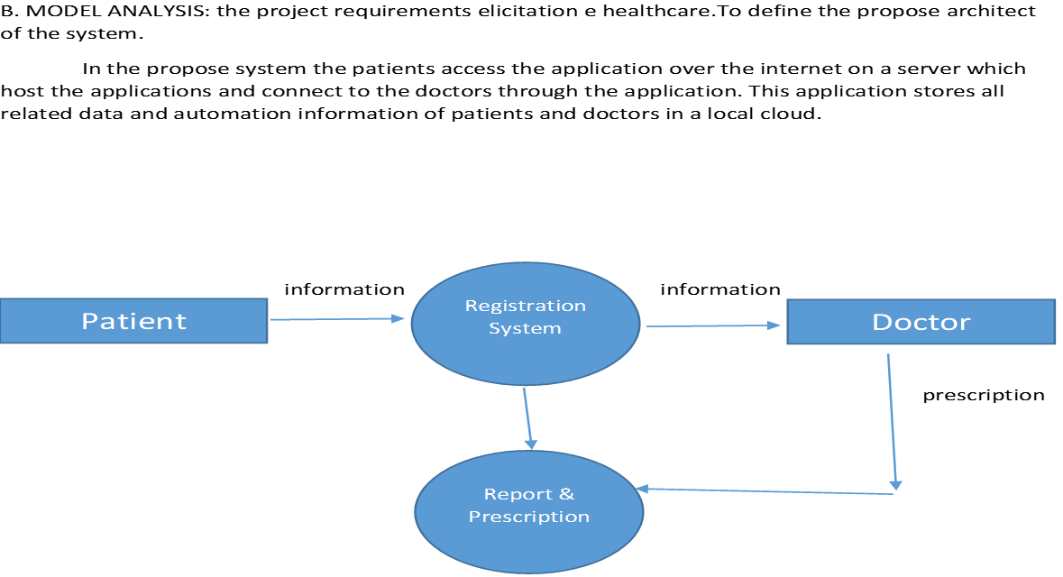

**Overview of E-Heath Care System:**

Doctor's facility Administration Programming is one of the fruitful result of the organization. The healing center administration programming or the product for doctor's facility administration ordinarily consolidates different fundamental highlights which help to run easily the normal everyday premise operations of any doctor's facility. The healing center or facility administration programming is made such a path, to the point that it takes care of the outpatients, inpatients, billings, database of the patients, and the doctor's facility data including the accessibility of the specialists, their specialization, the installments to different individuals from the staff and the charging procedure. In general, the doctor's facility data administration framework is exceptionally helpful to dealing with every one of the parts of running the clinic in the financially savvy way.

Sample Scenarios:

John Doe wishes to use e-health care system to manage his personal medical records on his android phone, but he does not have an account. So, John goes to the use e-health care system website at the login screen chooses to create a new account. The system prompts John to create a password and to enter his basic information, which includes his name, birth date, gender, ethnicity, weight, height, blood type, and a list of his known allergies. When John finishes entering his basic information, he is taken to a payment screen where he has to choose a method of payment. Now, the system assigns John a patient ID, which he will use in conjunction with his password to access his account. John is automatically logged in and is able to create new records for himself or view any existing records he may have.

Now that John has successfully created his account, he now wants his doctor, George Duckworth, to be able to view, update, and create medical records on his account. George, however, does not have an use e-health care system account. So, John recommends that George create himself an account. George agrees, and proceeds to do so. Since George is a doctor, the account he creates is slightly different from John’s. When George chooses to create an account, he chooses to create a “Healthcare Provider Account.” George goes through the same process as John while setting up the account; however he must enter some additional information to verify that he is indeed a legal doctor. The system now assigns him a healthcare provider ID, which he will use in conjunction with his password to log in. Since George currently has no patients registered to him, he is only able to view and create his own medical records. John goes to George’s office to sign a contract, which is downloadable from the main web site. The contract simply confirms the fact that George is John’s doctor and John wishes to grant George access to John’s personal medical records. The form is signed by both parties and sent to use e-health care system. Now, when George logs on to his account, before he is taken to the record browsing screen, he must choose which records he wants to access; John’s or his own.

Since both accounts have now been successfully created, and John is successfully registered as a patient of George, John now wishes to obtain the use e-health care system android application. John downloads the application onto his Phone and installs it. During the installation process, the application prompts John for his patient ID and password. This is used to link the application to John’s account. Now that the application has been installed, John will never have to enter his patient ID into the application because it is already linked to his account; he only needs to enter his password. John is now able to view his medical records on his Phone. John logs into the application, and the system performs an update routine, which is done every time John logs in. This routine simply checks to see if any changes have been made to John’s records. This includes new records being created or old records being changed or deleted. Now that the update routine is complete, John begins to browse his records, and notices that he has new records on his account. Since all records are labeled depending on the user who created or changed them, John can see that George has entered several new records on John’s account. These records are labeled as “new” until John views them for the first time. One of these records is an old test result from a CAT scan. John decides to view this particular document, so John selects it from the list of test and lab result records. Since test and lab results are not stored locally, the application downloads the record from use e-health care system and then displays it on the screen. John also notices that at any time, even before he logs in, there is an “Emergency Information” button that he can press. John logs out of the application, and while at the login screen, presses the button. The application accesses John’s basic information and displays it on the screen. John is now happy that he has chosen to use use e-health care system, and feels safer knowing that in the case of an emergency medical personnel are able to view his basic information, and his doctor is able to easily view his medical history.

**Glossary**

