EShoppingZone — Low Level Design (LLD)

1. System Overview
EShoppingZone is an e-commerce platform where:
- Users browse products
- Add/remove items from cart
- Place orders
- Pay using wallet or Cash on Delivery
- View previous orders
- Update profile
Two major actors:
- Customer
- Merchant/Admin
Main modules mentioned in the HLD:
- Profile Service
- Product Service
- Cart Service
- Order Service
- Wallet Service
- Website Controller

2. 3-Layer Architecture
The system follows:

1. Controller Layer (Presentation)
Handles HTTP requests.
Controllers:
- AuthController
- ProductController
- CartController
- OrderController
- WalletController
- ProfileController
Responsibilities:
- Accept API requests
- Validate input
- Call services
- Return API responses

2. Service Layer (Business Logic)
Implements core application logic.
Services:
- AuthService
- ProductService
- CartService
- OrderService
- WalletService
- ProfileService
Responsibilities:
- Handle business rules
- Manage cart logic
- Handle order placement
- Process wallet transactions

3. Repository Layer (Data Access)
Handles database operations.
Repositories:
- UserRepository
- ProductRepository
- CartRepository
- OrderRepository
- WalletRepository
- TransactionRepository
Responsibilities:
- Database CRUD operations
- Query handling
- Data persistence

3. High Level Architecture (3-Layer)
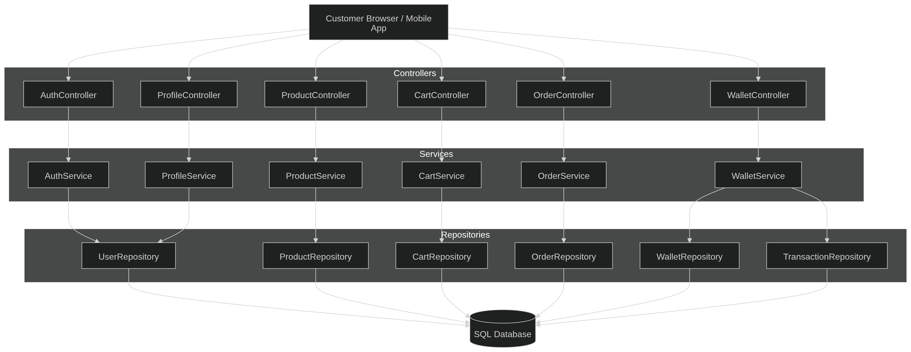
High Level Architecture

4. Project Structure
Project Structure

5. Domain Model (Entities)
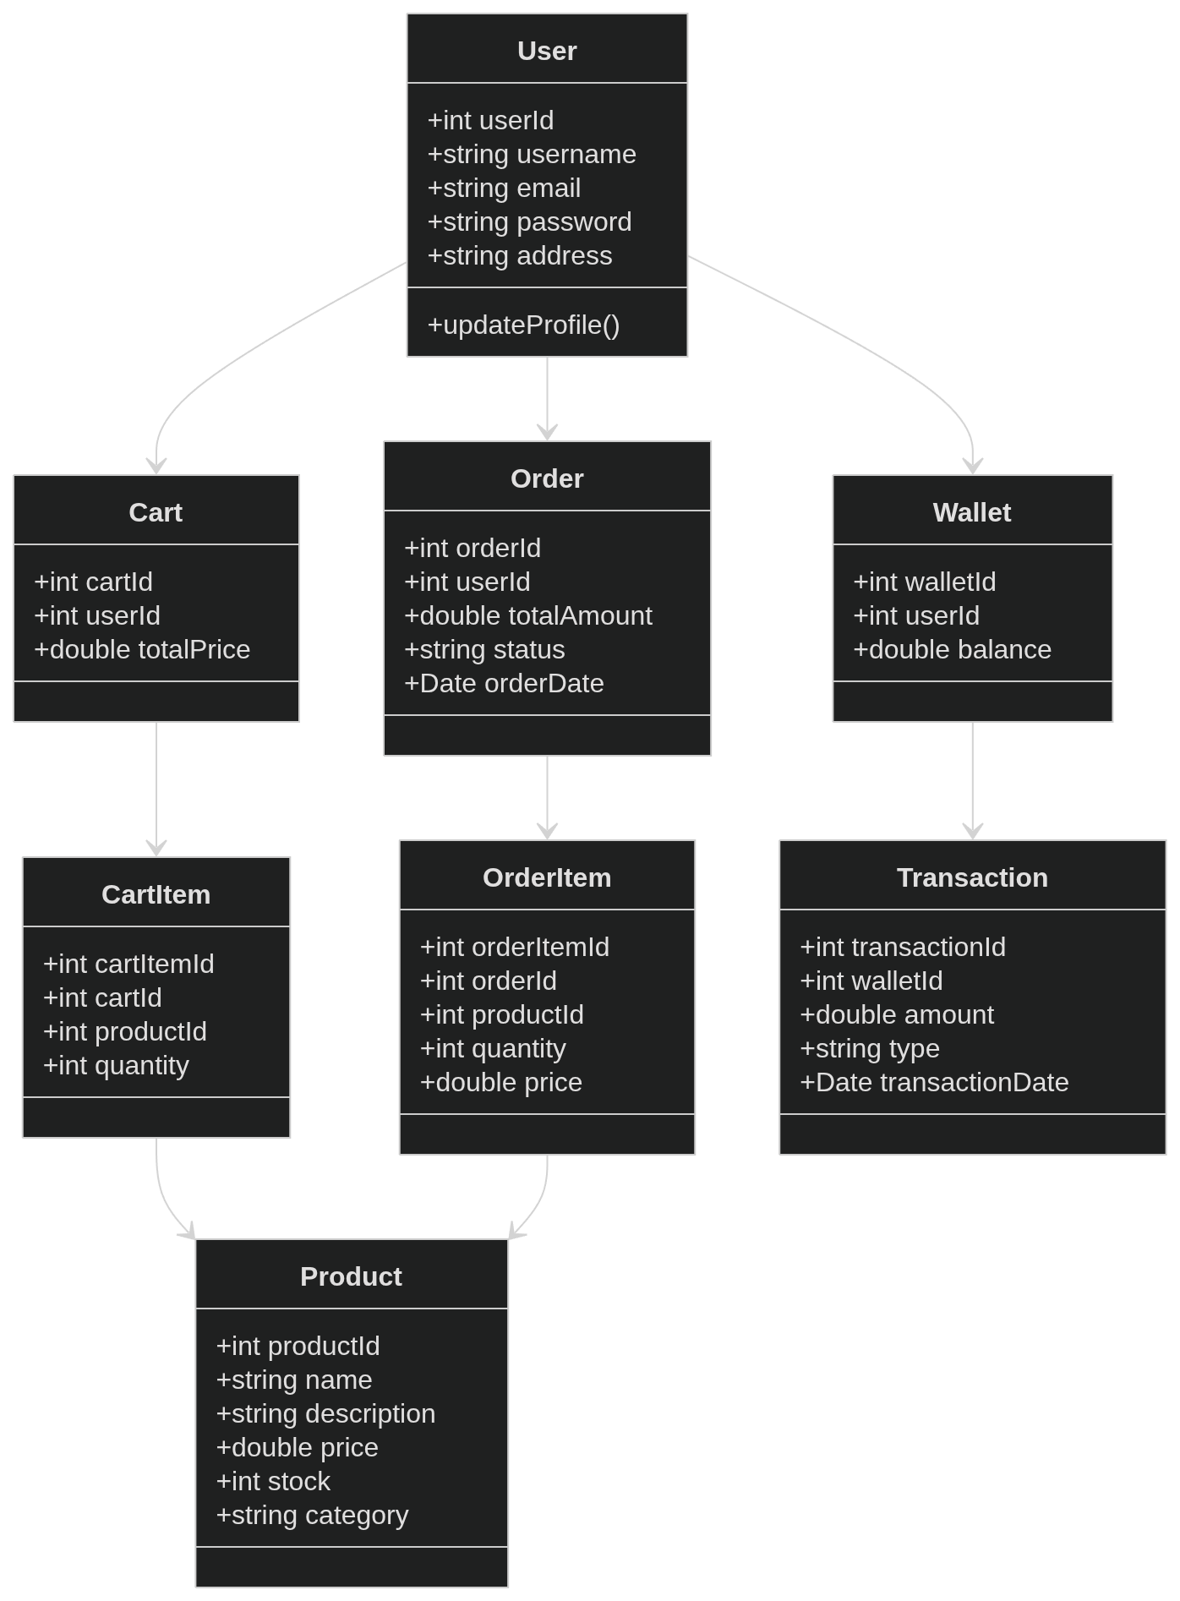
Domain Model

6. Database Design
Main tables:

Users
user_id (PK)
username
email
password
address

Products
product_id (PK)
name
description
price
stock
category

Cart
cart_id (PK)
user_id (FK)
total_price

CartItems
cart_item_id (PK)
cart_id (FK)
product_id (FK)
quantity

Orders
order_id (PK)
user_id (FK)
total_amount
status
order_date

OrderItems
order_item_id (PK)
order_id (FK)
product_id (FK)
quantity
price

Wallet
wallet_id (PK)
user_id (FK)
balance

Transactions
transaction_id (PK)
wallet_id (FK)
amount
type
transaction_date

7. Controller Design

AuthController
Endpoints
POST /signup
POST /login
Methods
signup(UserSignupDTO dto)
login(LoginDTO dto)

ProductController
Endpoints
GET /products
GET /products/{id}
GET /products/search
Methods
getAllProducts()
getProductById(id)
searchProduct(keyword)

CartController
Endpoints
POST /cart/add
DELETE /cart/remove
GET /cart
Methods
addItem(productId, quantity)
removeItem(productId)
viewCart()

OrderController
Endpoints
POST /order/checkout
GET /order/history
Methods
placeOrder()
getOrders()

WalletController
Endpoints
POST /wallet/add
GET /wallet/balance
POST /wallet/pay

8. Cart Flow (Sequence Diagram)
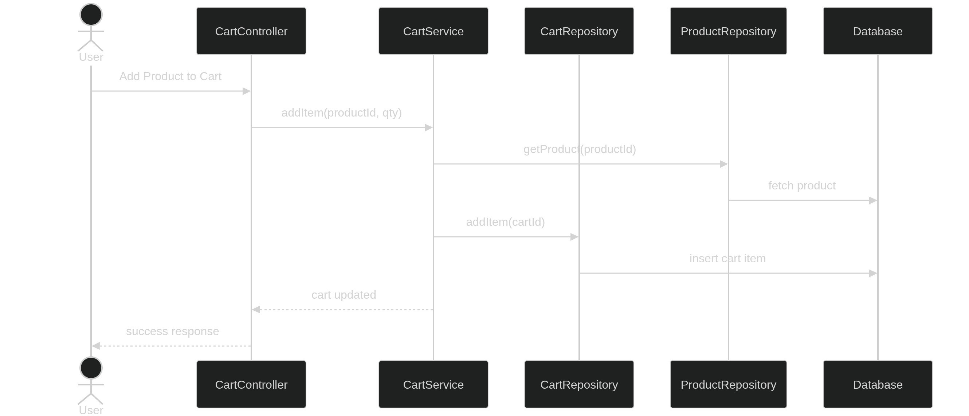
Cart Flow

9. Order Placement Flow
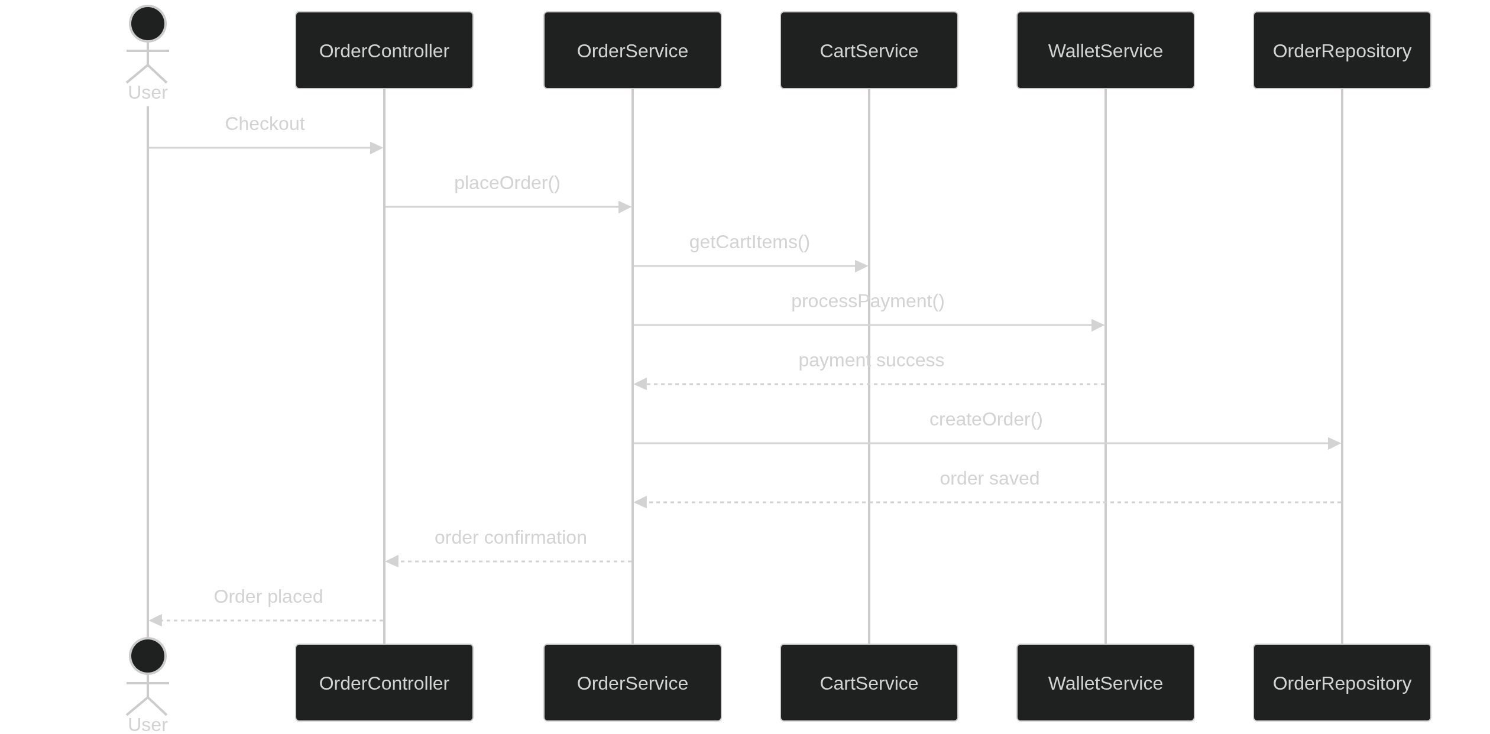
Order Placement Flow

10. Cart Service Logic (Pseudo)
addItem(productId, qty):
product = productRepository.findById(productId)
if product.stock < qty
throw "Product out of stock"
cart = cartRepository.getCart(userId)
if cartItem exists
update quantity
else
insert new cart item
update cart total
return updated cart

11. Wallet Payment Logic
processPayment(userId, amount):
wallet = walletRepository.getWallet(userId)
if wallet.balance < amount
throw InsufficientBalanceException
wallet.balance -= amount
transactionRepository.save(
walletId,
amount,
"DEBIT"
)
return paymentSuccess

12. Security
Authentication options:
- Email/password login
- GitHub OAuth login (from HLD)
Security features:
- JWT authentication
- Password hashing (bcrypt)
- Role-based authorization
- HTTPS

13. Exception Handling
Global middleware handles errors.
Common exceptions:
Exception | HTTP Code
ProductNotFound | 404
UnauthorizedAccess | 401
InsufficientBalance | 400
InvalidCart | 400

14. Key Functional Flows

User Registration
- User enters details
- AuthService validates
- UserRepository saves user

Add to Cart
- Product selected
- CartService adds item
- CartRepository updates database

Checkout
- Cart validated
- Wallet/COD selected
- Order created

Order History
- User requests orders
- OrderRepository fetches history

15. Possible Improvements
Future enhancements:
- Product recommendation system
- Microservices architecture
- Redis caching for cart
- Event-driven order processing

