LEARNQUEST

LINUX LABS
DOCUMENTATION

————————————

MODULES 1 & 2

Navigation, File Basics & Process Management

Command-Line Practice Documentation
Linux Fundamentals Coursework
July 2026

1. Introduction
Working confidently in Linux begins with knowing where you are in the filesystem, what files and directories surround you, and how to read, copy, move, and remove them. Beyond files, every running Linux system is also a collection of processes — some tied to what a user is doing directly, and others, called daemons, running quietly in the background to provide services such as web servers or databases.
This document brings together the two modules of hands-on lab practice completed so far. Module 1 covers filesystem navigation, listing, viewing, copying, and removing files. Module 2 introduces process management — inspecting what is running on a system and terminating a process when needed. Commands are grouped by function rather than listed in one long sequence, with each category followed by the terminal screenshots that demonstrate it in action.

2. Learning Objectives
By the end of these modules, the learner will be able to:
- Navigate the Linux filesystem using pwd and cd.
- List files and directories in multiple formats, including hidden files, using ls and its options.
- View and copy the contents of text files using cat and cp.
- Remove files and directories safely with rm and rm -r, and rename or relocate them with mv.
- Explain what a daemon is and recognize background services running on a system.
- Inspect running processes and their resource usage using ps -aux.
- Terminate a specific process using kill -9 and its Process ID (PID).

3. Learned Path
The commands across both modules build on one another in a natural, practical sequence:
Step 1 — Orient yourself: Use pwd and cd to find your current location and move around the filesystem.
Step 2 — List what's there: Use ls and its options (-l, -R, -a, -al) to inspect directory contents in increasing detail.
Step 3 — Work with file content: Use cat to view, create, and copy the contents of text files.
Step 4 — Duplicate and organize: Use cp to copy files and mv to rename or relocate them.
Step 5 — Clean up: Use rm and rm -r to remove files and directories that are no longer needed.
Step 6 — Monitor processes: Use ps -aux to view running processes and understand what a daemon is.
Step 7 — Manage processes: Use kill -9 PID to forcefully terminate a specific process.

4. Navigation
Command | Description
pwd | Displays the current working directory — your current location in the filesystem.
cd | Changes the current directory, allowing you to move between directories.
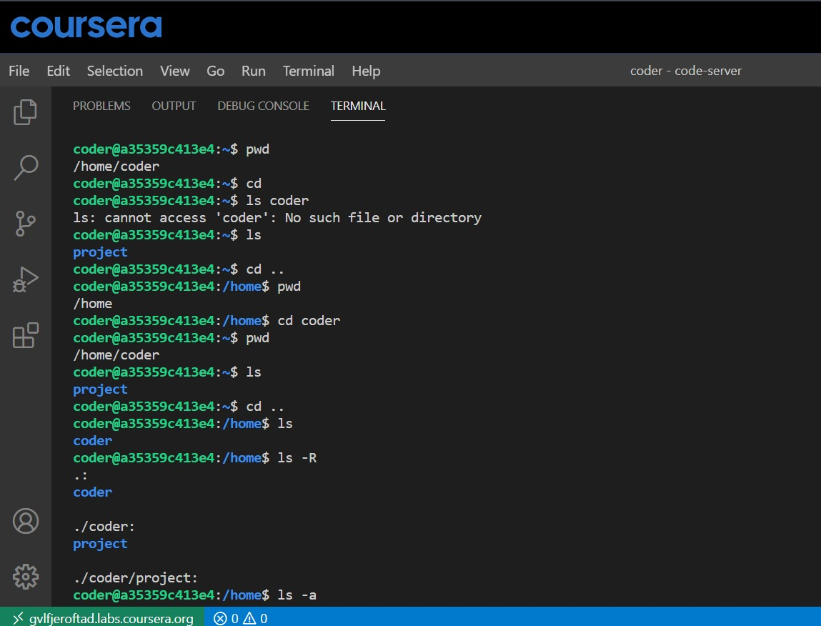
Figure 1 — Using pwd and cd to move between directories.

5. Directory & File Listing
Command | Description
ls | Lists the files and directories in the current directory.
ls -l | Displays files and directories in long format, showing permissions, owner, size, and modification date.
ls -R | Recursively lists all files and directories, including the contents of all subdirectories.
ls -a | Lists all files and directories, including hidden files (those beginning with a dot).
ls -al | Combines -l and -a: a detailed listing of all files, including hidden ones.
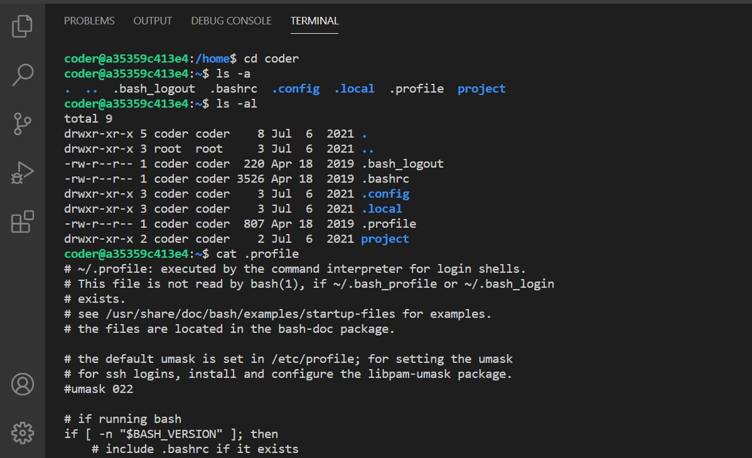
Figure 2 — ls -a and ls -al listing hidden files in detail.
ls and ls -R are covered in the table above; ls itself is also visible in Figure 1, and ls -R was practiced without a dedicated screenshot capture.

6. Viewing & Copying Files
Command | Description
cat | Displays, creates, concatenates (combines), and appends text files.
cat .profile > file | Copies the contents of .profile into file_name, overwriting it if it already exists.
cp | Copies files or directories from one location to another.
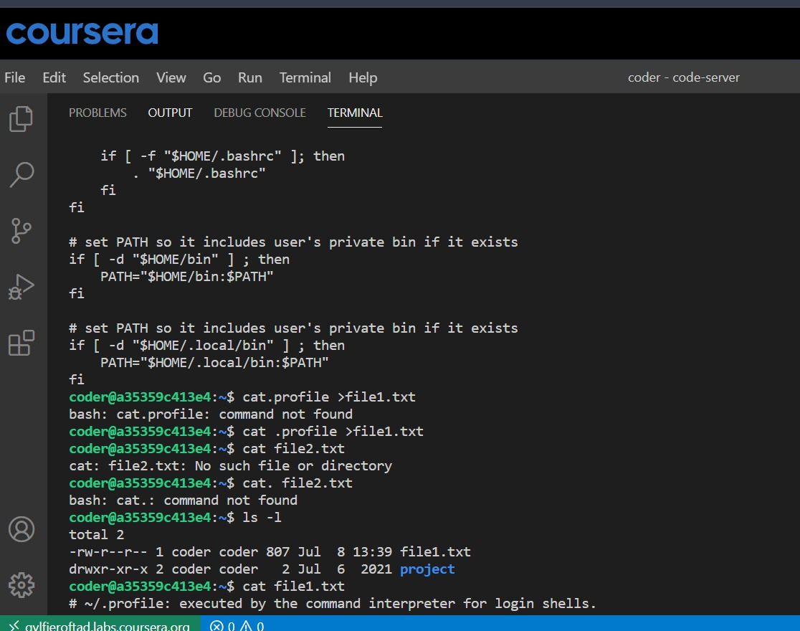
Figure 3 — Viewing the contents of a startup file with cat.
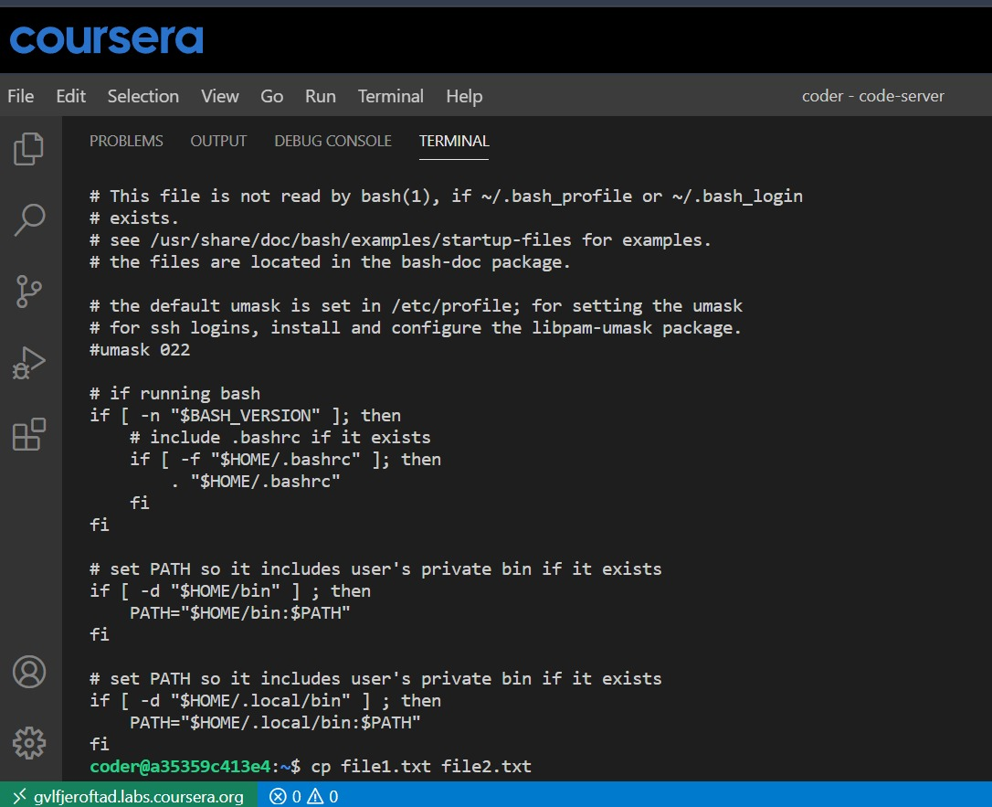
Figure 4 — Continued file content displayed by cat.
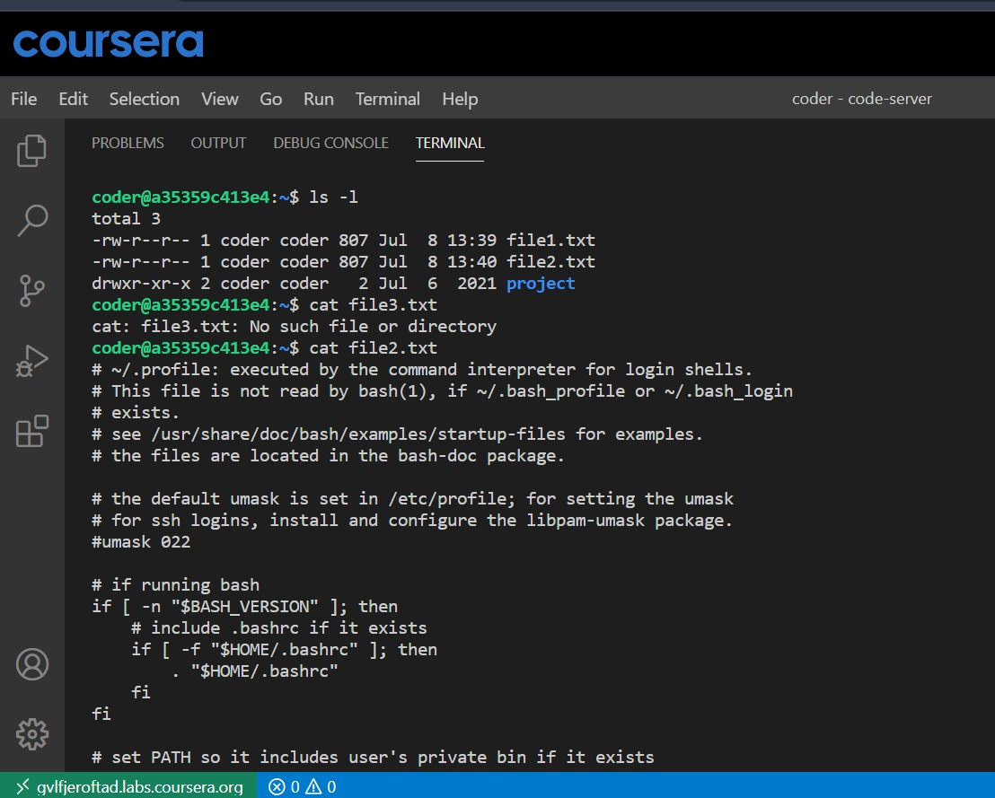
Figure 5 — ls -l followed by cat used on file2.txt and a missing file3.txt.
cp was practiced conceptually in this module; no dedicated terminal screenshot of cp was captured.

7. Removing & Renaming Files
Command | Description
rm | Removes (deletes) a file.
rm -r | Removes a directory and all of its contents — files and subdirectories — recursively.
mv | Moves or renames a file or directory.
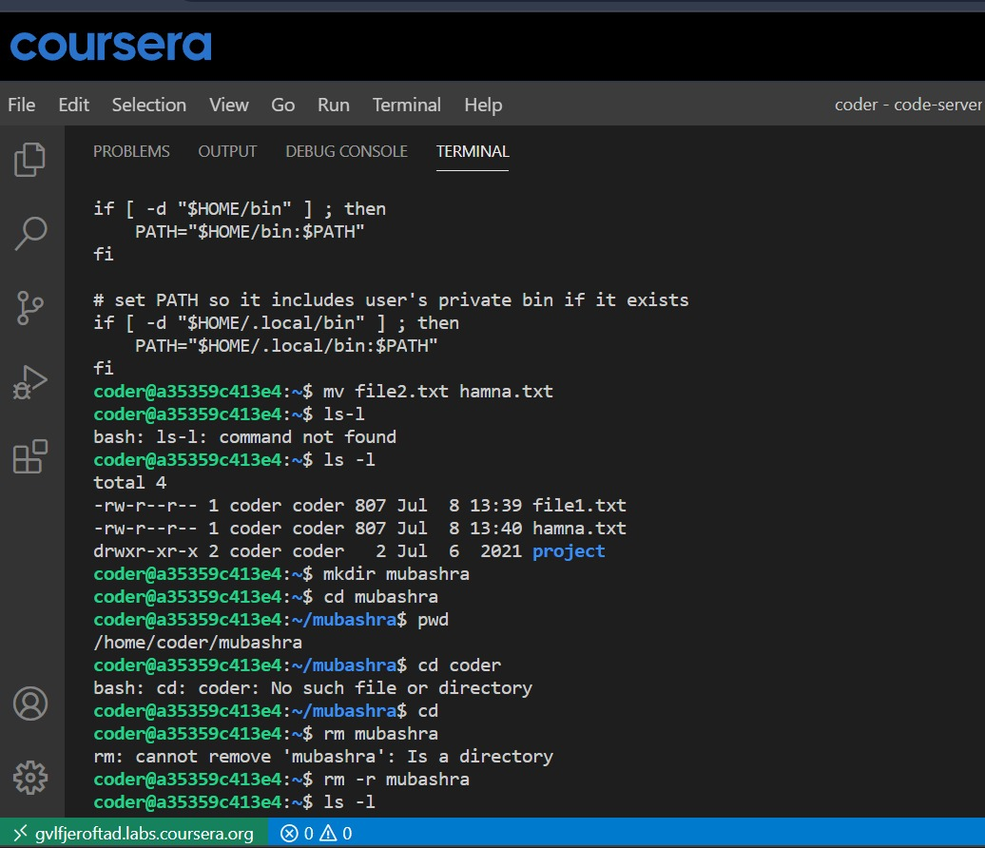
Figure 6 — Renaming a file with mv (file2.txt → hamna.txt).
rm and rm -r were practiced in this module; no dedicated terminal screenshot of rm was captured.

8. Process Management
Command | Description
ps -aux | Displays detailed information about all running processes: user, PID, CPU usage, memory usage, and the command that started each process.
kill -9 PID | Forcefully terminates the process with the specified Process ID (PID).
This module introduces the concept of a daemon (d) — a service or process that runs continuously in the background without requiring user interaction. Many Linux daemon names end in d, such as mysqld, sshd, and httpd. For example, when ps aux is run, the process mysqld may appear with its own Process ID (PID) — in this session, PID 149 — showing that the MySQL service is running in the background.
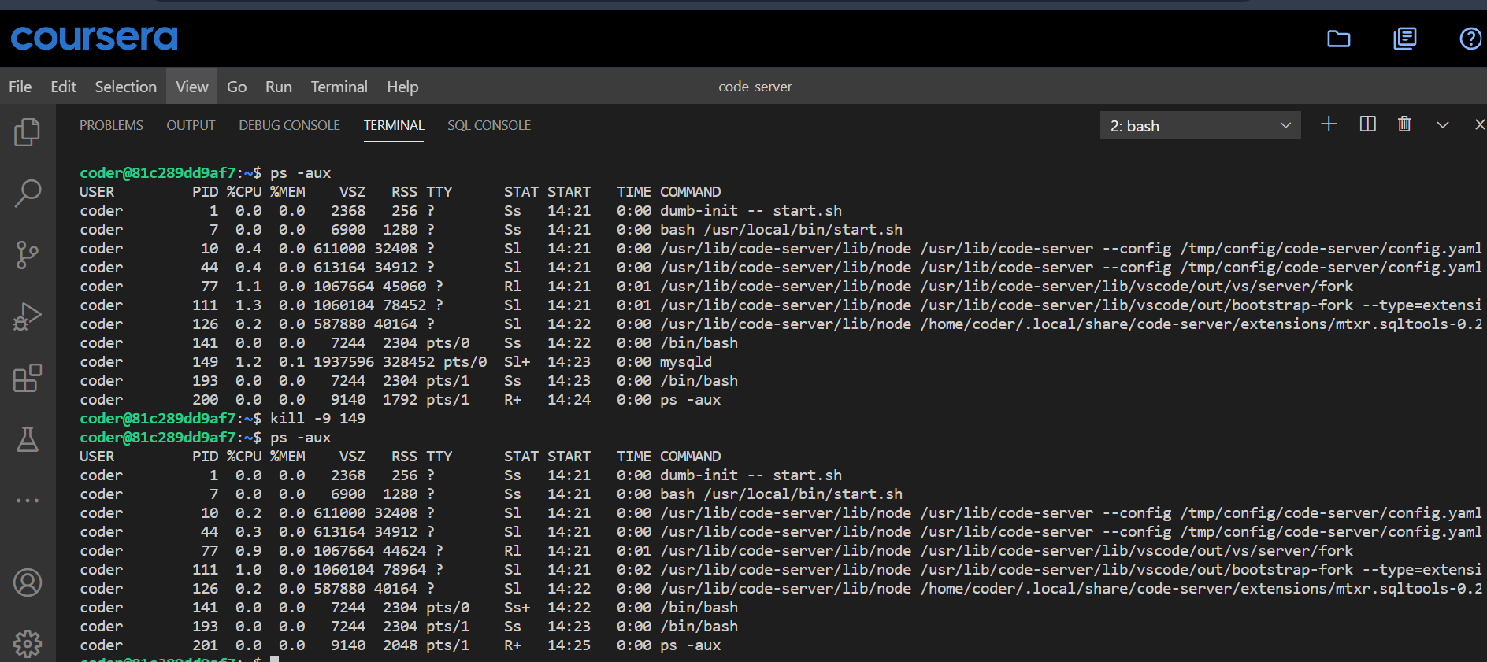
Figure 7 — ps -aux listing running processes, then kill -9 terminating the mysqld process.

9. Summary
Together, Modules 1 and 2 build a practical foundation for working in the Linux command-line environment: orienting yourself in the filesystem, listing and reading files in detail, copying and reorganizing them, cleaning up what's no longer needed, and finally looking beyond files to the processes — including background daemons — that keep a Linux system running.

