Q.2) Script of bash to copy history of linux machine in file at every hour and then that file copy to specific s3 bucket?

🡺

Step 1:-

Firstly login to aws to launch a instance. And then launch a instance.

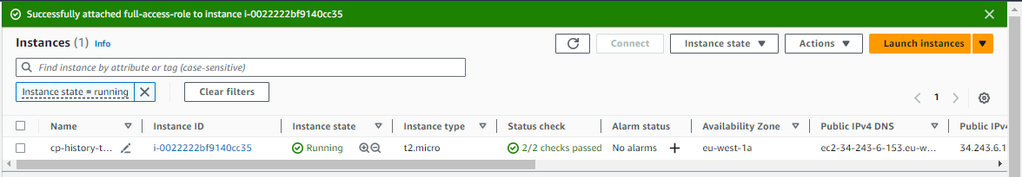

Step 2:-

Get access of it and then create a file .sh file to write a script In it.

I have created file name cp-history.sh. to created file and rdit it by command

# vim cp.history.sh and then write script in it

And make secure to change with some lines

In history_directory= gave the path of history directory and then in s3_bucket= gave bucket name and then save it.



history_dir="/root/history_dir"

s3_bucket="history-of-linux12"

history_file="command_history_$(date +%Y%m%d%H%M%S).txt"

mkdir -p "$history_dir"

copy_command_history() {

history > "$history_dir/$history_file"

}

upload_to_s3() {

aws s3 cp "$history_dir/$history_file" "s3://$s3_bucket/"

}

copy_command_history

upload_to_s3

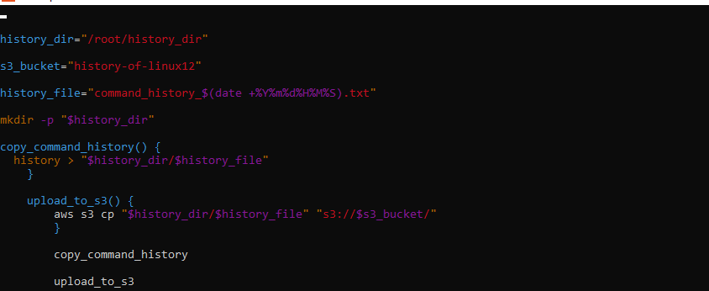

Step 3:-

After that gave it execute permission with command

# chmod 555 cp-history.sh

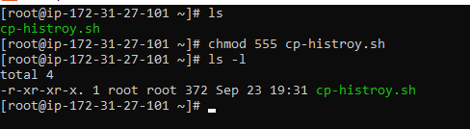

Step 4:-

Now attach a role to that instance or configure aws. i have configure aws user which has permission of s3.

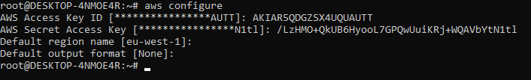

Step 5:-

Now you have to run this script on a particular time so you have to schedule crontabb job to run this script every hr. so run command to run create crontab job

# crontab –e and then write its filed and path of your .sh file

0 * * * * /root/cp-histroy.sh

And your job was schedule it means every 1 hr create history directory and that directory send to s3 bucket.

