Q.3) script for bash create a backup of rds mariadb database every 2nd and 4th of each month Friday?

🡺

Step 1:-

Login to aws account and go to ec2 service and launch a instance.

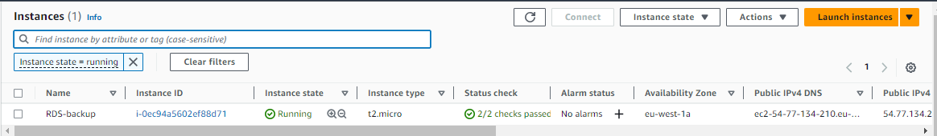

Step 2:-

Now if you have not RDS database then go to RDS service and create a database and if you have a database leave it and go to next step. I have created database already so I have to get snapshot it on every 2nd and 4th Friday of each month. So get access of your launched instance.

And in that instance create a .sh file to write a script for create snapshot of that RDS database.

I have created backup-db.sh file. And it that fil

# Replace with your RDS instance identifier and then aws region in which your database pf rds was created.

And then save that .sh file.

AWS region

RDS_INSTANCE_IDENTIFIER="my-database"

AWS_REGION="eu-west-1"

SNAPSHOT_IDENTIFIER="Snapshot-$(date +\%Y\%m\%d\%H\%M\%S)"

aws rds create-db-snapshot --db-instance-identifier "$RDS_INSTANCE_IDENTIFIER" --db-snapshot-identifier "$SNAPSHOT_IDENTIFIER" --region "$AWS_REGION"

# Print a message

echo "RDS snapshot created: $SNAPSHOT_IDENTIFIER"e I write following script.

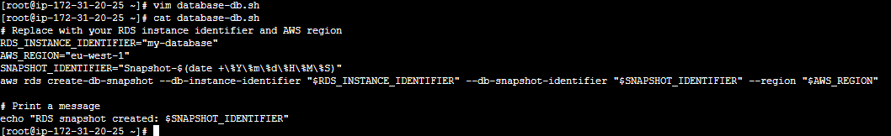

Step 3:-

Now gave that database-db.sh file a execute permission by run command

#chmod 555 database-db.sh and then configure aws user access and secrete key.

Remember one thing that user have access of RDS service access.

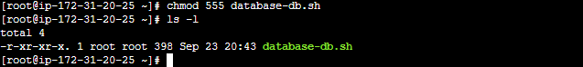

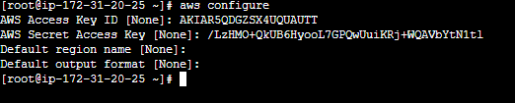

Step 4:-

Now last one is to schedule crontab job for create a snapshot on time.

So run command

# crontab –e

And your job was schedule to run on time database-db.sh file. And create snapshot.

