**Comp 2322 Computer Networking**

**Homework Five Solutions**

**Total marks: 10 points**

**Questions:**

1. (2 points) Consider the network shown below. Suppose AS3 and AS2 are running OSPF for their intra-AS routing protocol. Suppose AS1 and AS4 are running RIP for their intra-AS routing protocol. Suppose eBGP and iBGP are used for the inter-AS routing protocol. Initially suppose there is no physical link between AS2 and AS4.

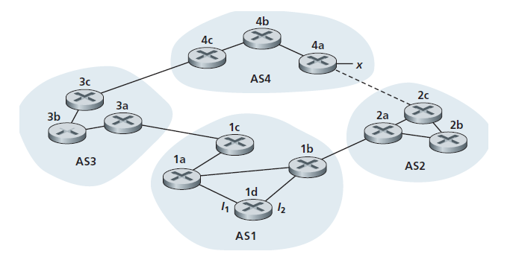

From which routing protocol: OSPF, RIP, eBGP, or iBGP, do the following routers learn about prefix x? Justify your answer.

1. Router 3c (1 point)
2. Router 1d (1 point)

Ans:

|  |  |  |
| --- | --- | --- |
| Router | Routing protocol | Justification |
| 3c | eBGP | Router 3c learns about prefix x from AS4 using the inter-AS routing protocol eBGP |
| 1d | iBGP | Router 1c learns about prefix x from AS3 using the inter-AS routing protocol eBGP.  Then router 1d learns about prefix x from 1c using the inter-AS routing protocol iBGP. |

1. (3 points) Referring to the previous problem, once router 1d learns about x it will put an entry (x, I) in its forwarding table.
2. Will I be set to I1 or I2 for this entry? Why? (1 point)

Ans:

I will set to I1. (0.5 point)

This is because the least cost path from 1d towards the gateway router 1c goes to interface I1. (0.5 point)

1. Now suppose that there is a physical link between AS2 and AS4, shown by the dotted line. Suppose router 1d learns that x is accessible via AS2 as well as via AS3. Will I be set to I1 or I2? Why? (1 point)

Ans:

I will set to I2. (0.5 point)

This is because both routes have equal AS path length but I2 begins the path that has the closest next-hop router. (0.5 point)

1. Now suppose there is another AS, called AS5, which lies on the path between AS2 and AS4 (not shown in diagram). Suppose router 1d learns that x is accessible via AS2 AS5 AS4 as well as via AS3 AS4. Will I be set to I1 or I2? Why? (1 point)

Ans:

I will set to I1. (0.5 point)

This is because I1 begins the path that has the shortest AS path length. (0.5 point)

1. (5 points) We consider the use of small packets for Voice-over-IP applications. Suppose that the packet consists of *L* bytes of data and 5 bytes of header.
2. A small packet size causes a fraction of link bandwidth to be consumed by overhead. The transmission overhead can be defined as the percentage of the amount of transmitted overhead bits relative over the total amount of transmitted bits. Determine the transmission overhead for *L* = 1,000 bytes and for *L* = 100 bytes. (2 points)

Ans:

The transmission overhead is calculated as $P=\frac{5}{L+5}×100\%$

For L= 1,000 bytes, $P=\frac{5}{1000+5}×100\%=0.50\%$ (1 point)

For L=100 bytes, $P=\frac{5}{100+5}×100\%=4.76\%$ (1 point)

1. Consider sending a digitally encoded voice source directly. Suppose the source is encoded at a constant rate of 128 kbps. Assume each packet is entirely filled before the source sends the packet into the network. The time required to fill a packet is the packetization delay. Packetization delays greater than 20 msec can cause a noticeable and unpleasant echo. In terms of *L* bytes, determine the packetization delay in milliseconds. Also, determine the packetization delay for *L* = 1,000 bytes and for *L* = 100 bytes. (3 points)

Ans:

The time required to fill L bytes is $\frac{L×8}{128×1000}$ seconds, i.e., $\frac{L}{16}$ msec. (1 point)

For L = 1,000 bytes, the packetization delay is $\frac{1000}{16}=62.5$ msec. (1 point)

For L = 100 bytes, the packetization delay is $\frac{100}{16}=6.25$ msec. (1 point)