**Comp 2322 Computer Networking**

**Tutorial Four**

**Questions:**

1. Consider sending a large file from a host to another over a TCP connection that has no loss.
2. Suppose TCP uses AIMD for its congestion control without slow start. Assuming cwnd increases by 1 MSS (maximum segment size) every time an ACK is received and assuming approximately constant RTT (round-trip time), how long does it take for cwnd increase from 6 MSS to 12 MSS (assuming no loss events)?
3. What is the average throughput (in terms of MSS and RTT) for this connection up to time = 6 RTT?
4. Consider the TCP congestion control. In the period of time from when the connection’s rate varies from W/(2·RTT) to W/RTT, only one packet is lost at the very end of the period, where W is the window size (measured in bytes) and RTT is the round-trip-time of a packet and its ACK. Show that the loss rate *L* (fraction of packets lost) is calculated as
$$L=\frac{1}{\frac{3}{8}W^{2}+\frac{3}{4}W}$$

5. According to TCP’s AIMD algorithm, the convergence of two competing sessions is shown as the figure.

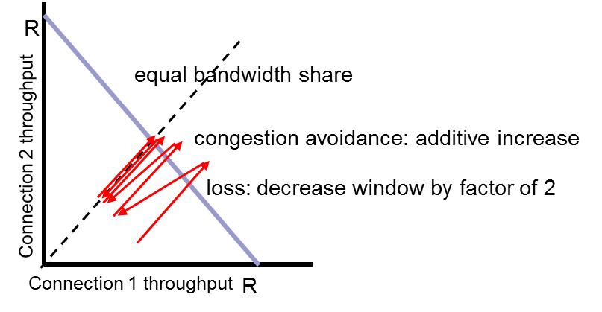

Suppose that instead of a multiplicative decrease, TCP decreases the window size by a constant amount. Would the resulting AIAD algorithm converge to an equal share point? Justify your answer.

1. We consider the delay introduced by the TCP slow-start phase. Consider a client and a Web server directly connected by one link of rate R. Suppose the client wants to retrieve an object whose size is exactly equal to 15S, where S is the MSS. Denote the round-trip time between client and server as RTT (assumed to be constant). Ignoring protocol headers, determine the time to retrieve the object (including TCP connection establishment) when
2. 2S/R < S/R + RTT < 4S/R
3. 4S/R < S/R + RTT
4. RTT < S/R