**Comp 2322 Computer Networking**

**Tutorial Five**

**Questions:**

1. Consider the network below.

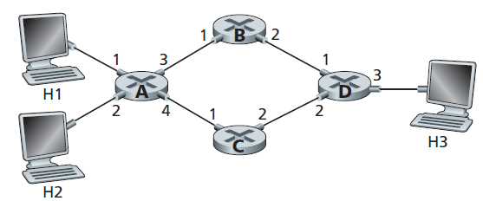

1. Show the forwarding table in router A, such that all traffic destined to host H3 is forwarded through interface 3.
2. Can you write down a forwarding table in router A, such that all traffic from H1 destined to host H3 is forwarded through interface 3, while all traffic from H2 destined to host H3 is forwarded through interface 4?
3. Consider a datagram network using 32-bit host addresses. Suppose a router has four links, numbered 0 through 3, and packets are to be forwarded to the link interfaces as follows:

|  |  |
| --- | --- |
| Destination Address Range | Link Interface |
| From 11100000 00000000 00000000 00000000  To 11100000 00111111 11111111 11111111 | 0 |
| From 11100000 01000000 00000000 00000000  To 11100000 01000000 11111111 11111111 | 1 |
| From 11100000 01000001 00000000 00000000  To 11100001 01111111 11111111 11111111 | 2 |
| Otherwise | 3 |

1. Provide a forwarding table that has five entries, uses longest prefix matching, and forwards packets to the correct link interfaces.
2. Describe how your forwarding table determines the appropriate link interface for datagrams with destination addresses:
   1. 11001000 10010001 01010001 01010101
   2. 11100001 01000000 11000011 00111100
   3. 11100001 10000000 00010001 01110111
3. Rewrite this forwarding table using the a.b.c.d/x notation instead of the binary string notation.
4. Consider sending a 2400-byte datagram into a link that has an MTU of 700 bytes. Suppose the original datagram is filled with the identification number 422. How many fragments are generated? What are the values in the various fields in the IP datagram(s) generated related to fragmentation?
5. Consider the seven-node network (with nodes labeled t to z) below. With the indicated link cost, use Dijkstra’s shortest-path algorithm to compute the shortest path from node z to all network nodes. Show the routing table for node z.

