**Comp 2322 Computer Networking**

**Tutorial Six**

**Questions:**

1. Consider the 5-bit generator, G=10011, and suppose that D has the value 1010101010. What is the value of R?
2. Suppose nodes A and B are on the same 10 Mbps broadcast channel, and the propagation delay between the two nodes is 325 bit times. Suppose CSMA/CD and Ethernet packets are used for this broadcast channel. Suppose node A begins transmitting a frame and, before it finishes, node B begins transmitting a frame. Can A finish transmitting before it detects that B has transmitted? Why or why not? If the answer is yes, then A incorrectly believes that its frame was successfully transmitted without a collision. (Hint: Suppose at time t = 0 bits, A begins transmitting a frame. In the worst case, A transmits a minimum-sized frame of 72*8=576 bit times. So A would finish transmitting the frame at t = 576 bit times. Thus, the answer is no, if B’s signal reaches A before bit time t = 576 bits.)
3. Consider three LANs interconnected by two routers, as shown in figure below.



Suppose Host A sends a datagram to Host F. Give the source and destination MAC addresses in the frame encapsulating this IP datagram as the frame is transmitted (i) from A to the left router, (ii) from the left router to the right router, (iii) from the right router to F. Also give the source and destination IP addresses in the IP datagram encapsulated within the frame at each of these points in time.

1. Consider the operation of a learning switch in the context of a network in which 6 nodes labeled A through F are star connected into an Ethernet switch (see the figure). The MAC addresses of the nodes are listed in the table. Suppose that (i) B sends a frame to E, (ii) E replies with a frame to B, (iii) A sends a frame to B, (iv) B replies with a frame to A. The switch table is initially empty. Show the state of the switch table before and after each of these events. For each of these events, identify the link(s) on which the transmitted frame will be forwarded, and briefly justify your answers.

|  |  |
| --- | --- |
| Node | MAC Address |
| A | 11-11-11-11-11-11 |
| B | 22-22-22-22-22-22 |
| C | 33-33-33-33-33-33 |
| D | 44-44-44-44-44-44 |
| E | 55-55-55-55-55-55 |
| F | 66-66-66-66-66-66 |

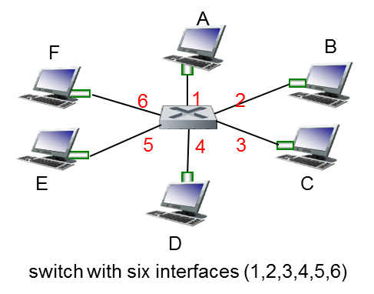

1. In this question, you will put together much of what you have learned about Internet protocols. Suppose you walk into a room, connect to Ethernet, and want to download a Web page. What are all the protocol steps that take place, starting from powering on your PC to getting the Web page? Assume there is nothing in your DNS or browser caches when you power on your PC. (Hint: the steps include the use of Ethernet, DHCP, ARP, DNS, TCP, and HTTP protocols.) Explicitly indicate in your steps how you obtain the IP and MAC addresses of a gateway router.