To be completed by the student |  | To be completed by the markers
Module Name and code | Introduction to Web Publishing | First Marker’s name (equivalent to the signature)
Student ID (UoW) | 14397246/1 | Second Marker’s name (equivalent to the signature)
Student ID (WIUT) | 00002210 | For Registrar’s office use only (hard copy submission)
Deadline date | April 3, 2014
Individual assignment | 
Group assignment | 
COURSEWORK SUBMISSION COVER PAGE

Submission instructions

Please note that all work must be submitted electronically unless instructed otherwise.

For online submission instructions refer to: http://intranet.wiut.uz/Shared%20Documents/Forms/AllItems.aspx- Coursework online submission instructions.doc

For hardcopy submission instructions refer to: http://intranet.wiut.uz/Shared%20Documents/Forms/AllItems.aspx- Coursework hard copy submission instructions.doc

Feedback
To be completed by markers

Assessment criterion and/or learning outcome | Marker’s comments and second marker’s comments if appropriate
1.

2.

3.

Table of Contents
Site Plan 2
Audience Profile 2
Goals and Objectives 2
Function and Features 3
Design Strategy 3
Accessibility 3
Navigation 3
JavaScript 3
Evaluation of Competitors Websites 5
Evaluation Strategy 5
Design Evaluation 6

Site Plan
Audience Profile
Nowadays as technology is being developed and penetrating to our lives, peoples do not want to go out home for things that can be done remotely. For instance, shopping or buying clothes on online store. There are too many websites that offer this feature, like Ebay or Amazon, but they are not appropriate for our country as they work with VISA or MasterCard and the warehouse is too far from our country that shipping will be expensive. That is why, I decided to create online store that will offer various clothes from famous brands for both men and women. The target market is people whose age between 10 to 70 years.
Goals and Objectives
The main goal of this site is provide the fashionable and accessible dresses to the public. Currently, the online stores is not popular in Uzbekistan, because of the people do not rely on and do not trust. That is why my service is a bit different, people order clothes on website then after delivering the bought cloth they will pay for them. This is my website’s advantage over the popular web stores.
Function and Features
Website has different functions that make it more user friendly. For example, users can add liked items to the cart and easily track the total price they have to pay, then, they are able to see what products they bought and how much they cost overall. If they do not like selected items, they can easily empty the cart and start shopping again. In addition, if user accidently closes the browser, they will not lose the selected items, all items will not be deleted while user will not empty the cart with empty button on the page. Moreover, I added attractive banner to the homepage, after pressing the button “shop now”, the user favorable popup window appears and asks the user to choose whether they want to buy clothes for men or women. One more function that user likes is sidebar on the shopping page, it will always accompany the user while he/she scrolling down.
Design Strategy
The website design is simple, for the sake of usability of the website. The navigation bar contains a few categories that user can choose. They are, home page – “La shoopa”, men and women shopping pages, about page that contain information about the store and support page. For the color structure of the website I chose light colors that gives the site luxury style, this earns user goodwill. The clothes are aligned in the triple blocks on each line, this makes the user to pay attention on each cloth, rather than too many clothes on each line that make user to skim the products. In addition, at the home page I included the list of latest and popular products that gives the user trending statistics. Finally, footer section contains store locations, if the user wants to buy items in the shop.
Accessibility
Website is accessible from all popular browsers, such as ‘Google Chrome’, ‘Mozilla Firefox’, ‘Opera’ and ‘MS Internet Explorer’. While old versions of browsers does not support html5 I added ‘shiv’ script that makes available as we covered in tutorials. While some users surf on internet through theirs mobile devices I am intending to create mobile and tablet version of website.
Navigation
The navigation is linear, while the structure is one dimensional and user simply choses the page and just scrolls down, and pages does not contain and child that would made the website hierarchical. The user is expected to visit each page sequentially without skipping around.
JavaScript
Some features of the website are implemented with JavaScript. They are, scrolling, lightbox, overall price counter and item gatherer, cart controlling, cart cleaner.

Firstly scrolling, it controls the sidebar that contains cloth category. Simply, its position must be fixed, that it orients on windows frame. But while user at the top the sidebar should not be on left side. So, scrolling function just switches CSS style of the sidebar, from static to fixed.
function scrolling(){  var scrollTop = document.documentElement.scrollTop || document.body.scrollTop;  var aside = document.getElementById("sidebar");  var asidemMarginTop = aside.currentStyle || window.getComputedStyle(aside);  asidemMarginTop = parseInt(asidemMarginTop.marginTop);  if(scrollTop > asidemMarginTop){  aside.style.position = "fixed";  aside.style.marginTop = 0;  aside.style.top = "10px";  }  else if(scrollTop < 100 + asidemMarginTop){  aside.style.position = "static";  aside.style.marginTop = "6.5em";  }  }  window.onscroll = scrolling; | Declaring the new function called scrolling  Declaring the variable “scrolltop” that computes how many pixel user scrolled down. I get with simple built function called “scrollTop “  Here I am getting the sidebar to control it with simple function “getElementById”, as well sidebar’s id is “sidebar”  Getting the style of the sidebar to know how many pixels was its margin.  Margin is in string type that is not compatible to math operations, that is why I am converting it to the number type.  The main logic is here, if user scrolled more that the margin of the sidebar, sidebar is fixed to the frame and always at the left side.  If use scrolled up to the margin size of sidebar, sidebar switches to static type.  This function is implemented each time when user scrolls up or down.

Second feature is “lightbox” or popup window.
function lightbox(){  var box = document.getElementById("lbox");  box.style.display = "block";  document.body.style.overflow = "hidden";  }  <button class="btn-large" onclick="lightbox();">SHOP NOW</button> | Declaring new function  Decalaring variable called box, and appending it div element with “lbox” id.  By default, box is hidden and its display feature is nome. If user presses the button it becomes visible and display style becomes “block”  I call this function when user clicks on button.

Third feature is overall price counter and item picker. This is done with the container called session storage. It contain any given element for a long time.
var totalToPay = document.getElementById("ttpay");  if (sessionStorage.getItem("totalToPay") == null) {  sessionStorage.setItem("totalToPay", 0);  totalToPay.innerHTML = 0;  }  else{  totalToPay.innerHTML = sessionStorage.getItem("totalToPay");  }  //Pay counter with item list  function gain(price, item){  var items = sessionStorage.getItem("cart");  sessionStorage.setItem("cart", sessionStorage.getItem("cart")+";"+item);  ttp = parseInt(sessionStorage.getItem("totalToPay"));  price = parseInt(price);  ttp = ttp + price;  sessionStorage.setItem("totalToPay", ttp);  totalToPay.innerHTML = ttp+"$";  console.log(ttp);  } | Declaring the variable to control the total to pay element.  Checking whether session storage is empty, if it is empty I am activating it with the value 0.  If it is not empty and activated I am getting its value  Declaring the function called gain with two arguments, first one price second one item.  If user wants to add the item, I am appending it to the storage  And ttp( total to pay) is equals to itself and the price of new item  Storing it again  Changing the value of html element that user could see how much he/she have to pay

Fourthly, cart controlling, gets items and puts them to list
var list = document.getElementById("cartList");  for (var i = 1; i < items.length ; i++) {  var li = document.createElement("li");  li.innerHTML = items[i];  li.style.marginBottom = ".5em";  list.appendChild(li);  }  var li = document.createElement("li");  li.innerHTML = "Overall "+sessionStorage.getItem("totalToPay");  list.appendChild(li); | List is equal to ul element, I will add items as a li element  This is a simple loop that start from 1 to the number of elements that user added to the cart.  Creating li element  Setting the content of li  Setting some styles for beauty  Appending it to the ul element  At the end I will show the user overall price  The same thing, but getting the overall price

Finally, fifth function is cart cleaner. It is very simple function that clear session storage.
function cleanIt() { sessionStorage.setItem("totalToPay", 0);  totalToPay.innerHTML = sessionStorage.getItem("totalToPay");  } | Setting the total to pay to zero  Setting html element

Evaluation of Competitors Websites
Evaluation Strategy
While evaluation stage or simply testing, I checked my website in different browsers and used various validators to fix the bugs. I found that each browser has its own CSS styles. For example, “-moz-box-sizing” is for “mozilla firefox”, “ -webkit-box-sizing” is for “Chrome”, “-o-transition” is for “Opera” and
“-ms-transition” is for “MS Internet Explorer”.
The very first and helpful tool I used was browser’s developer tools. It is very helpful tool that helped to easily manipulate the website CSS to configure it as I wanted quickly. Then, I was also helpful when checking my JavaScript code with console in developer tools.
Another helpful tool was markup validator and CSS validator by W3C. With these tools I fixed two bugs and tried to check competitor’s website, it showed more than 200 bugs on the CSS and Markup.
Design Evaluation
My competitors are Ebay and Amazon.
Firstly ebay( www.ebay.com), as you can see on the screenshot the usability is not excellent. There are too many pictures for the homepage. But this website is one of the best e-commerce websites on the world

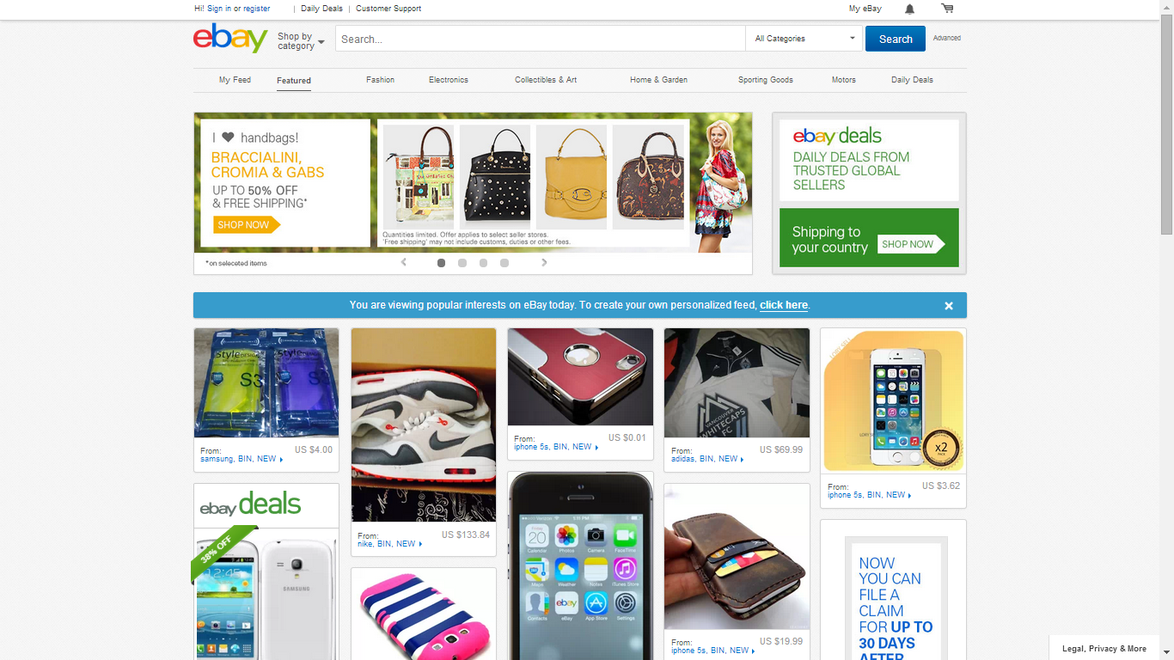

The markup CSS validators showed that there is 265 errors

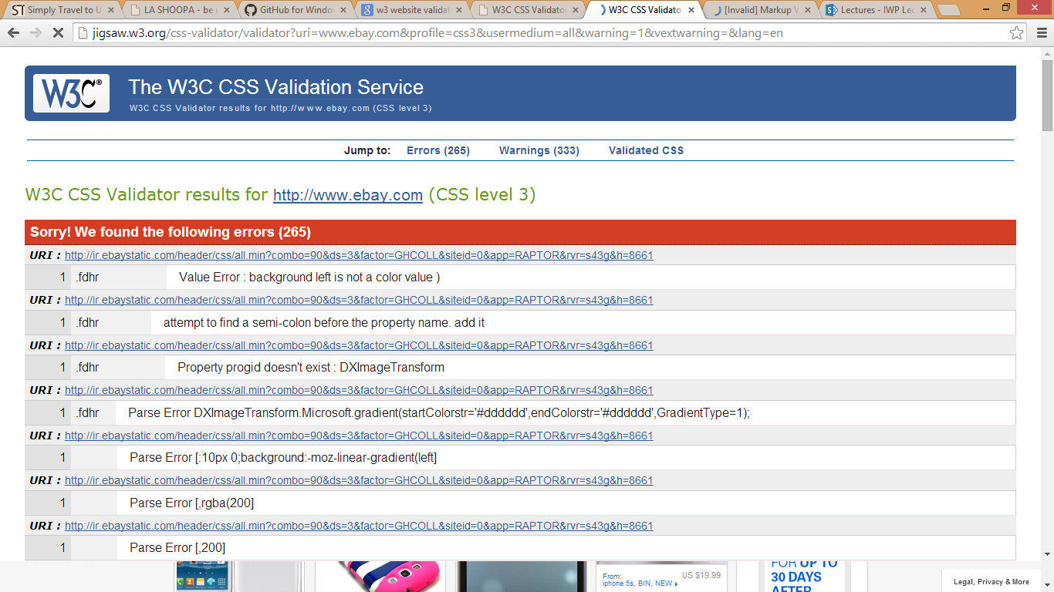

And Markup validator showed 796 errors

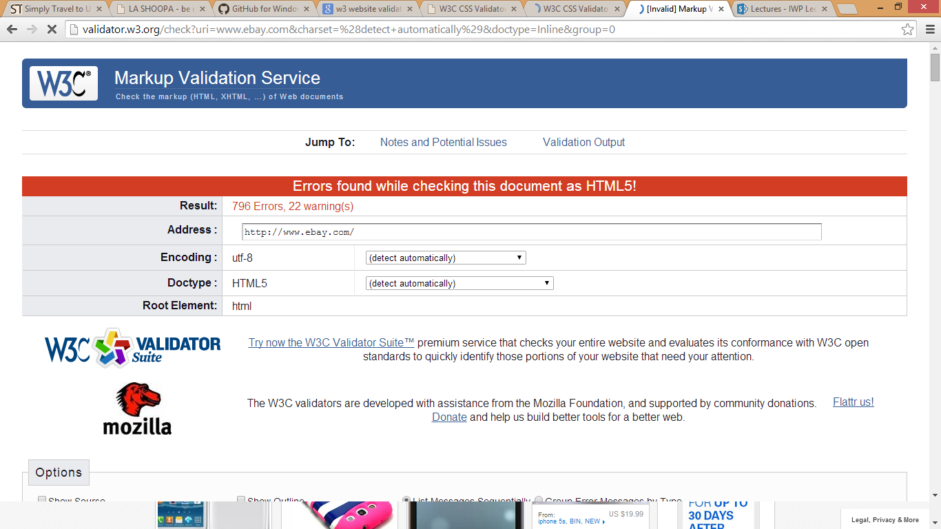
Amazon(www.amazon.com) is also very popular but it also have usability shortages, as you can see there are too many
Advertisement that makes user to leave this page

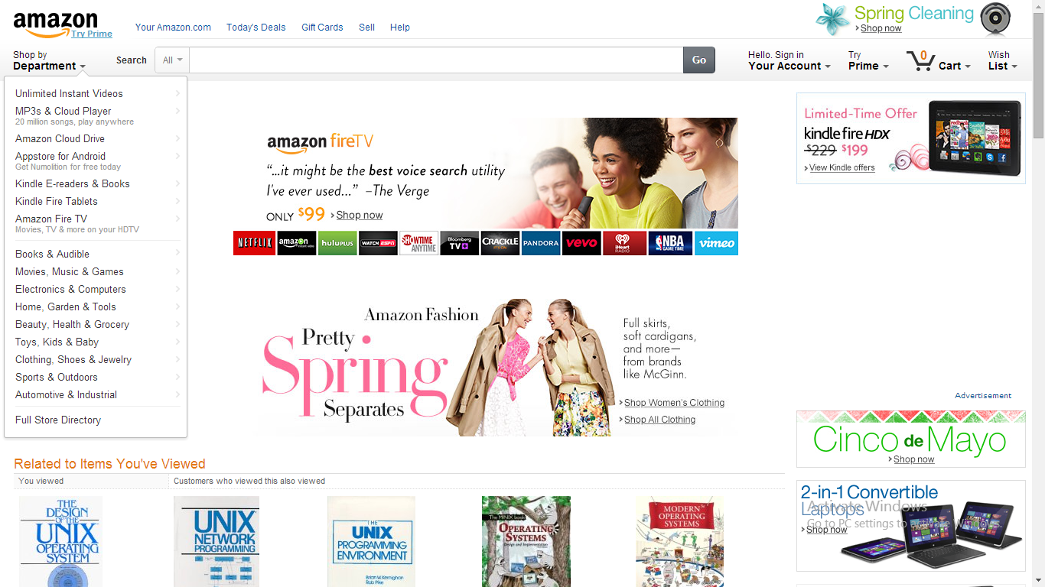

The CSS validator showed there is 331 errors
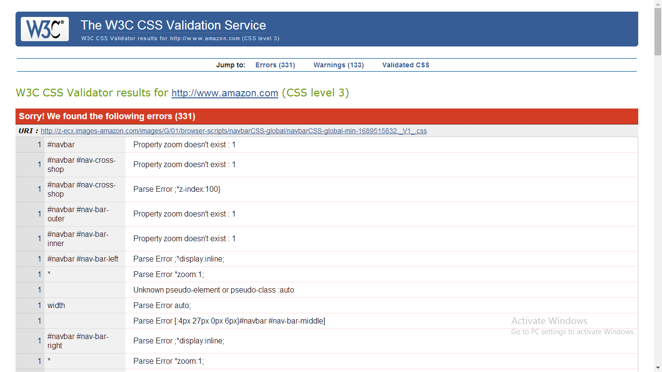

Markup validator showed 500 errors
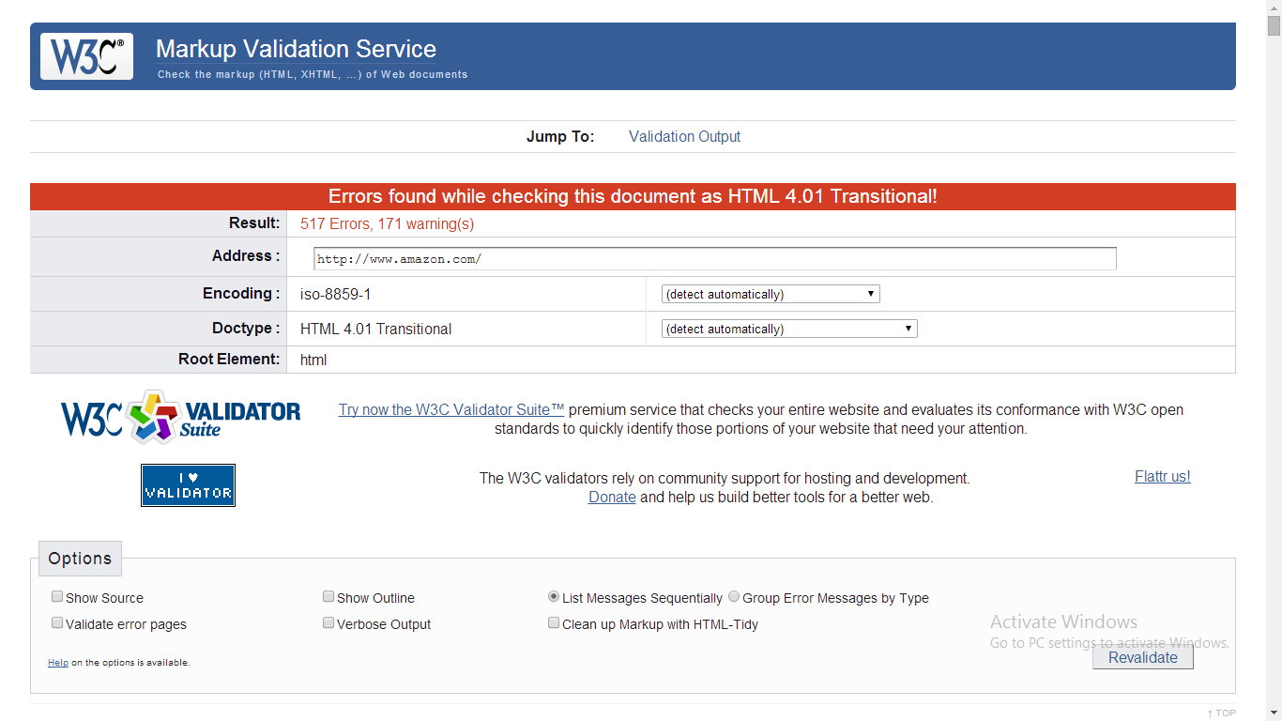

My website( 00002210.github.io) has very simple design with clear usability and there is no any advertisement.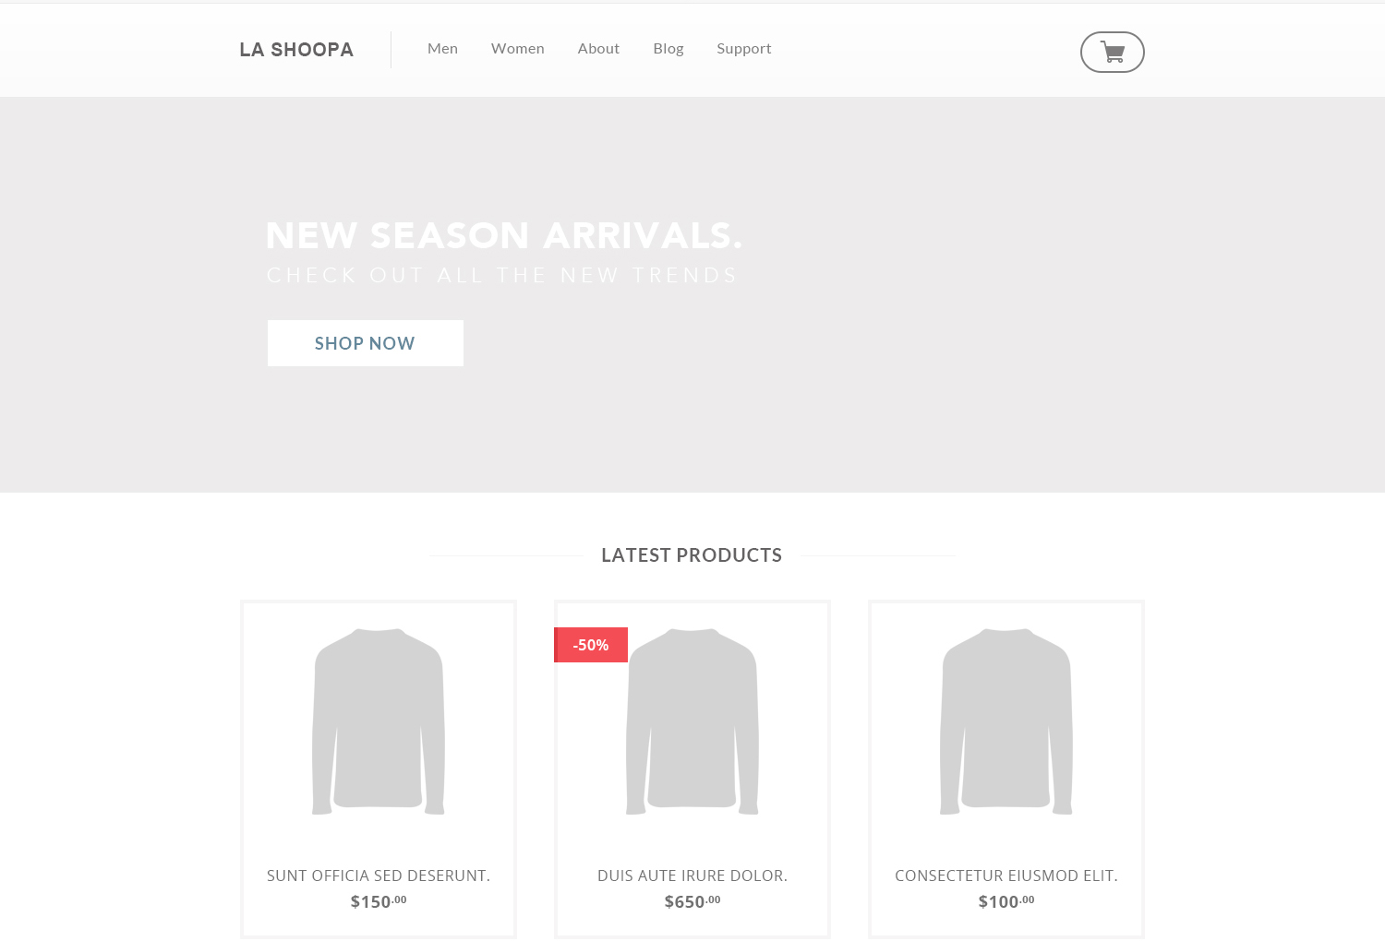

Markup validator shows no error

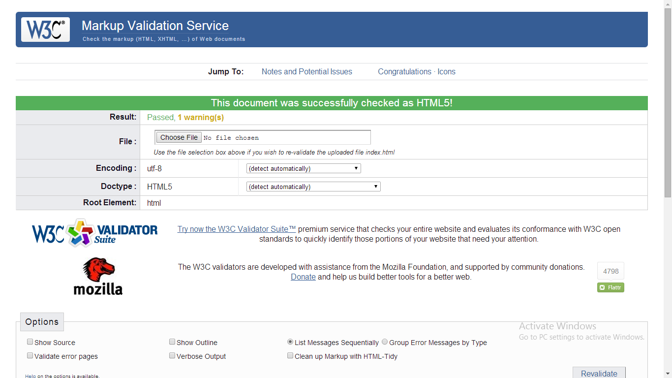
CSS validator also congratulates me
