COURSEWORK SUBMISSION FORM
STUDENT USE |  | STAFF USE
Module Name | Web Technology | First Marker’s  (acts as signature)
Module Code | 4BUIS011C | Second Marker’s  (acts as signature)
Lecturer Name | Bunyod Khoshimkhujaev | Agreed Mark
UoW Student IDs |  | For Registrar’s office use only (hard copy submission)
WIUT Student IDs | 00004047
Deadline date | 15.11.2017
Assignment Type | GroupIndividual

SUBMISSION INSTRUCTIONS

COURSEWORKS must be submitted in both HARD COPY (to the Registrar’s Office) and ELECTRONIC unless instructed otherwise.
For hardcopy submission instructions refer to: http://intranet.wiut.uz/Shared%20Documents/Forms/AllItems.aspx - Coursework hard copy submission instructions.doc
For online submission instructions refer to: http://intranet.wiut.uz/Shared%20Documents/Forms/AllItems.aspx - Coursework online submission instructions.doc

MARKERS FEEDBACK (Continued on the next page)

Report

Site plan
This website was developed for a company which is working in tourism industry aiming to increase number of customers and expend the business. Target audience for this website was chosen as middle class people of all ages, but with a primary focus to young generation. With the rapid development of technologies, nowadays most of the people especially in our target audience have smartphones, laptops and access to internet wherever they are and whenever they want. Even when they walk, when they are coming back from work they are using these devises and spent most of their time in internet, surfing web and chatting with friends.

Because of that internet marketing becomes very popular these days, more and more companies are trying to lunch websites to grab the attention of potential customers to their services and products. Based on my survey I have come up that young people do not like websites with many pages as it is very hard to navigate through them. It requires to go to several pages to collect all the necessary information and it is what they want especially when they are on the way. Based on this survey we have decided to create simple and user friendly website. And we have combined several pages into one landing page, so users can just access one page and get all the required information without need to go to other pages. Still there are several external to help users access company’s pages in different social sites and internal links to get additional information or sending feedback. Our main objective is to attract new customers and increase the revenue of the company.

Functions and features: JavaScript validation was implemented into the send message forms just to make sure we can always reply to all letters from our users. All fields must be filled in and valid email address should be entered to send messages. In itineration form “add sub destination” buttons were implemented to allow users type destinations name ad click on that button will write it in the bottom of thee form and several destinations could be added that way. Dynamically generated table is implemented in the ourbranchs section. To make some interactivity into the website several features were implemented in destinations section’ photos. When clicked see more button it will hide the text and show hidden part of the photo so users can enjoy its beauty fully. In the set Ittinery section were implemented functions to turn over the photo on hover and allow to read some information about destination.

Matrix navigation style was used for this website. Matrix to allow users access any point of the website from anywhere.

1.2 Evaliation
Evaluation of competitors’ websites: there are plenty of companies that has the same aim and objectives as our company, to grab customer’s attention via website and expand the business. One of this companies is “aznurtravel”

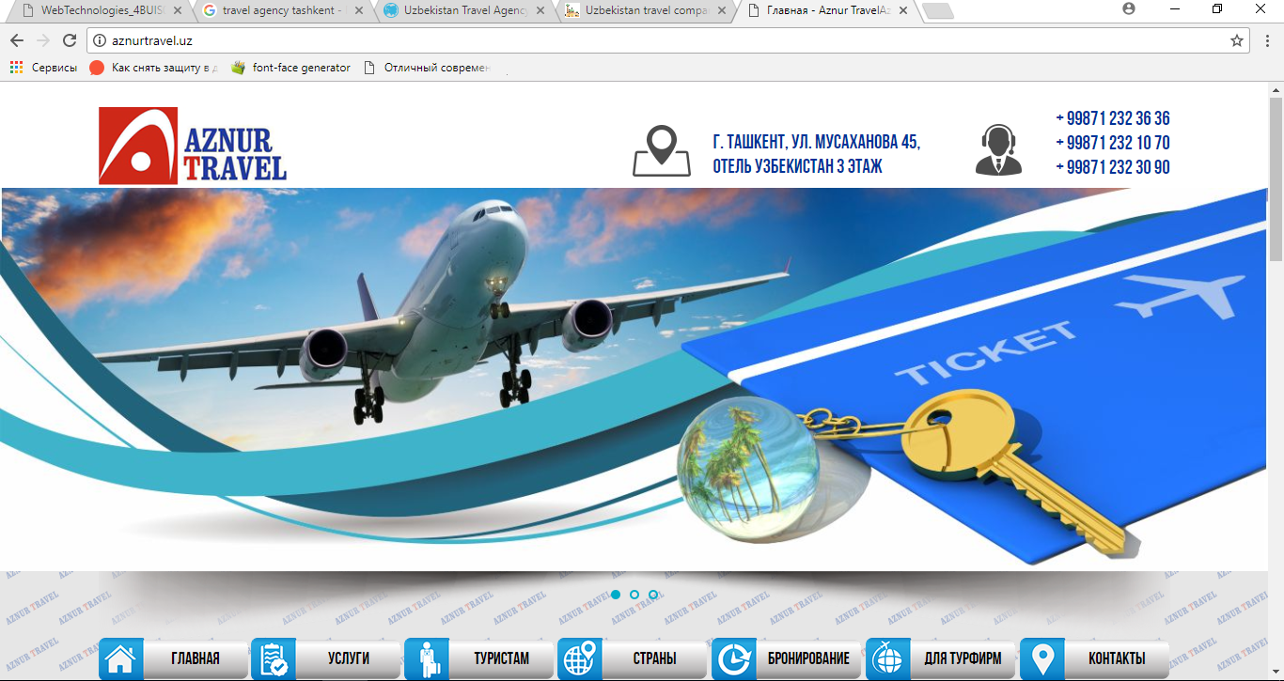

Available from: http://aznurtravel.uz/
Good website all the necessary information is included however it has too many sub divisions, a bit annoying to click and going to several links. No elements of persuasive language expert opinions or quotations, statistics, emotional appeal. Design is quite attractive and not flashy – appropriate font size, the text is readable. Appropriate choice of colors. Has some interactive functions. One of the advantages for tourists is it has current weather and exchange rate in homepage. One of the most annoying things is that you cannot scroll with your touchpad (using 2 fingers), I have tried in several other websites in all others touchpad scrolls work nice. With so many information included website is available only in one language which is Russian, it can also make some inconveniences as not all people speak Russian and website should be available in one of the international languages as well.
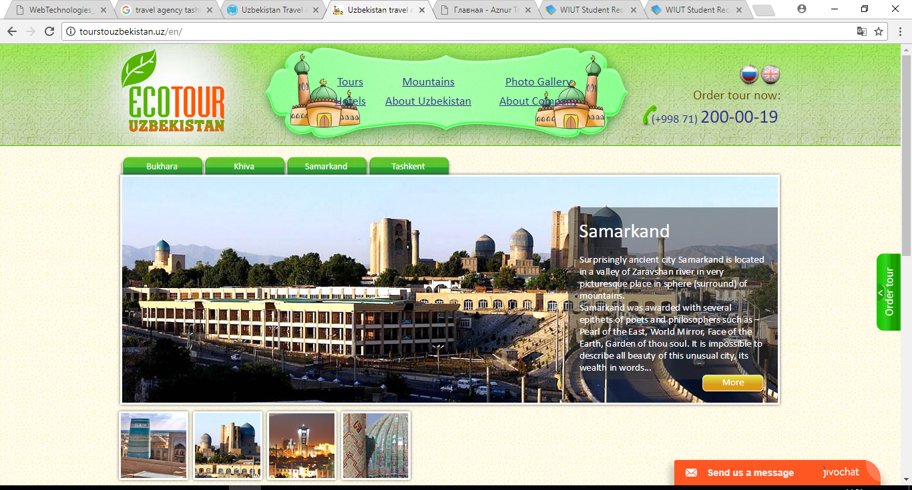

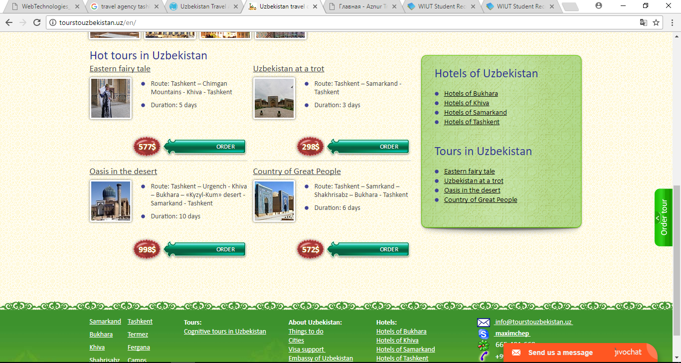
Available from: http://tourstouzbekistan.uz/en/
Good website all the necessary information is included. No elements of persuasive language (expert opinions or quotations, statistics, emotional appeal). Design is quite attractive and not flashy. Design highlights the culture and history of the company’s country of location – appropriate font size, the text is readable, appropriate choice of colors in the top side of homepage. However, bottom part is not designed as good as top one. Hot tours in Uzbekistan section seems as a spam advertisement. Another thing about this section, all the prices for tours are stated in us dollars, but no information about exchange rate is not provided. I think it will be good to include this feature as organizations are not allowed to use US dollars. Has some interactive functions such as banner and slider. Web page is available in three languages. Very easy to change and navigate through languages.

URL of my website https://00004047.github.io/

Usability test of web site
- Evaluate the website loading speed:
  - Fast
  - Normal
  - Slow
  - Other
- Is the website optimized for your device?
  - Yes
  - No
  - Partially
  - Other
- Does the website have attractive design and proper color combination?
  - Yes
  - No
  - Partially
  - Other
- Are the texts easy to read and related to the topic?
  - Yes
  - No
  - Partially
  - Other
- Does the website simple in use?
  - Yes
  - No
  - Other
6. The website was useful for me
a. Yes
b. No
c. Other
Additional comments: ____________________________________________________________________________________________________________________________________________________________________________

Usability test of web site
- Evaluate the website loading speed:
  - Fast
  - Normal
  - Slow
  - Other
- Is the website optimized for your device?
  - Yes
  - No
  - Partially
  - Other
- Does the website have attractive design and proper color combination?
  - Yes
  - No
  - Partially
  - Other
- Are the texts easy to read and related to the topic?
  - Yes
  - No
  - Partially
  - Other
- Does the website simple in use?
  - Yes
  - No
  - Other
6. The website was useful for me
a. Yes
b. No
c. Other
Additional comments: ____________________________________________________________________________________________________________________________________________________________________________

https://all-psd.ru/site-templates/5212-otlichniy_sovremenniy_maket_sayta_.html
https://everythingfonts.com/font-face
https://github.com/

