**COURSEWORK SUBMISSION FORM**

|  |  |  |  |
| --- | --- | --- | --- |
| **STUDENT USE** | | **STAFF USE** | |
| Module Name | Web Technologies | First Marker’s  (acts as signature) |  |
| Module Code | 4BUIS011C | Second Marker’s  (acts as signature) |  |
| Lecturer Name | Olga Yugay | Agreed Mark |  |
| UoW Student IDs |  | **For Registrar’s office use only (hard copy submission)** | |
| WIUT Student IDs | 00005428 |
| Deadline date | 15 November 2017 |
| Assignment Type | 🗌Group☑Individual |

**SUBMISSION INSTRUCTIONS**

**COURSEWORKS *must* be submitted in *both* HARD COPY (to the Registrar’s Office) *and* ELECTRONIC unless instructed otherwise.**

For hardcopy submission instructions refer to: <http://intranet.wiut.uz/Shared%20Documents/Forms/AllItems.aspx> - Coursework hard copy submission instructions.doc

For online submission instructions refer to: <http://intranet.wiut.uz/Shared%20Documents/Forms/AllItems.aspx> - Coursework online submission instructions.doc

|  |
| --- |
| **MARKERS FEEDBACK (Continued on the next page)** |
|  |

**Contents**

Introduction 3

Goals and Objectives 3

Functions and Features 3

Evaluation 4

Survey 5

Appendix 7

Refence 7

**Introduction**

Photo Exhibitions has been revolutionized into a new digital era, since the technology has made it possible to share art and masterpiece with just one click. There is no need to hang tons of pictures to the walls of museums and galleries anymore. The world of global network can bring you the chance to show your artworks to the whole world by just sitting at home.

**Goal and Objectives**

Photography Portfolios are becoming more and more popular these days, due to increasing need and taste for photo art. I have been interested in taking photos since the beginning of my studies here at Westminster. Therefore, I decided to start my first (doable) website with creating it for our university club. I am the manager of WIUT Photo Club, and this club has been operating for three years now. The club actively encourages students to attend our classes, because we believe that taking good pictures and sharing it help them maintain enthusiasm and creativity on their studies. My main target audience is the WIUT students, and my website is solely designed for showcase purposes. Students are often misled by some thoughts that coming to our club is a waste of time. However, it is a lot of fun when we gather and get to shoot breathtaking photographs.

I was wondering of how to regularly inform and show our works to the students so that they can stay up-to-date. I thought that it would be a good idea to combine two tasks into one, since it is win-win situation anyways. The main purpose of creating this website is to regularly post our photos to this website in order to make it easy to follow for students and others at the university. We ourselves, sometimes, have difficulties to find our photos and works as we don’t have one particular method to share it. Furthermore, the idea of having our own website gave me a thought of promoting it to other universities, since WIUT is well-known for its student social life and extracurricular activities. The website would be a great example of how talented and creative our students are.

**Functions and Features**

The website includes an easy controllable navigation bar and user-friendly footer that makes it look professional. I have included photo collage to one page, and added several portfolios in the gallery. In addition, I have included several functions such as slider and contact form, and photos are showed in blocks to make it look professional. When the home page is loading, the background image fades in, which give the website a dramatic load. My contact form informs the sender about the submission of the message, and then returns to the home page. The linear navigation bar is showed on the upper side, and if you scroll down, it follows the entire page. Navigation bar consists of all other pages which makes it easier to navigate through the website the whole time. If you press the icons on the footer, it will direct you to an actual page of Photo Club. I have included Privacy Policy and Terms of Use files to make my website look more professional.

**Evaluation**

In the following paragraphs, I will be comparing two similar websites. Both sites are similar regarding to their content and structure, since they both contain photo portfolios and gallery. However, websites are different in terms of target audience and users. The first website [www.worldinmylens.com](http://www.worldinmylens.com) (Figure 1) is all about travelling, and it was specifically designed to one kind of photographing and it is mostly travel and outdoor, while the second site [www.500px.com](http://www.500px.com) (Figure 2) offers many other kinds of photos. The home page of both websites begin with background photo and this feature captures the visitors’ attention. Therefore, I decided to use it on my website as well. Both website clearly designed with simplicity and usability in mind. The navigation is designed elegantly, and if you scroll the first website (Figure 1), you can see the collage which makes the first website more beautiful. The colors used in the first website are light and dark grey, and for text white was used. This combination makes the interface simple and unique, and it provides calmness and drama to the photo collage. This feature and colors are mainly used in galleries and museums of photography, and this makes the first website more prominent that the second one in terms of interface. While the second website uses three colors: white, blue and light grey. The blue color used in buttons has made it clear that the website is not free, and it can be seen that it is business website. However, the first website is only a showcase of photo works.

**Survey**

I have done a little survey with some of my friends, and this <https://goo.gl/forms/Yj0F3MiKcQZzpr1d2> link contains the questions I used in my survey. I asked them if they like the user interface and colors I used. They told me that look perfect, and the home page is the best one. The least thing they liked is the loading time. It takes some time to load the pages, and it is one of the disadvantages of my website. In general, they really liked my website, and told me that I should launch it.

**Appendix**

Figure 1 [ [www.worldinmylens.com](http://www.worldinmylens.com) ]

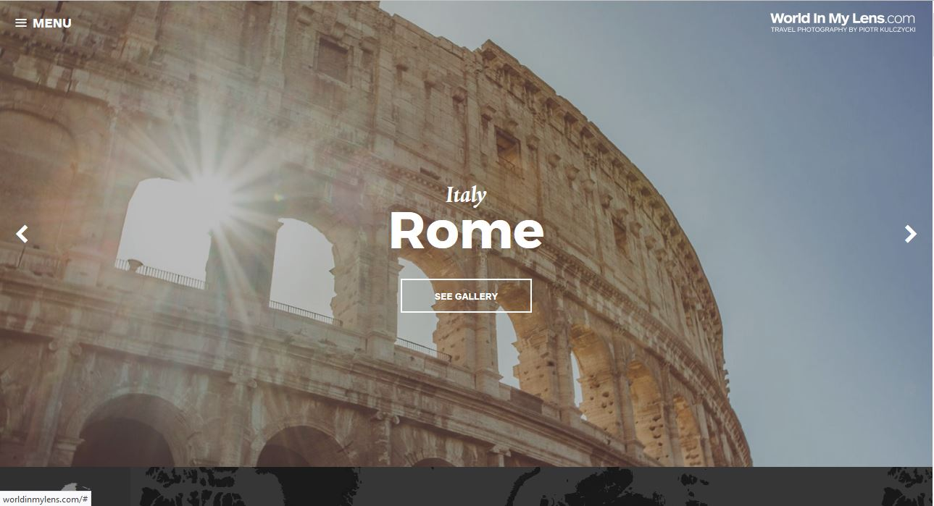

Figure 2 [ [www.500px.com](http://www.500px.com) ]

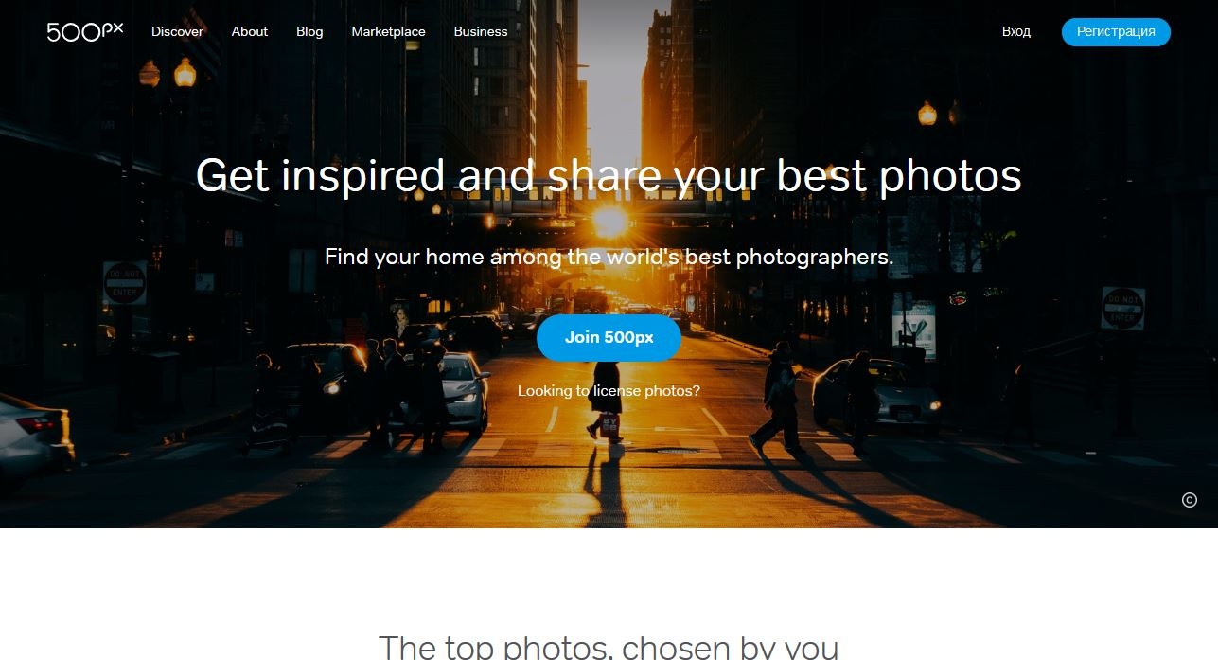

**Reference**

F. Hunter, S. Biver and P. Fuqua (2015). *Light: Science & Magic. An Introduction to Photographic Lighting 5th Edition.* Focal Press. Available from <https://www.lifestylefoto.ru/books/Light%20Science%20&%20Magic.pdf> [Accessed 14 November, 2017].

All photos are taken by the author (00005428) and WIUT Photo Club.