Given report will provide plan and evaluation of the ProfTours website.

1.0. Site Plan.

* 1. Audience Profile.

The purpose of the website is providing information of the services of the ProfTours company, which does not represent actual company. It should be mentioned that target audience is a usual person who is finding for the travel tour in some of the provided countries, such as Armenia, Uzbekistan, Azerbaijan or Georgia.

* 1. Functions and Features.

At first it should be mentioned that the home page of the given website is providing general information of the company and the services which are provided by ProfTours company. Also, the contact page, which is located in Navigation bar helps user to connect with ProfTours company in easier way.

* 1. Navigation.

The navigation of the website is using hierarchical method, which helps user easily find all of the needed information. The navigation of the ProfTours website is consisted of 4 main elements, which are “ProfTours” (home page), “Uzbekistan Tours”, “Foreign Tours” and “Contact Us” pages. It should be mentioned that “Uzbekistan Tours” and “Foreign Tours” are dropdown menus, which contain subpages of the provided services (cities where ProfTours is providing traveling tours). Also, navigation bar is fixed, which means that when user is scrolling the page it is always on the top of the page. Moreover, the navigation bar is collapsed, which creates special menu button, which is showing/hiding navigation for users with small screens.

2.0. Evaluation.

2.1. Evaluation of competitors’ website.

Given part will discuss asia-travel.uz and tourstouzbekistan.uz as competitors’ websites.

Asia-travel has proper home page which has all of the needed information, such as company information, sitemap, navigation bar which includes services of the company and contacts. It should be mentioned that “about us” information provides credibility to the given website, which means that users would have more trust. Also, the search bar helps user to find all of the needed information. Moreover, relevancy of this website is on the good level. All of the information is relevant and informing user about the aim of the website. Latest news, which is located on the home page contains slideshow and proper linked. There are no broken links on the asia-travel.uz. But there are some few disadvantages with usability, which should be changed. First disadvantage is color choice; website is using standard color choice (black text on the white background). Standard color choice is easier to read, but can cause user to forget about given website in short period of time. Second disadvantage is inability of the site to fit smaller devices. Nowadays, responsive architecture is key factor of successful design.

Tourstouzbekistan.uz is providing price list of the services on its home page, which is good practice. Also, the sitemap and contacts on the bottom is helping user to find all the needed information. But there is plurality of disadvantages. First disadvantage is inability to find any information of the company, which will most probably cause user to have lack of trust. Another problem is differences between the name of the company and website name. The fact that company name is “Ecotour” and website name is “tourstouzbekistan” is able to confuse user. Also there are problems in the navigation bar. Some of the links are not visible, because of the pictures. Slideshow on the home page is controlled by little image icons, which are located underneath. The controls of the slideshow should be replaced by arrows. The biggest problem of the given website is inability to fit smaller devices.

Asia-travel.uz home page

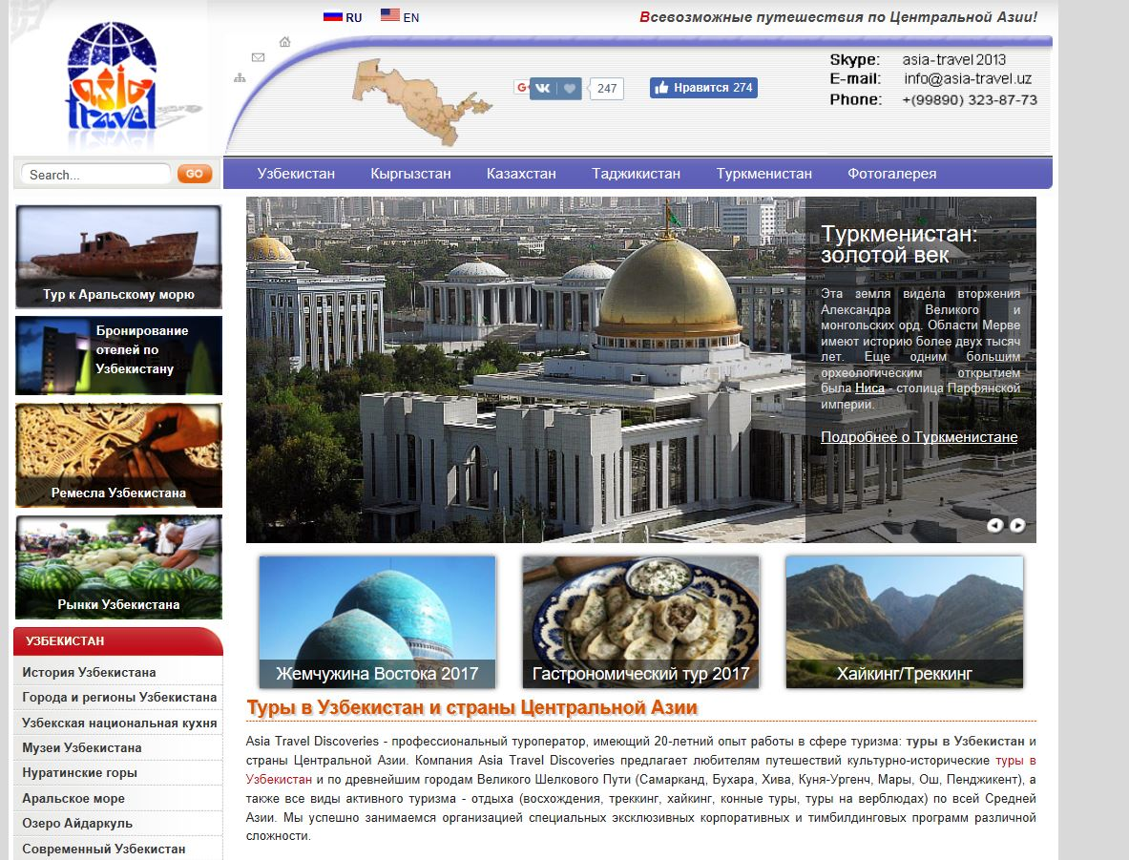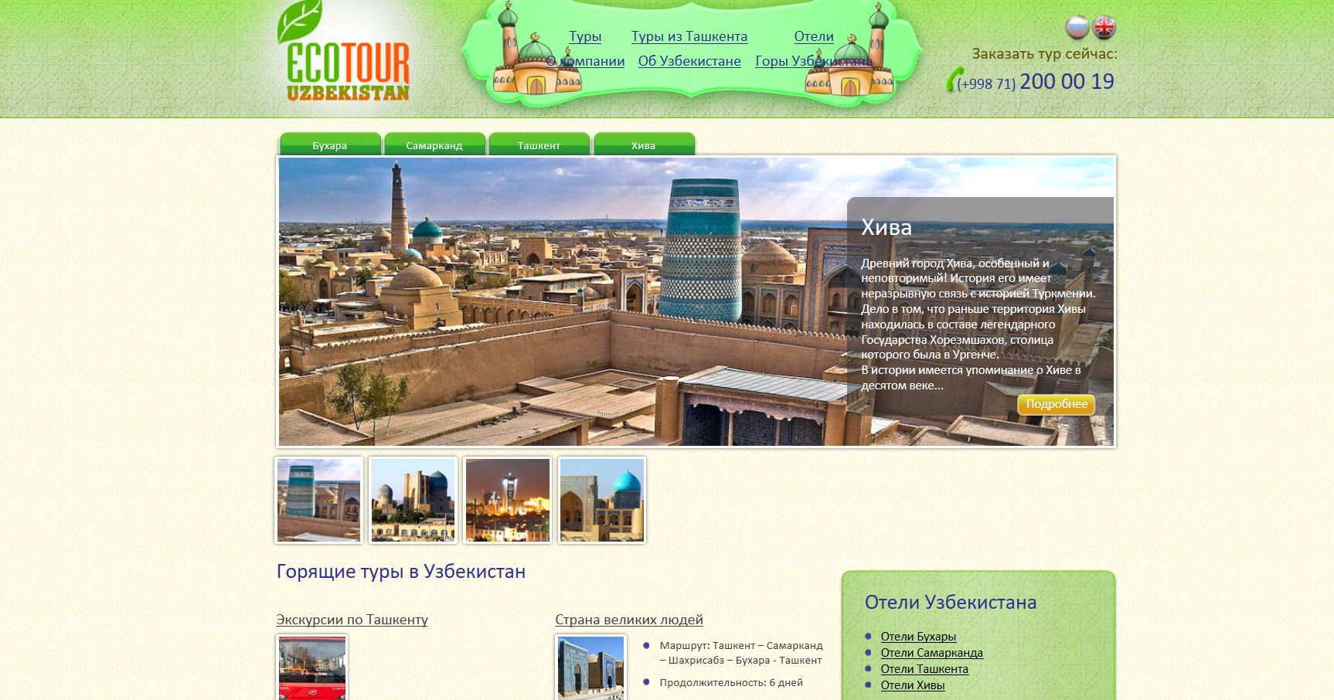

Tourstouzbekistan.uz

2.2. Usability test of your web site.

Two people were asked to answer few questions regarding the website, after using it for approximately 3-4 min. The results were:

Is it easy to find all of the needed info?

1. Yes, it was easy to find all the info in the given website, all of the useful links which lead to services and contacts are located in the navigation bar.
2. Some of the info, such as pricelist is missing, but all of the other info is available from navigation bar.

Is all of the text readable?

1. Yes, color choice of the given website is quite good. The text is readable.
2. Due to classic style (black text on the white background) the text is quite readable.

Is there any information which is unnecessary?

1. No.
2. All of the information was connected to the topic.

What are your overall feelings about given website?

1. The website fits the topic and has good design. All of the information is available on the navigation bar.
2. The website is meeting all of the requirements of a good company website.

Are there any suggestions on improvement of the website?

1. The more services should be provided and some more information about company should be included in the home page.
2. Only one thing, which should be implemented is pricelist of the services.