COURSEWORK SUBMISSION FORM
STUDENT USE |  | STAFF USE
Module Name | Web Technology | First Marker’s  (acts as signature)
Module Code | 4BUIS011C | Second Marker’s  (acts as signature)
Lecturer Name | Iskandar Anvarov | Agreed Mark
UoW Student IDs |  | For Registrar’s office use only (hard copy submission)
WIUT Student IDs | 00005728
Deadline date | 15th of November
Assignment Type | GroupIndividual

SUBMISSION INSTRUCTIONS

COURSEWORKS must be submitted in both HARD COPY (to the Registrar’s Office) and ELECTRONIC unless instructed otherwise.
For hardcopy submission instructions refer to: http://intranet.wiut.uz/Shared%20Documents/Forms/AllItems.aspx - Coursework hard copy submission instructions.doc
For online submission instructions refer to: http://intranet.wiut.uz/Shared%20Documents/Forms/AllItems.aspx - Coursework online submission instructions.doc

MARKERS FEEDBACK (Continued on the next page)
Contents
Site Plan 3
Evaluation 3
Usability test of your web site 4

Site Plan
The website is available from URL https://00005728.github.io/
The website is about movies, where users can find movies, which they want to watch. The site is appropriate to those individuals who don't comprehend what sort of films to watch. There is the sort of movies that were released in 2017 year, as well as the films in the table are categorized by their genres and ratings. Different movies have different target audiences, however to make the website successfully, I tried to create attracting design and to make it that would please the audiences. The website has 2 type of target audiences: the primary target is most identified through demographic variables such as gender, the names of actors and IMDb ratings without plots, the synopsizes of various people. The second type can be a large group of people, who love to leave their opinions, first impressions about movies and they prefer to criticize movies. Consequently, when the number of users increases, I would like to make a paid registration for watching movies and put paid advertisement on the website. The website has several main functions and features, which make the site more pleasant and enjoyable: FadeIn and FadeOut function, music player, slide, flipping cards and toggle “hide and show” function. FadeIn and FadeOut function, which works by jQuery (ready library of JS). It works simple by setting the function to “display:none” and using fadeIn, especially it works without having to set opacity value to the selector. JS slideshows are great for some reasons: we can use it to spice up photo albums, stories and etc. I read through Thau’s JavaScript Tutorial to get a better understanding of JavaScript slideshow. The function is simple, just call the classes or ids, which have several images and set interval time. Toggle “hide/show” function fits in order to hide some elements or content, and put clickable button, which will show the content after click on. Also, we can set time appearance. The website is made up of 8 pages, but navigation bar has 7 pages which include: Home, About, Drama, Action, Comedy, Animation and Contact. The navigation bar buttons sit neatly across on the top of pages. I tried to make it simpler, transparent color and without identification of active page, because it should not attract more attention, than content.

Evaluation
The navigation of the website is a clear indicator to both users and search engines what your primary focus is, and what you do best. Overloading a navigation with tons of links can do more harm than good.
1)The advantages: background is good, responsive, searcher, selection films by genres, year, quality, hover function, appearance of registration form, when click on bookmark or add comments.
1)The disadvantages: navigation is not on the top of site and creativity is bad, the design of site is not attracting, do have nothing unique, color choices is not suit, the fonts are small, content position is bad, low level of usability, footer is small and not visible, a lot of advertisement. http://kinoprofi.org/10475-vnedrenie-2016.html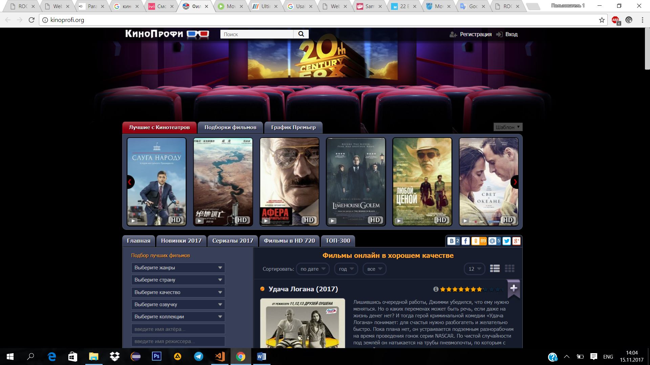
I recommend to change fonts’ color and family, colors, design, make content width broader, set the navigation on the top, make less advertisement, change more creative footer and navigationbar.

Usability test of your web site

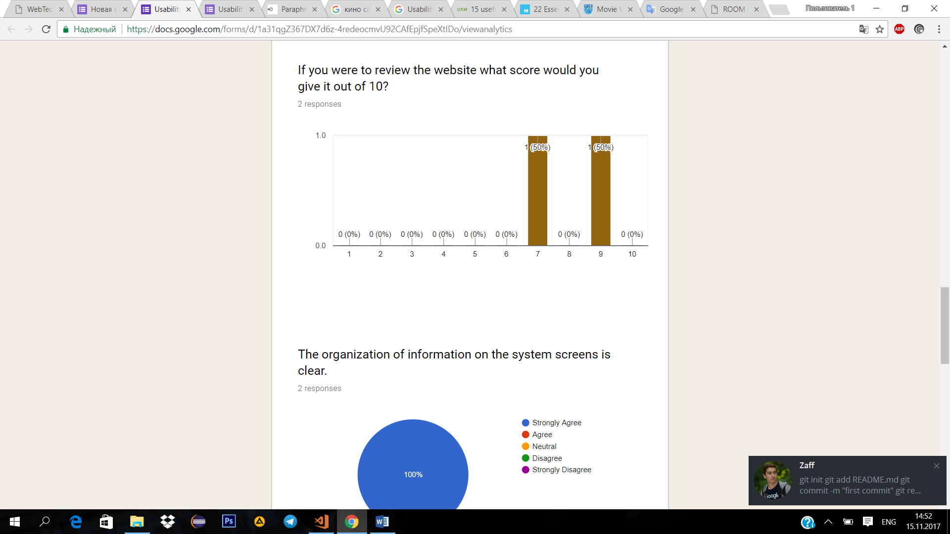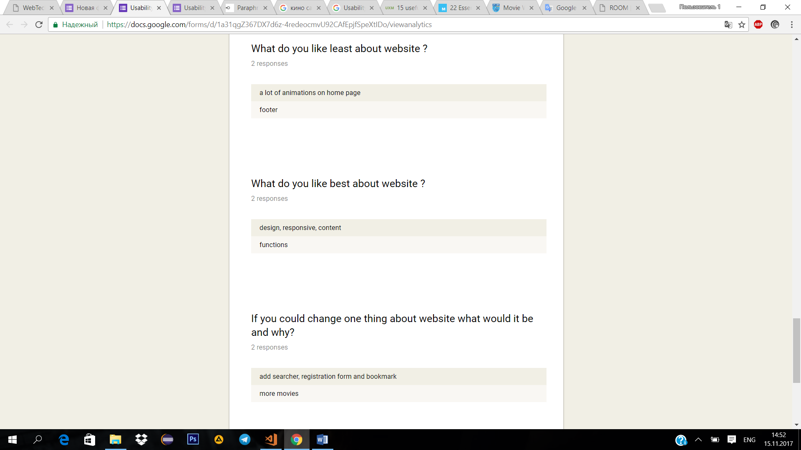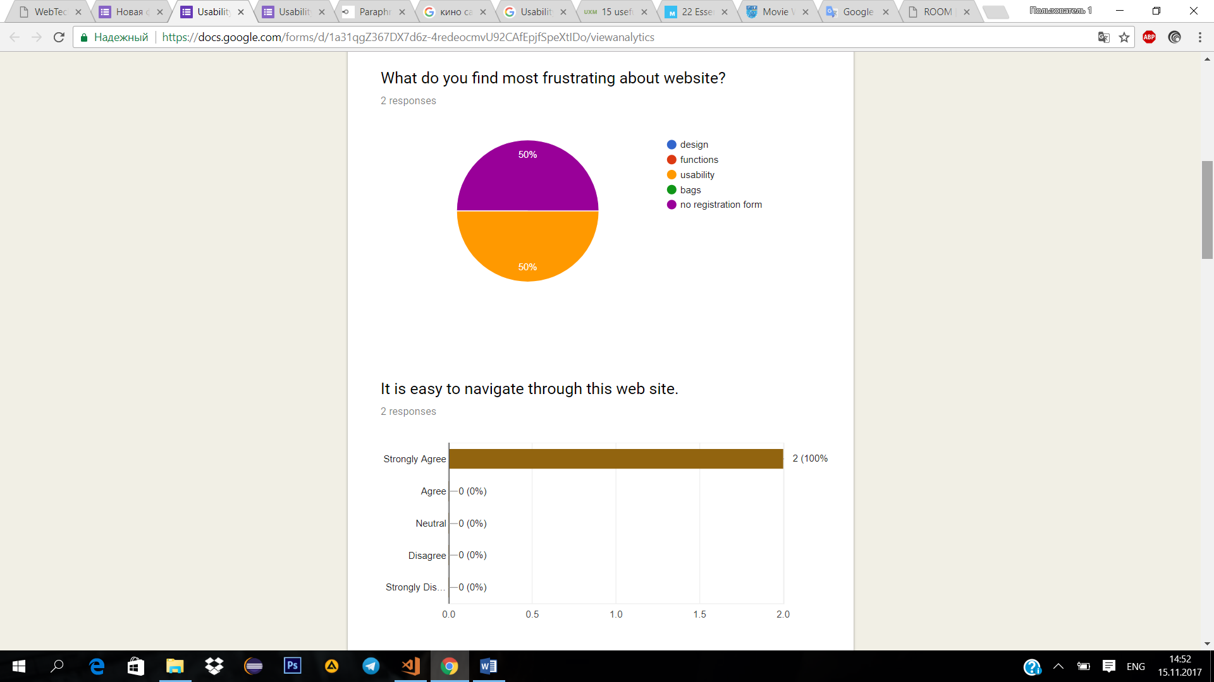
more information here: https://docs.google.com/forms/d/1a31qgZ367DX7d6z-4redeocmvU92CAfEpjfSpeXtIDo/viewanalytics

References
Most of content was taken from IMDb and Moviefone sites.(imdb.com and moviefone.com)
http://comiccoverage.com/wp-content/uploads/2017/06/Jumanji-welcome_to-the_jungle-movie_poster-logo.jpg

https://3.bp.blogspot.com/-EsSotd1P63c/WTSTau6PJ4I/AAAAAAAANu8/NGAKjSEFPpwU88io9kvkeAVqBBQPthRmgCLcB/s1600/wonderr.jpg

https://img4.goodfon.ru/original/1920x1080/d/a4/poster-oscar-isaac-carrie-fisher-zviozdnye-voiny-poslednie-d.jpg
https://img4.goodfon.ru/original/1920x1080/7/43/coco-animated-film-pixar-sull-skull-and-bones-boy-eyes-hat-a.jpg
https://www.moviefone.com/movie/wonder/20088964/main/
http://www.imdb.com/title/tt2283362/
http://www.imdb.com/title/tt2543472/?ref_=nv_sr_2
https://www.moviefone.com/movie/star-wars-the-last-jedi/20065709/main/
http://www.imdb.com/title/tt2527336/?ref_=nv_sr_2
http://www.imdb.com/title/tt2380307/?ref_=nv_sr_1
https://www.moviefone.com/movie/coco/vbvnXFhmbTpMe1MnOPWZV3/main/
https://d1nao0k9edgivc.cloudfront.net/wp-content/uploads/2017/09/jumanji_welcome_to_the_jungle_ver3_xxlg.jpg
https://www.startfilm.ru/images/base/film/f_663935/big_startfilmru1369448.jpg
https://i.imgur.com/1zN6hq4.jpg
http://www.youloveit.ru/uploads/posts/2017-09/1506175508_youloveit_ru_taina_koko_postery05.jpg
http://mediad.publicbroadcasting.net/p/shared/npr/styles/x_large/nprshared/201707/538362695.jpg
https://www.moviefone.com/movie/the-big-sick/mjEvhTDDBZwGMDENy9cgE2/main/
http://actress.camera/docs/styles/1260/public/imgthumb/Saoirse-Ronan_actress_Lady-Bird_film_Greta-Gerwig_2017_movie-poster.jpg?itok=h0l2mCxF
https://www.moviefone.com/movie/lady-bird/JVeFMNCK3nyfCXiVUAi3W4/main/
http://www.imdb.com/title/tt4925292/?ref_=nv_sr_1
http://s3.birthmoviesdeath.com/images/made/ingrid_poster_3_1200_1704_81_s.jpg
http://www.imdb.com/title/tt5962210/?ref_=nv_sr_1
https://www.moviefone.com/movie/ingrid-goes-west/CZQNUuDRpBZiCCmGJmwgy5/main/
https://www.moviefone.com/movie/literally-right-before-aaron/GnVLjQyW2o3sHUu5NaeiK5/main/
http://www.imdb.com/title/tt5758802/?ref_=fn_al_tt_1
https://www.sunsetcast.com/poster/5758802.jpg
https://www.moviefone.com/movie/american-made/20084739/main/
http://www.imdb.com/title/tt3532216/?ref_=fn_al_tt_1
http://www.filmhamster.com/wp-content/uploads/2017/09/American-Made-Poster.jpg
https://images.moviebuff.com/e9744bbc-d44d-4a71-a660-8ecc3a076d25?w=1000
http://www.imdb.com/title/tt6108090/?ref_=fn_al_tt_1
https://www.moviefone.com/movie/secret-superstar/chUqOc9Go2CFvUpTwzklj/main/?qsearch=Secret%20Superstar
https://st.kp.yandex.net/im/poster/2/9/8/kinopoisk.ru-Dunkirk-2984147--o--.jpg
http://www.imdb.com/title/tt5013056/?ref_=nv_sr_1
https://www.moviefone.com/movie/dunkirk/20087377/main/?qsearch=Dunkirk
http://image.tmdb.org/t/p/original/7jCluAIqHYus0eHM27pCA7l5yVO.jpg
http://www.imdb.com/title/tt5319866/?ref_=nv_sr_1
https://www.moviefone.com/movie/slamma-jamma/pKhgSODWWXDCV3aFoYXLA/main/
https://www.moviefone.com/movie/stronger/20083251/main/?qsearch=Stronger
http://www.imdb.com/title/tt3881784/?ref_=nv_sr_1
http://nothingbutgeek.com/wp-content/uploads/2017/09/STRONGER_FINISH_27x40_rgb-1.jpg
https://www.moviefone.com/movie/megan-leavey/b70YyiY0a7wJ8eGHwFtQD4/main/?qsearch=Megan%20Leavey
http://starmedia.no/dev/wp-content/files_mf/1509025125MeganLeaveyVOD.jpg
https://www.moviefone.com/movie/baby-driver/20087504/main/?qsearch=baby%20driver
http://www.movpins.com/big/MV5BMjM3MjQ1MzkxNl5BMl5BanBnXkFtZTgwODk1ODgyMjI/baby-driver-2017-large-cover.jpg
https://www.moviefone.com/movie/war-for-the-planet-of-the-apes/20072319/main/?qsearch=war%20for%20the%20planet%20of%20the%20apes
https://www.newsfolo.com/wp-content/uploads/2017/07/War-for-the-Planet-of-the-Apes.jpg
http://s3.birthmoviesdeath.com/images/made/Logan-Poster-Eyes_1200_1773_81_s.jpg
https://www.moviefone.com/movie/logan/20082257/main/?qsearch=logan
https://www.moviefone.com/movie/wonder-woman/20077742/main/?qsearch=wonder%20wom
https://i0.wp.com/www.my-sf.com/wp-content/uploads/2017/06/Wonder-Woman-theatrical-teaser-poster.jpg?fit=1584%2C2348
https://www.nyfa.edu/film-school-blog/wp-content/uploads/2017/07/FRAN-EDITED-IMAGE-2.jpg
https://www.moviefone.com/movie/spider-man-homecoming/20082370/main/?qsearch=spiderman%20homecoming
http://moviereviews.s3.amazonaws.com/2017/06/02/16/46/52/1e356363-2043-4324-8f9f-bee28e496a29/e1TliRWOdXQ73pRunbpFiGst6Kd.jpg
https://www.moviefone.com/movie/the-lego-batman-movie/20081343/main/?qsearch=The%20Lego%20Batman
http://www.lelocle.ch/uploads/pics/affiche-cars-3.jpg
https://www.moviefone.com/movie/cars-3/20073587/main/?qsearch=cars%203
https://www.moviefone.com/movie/the-boss-baby/20085854/main/?qsearch=The%20Boss%20Baby
https://cdn.egy.best/serve/movies/art-1313971347-x1200.jpg
https://www.moviefone.com/movie/captain-underpants-the-first-epic-movie/20081381/main/?qsearch=Captain%20Underpants%3A%20The%20First%20Epic%20Movie
https://upload.wikimedia.org/wikipedia/id/2/24/Captain_Underpants_The_First_Epic_Movie_poster.jpg
https://lh3.googleusercontent.com/Ru0cE_Zgs2eERrYpHSZSHhupdN_CWpUkG6WSQKWhF8QLcCq7b9agEwEEcrq0jNLJv2SV6B4SFnME9SKiA5zu=s0
https://www.moviefone.com/movie/despicableme3/10136679/main/?qsearch=Despicable%20Me%203

