**COURSEWORK SUBMISSION FORM**

|  |  |  |  |
| --- | --- | --- | --- |
| **STUDENT USE** | | **STAFF USE** | |
| Module Name | Web Technologies | First Marker’s  (acts as signature) |  |
| Module Code | 4BUIS011C | Second Marker’s  (acts as signature) |  |
| Lecturer Name | Bunyod Khashimkhojaev | Agreed Mark |  |
| UoW Student IDs |  | **For Registrar’s office use only (hard copy submission)** | |
| WIUT Student IDs | 00005731 |
| Deadline date | 15.11.2017 |
| Assignment Type | 🗌Group🗸Individual |

**SUBMISSION INSTRUCTIONS**

**COURSEWORKS *must* be submitted in *both* HARD COPY (to the Registrar’s Office) *and* ELECTRONIC unless instructed otherwise.**

For hardcopy submission instructions refer to: <http://intranet.wiut.uz/Shared%20Documents/Forms/AllItems.aspx> - Coursework hard copy submission instructions.doc

For online submission instructions refer to: <http://intranet.wiut.uz/Shared%20Documents/Forms/AllItems.aspx> - Coursework online submission instructions.doc

|  |
| --- |
| **MARKERS FEEDBACK (Continued on the next page)** |
|  |

Word count: 830.

The Geek ([www.00005731.github.io](http://www.00005731.github.io)) is a website which keeps humankind up to date with all the developments and innovations in the modern world. It allows people to broaden their outlook and guides its followers deep into their imagination bringing them new ideas and discovering their potential.

The main goal of the website is to inform the readers with the latest news and keep them up to date. The website contains information which can attract people of different age categories, starting with the interactive articles for the youth and ending up with informative reviews for adults.

With a rise of popularity, the website will be redesigned[1] and improved further. Future plans also include the creation of a special paid subscription for news, allowing users to get exclusive information from the experts and allocation of some place for income generation purposes such as advertisement and etc.

The establishment of a card design gives an advantage over other methods in information delivery - users concentrated on one card with some information cannot be distracted by other information flowing outside the card, also, the carousels, which are used in the index page provide a simple, but effective way to show some dynamics on the website, and provide more information by changing the content after a certain time. I also added a second column of news on the main page, some of which can be replaced by small ads or paid author articles as it was mentioned above.

The Geek website is created in the hierarchical system. This system allows to access news from the general list, as well as to have access to other news from the page itself. Thereby, users do not have to return to the main page if they want to change the article.

For comparison with other competitors’ webpages, I chose one of the most popular sites now - TheVerge.com and WindowsCentral.com.

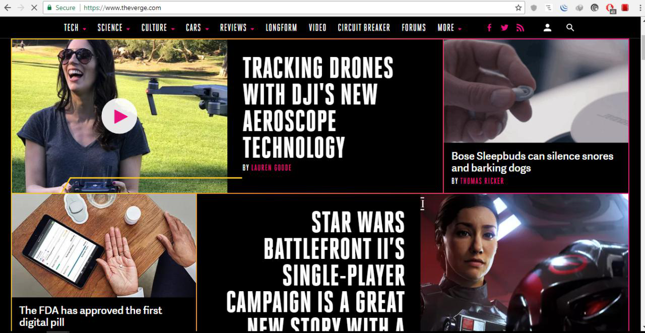

*Source: www.theverge.com – The main page*

As you can see on the front page of The Verge, some news overlaps other with a very large font and pictures and sometimes news are accompanied with an auto played animation or video, which is not appropriate as it loads the network and makes the page load much longer. They also use a hierarchical navigation system with some matrix implementation as on The Geek webpage. In general, the color accuracy in a high level and navigation bar look very good and modern.

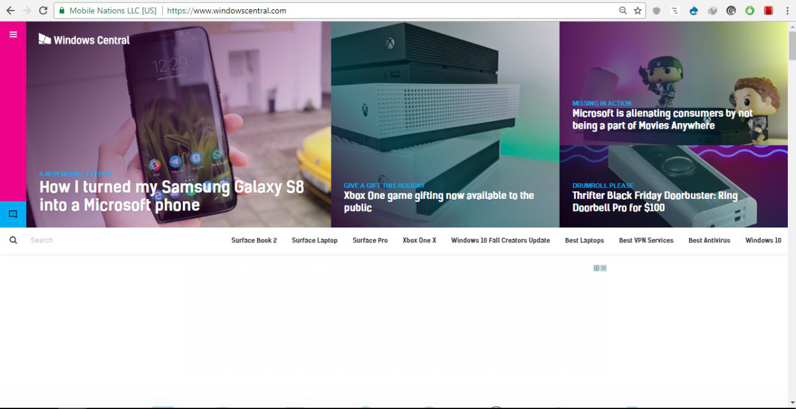

*Source: www.windowscentral.com*

On WindowsCentral website, in comparison to the previous one, everything is completely opposite. Due to the colors imposed on the pictures, it becomes difficult to determine the real color of the news image. Also, the text that is on the top of the picture is difficult to read on light pictures. It would be better if the text was implemented in a separate block, and the color filter of the pictures was removed at all. Moreover, the linear navigation system used here is not very suitable for this web site.

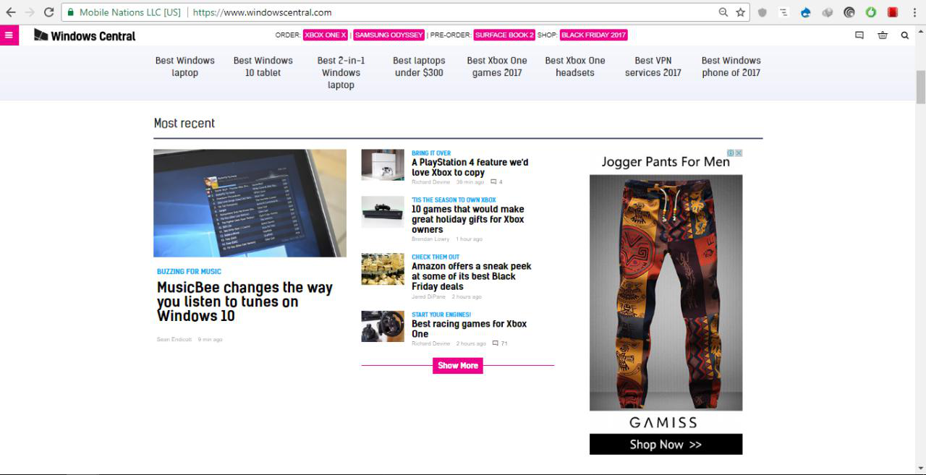

*Source: www.widnowscentral.com*

From the example of the next picture, one can see how empty space is used or unused, and how advertising stands out against the news. In this case, it is advised to reduce the size of the advertisement and to use that free space more properly. In addition, more than 70% of the navigation bar is allocated for advertisement, and there are almost no subdivisions until one presses a special button that shows the entire navigation bar.

Comparing these websites with The Geek, I used pictures of a much smaller size, but of the same quality, by using a special tool, to make the page load faster. The Verge and WindowsCentral use the images much larger and the loading process take longer than necessary.

After writing the whole site, I decided to check the usability of the website. To do this, the Google Form was created with several questions about the website and how it can be improved[2].

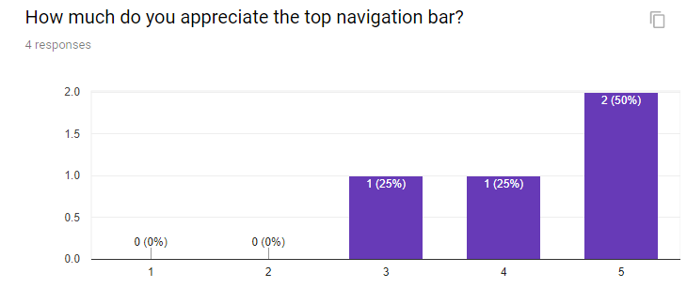

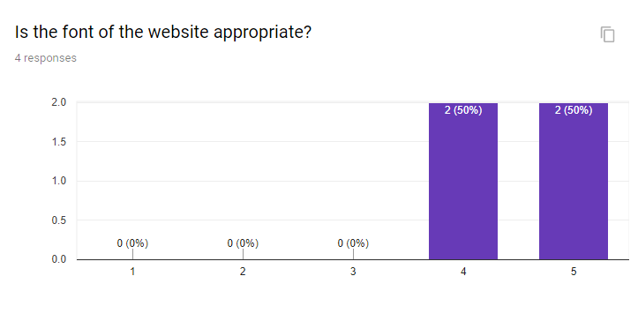

As people all from different parts of the world may have different ideas on how the website should look like, I asked friends from severl countries to visit my site and rate it in the survey by giving a useful feedback. In general, website got in average 4 out of 5 in usability check, which is a great result for this kind of webiste. 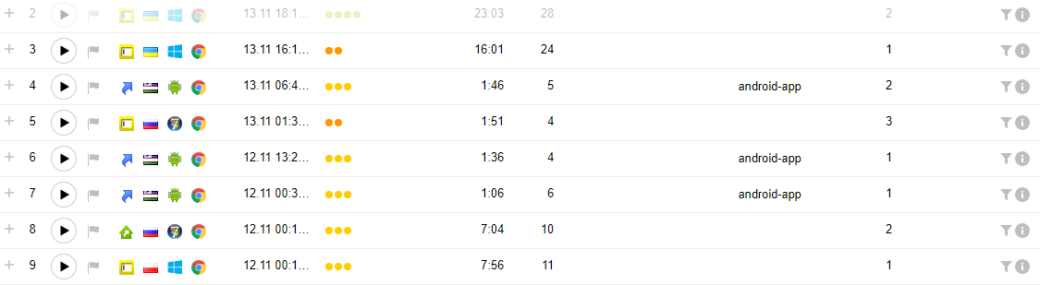

YandexMetrika Web Visor was also connected to the webpage to get more accurate results

Also, almost the half of the participants could visit the website through their smartphones, which shows that the website is fully responsive.

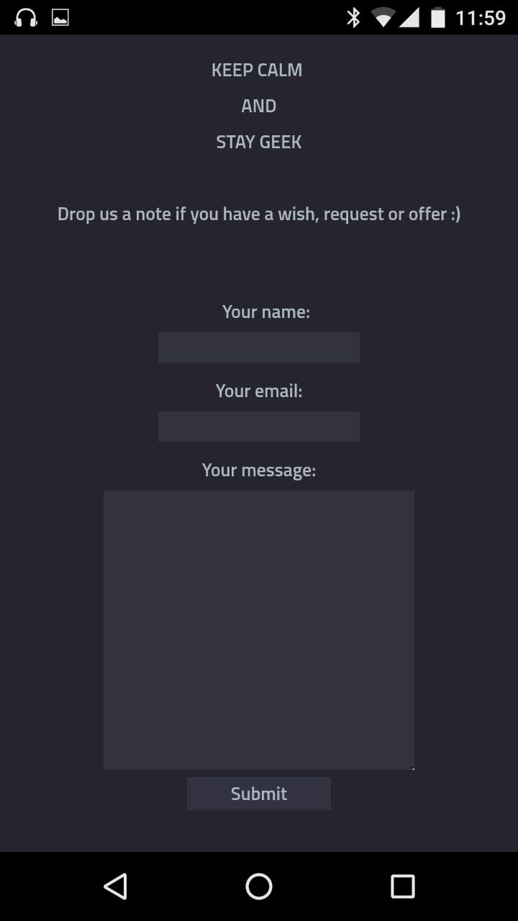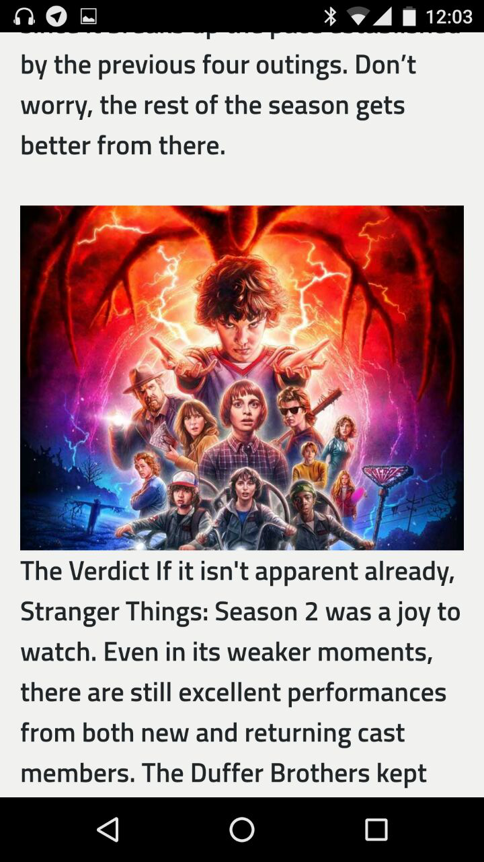

[www.00005731.github.io](http://www.00005731.github.io) – fully responsive

Finally, I checked my website for errors through the W3School validation checker webpage. The results are available in agenda of this coursework. In general, I received good impressions from the website-constructing, learned many new techniques in the language of JavaScript, understood that it is not necessary to write your navigation bar on each page of the website, and that one can insert it into your JavaScript document. I also managed how to make the fully worked feedback form and learned a lot about the external JavaScript libraries.

Appendix:

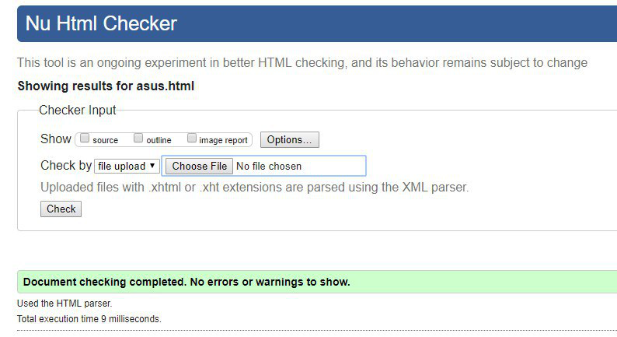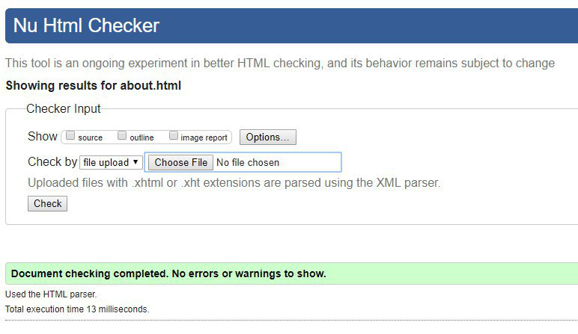 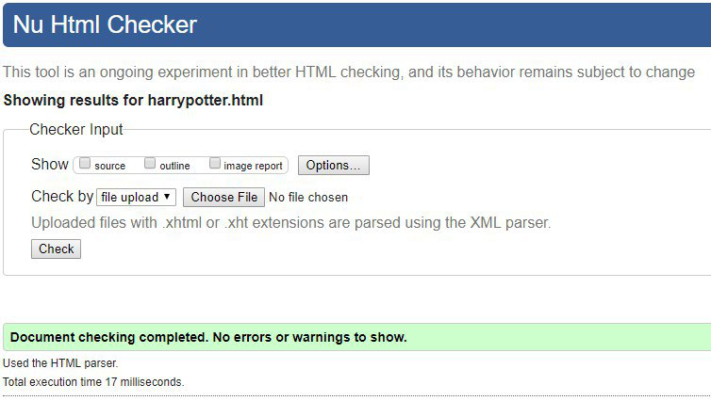 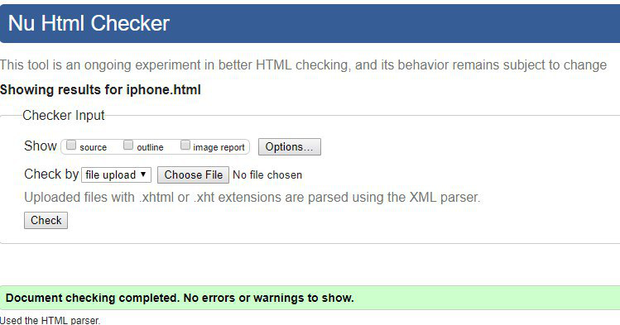

Almost every page of my website was checked in W3c validator.

Screenshot from <https://validator.w3.org/> after several validations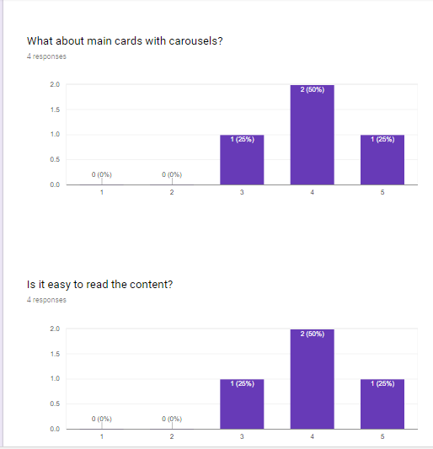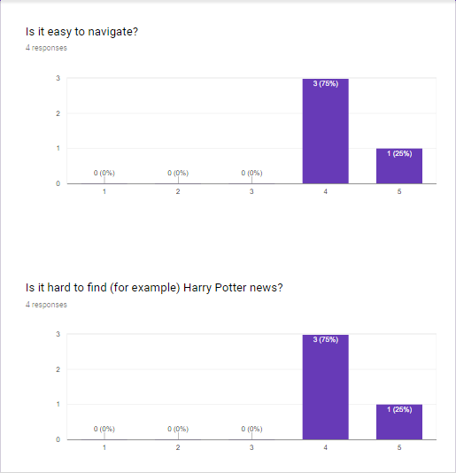

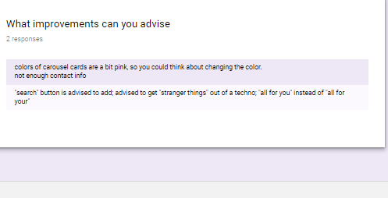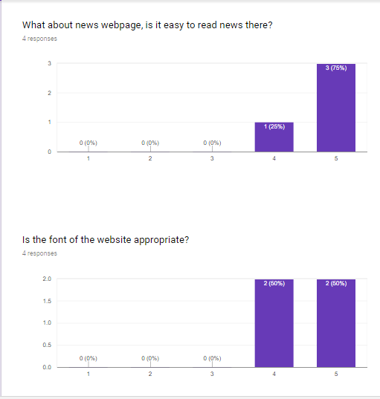 Questioner answers

Screenshot from [www.forms.google.com](http://www.forms.google.com)

Full questionaries and answers are aviliable at . <https://goo.gl/forms/qXG2w35aYMpIx5y62>

Reference list

DigitalSpy, (2017). [image] Available at: <http://digitalspyuk.cdnds.net/17/36/980x490/landscape-1504748132-untitled.jpg>(Accessed 14 Nov. 2017).

GooglePhotos, (2017). [image] Available at <https://lh3.googleusercontent.com/rEuyCbyhD7jJbneFZPF0vx8xjUv1k9kOA3hLVlzcmi5gryeqghVa8uthXLCZJWG2R4U=h900> (Accessed 14 Nov. 2017).

GooglePhotos, (2017). [image] Available at <https://lh3.googleusercontent.com/a94_s7OJYz01MEMKXZ0w2F10vcbKpnv5davhqiaup8e6SYbixKHAIBkUITnMI4U2wg=h900-rw>(Accessed 14 Nov. 2017).

IGN, (2017). [image] Available at http://assets1.ignimgs.com/2017/10/13/stranger-things-season-2-photo012-1507911105579.jpg (Accessed 14 Nov. 2017).

IGN, (2017). [image] Available at http://assets1.ignimgs.com/2017/10/13/stranger-things-season-2-photo001-1507911105569.jpg (Accessed 14 Nov. 2017).

IGN, (2017). [image] Available at http://assets1.ignimgs.com/2017/10/13/stranger-things-season-2-photo023-1507911105588.jpg (Accessed 14 Nov. 2017).

IGN, (2017). [image] Available at http://assets1.ignimgs.com/2017/10/13/stranger-things-season-2-photo010-1507911105578.jpg(Accessed 14 Nov. 2017).

IGN, (2017). [image] Available at: http://assets1.ignimgs.com/2017/10/13/stranger-things-season-2-photo006-1507911105575.jpg (Accessed 14 Nov. 2017).

IGN, (2017). [image] Available at: http://assets1.ignimgs.com/2017/10/13/stranger-things-season-2-photo009-1507911105577.jpg (Accessed 14 Nov. 2017).

IGN, (2017). [image] Available at <http://assets1.ignimgs.com/2017/10/13/stranger-things-season-2-photo008-1507911105576.jpg> (Accessed 14 Nov. 2017).

IGN, (2017). [image] Available at http://assets1.ignimgs.com/2017/10/13/stranger-things-season-2-photo009-1507911105577.jpg (Accessed 14 Nov. 2017).

IGN, (2017). [image] Available at: http://assets1.ignimgs.com/2017/10/13/stranger-things-season-2-photo006-1507911105575.jpg (Accessed 14 Nov. 2017).

IGN, (2017). [image] Available at: http://assets1.ignimgs.com/2017/10/13/stranger-things-season-2-photo005-1507911105574.jpg (Accessed 14 Nov. 2017).

IGN, (2017). [image] Available at: <http://assets1.ignimgs.com/2017/10/13/stranger-things-season-2-photo003-1507911105572.jpg> (Accessed 14 Nov. 2017).

TheVerge, (2017). [image] https://cdn.vox-cdn.com/thumbor/-gexOZQ-mFvRTKQ9wiRyEIWEcq8=/0x0:2040x1360/1570x883/filters:focal(928x1034:1254x1360):format(webp)/cdn.vox-cdn.com/uploads/chorus_image/image/57445389/jbareham_171102_2108_0017.1509662723.jpg(Accessed 14 Nov. 2017).

TheVerge, (2017). [image] https://cdn.vox-cdn.com/thumbor/cx_ejyet3d7vpAWy5VL2aAdwD6w=/1200x0/filters:no_upscale()/cdn.vox-cdn.com/uploads/chorus_asset/file/9597301/jbareham_171102_2108_0038.jpg(Accessed 14 Nov. 2017).

TheVerge, (2017). [image] https://cdn.vox-cdn.com/thumbor/XNUgWOy8Dhks-cNBYfuPDfpGkEM=/1200x0/filters:no_upscale()/cdn.vox-cdn.com/uploads/chorus_asset/file/9597307/jbareham_171102_2108_0009.jpg(Accessed 14 Nov. 2017).

TheVerge, (2017). [image] https://cdn.vox-cdn.com/thumbor/I1DjwgGOzIAH5J5toOLl2t9Vbb8=/1200x0/filters:no_upscale()/cdn.vox-cdn.com/uploads/chorus_asset/file/9597293/jbareham_171102_2108_0077.jpg(Accessed 14 Nov. 2017).

1. First scratches of new design are available on the pages about.html and on a special eastern-egg page – space.html
2. Full questionaries and answers are aviliable at <https://goo.gl/forms/qXG2w35aYMpIx5y62>