**00009620**

Task 1

<https://github.com/00009620/CSF->

Task 2

a) Convert my ID(9620) into binary code:

|  |  |  |
| --- | --- | --- |
| Division by 2 | Quotient | Remainder |
| 9620/2 | 4810 | 0 |
| 4810/2 | 2405 | 0 |
| 2405/2 | 1202 | 1 |
| 1202/2 | 601 | 0 |
| 601/2 | 300 | 1 |
| 300/2 | 150 | 0 |
| 150/2 | 75 | 0 |
| 75/2 | 37 | 1 |
| 37/2 | 18 | 1 |
| 18/2 | 9 | 0 |
| 9/2 | 4 | 1 |
| 4/2 | 2 | 0 |
| 2/2 | 1 | 0 |
| 1 | 0 | 1 |

Convert 9620 to hexadecimal

|  |  |  |
| --- | --- | --- |
| Division by 16 | Quotient | Remainder |
| 9620/16 | 601 | 4 |
| 601/16 | 37 | 9 |
| 37/16 | 2 | 5 |
| 2 | 0 | 2 |

Reverse the remainders and get answers.

Answer: 9620 in binary = 10010110010100

9620 in hex = 2594

b) 99999 is equal to 11000011010011111 in binary code.

Below are the results of subtraction and addition :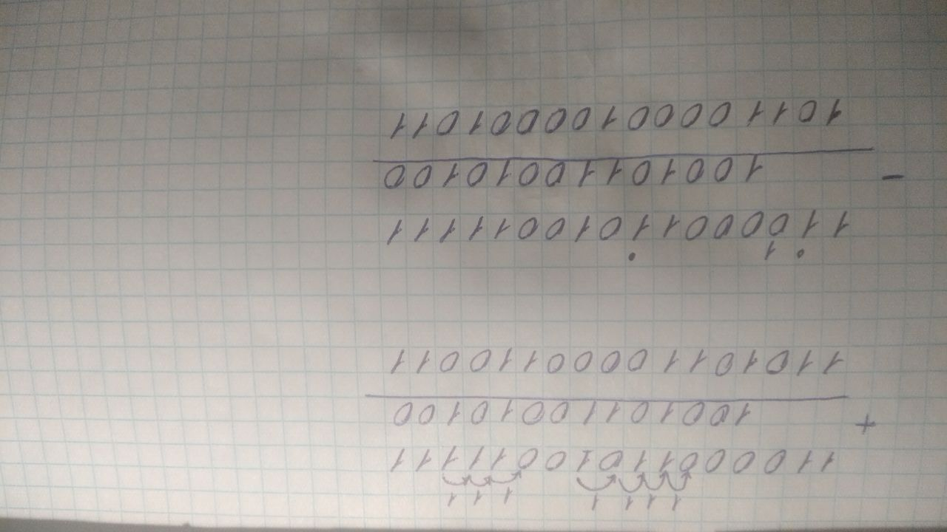

c) Hexadecimal code is most used for space exemption or simply is can hold more numbers of a binary code, using just a couple of digits. So, it is really great in terms of space allocation. The only possible drawback is that it is a bit hard for people to understand it and convert it straightforward to decimal in a head.