Table of Contents

Audience profile 1

Functions and features 1

Link to : 10

Website 10

Github 10

Reference 10

# Audience profile

This website was create to help for apartment buyers. The target audience here is people who need an apartment and also shopping centres. This company “bizning uylar” build buildings and help all their audience. By our website they may find their appropriate houses and apartment.

# Functions and features

This website consists of 7 (Home, about, cost, team, gallery, contact, bibliography) page and it 100% responsive. Also, the design was created using some codes and design. The main advantages of my website is that java script function was used perfectly and in the contact page you will se unfilled files- show erors (created using JS file).

Also, all pages can attract users in it and during using this website you can intertain yourself because of used lots of different design.

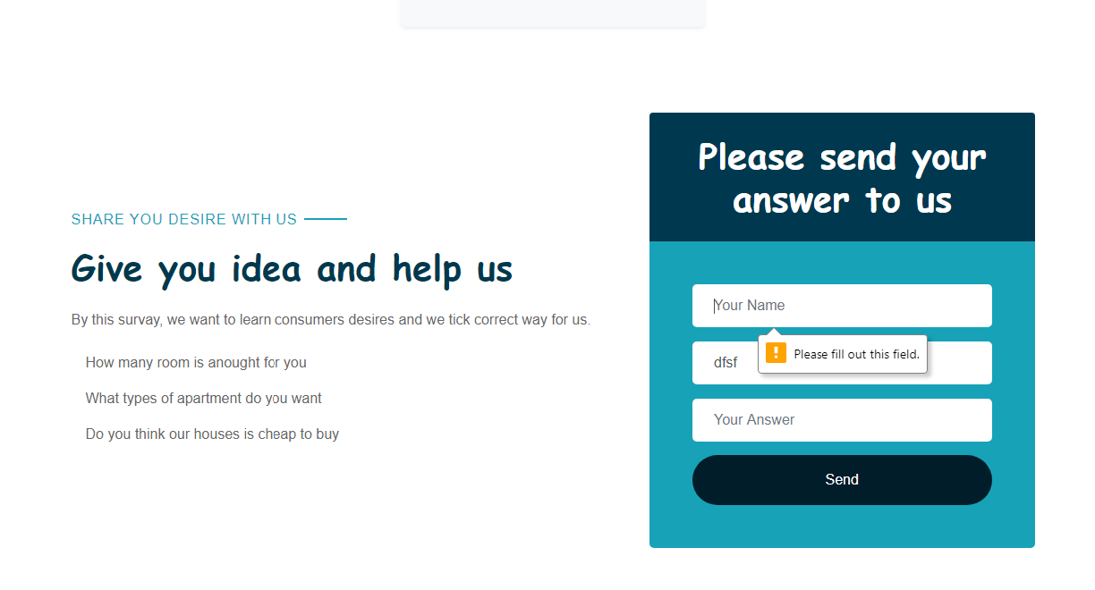

This is a main JS file (The most difficult) in my project

Home page: in the home page there is main information.

Based on the requirement “This website was created to fulfill Web Technology module’s requirements and does not represent an actual company or service (00009620) “ was written in the home page.

In the home page first of all you will se the aim of the website as well as this company. Than information about building apartments is given for the visitors.

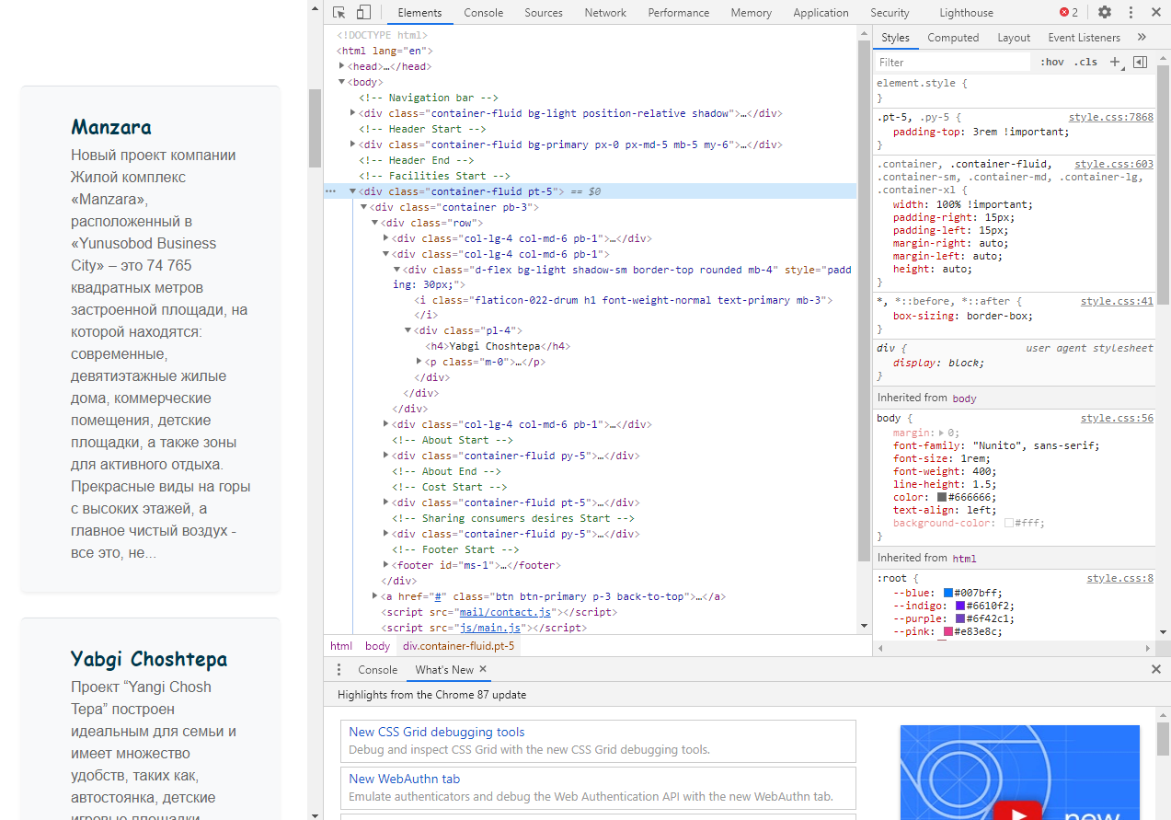

In this website all codes is given mostly in % because of being responsive and attractive. Also in this picture you may see how this website is responsive.

In the section you may learn about this company’s team (About Us)

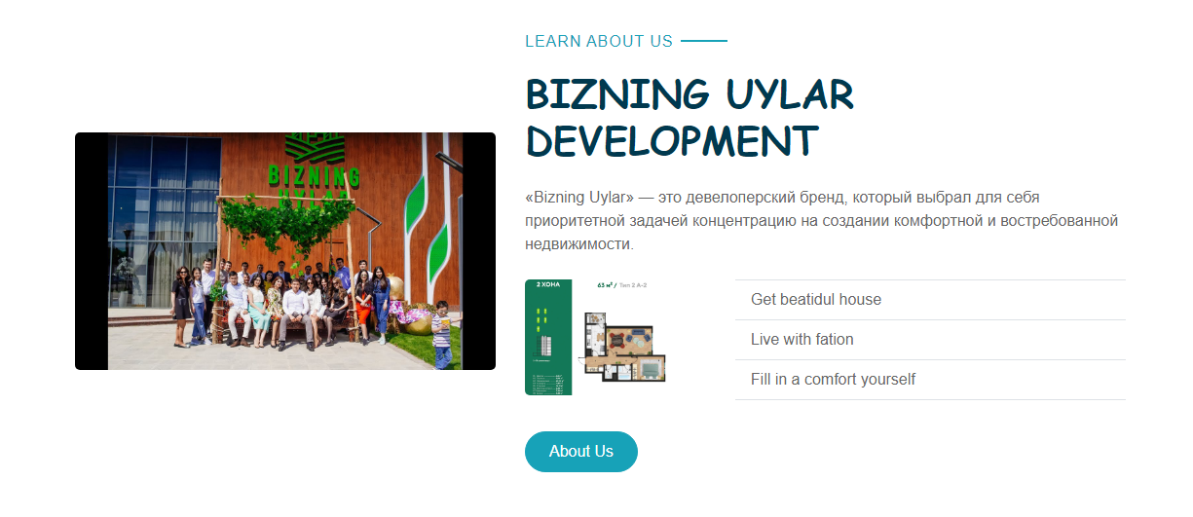

Here if you push this button (About Us) it leads you to About page

Belove this info you may see the cost of houses, which is one of the attractive designs of this website.

It is time to think about innovation. Here there is a survey list which help to find consumers desires.

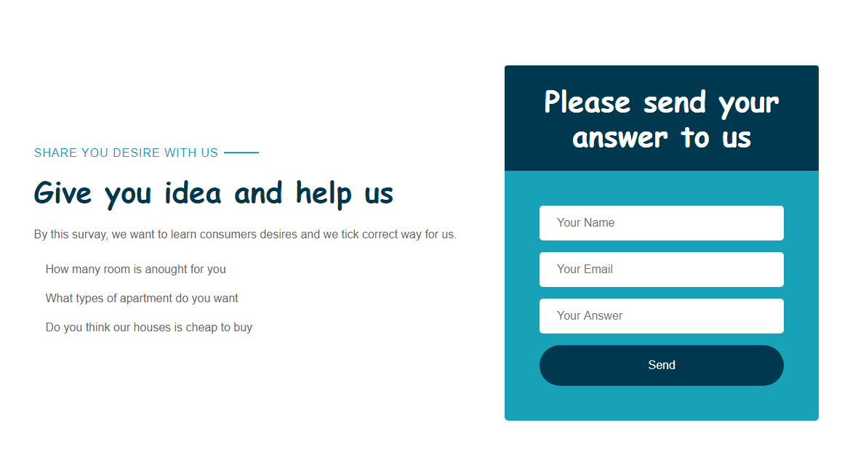

 <div class="container-fluid py-5">

        <div class="container">

            <div class="row align-items-center">

                <div class="col-lg-7 mb-5 mb-lg-0">

                    <p class="section-title pr-5"><span class="pr-2">Share you desire with Us</span></p>

                    <h1 class="mb-4">Give you idea and help us</h1>

                    <p>By this survay, we want to learn consumers desires and we tick correct way for us.</p>

                    <ul class="list-inline m-0">

                        <li class="py-2"><i class="fa fa-check text-success mr-3"></i>How many room is anought for you</li>

                        <li class="py-2"><i class="fa fa-check text-success mr-3"></i>What types of apartment do you want</li>

                        <li class="py-2"><i class="fa fa-check text-success mr-3"></i>Do you think our houses is cheap to buy</li>

                    </ul>

                </div>

                <div class="col-lg-5">

                    <div class="card border-0">

                        <div class="card-header bg-secondary text-center p-4">

                            <h1 class="text-white m-0">Please send your answer to us</h1>

                        </div>

                        <div class="card-body rounded-bottom bg-primary p-5">

                            <form>

                                <div class="form-group">

                                    <input type="text" class="form-control border-0 p-4" placeholder="Your Name" required="required" />

                                </div>

                                <div class="form-group">

                                    <input type="email" class="form-control border-0 p-4" placeholder="Your Email" required="required" />

                                </div>

                                <div class="form-group">

                                    <input type="email" class="form-control border-0 p-4" placeholder="Your Answer" required="required" />

                                </div>

                                <div>

                                    <button class="btn btn-secondary btn-block border-0 py-3" type="submit">Send</button>

                                </div>

                            </form>

                        </div>

                    </div>

                </div>

            </div>

        </div>

    </div>

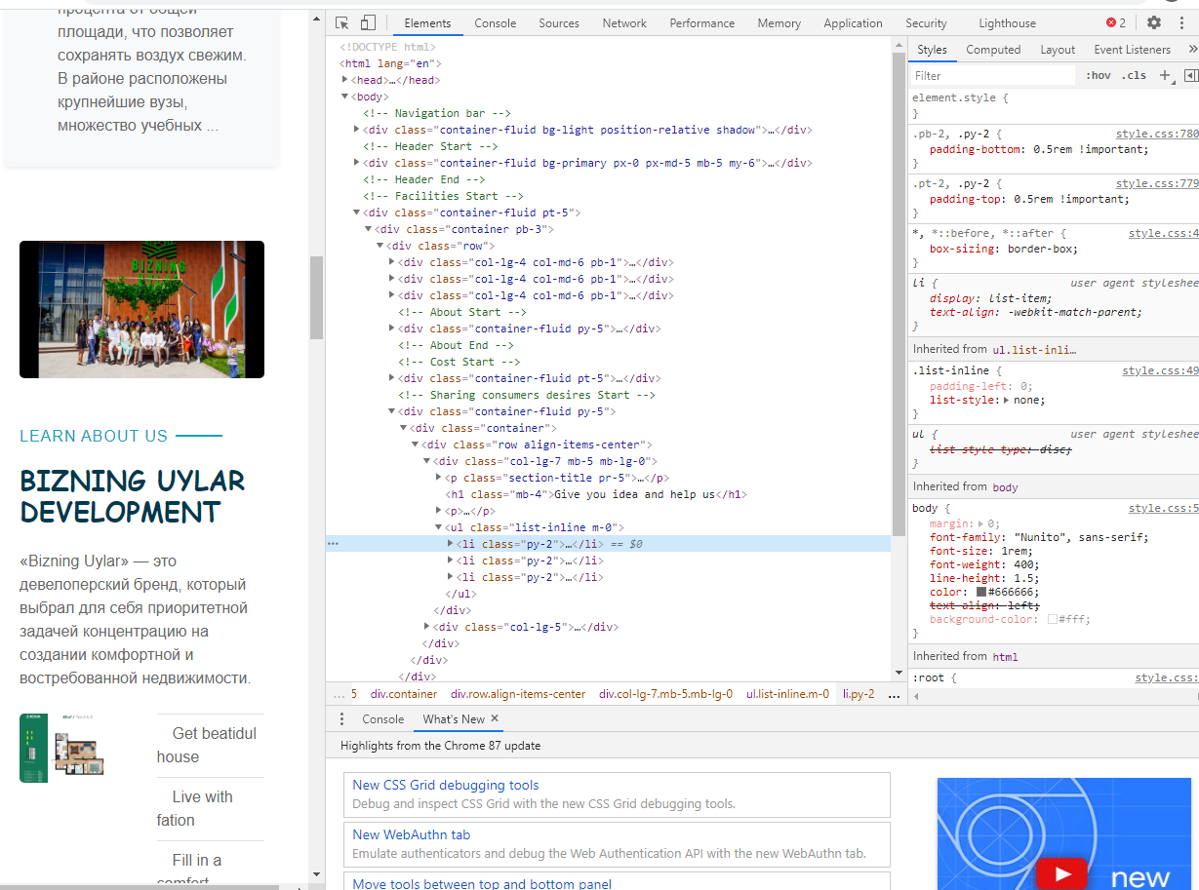

Creating this function was very difficult and I created it by watching video from YouTube. (I will give the link of video in the reference list).

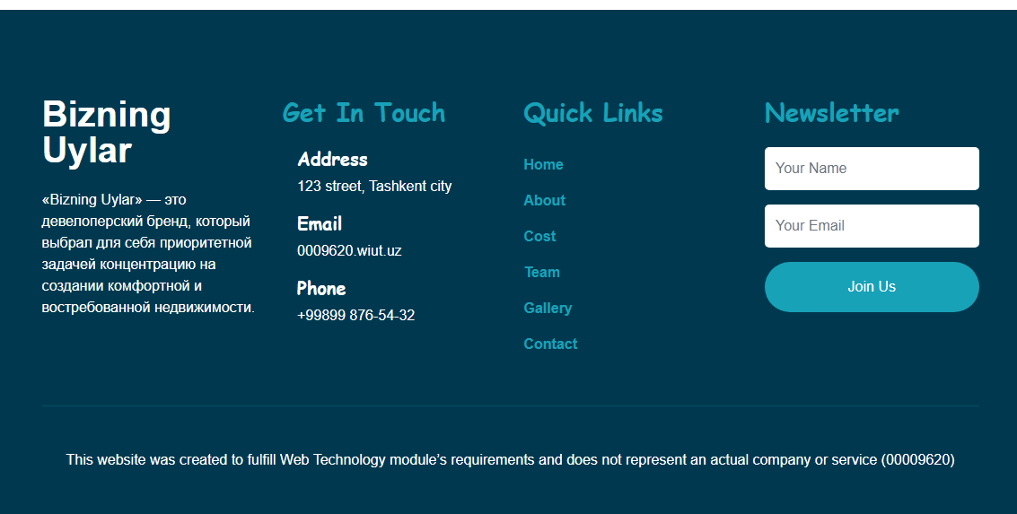

When it comes to footer the appropriate design is given also for footer

About Us:

In this page the is there is a new design called Our Team

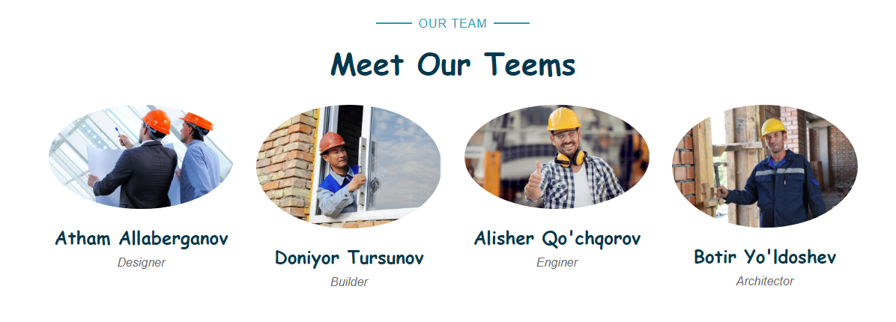

Other information is copy pasted from home page.

    <!-- About Start -->

    <div class="container-fluid py-5">

        <div class="container">

            <div class="row align-items-center">

                <div class="col-lg-5">

                    <img class="img-fluid rounded mb-5 mb-lg-0" src="img/team.jpg" alt="">

                </div>

                <div class="col-lg-7">

                    <p class="section-title pr-5"><span class="pr-2">Learn About Us</span></p>

                    <h1 class="mb-4">BIZNING UYLAR DEVELOPMENT</h1>

                    <p>«Bizning Uylar» — это девелоперский бренд, который выбрал для себя приоритетной задачей концентрацию на создании комфортной и востребованной недвижимости.</p>

                    <div class="row pt-2 pb-4">

                        <div class="col-6 col-md-4">

                            <img class="img-fluid rounded" src="img/inter.jpg" alt="">

                        </div>

                        <div class="col-6 col-md-8">

                            <ul class="list-inline m-0">

                                <li class="py-2 border-top border-bottom"><i class="fa fa-check text-primary mr-3"></i>Get beatidul house</li>

                                <li class="py-2 border-bottom"><i class="fa fa-check text-primary mr-3"></i>Live with fation</li>

                                <li class="py-2 border-bottom"><i class="fa fa-check text-primary mr-3"></i>Fill in a comfort yourself</li>

                            </ul>

                        </div>

                    </div>

                    <a href="http://www.bizninguylar.uz/about" class="btn btn-primary mt-2 py-2 px-4">About Us</a>

                </div>

            </div>

        </div>

    </div>

Team:

In this page there is video and table which are put to provide the requirement. This video is taken by YouTube.

Contact:

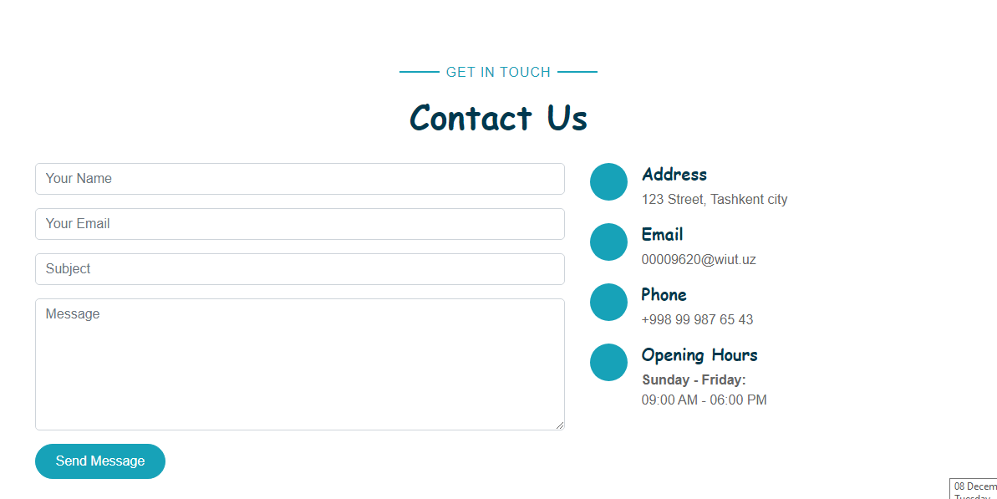

Creating contact page was the most difficult for me. Because I mi

    <!-- Contact Start -->

    <div class="container-fluid pt-5">

        <div class="container">

            <div class="text-center pb-2">

                <p class="section-title px-5"><span class="px-2">Get In Touch</span></p>

                <h1 class="mb-4">Contact Us</h1>

            </div>

            <div class="row">

                <div class="col-lg-7 mb-5">

                    <div class="contact-form">

                        <div id="success"></div>

                        <form name="sentMessage" id="contactForm" novalidate="novalidate">

                            <div class="control-group">

                                <input type="text" class="form-control" id="name" placeholder="Your Name" required="required" data-validation-required-message="Please enter your name" />

                                <p class="help-block text-danger"></p>

                            </div>

                            <div class="control-group">

                                <input type="email" class="form-control" id="email" placeholder="Your Email" required="required" data-validation-required-message="Please enter your email" />

                                <p class="help-block text-danger"></p>

                            </div>

                            <div class="control-group">

                                <input type="text" class="form-control" id="subject" placeholder="Subject" required="required" data-validation-required-message="Please enter a subject" />

                                <p class="help-block text-danger"></p>

                            </div>

                            <div class="control-group">

                                <textarea class="form-control" rows="6" id="message" placeholder="Message" required="required" data-validation-required-message="Please enter your message"></textarea>

                                <p class="help-block text-danger"></p>

                            </div>

                            <div>

                                <button class="btn btn-primary py-2 px-4" type="submit" id="sendMessageButton">Send Message</button>

                            </div>

                        </form>

                    </div>

                </div>

                <div class="col-lg-5 mb-5">

                    <div class="d-flex">

                        <i class="fa fa-map-marker-alt d-inline-flex align-items-center justify-content-center bg-primary text-secondary rounded-circle" style="width: 45px; height: 45px;"></i>

                        <div class="pl-3">

                            <h5>Address</h5>

                            <p>123 Street, Tashkent city</p>

                        </div>

                    </div>

                    <div class="d-flex">

                        <i class="fa fa-envelope d-inline-flex align-items-center justify-content-center bg-primary text-secondary rounded-circle" style="width: 45px; height: 45px;"></i>

                        <div class="pl-3">

                            <h5>Email</h5>

                            <p>00009620@wiut.uz</p>

                        </div>

                    </div>

                    <div class="d-flex">

                        <i class="fa fa-phone-alt d-inline-flex align-items-center justify-content-center bg-primary text-secondary rounded-circle" style="width: 45px; height: 45px;"></i>

                        <div class="pl-3">

                            <h5>Phone</h5>

                            <p>+998 99 987 65 43</p>

                        </div>

                    </div>

                    <div class="d-flex">

                        <i class="far fa-clock d-inline-flex align-items-center justify-content-center bg-primary text-secondary rounded-circle" style="width: 45px; height: 45px;"></i>

                        <div class="pl-3">

                            <h5>Opening Hours</h5>

                            <strong>Sunday - Friday:</strong>

                            <p class="m-0">09:00 AM - 06:00 PM </p>

                        </div>

                    </div>

                </div>

            </div>

        </div>

    </div>

# Link to :

Website: 00009620wiut.freetzi.com

Github: <https://github.com/00009620/Webtechnology>

# Reference

Bizninguylar.uz. 2020. *Bizning Uylar*. [online] Available at: <http://www.bizninguylar.uz/> [Accessed 8 December 2020].

Youtube.com. 2020. [online] Available at: <https://www.youtube.com/watch?v=VlwrnGjORn0&t=147s> [Accessed 8 December 2020].

W3schools.com. 2020. *W3schools Online Web Tutorials*. [online] Available at: <https://www.w3schools.com/> [Accessed 8 December 2020].

Youtube.com. 2020. [online] Available at: <https://www.youtube.com/> [Accessed 8 December 2020].