**Task#6**

Agile vs Waterfall: The main Differences Between these two popular methodologies are given below:

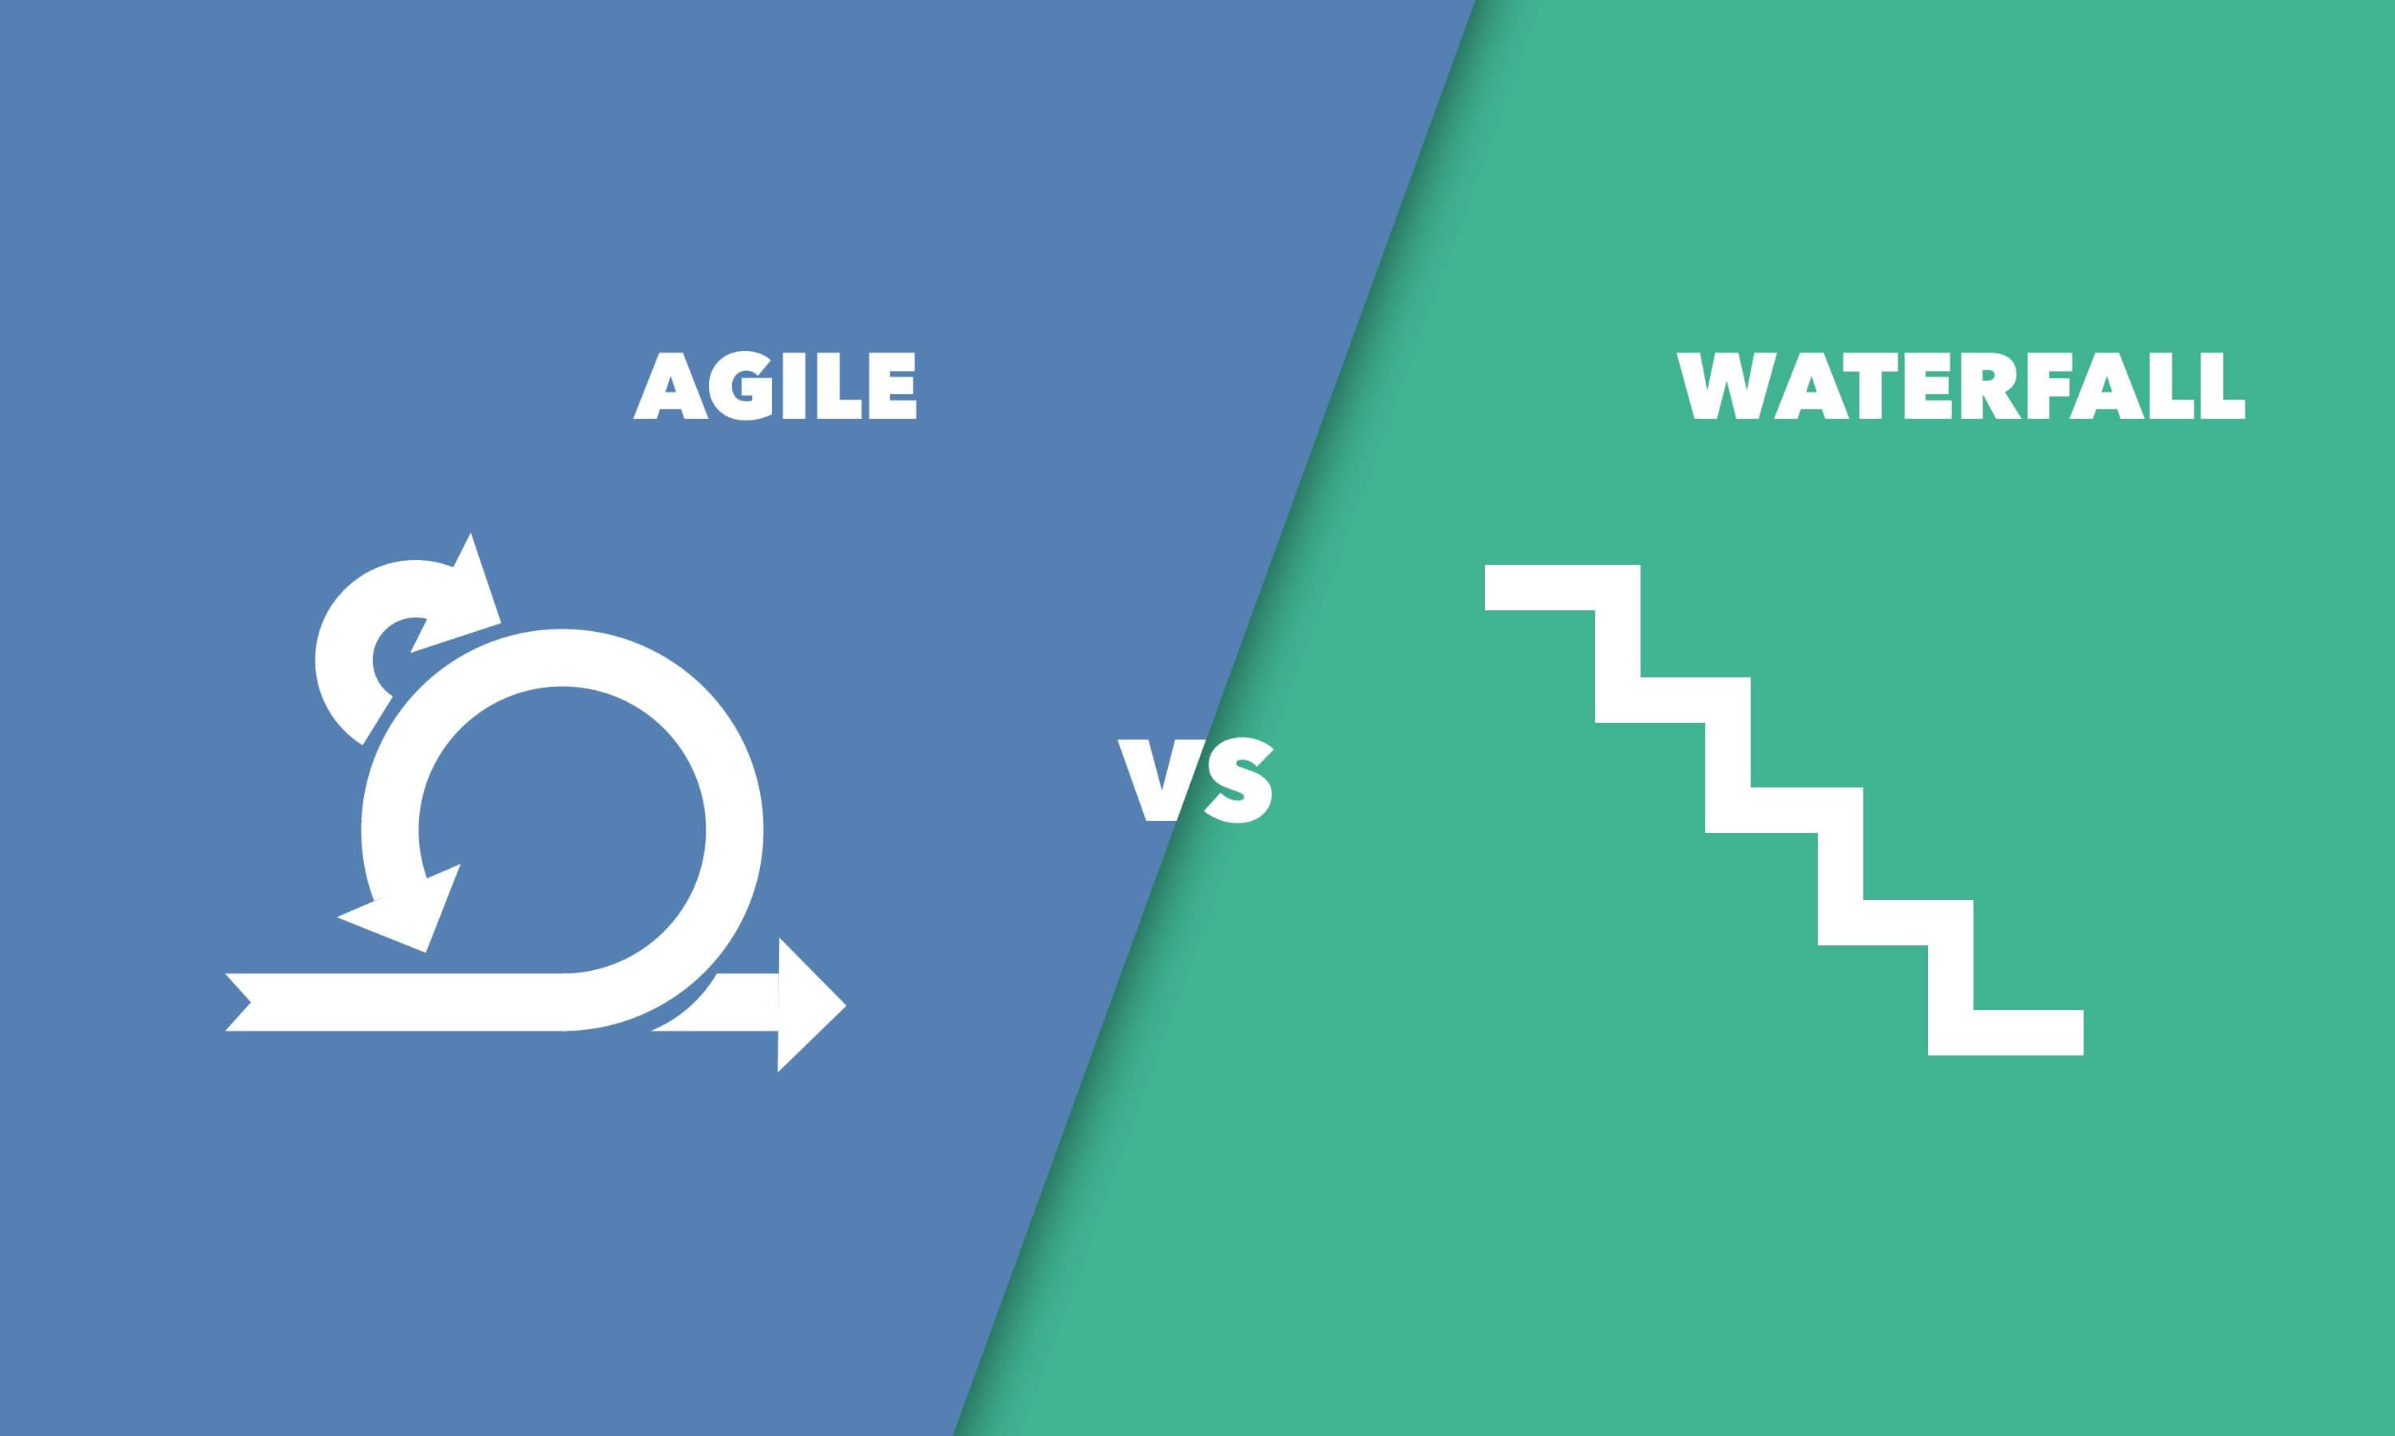

|  |  |
| --- | --- |
| **Waterfall** | **Agile** |
| **The Waterfall development process is divided into different phases.** | **Agile breaks the project development lifecycle into sprints.** |
| **Team coordination and synchronization are rather limited** | **The technique requires small but committed teams with a high degree of synchronization and coordination.** |
| **Company research plans requirements before the project begins.** | **A product owner with a team prepares requirements every day during project.** |
| **The processes are always straightforward so, the project manager plays crucial role during every stage.** | **Agile team members are exchangeable, so they work faster. There is no need of managers as the projects are managed by whole team.** |
| **To incorporate Waterfall, a detailed explanation needs to be used.** | **At any time during the process, you can change the description of the project information.** |
| **Only after build phase is done, testing phase comes** | **Testing is done in Agile simultaneously with software development.** |
| **All the project development phases are simultaneously.** | **The method follows an iterative approach. Different phases may appear more than once (2 or more times).** |
| **Waterfall shows a project mindset and focuses entirely on the accomplishment of the project.** | **Agile is a mindset where software product meets the needs of the end users and adjusts itself according to the demands of the consumer.** |
| **This is structured software development technique, so it can be very rigid much of the time.** | **Flexibility is what makes Agile different.** |
| **The development process is done as a one single project** | **Agile is set of many different projects** |

**2)**

Until an approach is implemented, a range of considerations should be taken into consideration.

1)When the project is limited by expense or time,

has strict regulatory requirements and the demands, scope is well known, and no space for modifications, the Waterfall would become the best methodology. In these cases, the Waterfall methodology gives a series of procedures that help to make the work easier. Also, when the timeline of project is fixed and cannot be changed or moved, Waterfall will offer a more foreseen and exact outcome.

Moreover, in offering a precise feature set within a restricted finite or timeline, the Waterfall methodology does a better job.

2) Agile is far better when the product team is uncertain what needs to be made or they need to find what should be built relying on adjustments they make along the way. Agile will produce way more features in a short period of time and moreover, it gives the team more of a flexibility throughout the entire process that they can take benefits of opportunities as the project discloses.

Additionally, agile prioritizes features and pace to market over strictly adhering to a schedule if you do have any budget flexibility. During Agile growth, a new, useful function may often be found, but may take a little extra time and money to implement. If this works for the team, Agile is the right match for you.