**Task#2**

1. ID: 00009647

To convert (9647)10 to Binary, we divide by two continuously until quotient is equal to 0 and get integer quotient. According to the integer quotient we will write binary value either 0 or 1.

|  |  |  |
| --- | --- | --- |
| Dividing by 2 | Quotient | Reminder |
| 9647/2 | 4823 | 1 |
| 4823/2 | 2411 | 1 |
| 2411/2 | 1205 | 1 |
| 1205/2 | 602 | 1 |
| 602/2 | 301 | 0 |
| 301/2 | 150 | 1 |
| 150/2 | 75 | 0 |
| 75/2 | 37 | 1 |
| 37/2 | 18 | 1 |
| 18/2 | 9 | 0 |
| 9/2 | 4 | 1 |
| 4/2 | 2 | 0 |
| 2/2 | 1 | 0 |
| 1/2 | 0 | 1 |

Step 2: We write the answer starting from the last result

Answer: (10010110101111)2

We do the similar steps for Hexadecimal but the divided number will be 16

Step 1:

|  |  |  |
| --- | --- | --- |
| Dividing by 16 | Quotient | Reminder |
| 9647/16 | 602 | 15 |
| 602/16 | 37 | 10 |
| 37/16 | 2 | 5 |
| 2/16 | 0 | 2 |

Step 2:

|  |  |
| --- | --- |
| Decimal | Hexadecimal |
| 15 | F |
| 10 | A |
| 5 | 5 |
| 2 | 2 |

(9647)10=(25AF)16

**Step 1:**

(9647)10= (10010110101111)2 and we need to convert (99999)10 = X2

|  |  |  |
| --- | --- | --- |
| Dividing by 2 | Quotient | Reminder |
| 99999/2 | 49999 | 1 |
| 49999/2 | 24999 | 1 |
| 24999/2 | 12499 | 1 |
| 12499/2 | 6249 | 1 |
| 6249/2 | 3124 | 1 |
| 3124/2 | 1562 | 0 |
| 1562/2 | 781 | 0 |
| 781/2 | 390 | 1 |
| 390/2 | 195 | 0 |
| 195/2 | 97 | 1 |
| 97/2 | 48 | 1 |
| 48/2 | 24 | 0 |
| 24/2 | 12 | 0 |
| 12/2 | 6 | 0 |
| 6/2 | 3 | 0 |
| 3/2 | 1 | 1 |
| ½ | 0 | 1 |

(110000110100111110)2=(99999)10 ; (10010110101111)2 = (9647)10

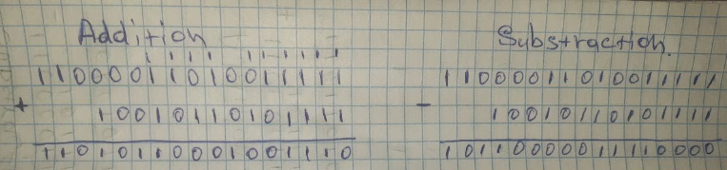**Step 2:**

С) Hex codes are used to simplify binary codes in many fields of computation. It is important to remember that hexadecimal is not used by computers - it is used by the people to simplify the binary form to a form that is easier to comprehend. For machine use, Hexadecimal is converted into binary.

Hexadecimal numerals are commonly used as they offer a human-friendly representation of binary-coded values for computer programmers.