**Task#3**

**Oybek&Mavjuda**

|  |  |  |  |
| --- | --- | --- | --- |
| Character | Frequency | Encoding | Code length |
| O | 1 | 1111 | 4 |
| y | 1 | 1110 | 4 |
| b | 1 | 110 | 3 |
| e | 1 | 1010 | 4 |
| k | 1 | 1011 | 4 |
| & | 1 | 100 | 3 |
| M | 1 | 0111 | 4 |
| v | 1 | 0110 | 4 |
| j | 1 | 010 | 3 |
| u | 1 | 0011 | 4 |
| d | 1 | 0010 | 4 |
| a | 2 | 000 | 3 |

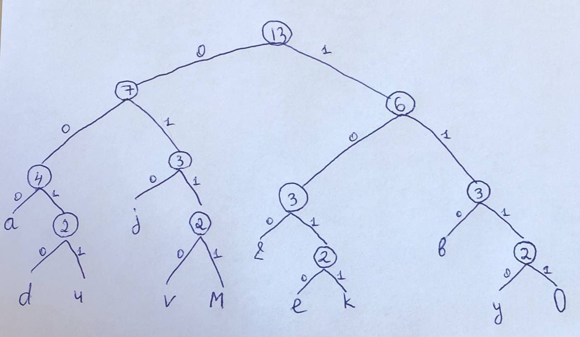

1*4+1*4+1*3+1*4+1*4+1*3+1*4+1*4+1*3+1*4+1*4+1*3= 44 bits will be required for encoding message ‘Oybek&Mavjuda’ using Huffman encoding