**Task#7**

The Bus and Star topologies will be compared below:

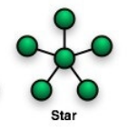

Some of the advantages of Star (the fastest) topology:

1. The topology allows ease of operation because of its centralized nature.
2. In the network each device is isolated
3. It's easy to add or delete network nodes, it can be accomplished without impacting the whole network.
4. Due to the centralized design of network, it is easy to identify errors.
5. With the use of central hub with high-capacity, traffic load can be handled at fairly decent speed.

Some of the disadvantages of Star topology:

1) The activity of the network relies on the central hub. Therefore, central hub failure leads to the entire network failure.

2) The number of nodes that can be added is dependent on the central hub's capacity.

3) The cost of the setup is very high.

There are 5 advantages and 3 disadvantages we can count.

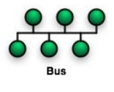

Some of the advantages of Bus topology:

1)Set up, implementation and handling are easy

2)This type of topology is best suited for the small networks

3)Cheap

Some of the disadvantages of Bus topology:

1. The cable length is limited. This limits the number of network nodes that can be connected
2. Only for a small number of nodes will this network topology perform well.
3. The performance reduces as the number of devices attached to the bus increases.
4. It is ideal for low-traffic networks. Heavy traffic raises the bus load, and the performance of the network reduces.
5. The Central Bus is heavily reliant on it. A bus fault refers to network loss.
6. It is quite difficult to isolate network nodes
7. All data being transmitted is "seen" by each computer on the network, thereby posing a security danger.

2)

Star topology

This topology is mainly used for connecting hosts to the hub.

The dominant physical topology for LANs has been Star topology. ARCNET first popularized the star, and Ethernet later adopted it. Each node is linked directly to a central computer, such as a hub or a switch. As shown below

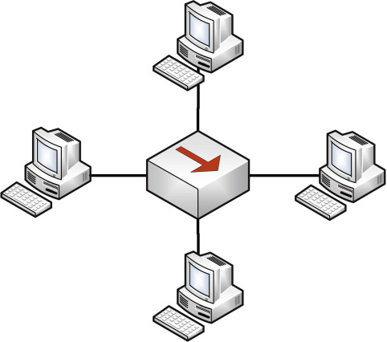

Overall, this topology is more of suitable for connecting hosts to the hubs, which reduces the impact of transmission failure. There are many reasons why star is used for this purpose such as: its centralized nature (makes operation easy), as each hosts is distinct, it is easy to add or delete nodes (additionally, it can be accomplished without impacting whole network) , use of central hub makes traffic load at a decent speed(fast).

Bus topology

This topology type is most of *suitable for connecting computers,* along a single or more cable as shown below:

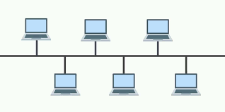All nodes are connected to single cable.

The cable to which all nodes are connected is called “backbon”. If the backbone is broken, the entire segment fails.

A network that uses a bus topology is known as a "bus network" the original type of Ethernet networks. For bus topology, Ethernet (also known as thinnet) is used.