The link to the GitHub repository: <https://github.com/00009815/CSF.CW1.00009815/tree/exam>

Task 2

1. ID = 9815

9815/2 = 4907 Remainder: 1

4907/2 = 2453 Remainder: 1

2453/2 = 1226 Remainder: 1

1226/2 = 613 Remainder: 0

613/2 = 306 Remainder: 1

306/2 = 153 Remainder: 0

153/2 = 76 Remainder: 1

76/2 = 38 Remainder: 0

38/2 = 19 Remainder: 0

19/2 = 9 Remainder: 1

9/2 = 4 Remainder: 1

4/2 = 2 Remainder: 0

2/2 = 1 Remainder: 0

1/2 = 0 Remainder: 1

9815 in decimal = 10011001010111

Binary: 10 0110 0101 0111 => Hex: 2657

9815 in hex = 2657

1. Remainder

99999/2 = 49999 1

49999/2 = 24999 1

24999/2 = 12499 1

12499/2 = 6249 1

6249/2 = 3124 1

3124/2 = 1562 0

1562/2 = 781 0

781/2 = 390 1

390/2 = 195 0

195/2 = 97 1

97/2 = 48 1

48/2 = 24 0

24/2 = 12 0

12/2 = 6 0

6/2 = 3 0

3/2 = 1 1

1/2 = 0 1

99999 in decimal = 11000011010011111

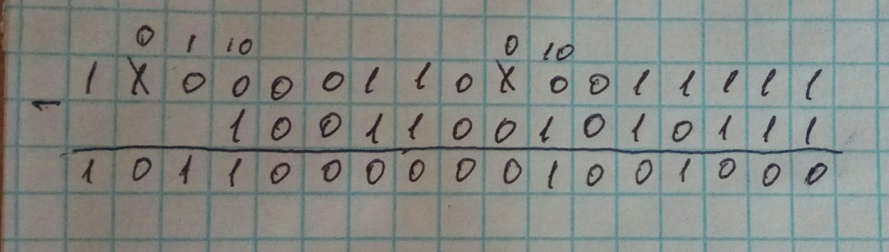

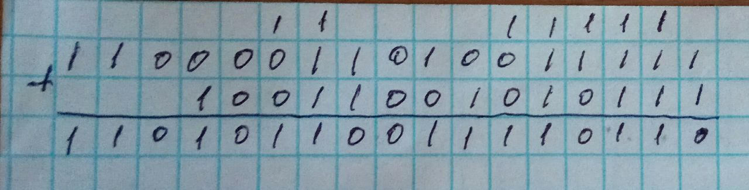

1. Hexadecimal system is more concise than binary and allows to represent large binary numbers in a few digits. Additionally, it is easy to convert between the hex system, decimal and binary. Hexadecimal is used in definitions of memory locations, colours, MAC addresses and error messages (Teach Computer Science, 2018).

Task 3

Altina&Shavkat

|  |  |  |  |  |  |  |  |  |  |
| --- | --- | --- | --- | --- | --- | --- | --- | --- | --- |
| A | L | T | I | N | & | S | H | V | K |
| 4 | 1 | 2 | 1 | 1 | 1 | 1 | 1 | 1 | 1 |

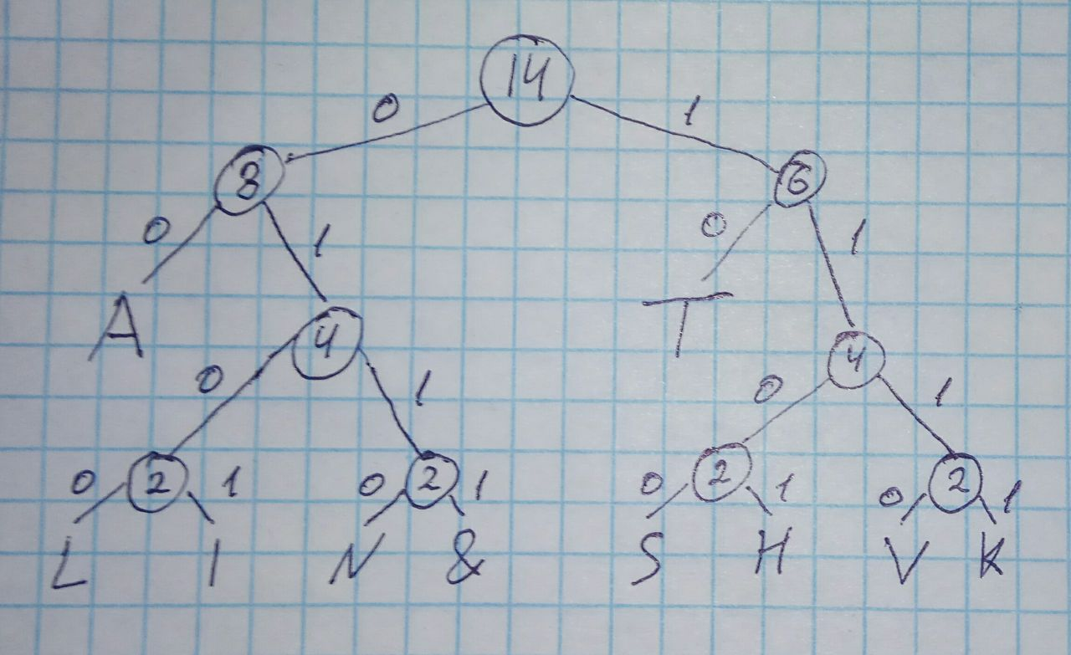

Altina&Shavkat => 00010010010101100001111100110100111011110010

Total number of bits = 4*2 + 1*4 + 2*2 + 1*4 + 1*4 + 1*4 + 1*4 + 1*4 + 1*4 + 1*4 = 44

Task 4

The list of numbers: 1 2 3 4 5 7 8 9

The wanted number: 8

Pseudocode:

X = 8 (wanted number)

1. Midpoint = 4 (8/2)
2. X > midpoint (8>4), drop the left side
3. Midpoint = 7 (4/2)
4. X > midpoint (8>7), drop the left side
5. Midpoint = 8 (2/2)
6. X = midpoint (8=8), number found

References:

Teach Computer Science. (2018). Uses of Hexadecimal | Hexadecimal & Character Sets | Computer Science. *Teach Computer Science*. Available from https://teachcomputerscience.com/uses-of-hexadecimal/.

‌