**Task 2**

**a)** *Decimal to Binary (R – Remainder):*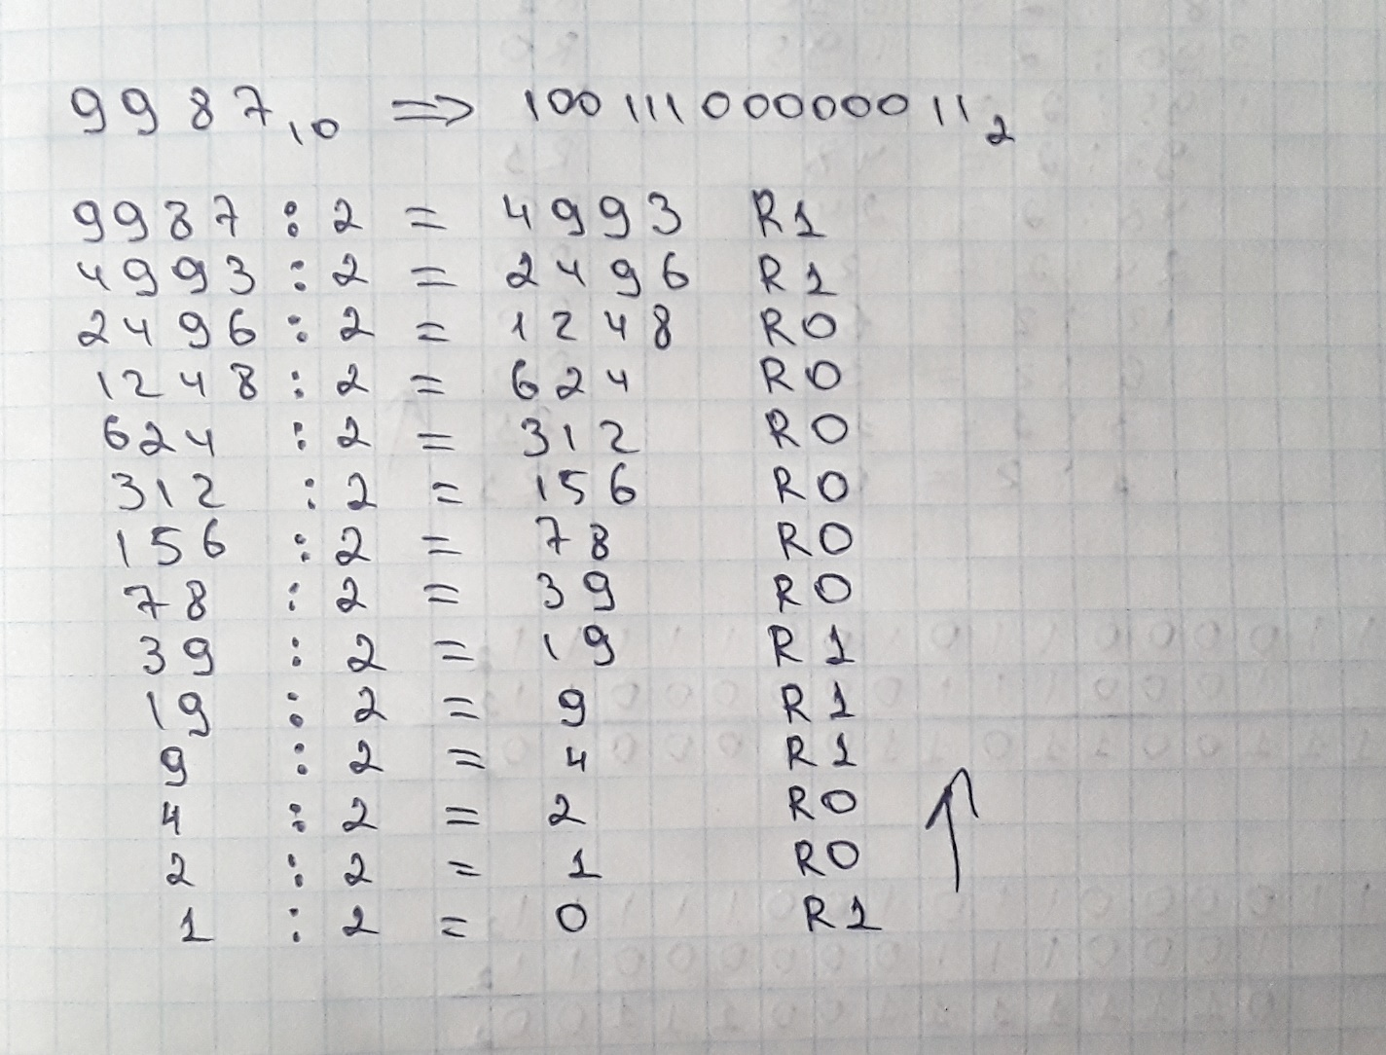

*Decimal to Hex:*

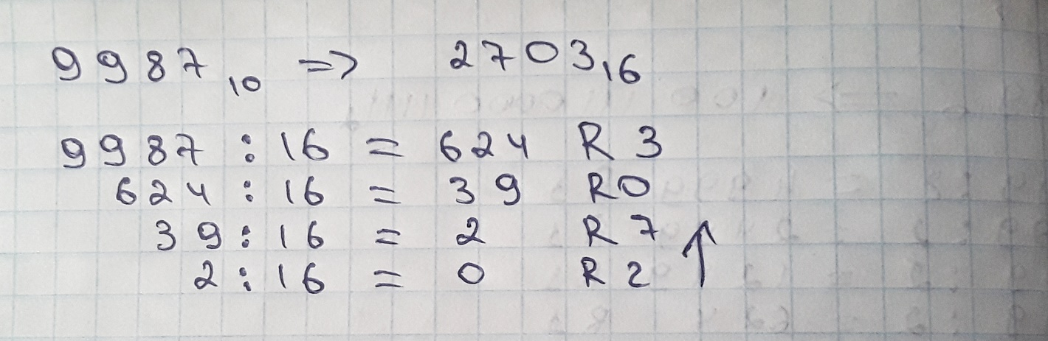

**b)** *Conversion of 99,999 to binary: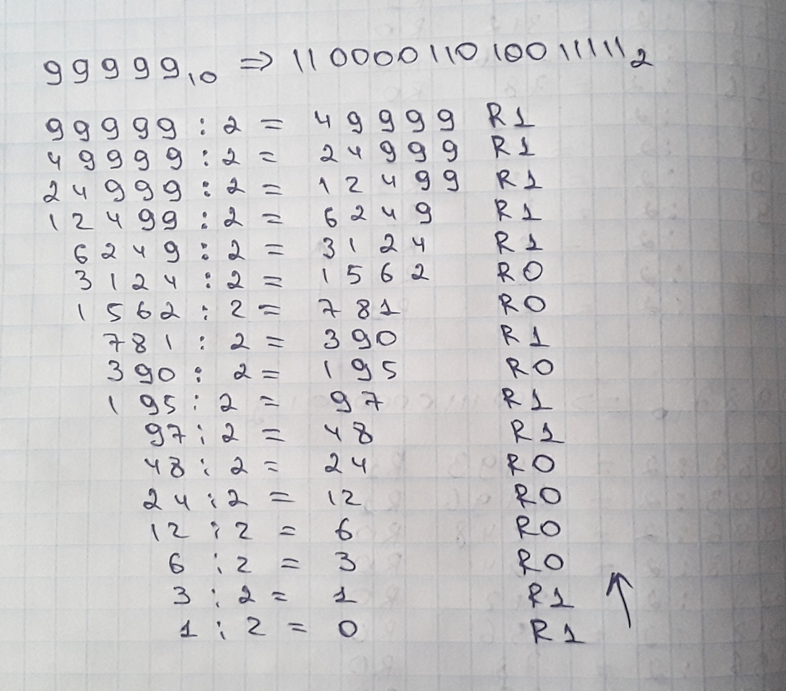*

*Addition and subtraction respectively:*

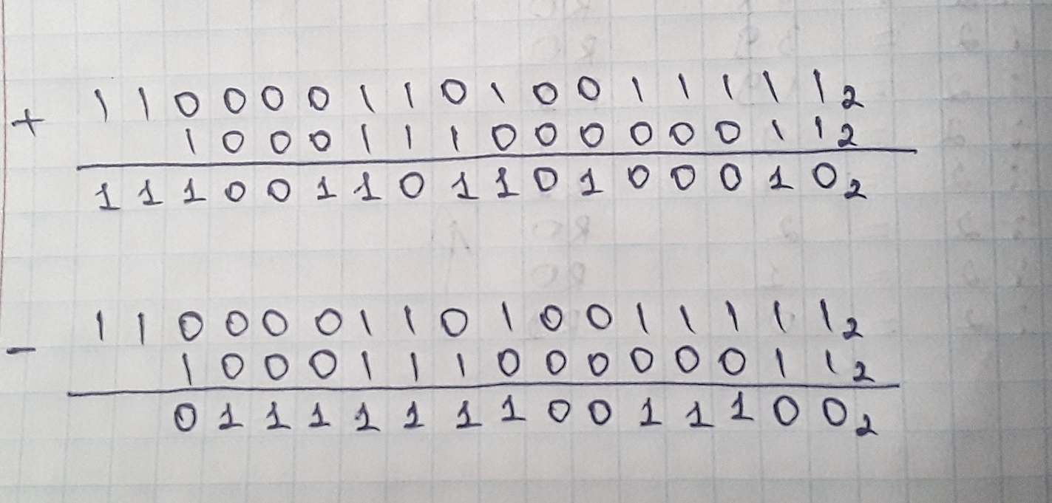

**c)** There are several reasons why using hexadecimal is more efficient than other number bases. The reasons are, firstly, since digits that are more closely look alike to usual base-10 number system used in hexadecimal, it is easier to read the digits at the first glance. Secondly, higher information density, that is in order to show any number between 0 and 255, only 2 digits are required in hexadecimal, and when it comes to do the exact same thing in binary, 8 digits are required (Savas, 2016).

**Task 3**

*Table and Huffman tree respectively:*

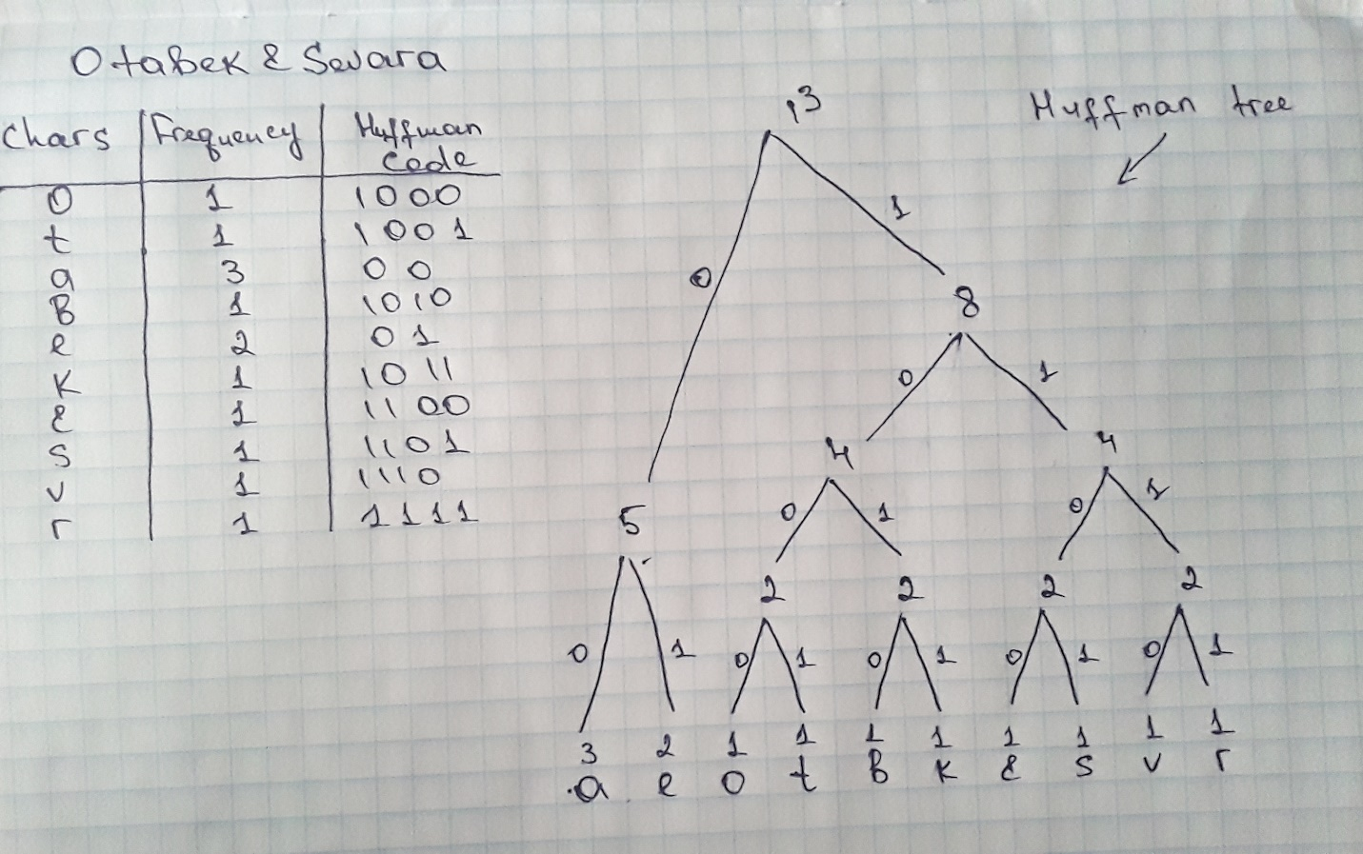

**Task 4**

**Step 1:**

The numbers are 9, 9, 8, 7, 4, 5, 2, 3, 7

In ascending order: 2, 3, 4, 5, 7, 7, 8, 9, 9

The number to look for is 4 (x = 4).

**Step 2:**

* Midpoint is 7 (9 / 2 = 4.5, 5th number is the midpoint)

2, 3, 4, 5, 7, 7, 8, 9, 9

* Since x < midpoint, ignore the range on the right (7 – 9)

2, 3, 4, 5, ~~7, 7, 8, 9, 9~~

* Midpoint is 3 (4 / 2 = 2, 2nd number is the midpoint)

2, 3, 4, 5, ~~7, 7, 8, 9, 9~~

* Since x > midpoint, ignore the range on the left (2 – 3)

~~2, 3,~~ 4, 5, ~~7, 7, 8, 9, 9~~

* Midpoint is 4 (2 / 2 = 1, 1st number is the midpoint)

~~2, 3,~~ 4, 5, ~~7, 7, 8, 9, 9~~

* x is equal to midpoint (5 = 5). The number we are looking for is found.

**Reference list**

Savas, N. (2016). Why do we use hexadecimal? *Medium*. Available from <https://medium.com/@savas/why-do-we-use-hexadecimal-d6d80b56f026> [Accessed 14 January 2021].