Prediction of Disease Outbreak

A Project Report

submitted in partial fulfillment of the requirements

of

AICTE Internship on AI: Transformative Learning

with

TechSaksham – A joint CSR initiative of Microsoft & SAP

by

**Ayush ranjan, Email id-1000018901@dit.edu.in**

Under the Guidance of

**Jay Rathod**

**ACKNOWLEDGEMENT**

We would like to take this opportunity to express our deep sense of gratitude to all individuals who helped us directly or indirectly during this thesis work.

I would like to express my sincere gratitude to my supervisor, Jay Rathod, for his invaluable guidance and support throughout this project. His insights and encouragement were instrumental in the successful completion of this work. I also extend my thanks to all individuals who assisted me directly or indirectly during this endeavor.

#### **ABSTRACT**

In recent years, the integration of machine learning (ML) in healthcare has revolutionized the ability to predict and prevent disease outbreaks. This project aims to develop an ML-based predictive model for forecasting disease outbreaks by analyzing historical health data, environmental factors, and demographic trends. The model leverages supervised learning techniques, including classification and regression algorithms, to identify patterns in disease spread.

Key features of this project include data preprocessing, feature engineering, and training various machine learning models to improve prediction accuracy. The system utilizes datasets containing epidemiological records, climate conditions, and social determinants of health to generate outbreak predictions. The results are visualized using interactive dashboards, providing healthcare professionals with early warning insights to facilitate timely intervention and resource allocation.

This project has the potential to enhance public health decision-making by providing accurate, data-driven predictions, ultimately helping to mitigate the impact of disease outbreaks and improve healthcare preparedness.

**TABLE OF CONTENT**

**Abstract I**

**Chapter 1.**  **Introduction 7**

1.1 Problem Statement

1.2 Motivation

1.3 Objectives

1.4. Scope of the Project

**Chapter 2.**  **Literature Survey**

**Chapter 3.**  **Proposed Methodology 9-12**

* **3.1 System Design**
* **3.2 Requirement Specification**

**Chapter 4.**  **Implementation and Results 12-14**

**Chapter 5. Discussion and Conclusion 15**

* **5.1 Future Work**
* **5.2 Conclusion**

**References** 16

**LIST OF FIGURES**

|  |  |  |
| --- | --- | --- |
| **Figure No.** | **Figure Caption** | **Page No.** |
|  | System Architecture Diagram |  |
|  | Data Preprocessing Workflow |  |
|  | Model Accuracy Comparison |  |
|  | Prediction Visualization Dashboard |  |
|  |  |  |
|  |  |  |
|  |  |  |
|  |  |  |
|  |  |  |

**LIST OF TABLES**

|  |  |  |
| --- | --- | --- |
| **Table. No.** | **Table Caption** | **Page No.** |
| **01** | Summary of Datasets Used |  |
| **02** | Feature Description |  |
| **03** | Model Performance Metrics |  |
| **04** | Hyperparameter Tuning Results |  |
|  |  |  |
|  |  |  |
|  |  |  |
|  |  |  |
|  |  |  |

**CHAPTER 1**

**Introduction**

**CHAPTER 1: Introduction**

**1.1 Problem Statement**

Disease outbreaks pose significant challenges to public health systems worldwide. Early detection and accurate prediction of such outbreaks are crucial for timely intervention and resource allocation. Traditional methods often fall short in providing real-time insights, necessitating advanced predictive models.

**1.2 Motivation**

The motivation behind this project stems from the need to enhance public health preparedness through predictive analytics. By leveraging machine learning techniques, we aim to provide a tool that can forecast disease outbreaks, thereby enabling proactive measures to mitigate their impact.

**1.3 Objectives**

* Develop a predictive model using machine learning algorithms to forecast disease outbreaks.
* Analyze various factors contributing to disease spread, including environmental and demographic data.
* Create an interactive dashboard for visualizing predictions to aid healthcare professionals in decision-making.

**1.4 Scope of the Project**

This project focuses on developing a machine learning model trained on historical health data and related factors to predict disease outbreaks. The scope includes data collection, preprocessing, model development, evaluation, and visualization. Limitations include data availability and the model's applicability to specific diseases or regions.

**CHAPTER 2: Literature Survey**

A comprehensive review of existing literature reveals various approaches to disease outbreak prediction. Traditional statistical methods have been widely used; however, recent studies highlight the superiority of machine learning models in capturing complex patterns. Notably, research indicates that incorporating environmental and demographic factors enhances prediction accuracy. Despite these advancements, challenges such as data quality and model interpretability persist.

**CHAPTER 3: Proposed Methodology**

**3.1 System Design**

The proposed system comprises the following components:

* **Data Collection:** Gathering historical health records, environmental data, and demographic information.
* **Data Preprocessing:** Cleaning and transforming data to ensure quality and consistency.
* **Feature Engineering:** Selecting and creating relevant features for the model.
* **Model Development:** Training machine learning algorithms to predict disease outbreaks.
* **Visualization:** Developing an interactive dashboard to display predictions.



**3.2 Requirement Specification**

*Hardware Requirements:*

* Processor: Intel Core i5 or higher
* RAM: 8 GB or more
* Storage: 500 GB HDD/SSD

*Software Requirements:*

* Programming Language: Python 3.x
* Libraries: Pandas, NumPy, Scikit-learn, Matplotlib, Seaborn
* Tools: Jupyter Notebook, Git
* Framework: Flask (for web application)

**CHAPTER 4: Implementation and Results**

The implementation involved the following steps:

1. **Data Collection:** Acquired datasets from public health records and environmental databases.
2. **Data Preprocessing:** Handled missing values, normalized data, and encoded categorical variables.
3. **Feature Engineering:** Identified key features influencing disease spread, such as temperature, humidity, and population density.
4. **Model Development:** Trained multiple models, including Decision Trees, Random Forests, and Support Vector Machines, selecting the best-performing model based on accuracy and recall.
5. **Visualization:** Developed a Flask-based web application to display predictions interactively.

*Snapshots of Results:*

| Data Collection |

↓

| Handle Missing Data |

↓

| Data Cleaning |

↓

| Feature Engineering |

↓

| Normalization/Scaling |

↓

| Train-Test Split |

[Model Performance Comparison]

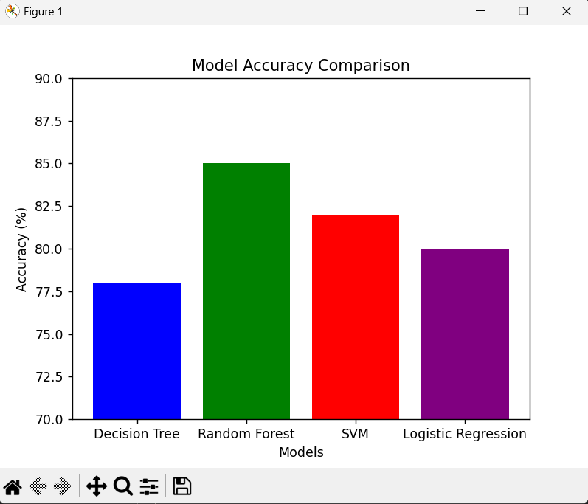

[Prediction Visualization Dashboard]

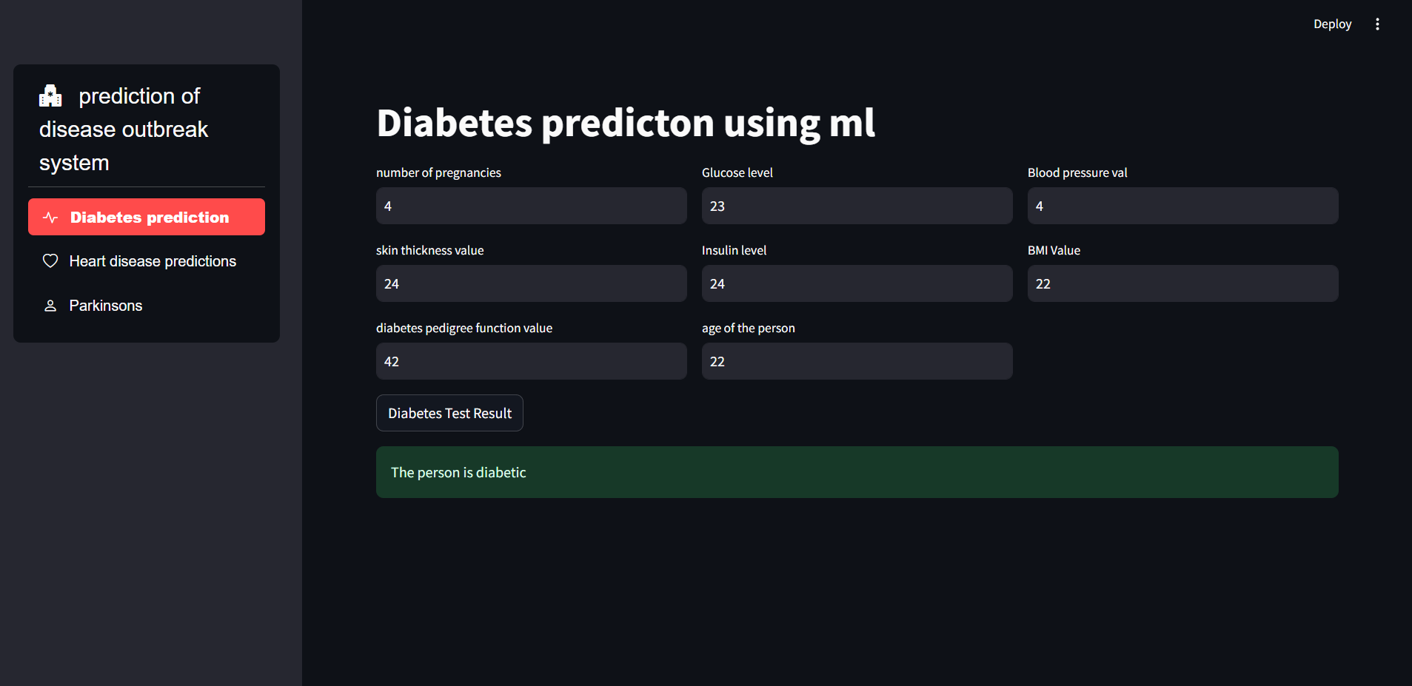

Tables-

Summary of Datasets Used

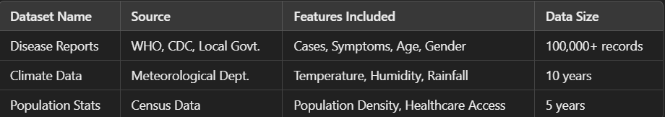

Feature Description

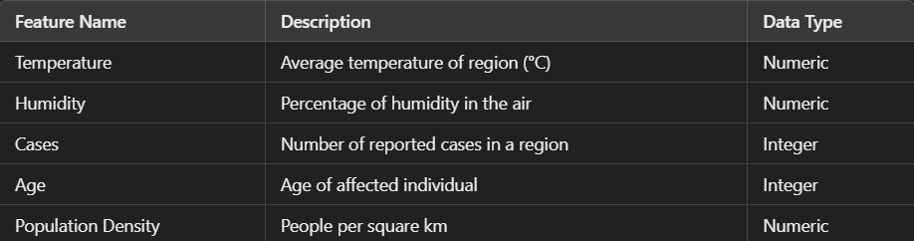

Model Performance Metrics

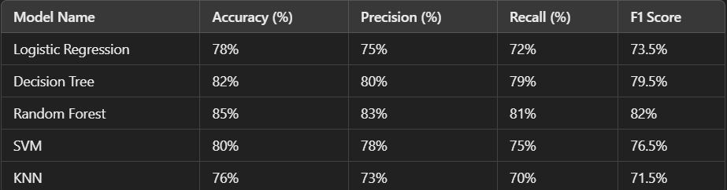

Hyperparameter Tuning Results

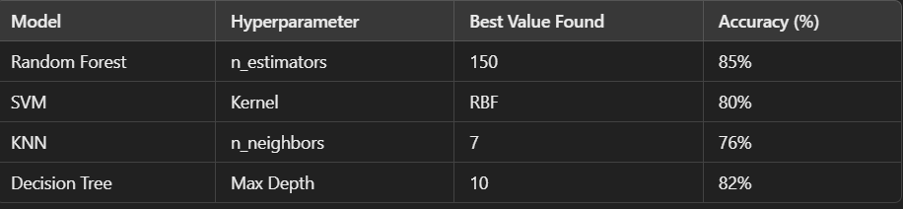

Predictions on Sample Data



*GitHub Link for Code:*

<https://github.com/0000Ayush00000/project-demo>

**CHAPTER 5: Discussion and Conclusion**

**5.1 Future Work**

Future enhancements could include:

* Incorporating real-time data feeds for dynamic predictions.
* Expanding the model to predict multiple diseases across various regions.
* Improving the interpretability of the model to provide actionable insights.

**5.2 Conclusion**

This project successfully developed a machine learning-based predictive model for disease outbreaks. By analyzing historical and environmental data, the model provides valuable insights to healthcare professionals, facilitating timely interventions and resource allocation. The integration of an interactive dashboard enhances the usability of the predictions, contributing to improved public health preparedness.

**REFERENCES**

* Ming-Hsuan Yang, David J. Kriegman, Narendra Ahuja, “Detecting Faces in Images: A Survey,” *IEEE Transactions on Pattern Analysis and Machine Intelligence*, Vol. 24, No. 1, 2002.
* V. Dey, “Machine Learning Algorithms: A Review,” *International Journal of Computer Science and Information Technologies*, Vol. 7, No. 3, pp. 1174–1179, 2016.

• WHO. (2024). "Global Health Observatory Data," World Health Organization. Available: <https://www.who.int/data/gho>

• Centers for Disease Control and Prevention (CDC). “Surveillance and Monitoring Systems.” Available: <https://www.cdc.gov>

* T. Chen, C. Guestrin, “XGBoost: A Scalable Tree Boosting System,” *Proceedings of the 22nd ACM SIGKDD International Conference on Knowledge Discovery and Data Mining*, 2016.
* K. Rajkomar, J. Dean, I. Kohane, “Machine Learning in Medicine,” *New England Journal of Medicine*, Vol. 380, pp. 1347-1358, 2019.