Source: https://www.geeksforgeeks.org/sql/sql-tutorial/

1. Introduction:
ACID property of SQL
Comments:
1.Single line --
2.Multi Line /* */

SQL Commands
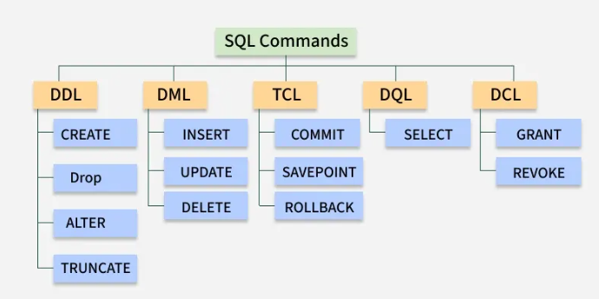

2. Data Types
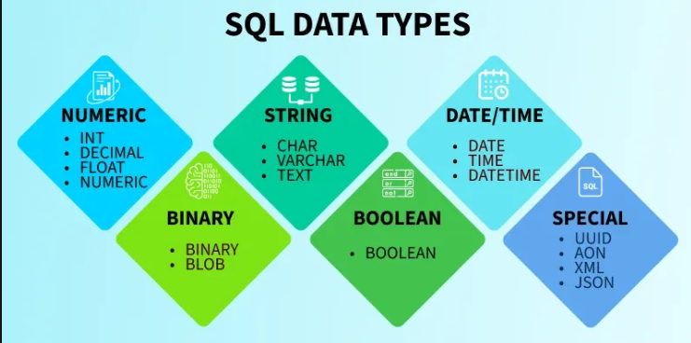

Data Type | Description | Range
BIGINT | Large integer numbers | -9,223,372,036,854,775,808 to 9,223,372,036,854,775,807
INT | Standard integer values | -2,147,483,648 to 2,147,483,647
SMALLINT | Small integers | -32,768 to 32,767
TINYINT | Very small integers | 0 to 255
DECIMAL | Exact fixed-point numbers (e.g., for financial values) | -10^38 + 1 to 10^38 - 1
NUMERIC | Similar to DECIMAL, used for precision data | -10^38 + 1 to 10^38 - 1

Data Type | Description | Range
FLOAT | Approximate numeric values | -1.79E+308 to 1.79E+308
REAL | Similar to FLOAT, but with less precision | -3.40E+38 to 3.40E+38

Data Type | Description
Char | The maximum length of 8000 characters. (Fixed-Length non-Unicode Characters)
Varchar | The maximum length of 8000 characters. (Variable-Length non-Unicode Characters)
Varchar(max) | The maximum length of 2^31 - 1 characters(SQL Server 2005 only). (Variable Length non-Unicode data)
Text | The maximum length of 2,127,483,647 characters(Variable Length non-Unicode data)

Data Type | Description | Storage Size
DATE | stores the data of date (year, month, day) | 3 Bytes
TIME | stores the data of time (hour, minute,second) | 3 Bytes
DATETIME | store both the data and time (year, month, day, hour, minute, second) | 8 Bytes

Data Type | Description | Max Length
Binary | Fixed-length binary data. | 8000 bytes
VarBinary | Variable-length binary data. | 8000 bytes
Image | Stores binary data as images. | 2,147,483,647 bytes

Boolean Data type -> Bit
CREATE TABLE User_Status (
UserID INT PRIMARY KEY,
IsActive BIT,
IsVerified BIT
);

Special data type -> XML
CREATE TABLE XML_Records (
RecordID INT PRIMARY KEY,
ConfigData XML
);

3.SQL Operators
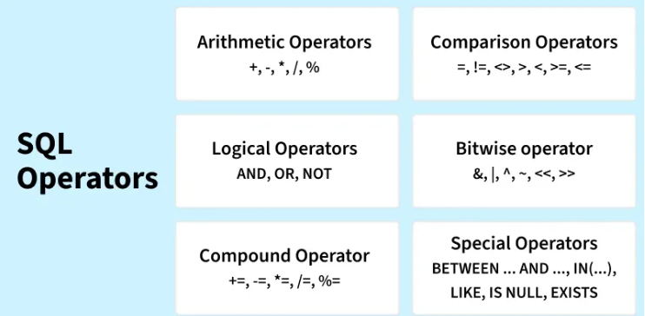

4. Database
CREATE , DROP, RENAME, SELECT

5.Tables
CREATE, DROP, RENAME, ALTER,
TRUNCATE= delete the data keep the schema
COPY
- Simple Cloning -> schema + data, no constraints like primary key, auto increment
- Shallow Cloning -> schema + constraints, no data
- Deep Cloning -> schema + data + constraints
TEMP
- Local temporary table
CREATE PROCEDURE ProcTemp
AS
BEGIN
CREATE TABLE #EmpDetails
INSERT INTO #EmpDetails VALUES ( 01, 'Lalit'), ( 02, 'Atharva')
SELECT * FROM #EmpDetails
END
EXECUTE ProcTemp

- Global Temporary table
CREATE TABLE ##EmpDetails (id INT, name VARCHAR(25))

Local Temporary Table | Global Temporary Table
# (Single hash) | ## (Double hash)
Only the session that created it | Available to all sessions
Automatically dropped when the session ends | Dropped when the last connection referencing the table ends
Only the creating session can access it | All sessions can access it
Session-specific data storage | Shared temporary data storage for multiple sessions

6. Queries
SELECT, INSERT, UPDATE, DELETE

7. Clause
WHERE, WITH, HAVING, ORDER BY, GROUP BY, LIMIT, DISTINCT, FETCH, Alises
WITH cte_name (column1, column2, ...)
AS (
SELECT column1, column2, ...
FROM table_name
WHERE condition
)
SELECT *
FROM cte_name;

- SQL TOP Clause is used in SQL Server and Sybase to limit the number of records returned.
- SQL LIMIT Clause is utilized in MySQL, PostgreSQL, and SQLite.
- SQL FETCH FIRST Clause is supported by Oracle, DB2, PostgreSQL, and SQL Server via OFFSET-FETCH.

8. Operators
Logical, LIKE, IN, NOT, NOT EQUAL, IS NULL, UNION, UNION ALL, EXCEPT, BETWEEN, ALL and ANY, INTERSECT, EXIXTS, CASE
%-> zero or more number of characters
_ -> exactly one character

9. Aggregate
COUNT(), SUM(), MIN(), MAX(),AVG()

10. Constraints
NOT NULL, Primary key, foreign key, composite key,
Unique constraints -> no duplication,
Alternate Key-> no primary but can serve as primary,
CHECK -> enforce rules on column while insert or update,
DEFAULT-> default value for column when no value given

11. Joins
Inner JOIN, Outer JOIN, Left JOIN, Right JOIN, Full Join,
Cross Join
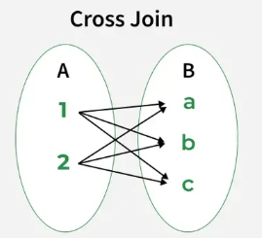
, SELF JOIN, Update with join
, delete join -> delete rows from one table based on matching conditions in another related table
, recursive join -> handle hierarchical data like employee-manager or parent-child relationships by repeatedly joining a table with itself. It is done using recursive CTEs, which run the query multiple times to retrieve all related levels of data

12. Functions
Date Functions -> Now(), CurDate(), Curtime(), Date(), Extract(), Date_add(), Date_sub(), DateDiff(), Date_format(), Adddate(), addtime()
, String Functions -> concat(), char_lenght(), upper(), lower(), length(), replace(), substring(), left(), right(), Instr(), Trim(), reverse(), ascii(), concat_ws(), find_in_set(), format(), Lcase(), locate(), Lpad(), mid(), position(), repeat(), rpad(), rtrim(), space(), strcmp(),
, Numeric Functions -> abs(), ceil(), floor(), round(), truncate(), mod(), power(), sqrt(), exp(), log(), rand(),
, Statistical Functions-> avg(), sum(), count(), min(), max(), var(), stddev(), corr(), covar_pop(), percentile_cont()
, JSON Functions, Conversion Functions, Datatype Functions, LTRIM Function, UPPER Function, RTRIM Function

13. Views
It does not store data itself but displays data from one or more tables when accessed.
- Simplifies complex SQL queries
- Improves data security by restricting column access
- Makes reporting and repeated queries easier to manage
Create view
CREATE VIEW view_name AS
SELECT column1, column2, ...
FROM table_name
WHERE condition;
, update view
UPDATE view_name
SET column1 = value1, column2 = value2, ...
WHERE condition;
, rename view
EXEC sp_rename 'old_view_name', 'new_view_name';
, drop view
removes only the view definition, not the actual data stored in the base tables

14. Indexes
speed up data retrieval. improve query performance and overall database efficiency.
create index, drop index, show indexes
, unique index
CREATE UNIQUE INDEX index_name
ON table_name (column1, column2, ..., columnN);
, clustered index v/s Non-clustered index
Clustered Index | Non-Clustered Index
Faster for range-based queries and sorting. | Slower for range-based queries but faster for specific lookups.
Requires less memory for operations. | Requires more memory due to additional index structure.
The clustered index stores data in the table itself. | The non-clustered index stores data separately from the table.
A table can have only one clustered index. | A table can have multiple non-clustered indexes.
The clustered index can store data on the disk. | The non-clustered index stores the index structure (B-tree) on disk with pointers to the data pages.
Stores pointers to the data blocks, not the data itself. | Stores both the indexed value and a pointer to the actual row in a separate data page.
Leaf nodes contain the actual data itself. | Leaf nodes contain indexed columns and pointers to data.
Defines the physical order of the rows in the table. | Defines the logical order of data in the index, not the table.
The data is physically reordered to match the index. | The logical order does not match the physical order of rows.
Primary keys are by default clustered indexes. | Composite keys used with unique constraints are non-clustered.
Typically larger, especially for large primary clustered indexes. | Smaller than clustered indexes, especially when composite.
Ideal for range queries and sorting. | Suitable for optimizing lookups and queries on non-primary columns.
A clustered index directly impacts the table's physical storage order. | A non-clustered index does not affect the physical storage order of the table.

15.Subquery
query nested inside another SQL query
SELECT column_name
FROM table_name
WHERE column_name expression operator
(SELECT column_name FROM table_name WHERE ...);
Correlated subqueries
SELECT last_name, salary, department_id
FROM employees AS outer
WHERE salary > (
SELECT AVG(salary)
FROM employees
WHERE department_id = outer.department_id
);
Nested (Non-Correlated) Subquery | Correlated Subquery
Executes once before the outer query. | Executes for each row of the outer query.
Independent of the outer query. | Dependent on values from the outer query.
Usually more efficient for large datasets. | Can be slower as it runs multiple times.
Example: WHERE col IN (SELECT col FROM table2) | Example: WHERE col > (SELECT AVG(col) FROM table 2 WHERE table2.id = outer.id)

16. Miscellaneous
Wildcard characters -> pattern matching
Wildcard Character | Description
% | Represents zero or more characters.
_ | Represents exactly one character.
[ ] | Represents a range of characters, used to match any single character within the range.
[ ] with ^ or ! | Matches any character that is NOT in the specified range.

Pivot and unpivot -> more readable, efficient, and manageable; switching between rows and columns
SELECT (ColumnNames)
FROM (TableName)
PIVOT
(
AggregateFunction(ColumnToBeAggregated)
FOR PivotColumn IN (PivotColumnValues)
) AS (Alias) //Alias is a temporary name for a table
Example to clear: Pivot and Unpivot in SQL - GeeksforGeeks

SQL Triggers
create trigger [trigger_name]
[before | after]
{insert | update | delete}
on [table_name]
FOR EACH ROW
BEGIN
END;
- trigger_name: The name of the trigger to be created
- BEFORE | AFTER: Specifies whether the trigger is fired before or after the triggering event (INSERT, UPDATE, DELETE).
- {INSERT | UPDATE | DELETE}: Specifies the operation that will activate the trigger.
- table_name: The name of the table the trigger is associated with.
- FOR EACH ROW: Indicates that the trigger is row-level, meaning it executes once for each affected row.
- trigger_body: The SQL statements to be executed when the trigger is fired
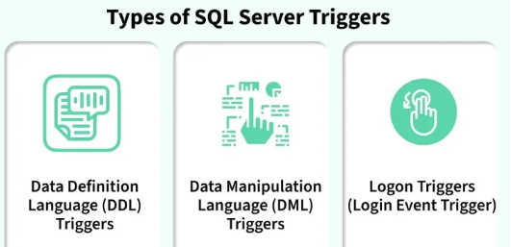

SQL Hosting
- On-Premises Hosting
- Cloud Hosting
- Shared Hosting -> shared server
- Dedicated Hosting -> dedicated server
- Managed Hosting -> 3rd party managed
- Serverless Hosting
SQL performance tuning
- Table Size: Larger tables with millions of rows can slow down query performance if the query hits a large number of rows.
- Joins: The use of complex joins, especially when joining multiple tables, can significantly affect query execution time.
- Aggregations: Queries that aggregate large datasets require more processing time and resources.
- Concurrency: Simultaneous queries from multiple users can overwhelm the database, leading to slow performance.
- Indexes: Proper indexing speeds up data retrieval but, when misused, can lead to inefficiencies.
Techniques:
1. SELECT fields instead of using SELECT *
2. Avoid SELECT DISTINCT
3. Use INNER JOIN Instead of WHERE for Joins
4. Use WHERE Instead of HAVING
5. Limit Wildcards to the End of a Search Term
6. Use LIMIT for Sampling Query Results
7. Run Queries During Off-Peak Hours

Points to consider while creating indexes:
- Short indexes for reduced disk space and faster comparisons
- Distinct indexes with minimal duplicates for better selectivity
- Clustered indexes covering all row data for optimal performance
- Static data columns for clustered indexes to minimize shifting

SQL Stored Procedure
A SQL Stored Procedure is a collection of SQL statements bundled together to perform a specific task.
CREATE PROCEDURE procedure_name
(parameter1 data_type, parameter2 data_type, ...)
AS
BEGIN
-- SQL statements to be executed
END
SQL Transactions
BEGIN TRANSACTION transaction_name ;
ROLLBACK;
COMMIT;
SAVEPOINT SAVEPOINT_NAME;
RELEASE SAVEPOINT SAVEPOINT_NAME;

SQL SEQUENCES -> user-defined database objects designed to generate a series of numeric values
CREATE SEQUENCE sequence_name
START WITH initial_value
INCREMENT BY increment_value
MINVALUE minimum value
MAXVALUE maximum value
CYCLE|NOCYCLE ;
SQL Auto Increment -> primary key auto increase
Window Functions in SQL
performing calculations across a set of rows that are related to the current row, without collapsing the result into a single value.
SELECT column_name1,
window_function(column_name2)
OVER ([PARTITION BY column_name3] [ORDER BY column_name4]) AS new_column
FROM table_name;
  - Aggregate Window Function -> Sum(),AVG(),COUNT(),MAX(),MIN()
  - Ranking Window Function -> RANK(), DENSE_RANK(), ROW_NUMBER(), PERCENT_RANK()
Cursor {T SQL}
process data one row at a time, useful when row-by-row handling is needed instead of bulk processing
- Implicit Cursors
- Explicit Cursors
DECLARE cursor_name CURSOR FOR SELECT * FROM table_name
OPEN cursor_connection
FETCH NEXT/FIRST/LAST/PRIOR/ABSOLUTE n/RELATIVE n FROM cursor_name
CLOSE cursor_name
DEALLOCATE cursor_name
Feature | Implicit Cursors | Explicit Cursors
Creation | Automatic | Manual (requires declaration)
Management | Fully managed by SQL engine | User-managed (open, fetch, close)
Attributes | %FOUND, %NOTFOUND, %ROWCOUNT, %ISOPEN | Same as implicit cursors
Use Case | Simple DML operations | Complex, row-by-row operations

Common Table Expression (CTE)
essential tool for simplifying complex queries and making them more readable. By defining temporary result sets that can be referenced multiple times, a CTE in SQL allows developers to break down complicated logic into manageable parts.
WITH cte_name AS (
SELECT query
)
SELECT *
FROM cte_name;
Limitations of CTEs in SQL
- Temporary Scope: A CTE exists only during the execution of the query. Once the query completes, the CTE is discarded.
- Performance Issues: For very large datasets, CTEs can sometimes lead to performance degradation due to multiple references to the same CTE.
- Not Allowed in All Database Operations: Some operations, such as INSERT and UPDATE, may have restrictions when using CTEs in certain databases.
CTE | Subquery
Can be referenced multiple times. | Typically used once.
Improves readability for complex queries. | Can become difficult to read when nested.
Optimized for multiple references. | May be less efficient for repeated operations.

SQL Database Tuning
designed to optimize database performance.
- Database Normalization
- Proper Indexing
- Avoid Improper Queries
- Avoid using Select Distinct
- Avoid Multiple OR conditions
- Use WHERE instead of HAVING
Dynamic SQL -> allows us to construct and execute SQL statements at runtime
EXEC sp_executesql N'SELECT statement';
Aspect | Static SQL | Dynamic SQL
Definition | SQL statements predefined in the code. | SQL statements generated at runtime.
Flexibility | Limited to predefined queries. | Highly flexible for dynamic scenarios.
Performance | Faster, as it is precompiled. | Slower, as it requires runtime parsing.
Use Cases | Fixed queries and repetitive tasks. | Dynamic conditions and user-defined inputs.

Steps:
- Declare variable
DECLARE
@var1 NVARCHAR(MAX),
@var2 NVARCHAR(MAX);

- Assign values to variables
SET @var1 = N'table_name';

- Construct the SQL statement
SET @var2= N'SELECT *
FROM ' + @var1;

- Execute the SQL statement
EXEC sp_executesql @var2;

Regular Expression in SQL
- REGEXP_LIKE
- REGEXP_REPLACE
- REGEXP_SUBSTR
Pattern | Description | Example | Matches
^[A-Za-z0-9._%+-]+@[A-Za-z0-9.-]+\\.[A-Za-z]{2,}$ | Validates an email address. | john.doe@gmail.com | Valid email addresses
^[0-9]+$ | Matches a numeric string only. | 123456 | 123, 456, 7890
https?://[^ ]+ | Matches a URL starting with http or https. | https://example.com/ | URLs
^[A-Za-z0-9]+$ | Matches alphanumeric strings. | User123 | abc123, xyz789

