Snowflake Learning

Role Based Access control (RBAC)
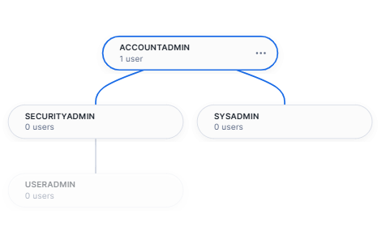
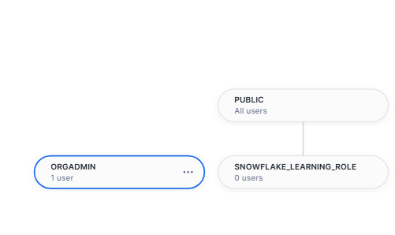
Discretionary Access control (DAC) :
you create it you own it

