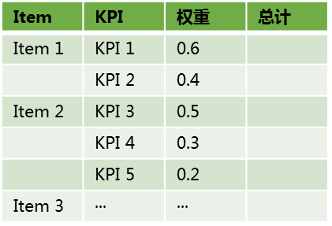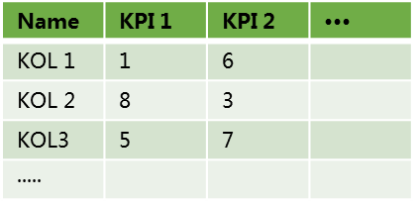

**KOL analysis report**

**KPI calculation**

**Methodology**

**Grab data and standardize**

**KPI weighting**