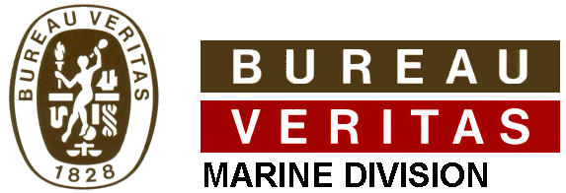
WELDER APPROVAL TEST CERTIFICATE
According to Bureau Veritas Rules
for the Classification of Steel Ships
Employer’s name and address: | Jiangnan Heavy Industry Co., Ltd
Welder’s name: | Panjianyun
Identification: | 320624197203265181
Method of identification:
Date and place of birth: | 1972/3/26, China

Production type | Steel hull | × |  |  | Others
(1)Approval conditions are based on following recognized standard: ISO9606-1

Manufacturer’s Welding Procedure(s) Specification number
BV09-0001

Type of test and examination | Not performed / Performed & Test report number
Visual examination | Acceptable
Radiography test | Acceptable
Magnetic particle test | N.A.
Dye penetrant test | N.A.
Macrography | N.A.
Fracture test | N.A.
Bend test | N.A.
Others | N.A.
Welding variables | Range of approval
Welding process | F.C.A.W. With CO₂ gas shield
Welding consumable | TWE-711(at approval test)
Base material group | All hull steel grades
Type of base product
Type of weld joint | V type groove
Range of thickness | t≥5mm
Range of Diameter | D>150mm
Welding positions | PA&PF positions in butt / fillet welding
Backing and gouging condition | One side with backing / Both side with gouging
Others | According to rule note ISO9606-1
This is to attest that the welder identified above has passed the approval tests, under the supervision of Bureau Veritas, in accordance with Rule Note NR 476 and Bureau Veritas Rules for the Classification of Steel ships.

Date and place of issue : | 2009-8-12, China | This certificate expires on : | 2011-8-11
Surveyor’s name, signature and stamp : |  | Employer’s endorsment to confirm the validity for the following six months ( date, name, position, signature) :

