Incoherencia SIOP (Nuevos ingresos 07/05).

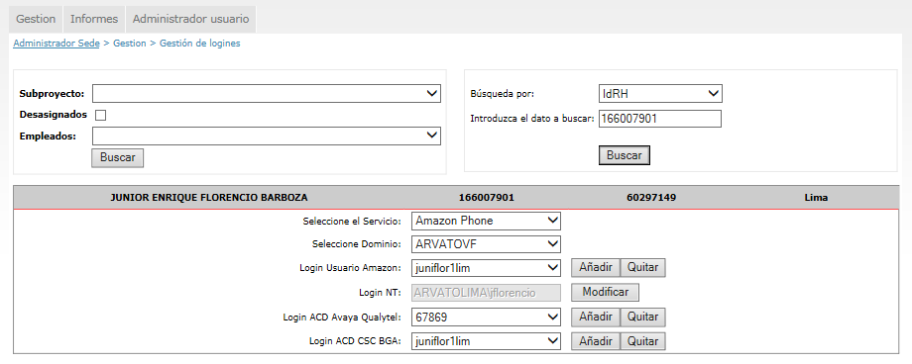

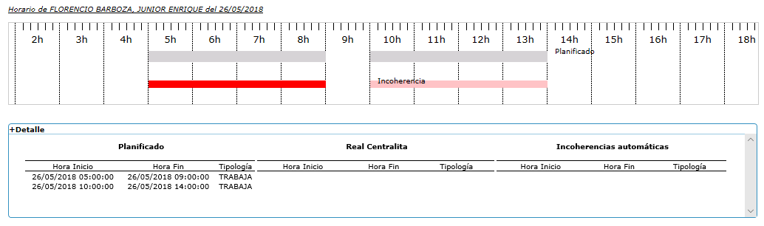

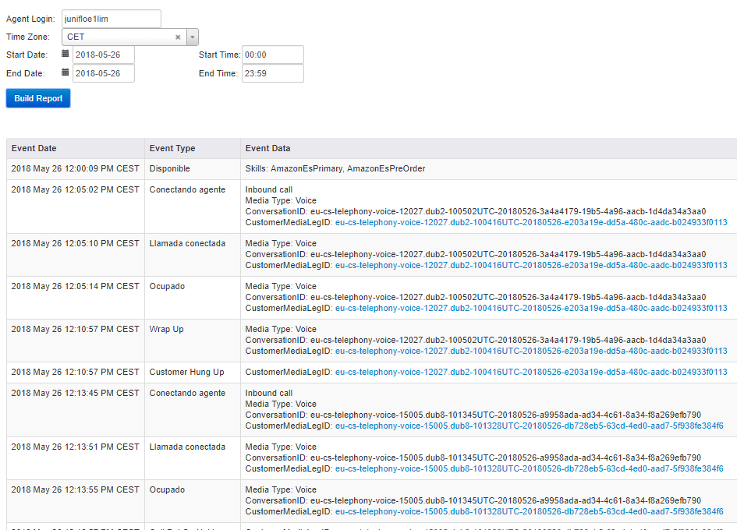

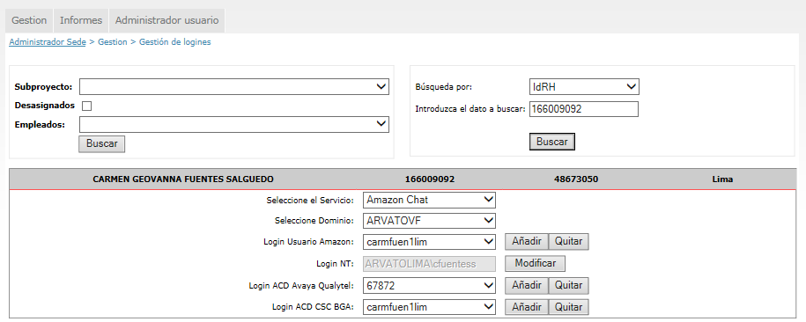

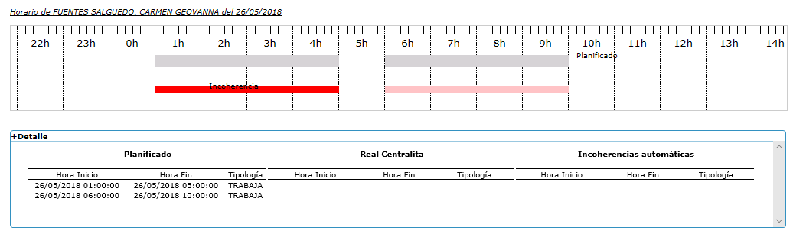

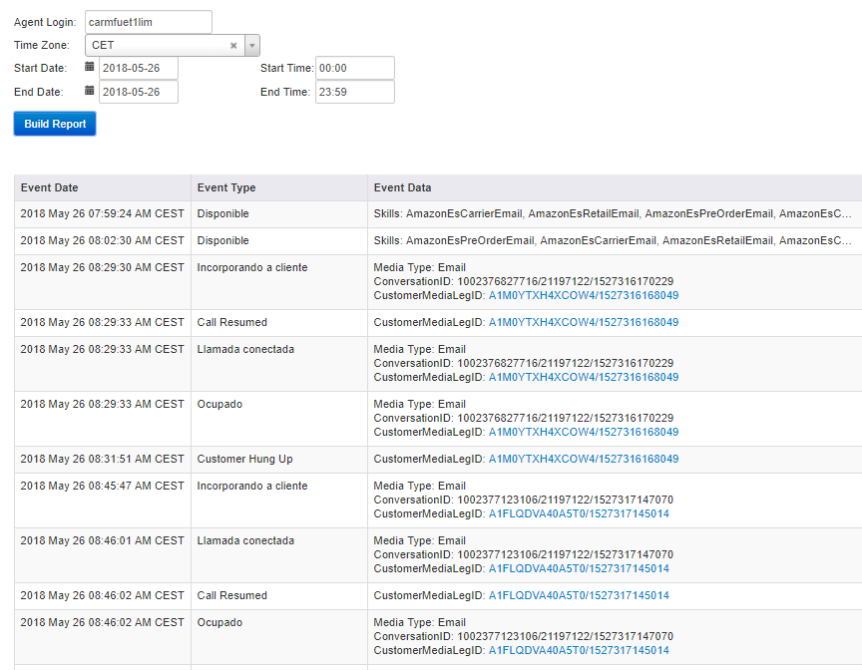

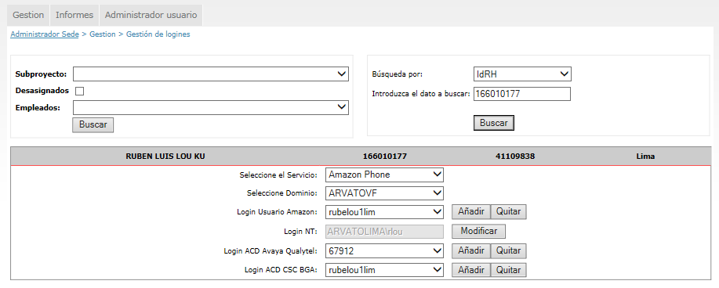

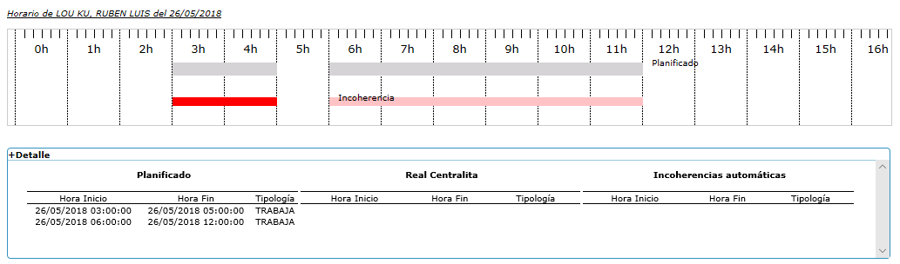

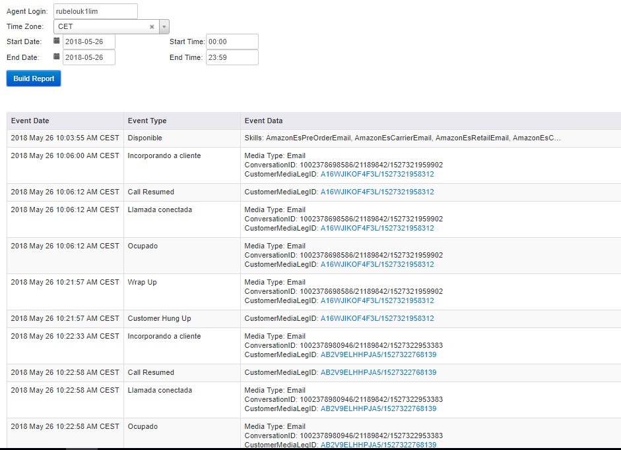

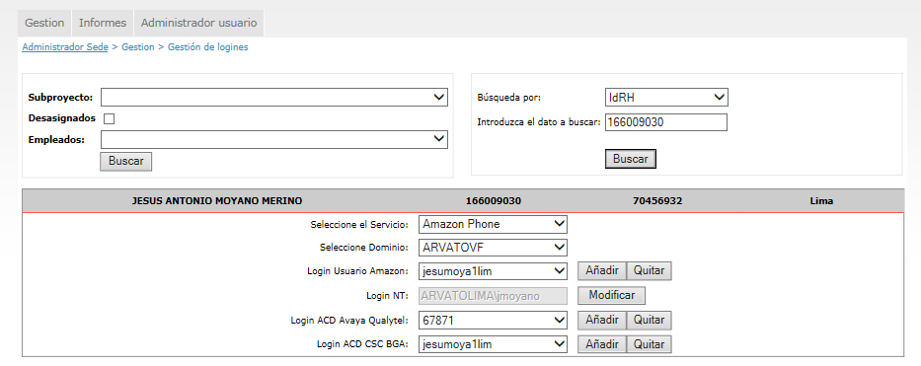

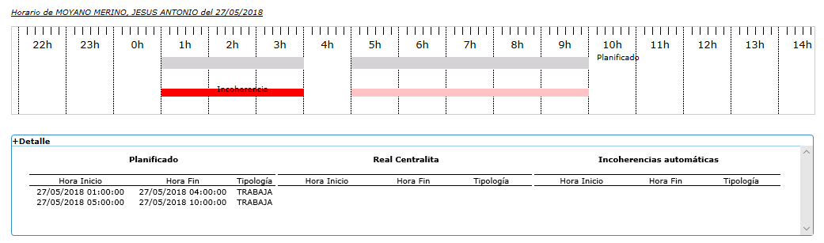

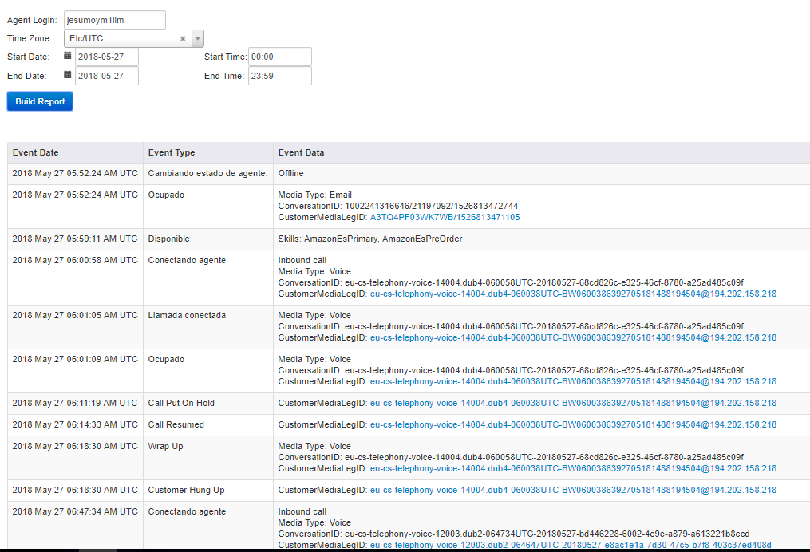

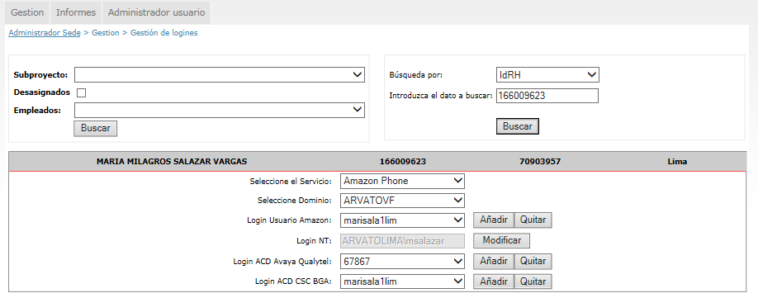

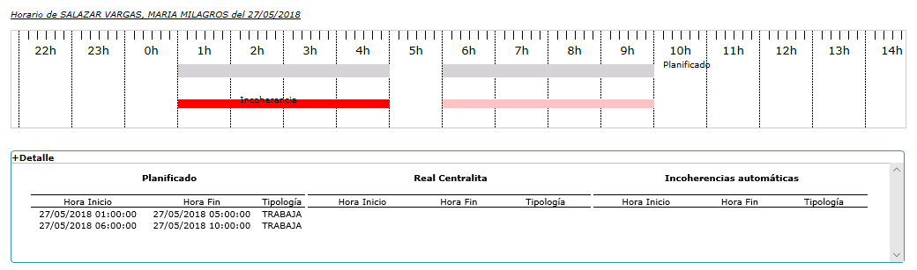

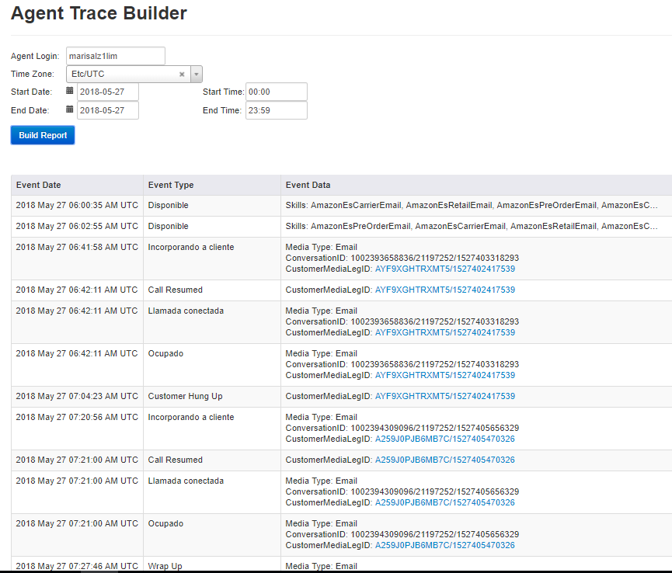

Datos de nuevos ingresos. (07/05).

|  |  |  |
| --- | --- | --- |
| **DNI** | **APELLIDOS Y NOMBRES** | **IDRH** |
| 73934561 | BRIONES ALCANTARA ANGELO ANDRE NICHOLAS | 166010160 |
| 73817611 | CANO MEZA LEONARD ANTONNI | 166010163 |
| 48517823 | CASTILLO MALQUICHAGUA VICTOR MARTIN | 166010161 |
| 43744901 | ESPEJO RIVERA CHRISTIAN ANTONIO | 166010164 |
| 10798137 | HIGA TAIRA NELIDA HARUMI | 166010174 |
| 70456932 | MOYANO MERINO JESUS ANTONIO | 166009030 |
| 73024680 | PANTOJA PACHAS JULIO CESAR | 166010175 |
| 41769316 | RAMOS LAVALLE DAISY JACQUELINE | 166010158 |
| 77328591 | RONDOY CACERES FIORELLA MICHELLE | 166010168 |
| 46045581 | RUIZ RUIZ DE MENA CELESTE CRYSTAL | 166010167 |
| 45783231 | SORAS VERTIZ VALERIA PATRICIA | 166010171 |
| 45769466 | VASQUEZ PAZ BLANCA ELIZABETH | 166010165 |
| 72640817 | PAREDES HUAMAN KATHERINE ANDREA | 166010172 |
| 74611408 | AQUINO PUENTE DE LA VEGA WINNY ESTRELLA | 166010178 |
| 60297149 | FLORENCIO BARBOZA JUNIOR ENRIQUE | 166007901 |
| 48673050 | FUENTES SALGUEDO CARMEN GEOVANNA | 166009092 |
| 70362065 | JIMENEZ SALCEDO MARCO ANTONIO | 166009524 |
| 41109838 | LOU KU RUBEN LUIS | 166010177 |
| 70903957 | SALAZAR VARGAS MARIA MILAGROS | 166009623 |
| 47541191 | SAN MIGUEL MARQUEZ DAVID ROGER | 166008147 |
| 76839342 | YRIGOYEN TERRONES KARLA DANIELA | 166010179 |
| 73201874 | QUEREVALU DIOSES CLARA ROSA | 166010183 |
| 70978488 | CASTILLO HUAMANI PIERO GONZALO | 166010153 |
| 44388611 | CHUQUIHUARA SIFUENTES VANESSA LIZETTE | 166010156 |
| 75458389 | GOMEZ SERREPE FRANCESSCA JOHANNA | 166010144 |
| 72735819 | MARQUEZ HUAMAN DIANA IBETH | 166007688 |
| 48566798 | PALACIOS MERA ALEJANDRO | 166010140 |
| 48552593 | REY ALAMA PIERRE EDINSON | 166010154 |
| 72846400 | TABOADA JUNCHAYA IRIS KRISBELL | 166010145 |
| 44007460 | URBINA LOPEZ LUZ PILAR | 166010150 |
| 46293705 | VELASQUEZ AREVALO LINDA MELINA | 166010148 |
| 44773235 | VILCHEZ DELGADO KARLA FAVIOLA | 166010147 |
| 46551094 | YOCYA PORTILLA ERICKA GERALDINE | 166010143 |
| 74027661 | YSLA RAMIREZ MARIA CONCEPCION | 166010151 |

Datos de nuevos ingresos. (04/06).

|  |  |  |
| --- | --- | --- |
| **DNI** | **APELLIDOS Y NOMBRES** | **IDRH** |
| 70859088 | CELESTINO CARHUAJULCA MARYORY ELIZABETH | 166010370 |
| 71756398 | GURREONERO ROQUE SHARON MILAGROS | 166010375 |
| 48490954 | HUAMAN CALLO CESAR ARI WALDIR | 166010376 |
| 76473929 | LUGO GUTIERREZ ANITA CECILIA | 166010377 |
| 46495736 | MACARLUPU SOVERO MANUEL ENRIQUE | 166010378 |
| 46760334 | MAMANI FERNANDEZ REBECA FANNY | 166010379 |
| 73451668 | MARINI VERA JOSE MiGUEL | 166010380 |
| 73598907 | ROJAS ZARATE YHOSMEL | 166010385 |
| 40780297 | SEMINARIO LOPEZ DANIEL | 166010401 |
| 71244258 | SERRANO ESQUIVEL WENDY ESTEFANY | 166010389 |
| 47970313 | TENORIO RETER SHEYLA DEL PILAR | 166010392 |
| 73779983 | VENTURA  CARBONEL  ANDERSON ALEXIS | 166010394 |
| 43762831 | VILLACORTA PONCE FRANCISCO PABLO | 166010395 |
| 47584179 | CHERO MARQUEZ ESTRELLA DEL PILAR | 166010371 |
| 74124730 | FLORES SALDAÑA ANNIA TAMARA | 166010373 |
| 72859439 | ALVA OBANDO GANDHI YASSER | 166010367 |
| 71727041 | DELGADO FLORES  DÉBORA MARÍA | 166010372 |
| 74089651 | MEJIA MARQUILLO MARIA VICTORIA | 166010381 |
| 73015810 | SANTANA VILLAVICENCIO CARLOS ISRAEL | 166010388 |
| 46737148 | SOSA MORENO ALEZANDRA ESPERANZA | 166010391 |
| 75171818 | SOSA GONZALES STEPHANY JACKELINE | 166010390 |
| 70563841 | GRANDEZ GUERRERO MADELEINE ESTHEFANY | 166010374 |
| 73944979 | QUEREVALÚ PINGO LUISA JULISSA | 166010383 |
| 46393310 | RUMICHE MILLA MARIA DE JESUS | 166010386 |
| 74417970 | ATOCHE GOMEZ  KAROLAY BRIGGIT | 166010344 |
| 75329006 | BAUTISTA VALCARCEL PATRICIO VINSHENZO | 166010345 |
| 73373025 | BAYONA CASTRO JERSON MARTIN | 166010346 |
| 46789641 | BAZALAR DOMINGUEZ ANGELA MEDALIT | 166010347 |
| 25852183 | FARIAS FAGGIANI KATERINE KATIUSKA | 166010350 |
| 72016980 | GONZALES DE LA CRUZ JOSÉ CARLOS JESÚS | 166010351 |
| 73871003 | GUZMAN VALVERDE KEVIN ROGER | 166010352 |
| 46794117 | LUISA LUCIO ELVA JANET | 166010355 |
| 70417431 | MENDIOLA CARHUACHIN KATHYA JACKELINE | 166010356 |
| 41869072 | MORALES   NÚÑEZ SUSAN JANET | 166010358 |
| 41065856 | PONCE BERNABE FANNY VANESSA | 166010359 |
| 48877119 | RAMÍREZ LEÓN JUAN CARLOS | 166010360 |
| 61116806 | ROMERO GUZMÁN LUZANGELY KARINA | 166010362 |
| 70553001 | ROSALES  VALDIVIA JAZMIN EVELYN | 166010363 |
| 73190780 | SILVA LEON RENZO RENATO | 166010365 |
| 73501084 | TELLO CHUMPITAZ JESÚS ALBERTO | 166010366 |
| 71325607 | NALVARTE  ARBIETO ANTHONY | 166010382 |
| 71914379 | GONZALES CENTENO ANA FABIOLA | 166010402 |
| 46770503 | RODRIGUEZ GUERRA JOHNNATTAN KAREL | 166010361 |