CHAPTER FOUR
SYSTEM IMPLEMENTATION AND RESULTS
4.1. Introduction
This chapter presents the implementation and results of the proposed web-based student library management system. It describes how the system was designed, developed, and tested using modern web technologies and machine learning techniques.
The system was implemented using Flask for the backend, with HTML, CSS, and JavaScript for the frontend interface. A database was used to store user information, book records, and system activities. In addition, the Random Forest Algorithm was integrated to provide personalized book recommendations based on user interactions and book features.
This chapter is organized into relevant sections. Section 4.2 discusses the system implementation and development tools used. Section 4.3 presents the system interfaces with screenshots of the application. Section 4.4 explains the system testing process, while Section 4.5 presents the results obtained and discusses system performance.
4.2. System implementation and development tools
This section describes how the proposed student library management system was developed and the technologies used in its implementation. The system was designed as a web-based application to allow easy access for users through a browser.
The backend of the system was developed using Flask, which handles the core logic of the application, including user authentication, request processing, and communication with the database. The frontend was built using HTML, CSS, and JavaScript to provide an interactive and user-friendly interface for different categories of users.
The system uses a database (SQLite/MySQL) to store important data such as user information, book records, categories, and system activities. This ensures proper data management, integrity, and easy retrieval of information when needed.
The implementation also includes different functional modules to support system operations. These include the user authentication module, which allows users to register and log in; the admin module, which manages users and approves uploaded books; the teacher module, which enables uploading of academic materials; and the student module, which allows searching, viewing, and downloading of books.
In addition, the system integrates a machine learning component using the Random Forest Algorithm. This model was implemented using Python libraries and is responsible for generating personalized book recommendations. It analyzes features such as book category and usage patterns to suggest relevant materials to students.
Overall, the system implementation combines web development technologies with machine learning techniques to provide an efficient, intelligent, and user-friendly digital library platform.
4.3. System interface
This section presents the graphical user interfaces of the developed student library management system. It shows how users interact with the system and the various functionalities available to different user roles. The interfaces are designed to be simple, user-friendly, and efficient.
4.3.1 Homepage
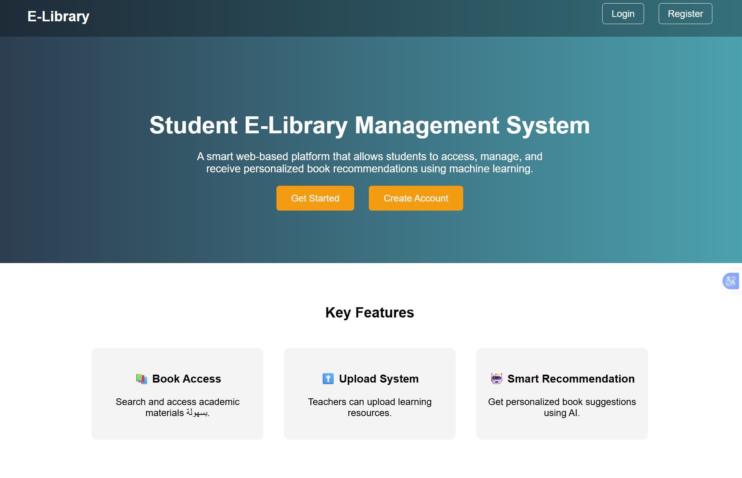
Figure 4.1: Homepage of the System
Description:
The homepage serves as the entry point of the system. It provides basic information about the e-library and allows users to navigate to the registration and login pages.
4.3.2 Registration Page
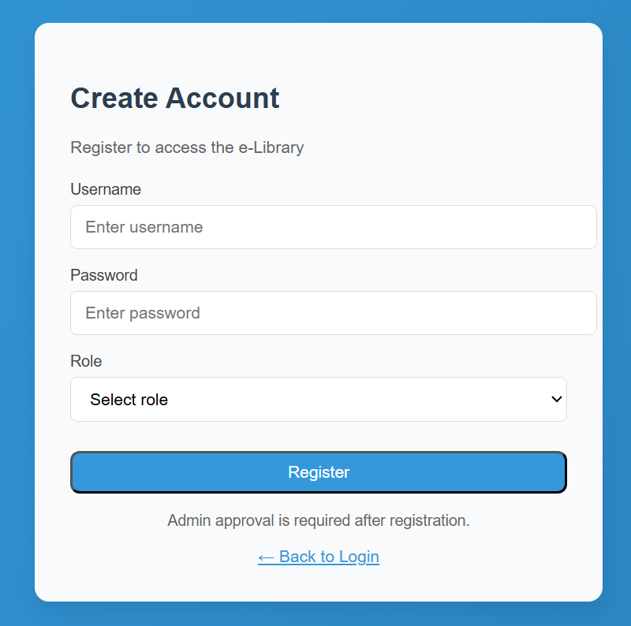
Figure 4.2: Registration Page
Description:
This interface allows new users to create an account by entering required details such as username, email, and password.

4.3.3 Login Page
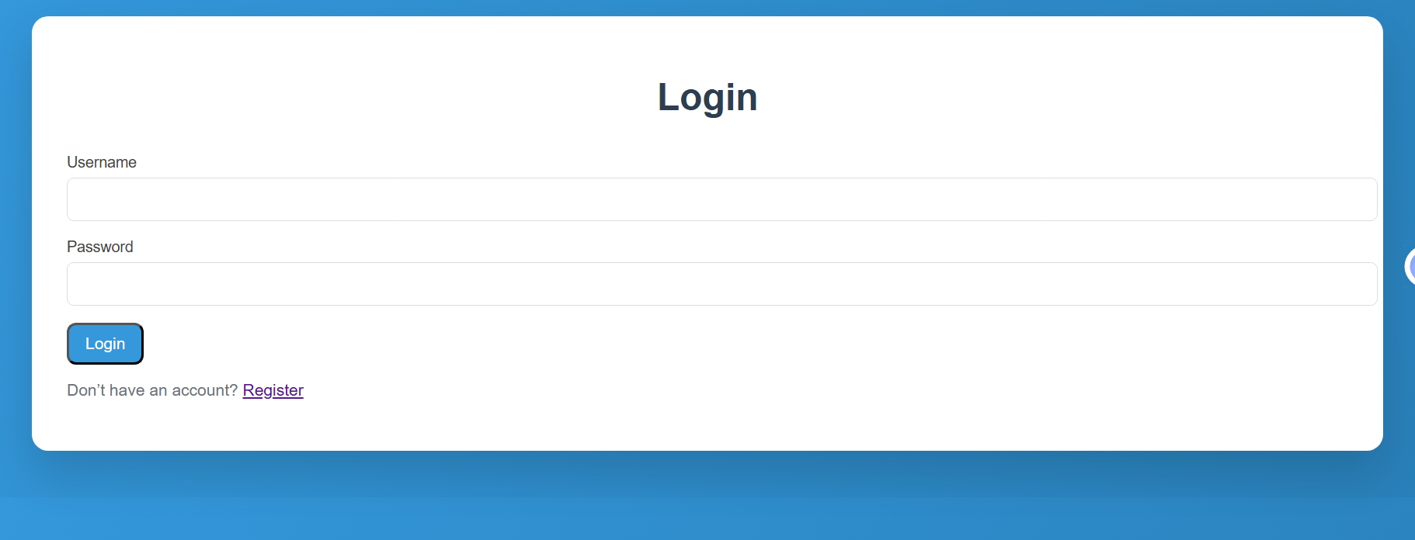
Figure 4.3: Login Page
Description:
Users enter their credentials on this page to gain access to the system. The system verifies the information before granting access.

4.3.4 Admin Dashboard
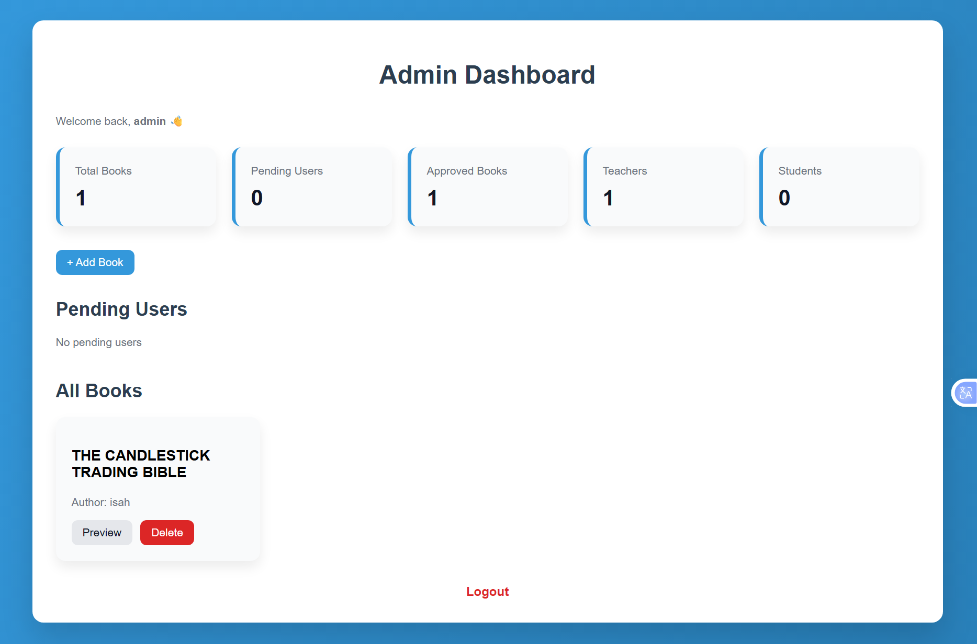

Figure 4.4: Admin Dashboard
Description:
The admin dashboard provides functionalities such as managing users, reviewing uploaded books, and approving or rejecting materials.

4.3.5 Teacher Upload Page
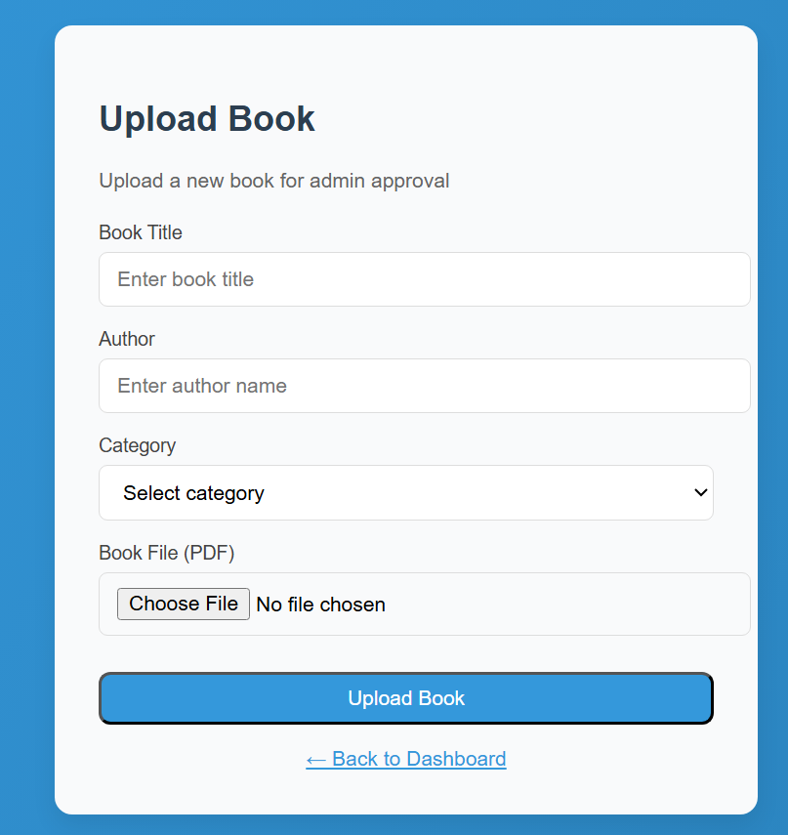
Figure 4.5: Teacher Upload Page
Description:
This page allows teachers to upload books and academic materials into the system for approval.

4.3.6 Student Dashboard
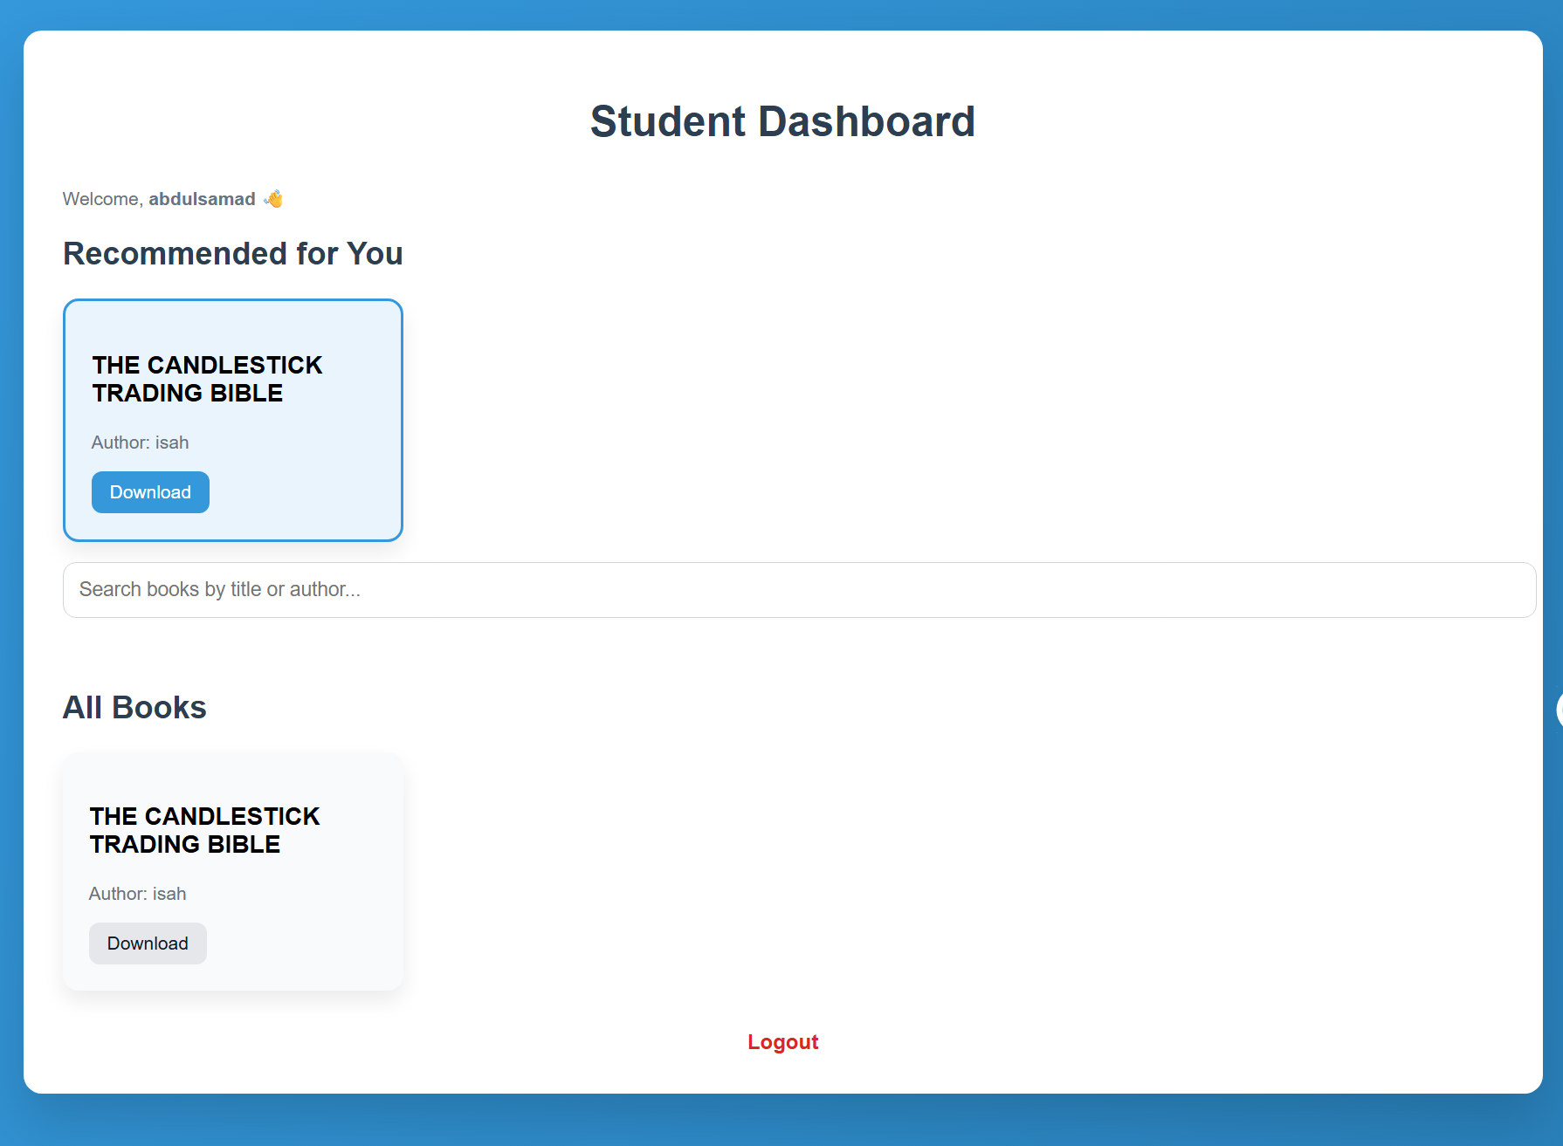
Figure 4.6: Student Dashboard
Description:
The student dashboard displays available books and recommended materials generated by the system.
4.3.7 Book Search Page
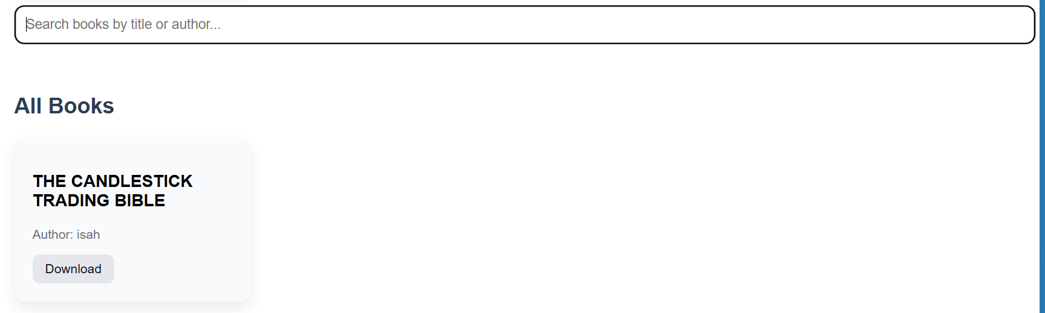
Figure 4.7: Book Search Page
Description:
Students can search for books using keywords and filters to find relevant materials quickly.
4.3.8 Recommendation Page

Figure 4.8: Recommendation Page
Description:
This interface displays personalized book recommendations generated using the Random Forest Algorithm.
4.4 System Testing
The developed system was tested to ensure that all functionalities operate correctly and meet the intended objectives. Functional testing was carried out on the major components of the system to verify their performance.
The login module was tested to confirm that registered users can successfully access the system using valid credentials, while invalid login attempts are rejected. The book upload functionality was also tested to ensure that teachers can upload academic materials without errors.
Furthermore, the admin approval module was tested to verify that uploaded books are properly reviewed and approved before becoming accessible to students. The student module was tested to confirm that users can search, view, and download available books.
In addition, the recommendation feature based on the Random Forest Algorithm was tested to ensure that the system is able to display suggested books based on available data.
The testing results indicate that the system functions correctly and meets the basic requirements of a student library management system.
4.5 Results Obtained
The implementation of the system produced positive results in terms of functionality and usability. The system successfully allows users to register, log in, and perform their respective roles based on access levels.
Students are able to search for books easily and access available academic materials without difficulty. The system also provides recommended books, which helps improve the process of finding relevant learning resources.
Additionally, the system reduces the time required to locate and access books compared to manual library systems. The integration of the recommendation feature enhances user experience by providing more personalized results.
Overall, the system achieved its objective of developing an efficient and intelligent student library management platform.
4.6 Discussion of Results
The results obtained from the system demonstrate that integrating machine learning into a library management system improves its overall effectiveness. Compared to traditional manual systems, the developed system provides faster access to academic resources and reduces the stress associated with searching for relevant materials.
The recommendation feature further enhances usability by guiding students toward useful books, thereby improving their learning experience. Although the system performs effectively, its performance can be improved with larger datasets and more advanced models in future implementations.

CHAPTER FIVE
SUMMARY, CONCLUSION AND RECOMMENDATIONS
5.1.

