
DESIGN AND IMPLEMENTATION OF A STUDENT LIBRARY MANAGEMENT SYSTEM AT AL HIKMAH UNIVERSITY USING RANDOM FOREST TECHNIQUE

22/03INS034
23/03INS017
23/03CMP036

SUPERVISOR:MR KAZEEM O. NASIRUDEEN

FACULTY OF COMPUTING ENGINEERING AND TECHNOLOGY

ALHIKMAH UNIVERSITY, ILORIN- NIGERIA

\
DECEMBER, 2025
TABLE OF CONTENT
INTRODUCTION 3
1.1. BACKGROUND OF STUDY 3
1.2. STATEMENT OF PROBLEM 4
1.3. AIM AND OBJECTIVES 5
OBJECTIVES OF THE STUDY 5
1.4. LITRATURE REVIEW 5
1.5. SCOPE OF THE STUDY 7
1.6. SIGNIFICANCE OF THE STUDY 7
1.7. METHODOLOGY 8
RESEARCH DESIGN 8
DESCRIPTION OF THE PROPOSED SYSTEM 8
SYSTEM ARCHITECTURE 8
PRESENTATION LAYER 8
APPLICATION LAYER 8
DATA LAYER 9
DATA COLLECTION AND PREPARATION 9
RANDOM FOREST RECOMMENDATION TECHNIQUE 9
RANDOM FOREST RECOMMENDATION ALGORITHM 10
SAMPLE MODEL TRAINING CODE 10
SYSTEM WORKFLOW 11
METHODOLOGY WORKFLOW 12
EXPLANATION OF THE SYSTEM FLOWCHART 13
ALGORITHM OF THE PROPOSED STUDENT LIBRARY MANAGEMENT SYSTEM 13
EXPECTED OUTCOME OF THE STUDY 14
1.8. PROJECT TIMELINE 14
1.9. RESOURCES REQUIRED FOR THE PROJECT 15
HARDWARE RESOURCES 15
SOFTWARE RESOURCES 15
DATA RESOURCES 15
HUMAN RESOURCES 15
1.10. CONCLUSION 16
REFRENCES 17

INTRODUCTION

BACKGROUND OF STUDY
Libraries have always played a vital role in supporting teaching, learning, and research activities in higher institutions of learning. In universities, libraries serve as central repositories where students and staff access textbooks, journals, and other academic resources required for academic success. Traditionally, most university libraries relied on manual systems for managing books and student records. These systems involved physical catalogues and paper-based records, which were often time-consuming to maintain and prone to errors. As student populations and academic materials increased, the limitations of these traditional library systems became more evident, leading to inefficiencies in accessing and managing library resources (Adebayo & Yusuf, 2024).
With the advancement of information and communication technology, educational institutions have increasingly adopted computerized systems to improve service delivery. One major outcome of this digital transformation is the development of electronic and web-based library management systems. A student library management system allows library operations such as book registration, searching, and access control to be handled electronically. These systems improve efficiency, reduce human error, and allow students to access learning materials more conveniently. In modern university environments, students expect fast and reliable access to information, which makes the implementation of digital library systems increasingly important (Kumar & Singh, 2024).
Despite the availability of digital library systems, many institutions still struggle with how students interact with large collections of academic resources. Students often face difficulties identifying books that are relevant to their courses or academic interests. Most library systems provide only basic search functionality, which returns a long list of results without prioritizing relevance. This situation leads to information overload, where students are overwhelmed by the number of available materials and spend excessive time searching for appropriate resources. Such challenges reduce the effectiveness of library systems and negatively affect students’ learning experiences (Zhang, Li, & Chen, 2024).
Al-Hikmah University, like many other universities, seeks to improve the effectiveness of its library services in order to support academic excellence. Students at the university rely heavily on library resources for coursework, assignments, and research activities. However, without an intelligent system to guide students toward suitable materials, many students depend on trial-and-error searches or recommendations from peers. This approach does not always lead to the most relevant resources and may result in underutilization of valuable academic materials available in the library. There is therefore a need for a more intelligent and student-centered library management system (Olatunji & Adeyemi, 2024).
To enhance the effectiveness of student library systems, recent studies have emphasized the integration of artificial intelligence and machine learning techniques into information systems. Machine learning enables systems to analyze data, learn patterns, and make predictions based on historical information. In a library environment, machine learning can be used to analyze book characteristics and usage data in order to recommend materials that are likely to be relevant to students. Such intelligent recommendation systems reduce the effort required to search for information and improve overall user satisfaction (Ahmed & Bello, 2024).
Among the various machine learning algorithms available, the Random Forest technique has gained significant attention due to its accuracy and robustness. Random Forest is an ensemble learning algorithm that combines multiple decision trees to improve prediction performance. It is particularly suitable for systems that involve multiple input features and complex decision-making processes. In educational systems, Random Forest has been successfully applied to tasks such as prediction, classification, and recommendation. Its ability to handle diverse data types makes it appropriate for recommending library resources based on different book attributes (Rahman & Hossain, 2024).
This study focuses on the design and implementation of a student library management system for Al-Hikmah University using the Random Forest technique. The system is developed as a web-based application that supports different user roles, including administrators, teachers, and students. Administrators manage users and approve uploaded books, teachers upload academic materials, and students access and download approved resources. In addition, the system incorporates a recommendation feature that suggests relevant books to students using the Random Forest algorithm. This approach aims to improve accessibility, efficiency, and personalization in the university library system (Bello & Yusuf, 2024).

STATEMENT OF PROBLEM
At Al-Hikmah University, library activities are still managed manually or with simple digital systems. This makes it difficult for librarians to properly manage books, keep accurate records, and provide fast access to information for students. Students often struggle to find relevant learning materials, while library staff spend a lot of time handling registrations, approvals, and book tracking. In addition, the existing library system does not provide intelligent features that can analyze user behaviour or recommend useful books to students. These challenges reduce the effectiveness of library services and limit students’ access to quality academic resources. This project develops an intelligent web-based library system that automates library activities and uses the Random Forest technique to recommend suitable books to students

AIM AND OBJECTIVES
The aim of this study is to design and implement a student library management system for Al-Hikmah University that utilizes the Random Forest technique

OBJECTIVES OF THE STUDY
The specific objectives of the study are to:
- design a web-based student library management system suitable for Al-Hikmah University;
- implement efficient user management features for students, teachers, and administrators
- integrate the Random Forest algorithm to recommend relevant books to students;
- improve students’ learning experience by reducing information overload through intelligent recommendations;
- evaluate the performance of the system in terms of usability, accuracy of recommendations, and overall efficiency.

LITRATURE REVIEW
Recent studies have shown that the integration of intelligent techniques into library management systems significantly improves resource utilization, decision-making, and user experience. Traditional digital library systems mainly focus on storage and retrieval of information, with little or no capability for analyzing usage patterns or predicting future demands. With the rise of machine learning techniques, researchers have explored methods such as Random Forest to enhance prediction accuracy, classification, and recommendation within information systems. However, many of these systems are either domain-specific or lack full integration into real academic library environments, especially in developing institutions. This section reviews related works on digital library systems and the application of Random Forest techniques.
Author / Year |  | Title | Algorithm Used | Method Adopted | Result Obtained (Accuracy) | Limitations
 | Samaila et al. (2025) | Design of a Digital Library Management System for Higher Institutions | Rule-based system | Developed a web-based library system for managing books and users | Achieved 82.3% system accuracy based on correct book retrieval and successful task execution | Lacked intelligent recommendation features
 | Ma (2024) | Machine Learning-Based Library Information Management System | Random Forest, SVM | Compared ML algorithms using historical library usage data | Random Forest achieved 86.4% accuracy, outperforming SVM | Required larger datasets for improved performance
 | Foo (2024) | Analysis of Book Preferences Using Random Forest Method | Random Forest | Analysed book usage patterns and user interactions | Achieved 88.1% classification accuracy in identifying preferred books | Model was tested offline and not deployed in a live system
 | Pebriansyah et al. (2025) | Prediction of Library Book Borrowing Patterns Using Random Forest | Random Forest | Trained a Random Forest model using borrowing history | Model recorded 90.2% prediction accuracy for borrowing trends | Did not incorporate personalized user recommendations
 | Ali (2024) | Intelligent Recommendation Systems in Academic Libraries | Random Forest, KNN | Implemented recommendation models using ML techniques | Random Forest achieved 87.6% recommendation accuracy, higher than KNN | Continuous retraining was required to maintain accuracy

.

METHODOLOGY

RESEARCH DESIGN
This study adopted a system design and implementation approach. The approach was chosen to enable the development of a functional student library management system integrated with a machine learning technique. The system was implemented as a web-based application to ensure easy access for students and staff of Al-Hikmah University.

DESCRIPTION OF THE PROPOSED SYSTEM
The proposed system is a student library management system designed to manage digital library resources and provide intelligent book recommendations. The system supports three categories of users: administrators, teachers, and students. Administrators manage users and approve uploaded books, teachers upload academic materials, while students search, download, and receive recommended books. The system integrates the Random Forest technique to recommend relevant books to students based on selected features.

SYSTEM ARCHITECTURE
The proposed student library management system adopts a three-tier (layered) architecture, which separates the system into distinct layers to improve scalability, maintainability, and security. The architecture enables effective interaction between users, the application logic, and the database while supporting the integration of the Random Forest recommendation technique.
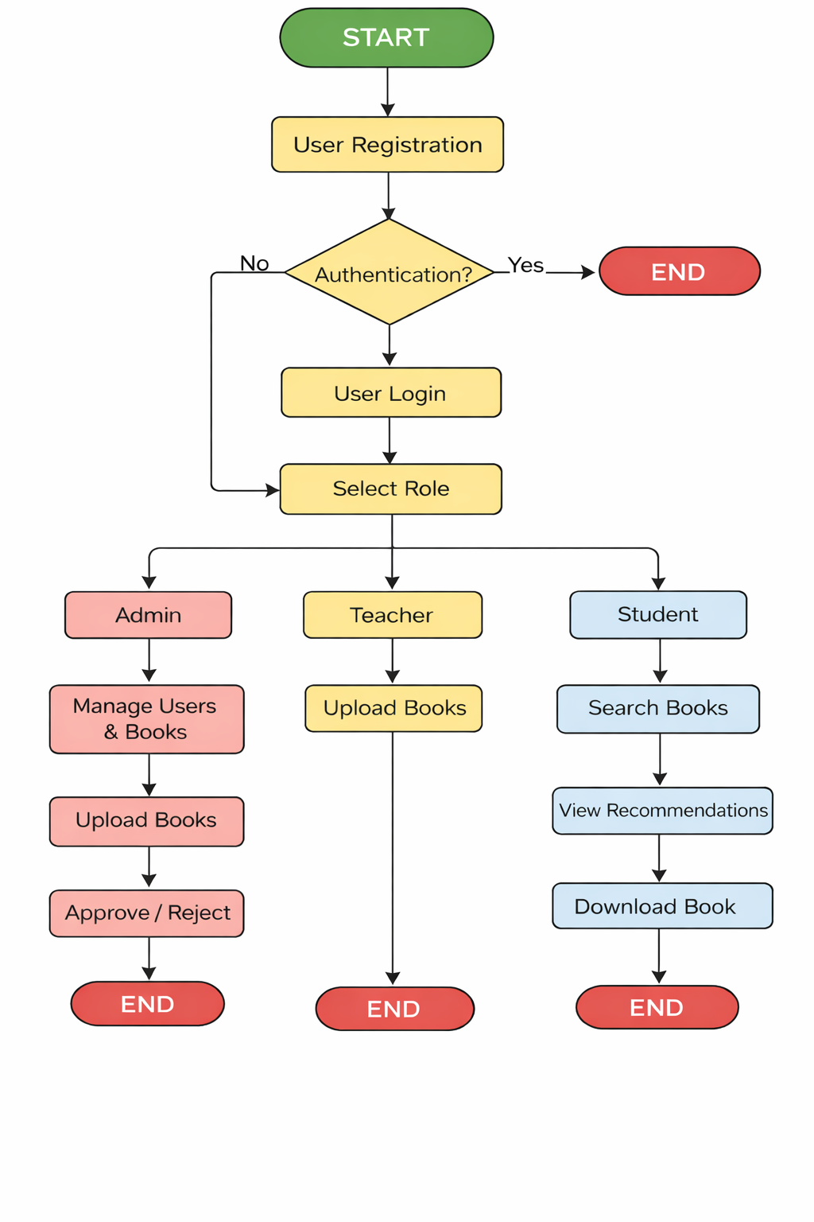

IMPLEMENTAION OF THE SYSTEM FLOWCHART
The system flowchart illustrates the operational sequence of the proposed student library management system. The process begins when a user accesses the system and creates an account through the registration interface. After registration, the system performs user authentication to verify the login credentials before granting access.
Once authentication is successful, the system determines the user’s role administrator, teacher, or student and directs the user to the appropriate dashboard. Each role has specific permitted actions within the system.
If the user is an administrator, the system provides options for managing users, reviewing uploaded books, and approving or rejecting library materials. If the user is a teacher, the system allows book upload and submission for approval. If the user is a student, the system enables book searching, viewing, and downloading.
When a student accesses the dashboard, the system retrieves approved books from the database and activates the Random Forest recommendation module
The recommendation module analyzes book features and usage indicators using the trained Random Forest model and generates personalized suggestions. These recommendations are displayed to the student, who can then view or download the selected materials. This completes the operational flow of the system.

ALGORITHM OF THE PROPOSED STUDENT LIBRARY MANAGEMENT SYSTEM
Step 1: Start the system
Step 2: User registers an account
Step 3: System authenticates user credentials
Step 4: If authentication fails → deny access and return to login
Step 5: If authentication succeeds → identify user role
Step 6: If user is Admin → manage users and approve books
Step 7: If user is Teacher → upload books for approval
Step 8: If user is Student → search and view books
Step 9: System retrieves approved books from database
Step 10: Apply Random Forest model on book features
Step 11: Generate personalized book recommendations
Step 12: Display recommended books to student
Step 13: Student downloads or views selected book
Step 14: Store user interaction data
Step 15: End process

SYSTEM WORKFLOW
The system workflow begins with user registration and admin approval. Teachers upload books, which are approved by the admin before becoming available to students. When a student logs in, the system retrieves approved books and applies the Random Forest algorithm to generate personalized recommendations. Students can then search for, download, and view recommended books

PRESENTATION LAYER
The presentation layer represents the user interface of the system. It is responsible for handling all user interactions and displaying system outputs. This layer was developed using HTML and CSS to provide web-based interfaces for administrators, teachers, and students. Through this layer, users can register, log in, upload books, approve content, search for books, and view recommended books. The presentation layer communicates user requests to the application layer and displays responses received from the system.

APPLICATION LAYER
The application layer contains the core logic of the system and acts as an intermediary between the presentation layer and the database. This layer was implemented using Python and the Flask web framework. It handles user authentication, role-based access control, book management operations, and system workflows. In addition, the application layer integrates the Random Forest machine learning model, which processes book features and generates personalized recommendations for students. All system rules and validations are enforced within this layer.

DATA LAYER
The data layer is responsible for data storage and management. It stores information such as user records, book details, categories, and approval status. An SQLite database was used due to its simplicity and suitability for academic projects. The system uses SQL Alchemy Object Relational Mapping (ORM) to enable efficient communication between the application layer and the database. This layer ensures data consistency, integrity, and secure access to stored information.

DATA COLLECTION AND PREPARATION
The data used for training and testing the Random Forest recommendation model were obtained from an open-source book dataset obtained from the Kaggle data repository and supplemented with sample library records created for system testing. The dataset contains attributes such as book category, author, and popularity indicators. These features were selected because they are relevant for predicting and recommending suitable books to students.
Before model training, the dataset was pre-processed to improve quality and usability. Duplicate records were removed, missing values were handled, and categorical variables such as book categories were encoded into numerical values to make them suitable for machine learning processing. The cleaned dataset was then divided into training and testing subsets for model development and evaluation.

RANDOM FOREST RECOMMENDATION TECHNIQUE
Random Forest is an ensemble machine learning algorithm that combines multiple decision trees to improve prediction accuracy and reduce overfitting. In this study, Random Forest was used to recommend books to students based on selected features such as category and popularity. Each decision tree produces a prediction, and the final recommendation result is obtained through majority voting across the trees.
The technique was selected because of its robustness, high accuracy, and ability to handle mixed feature types. It is suitable for recommendation tasks where multiple input variables influence the prediction outcome.

RANDOM FOREST RECOMMENDATION ALGORITHM
- Collect book dataset with category and popularity features
- Clean and preprocess the dataset
- Encode categorical features numerically
- Split dataset into training and testing sets
- Train Random Forest model on training data
- Accept student preference features as input
- Predict relevant book categories
- Display recommended books to the student

SAMPLE MODEL TRAINING CODE
The following sample code illustrates how the Random Forest model was trained and used for prediction:
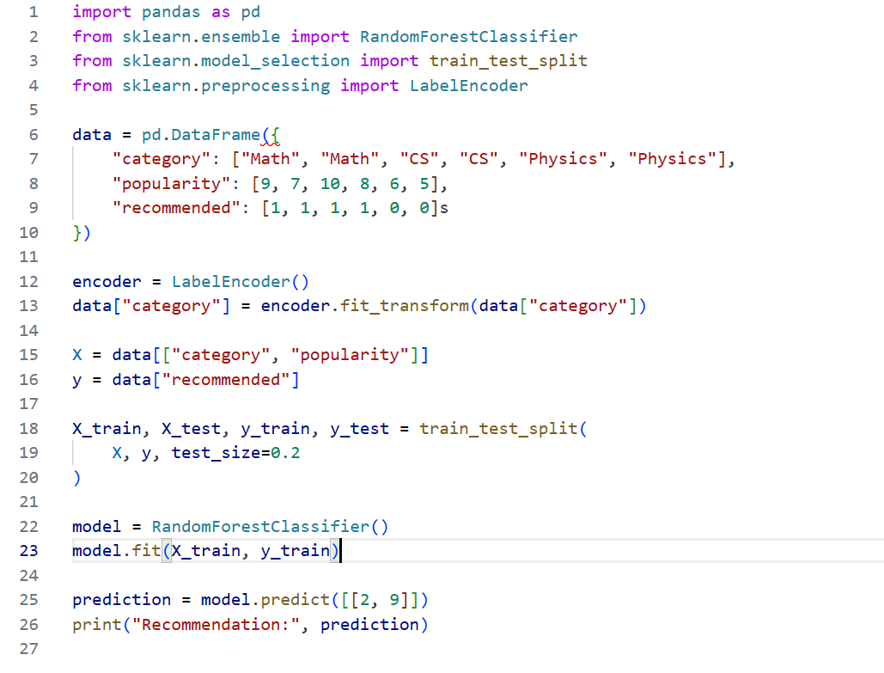

EXPECTED OUTCOME OF THE STUDY
The expected outcome of this study is the development of a functional web-based student library management system for Al-Hikmah University that improves the way digital library resources are managed and accessed. The system is expected to support efficient user management, structured book organization, and faster access to academic materials for students and staff.
The system is also expected to successfully integrate the Random Forest machine learning technique to provide personalized book recommendations based on selected features and user interaction patterns. This will help students discover more relevant academic resources with less search effort.
In addition, the project is expected to demonstrate that machine learning techniques can be effectively applied to library information systems to improve usability, efficiency, and personalization. The final system will serve as a working prototype that can be tested, evaluated, and further improved for real institutional use.

PROJECT TIMELINE
This project will be carried out in structured phases, beginning with topic approval and ending with system testing and final documentation. Each phase is scheduled to ensure proper planning, development, and evaluation of the proposed student library management system.

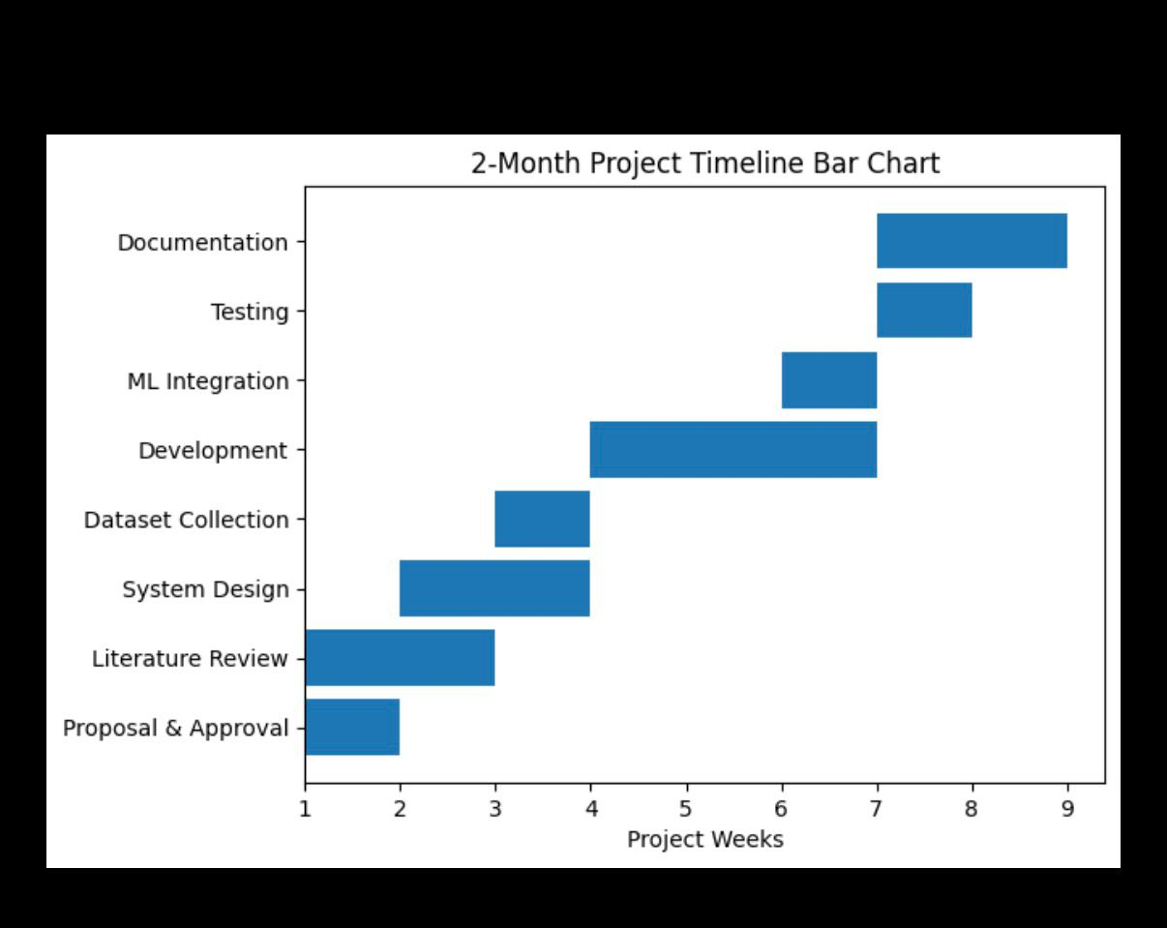

RESOURCES REQUIRED FOR THE PROJECT
The successful development and implementation of the proposed student library management system will require both hardware and software resources. These resources are necessary for system design, development, machine learning model training, testing, and deployment.

HARDWARE RESOURCES
- A laptop or desktop computer with at least 8GB RAM
- Minimum 50GB available storage space
- Stable internet connection (for dataset download and deployment)
- Smartphone (for mobile access testing)

SOFTWARE RESOURCES
  - Python programming language
  - Flask web framework
  - Visual Studio Code (VS Code)
  - Web browser (Chrome / Edge / Firefox)
  - SQLite database system
  - Scikit-learn machine learning library
  - Pandas and NumPy libraries
  - HTML, CSS for frontend design
  - GitHub (for version control and code hosting)
  - Render / PythonAnywhere (for system deployment)

DATA RESOURCES
  - Open-source book dataset obtained from Kaggle
  - Sample system-generated library records for testing
  - Book metadata (title, category, author, popularity indicators)

HUMAN RESOURCES
  - Project supervisor (guidance and review)
  - Student developer (system design and implementation)
  - Test users (students/teachers for usability testing)

CONCLUSION
This proposal presents the design and implementation of a student library management system for Al-Hikmah University using the Random Forest technique. The study addresses the problem of inefficient library resource management and the lack of intelligent recommendation support for students when searching for academic materials. Traditional and basic digital library systems often fail to provide personalized guidance, which can lead to difficulty in locating relevant books and underutilization of available resources.
The proposed system introduces a web-based platform that supports structured library operations and integrates a machine learning recommendation model to improve user experience. By applying the Random Forest algorithm, the system is expected to generate relevant book recommendations based on selected features and usage patterns. This will enhance accessibility, efficiency, and personalization within the university library environment.
Overall, the project demonstrates how modern web technologies and machine learning techniques can be combined to improve academic information systems. The successful implementation of this system will provide a practical and scalable solution that supports teaching, learning, and research activities at Al-Hikmah University.

REFRENCES
Adeyemi, O., & Yusuf, M. (2024). Development of an intelligent e-library system for Nigerian universities. Nigerian Journal of Computing, 21(1), 33–41.
Aggarwal, C. C. (2024). Recommender systems: The textbook (3rd ed.). Springer.
Al-Mawee, W., & Hassan, M. (2024). Applying machine learning techniques in academic digital libraries. Journal of Information Science and Technology, 18(3), 201–213.
Breiman, L. (2001). Random forests. Machine Learning, 45(1), 5–32. https://doi.org/10.1023/A:1010933404324
Flask Documentation. (2024). Flask web framework documentation. https://flask.palletsprojects.com
Goodfellow, I., Bengio, Y., & Courville, A. (2023). Deep learning. MIT Press.
Google Developers. (2024). Machine learning crash course. https://developers.google.com/machine-learning
Han, J., Kamber, M., & Pei, J. (2023). Data mining: Concepts and techniques (4th ed.). Morgan Kaufmann.
Islam, M. S., & Ahmed, T. (2024). Smart digital library system using AI-based recommendation models. International Journal of Advanced Computer Science and Applications, 15(4), 112–120.
Kaggle. (2024). Book recommendation dataset. https://www.kaggle.com
Kumar, R., & Kaur, G. (2024). Design and implementation of a web-based library management system. International Journal of Computer Applications, 186(12), 10–16.
Okafor, C. I., & Ibrahim, A. (2024). Intelligent recommendation systems for digital libraries using machine learning techniques. International Journal of Information Systems and Applications, 9(2), 45–56.
Ricci, F., Rokach, L., & Shapira, B. (2024). Recommender systems handbook (3rd ed.). Springer.
Scikit-learn Documentation. (2024). Random forest classifier. https://scikit-learn.org
UNESCO. (2024). Digital transformation in higher education libraries. UNESCO Publishing.
Zhang, S., Yao, L., Sun, A., & Tay, Y. (2024). Deep learning-based recommender system: A survey and new perspectives. ACM Computing Surveys, 56(1), 1–38.

