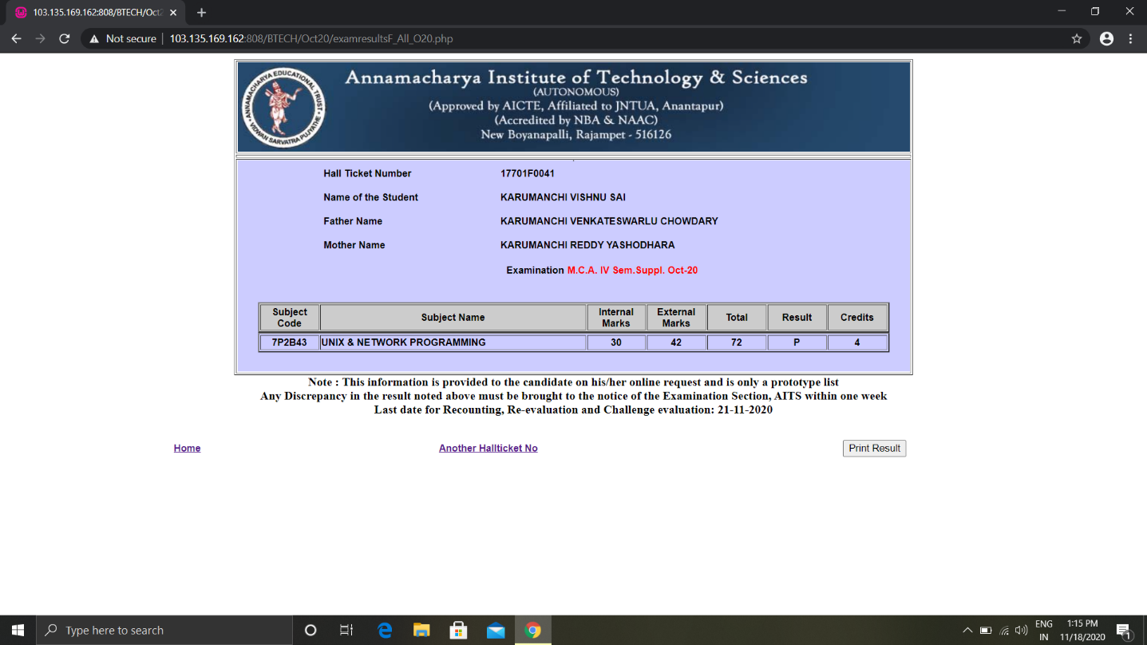

# 17701F0041 KARUMANCHI VISHNU SAI

|  |  |  |  |  |  |  |
| --- | --- | --- | --- | --- | --- | --- |
| 7P2B11 | MATHEMATICAL FOUNDATIONS OF COMPUTER SCIENCE | 23 | 24 | 47 | F | 0 |
| 7P2C13 | PROBABILITY AND STATISTICS | 21 | 24 | 45 | F | 0 |
| 7P2B15 | OBJECT ORIENTED PROGRAMMING WITH C++ | 11 | 39 | 50 | P | 4 |
| 7P2C16 | TECHNICAL COMMUNICATION AND PROFESSIONAL ETHICS | 24 | 38 | 62 | P | 4 |