## ****Step 1: Log In to MongoDB****

docker exec -it 0cbe3316277d mongosh -u root -p rootpassword

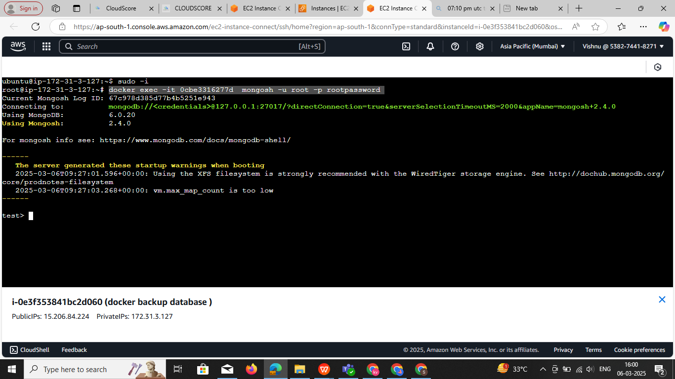

#### Show All Databases

show dbs

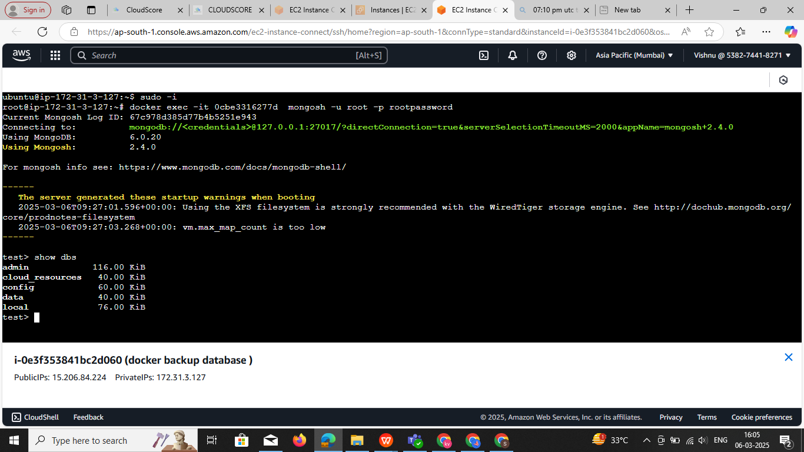

#### ****Explanation:****

* Lists **all databases** in the MongoDB server.
* Displays **database names** along with their **size**.
* Only databases that contain at least **one collection** and **some data** are shown.

Switch to a Database (or Create a New One)

use cloud_resources use <database_name>

#### ****Explanation:****

* If cloud_resources exists, it **switches** to that database.
* If cloud_resources does **not exist**, it **creates** it (but it won’t appear in show dbs until you insert data).

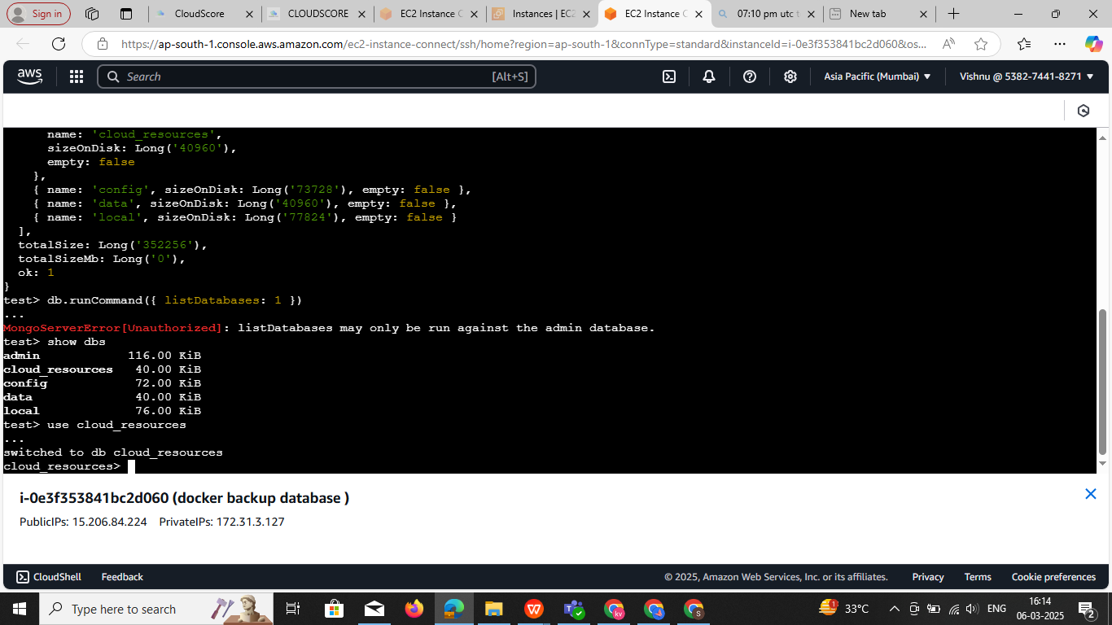

### ****3️⃣ Show Collections (List Tables)****

#### ****Command:****

show collections

#### ****Explanation:****

* Lists **all collections** (equivalent to tables in SQL) inside the current database.

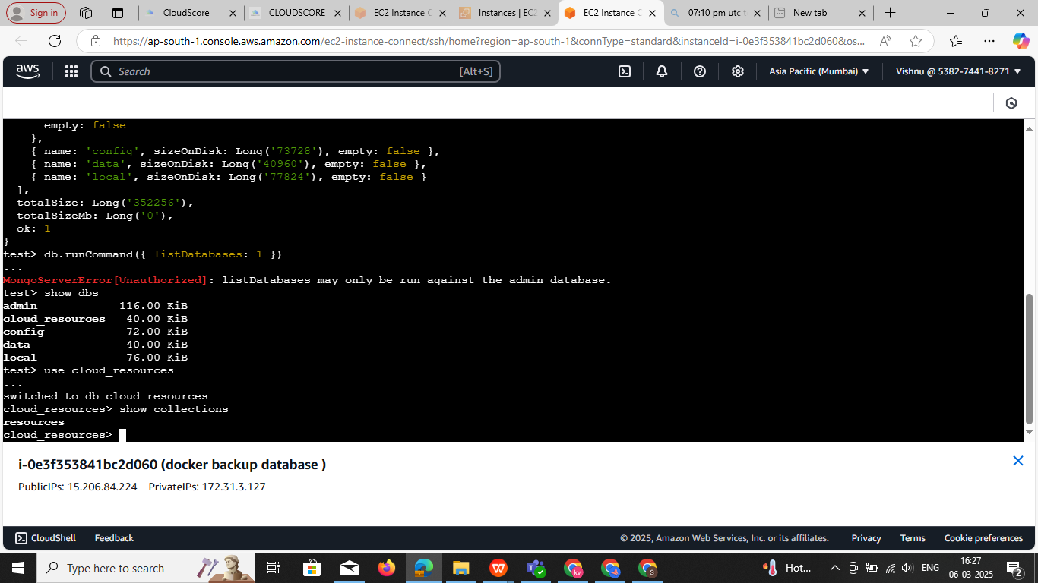

**step4:** 1commands is used in **MongoDB** to retrieve and display all documents from the servers collection in a more readable format.

1 db.servers.find().pretty()   
 2 db.getMongo().getDBs() This will also show **empty databases** with an "empty": true field.

### Breakdown of the command:

**db.servers.find()**

* db refers to the current database.
* servers is the collection from which data is being retrieved.
* find() retrieves all documents from the collection (similar to SELECT * FROM servers in SQL).

**.pretty()**Formats the output to make it more human-readable (with indentation and line breaks). Without .pretty(), MongoDB returns the result in a compact JSON format, which can be harder to read.

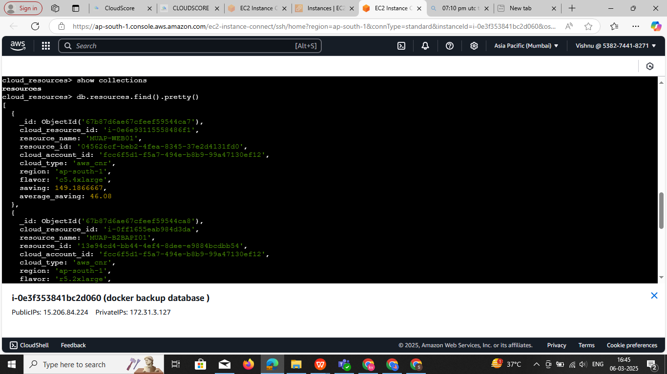

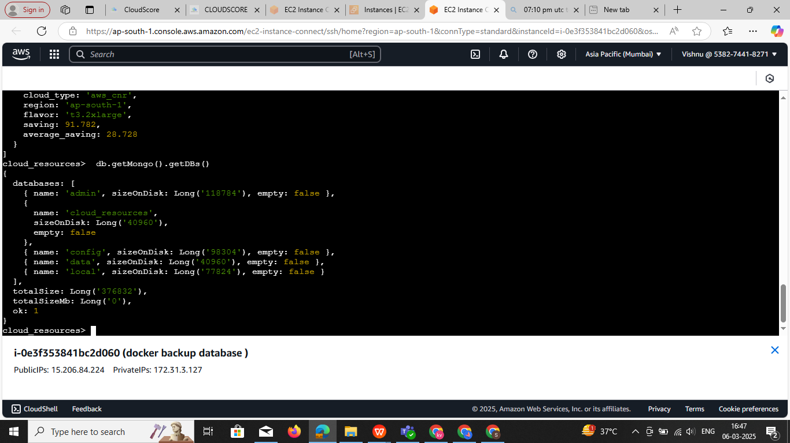**db.getMongo().getDBs()**  This will also show **empty databases** with an "empty": true field.

### Step5: ****Deleting a Single Record in MongoDB & Multiple record****

#### ****1️⃣ Delete a Record by**** _id

To delete a specific document from the resources collection, use the _id field.

**Example:** Delete the record with _id: ObjectId('67b87d6ae67cfeef59544ca8')

db.resources.deleteOne({ _id: ObjectId('67b87d6ae67cfeef59544ca8') })

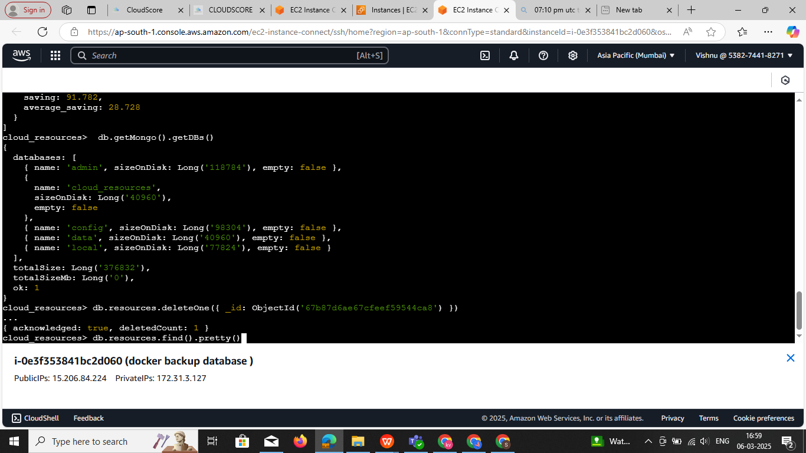

### ****Delete All Documents from the**** resources ****Collection****

To delete all records in the resources collection **without deleting the collection itself**, use:

db.resources.deleteMany({}) This removes **all documents** but keeps the collection structure.

### ****Drop the Entire Collection (If Needed)****If you also want to delete the **collection itself**, use:

db.resources.drop() This **completely removes** the resources collection, including its indexes.

### ****Important Notes****

* deleteMany({}) **only deletes the documents**, but the collection remains.
* drop() **deletes the collection entirely**, so you'll have to recreate it if needed.

**BACKUP AND RESTORE script & manual back and resore**

#!/bin/bash

# Configuration

CONTAINER_NAME="mongodb"

USERNAME="root"

PASSWORD="rootpassword"

AUTH_DB="admin"

MONGO_HOST="localhost"

MONGO_PORT="27017"

# Backup retention (days)

RETENTION_DAYS=7

# Email configuration (Set your email for alerts)

EMAIL="your_email@example.com"

# Get date and time dynamically

TODAY=$(date +"%d-%m-%Y")

TIMESTAMP=$(date +"%H%M%S")

# Backup directory

BACKUP_DIR="/root/pod/$TODAY"

# Log file

LOG_FILE="/var/log/mongo_backup.log"

# Ensure backup directory exists

mkdir -p "$BACKUP_DIR"

log_and_alert() {

    echo "$(date '+%Y-%m-%d %H:%M:%S') - $1" | tee -a "$LOG_FILE"

    echo "$1" | mail -s "MongoDB Backup Alert" $EMAIL

}

full_backup() {

    log_and_alert "🔹 Taking full backup..."

    BACKUP_PATH="$BACKUP_DIR/full-$TIMESTAMP"

    if ! docker exec $CONTAINER_NAME mongodump --host=$MONGO_HOST --port=$MONGO_PORT --username=$USERNAME --password=$PASSWORD --authenticationDatabase=$AUTH_DB --out=/data/mongodump; then

        log_and_alert "❌ Full backup failed!"

        exit 1

    fi

    docker cp $CONTAINER_NAME:/data/mongodump $BACKUP_PATH

    log_and_alert "✅ Full backup saved at: $BACKUP_PATH"

}

incremental_backup() {

    log_and_alert "🔹 Taking incremental backup (Oplog)..."

    BACKUP_PATH="$BACKUP_DIR/oplog-$TIMESTAMP"

    if ! docker exec $CONTAINER_NAME mongodump --username $USERNAME --password $PASSWORD -d local -c oplog.rs --out /data/oplog; then

        log_and_alert "❌ Incremental backup failed!"

        exit 1

    fi

    docker cp $CONTAINER_NAME:/data/oplog $BACKUP_PATH

    log_and_alert "✅ Incremental backup (oplog) saved at: $BACKUP_PATH"

}

restore_backup() {

    log_and_alert "🔹 Restoring full backup..."

    read -p "Enter full backup path: " FULL_PATH

    read -p "Enter oplog backup path (optional, press Enter to skip): " OPLOG_PATH

    if [ ! -d "$FULL_PATH" ]; then

        log_and_alert "❌ Error: Full backup path does not exist!"

        exit 1

    fi

    docker cp "$FULL_PATH" $CONTAINER_NAME:/data/mongodump

    docker exec $CONTAINER_NAME mongorestore --host=$MONGO_HOST --port=$MONGO_PORT -u $USERNAME -p $PASSWORD --authenticationDatabase=$AUTH_DB --dir=/data/mongodump --drop

    if [ -n "$OPLOG_PATH" ] && [ -d "$OPLOG_PATH" ]; then

        docker cp "$OPLOG_PATH" $CONTAINER_NAME:/data/oplog

        docker exec $CONTAINER_NAME mongorestore --oplogReplay /data/oplog

    fi

    log_and_alert "✅ Restore completed!"

}

cleanup_old_backups() {

    log_and_alert "🔹 Deleting backups older than $RETENTION_DAYS days..."

    find /root/pod/ -type d -mtime +$RETENTION_DAYS -exec rm -rf {} \;

    log_and_alert "✅ Old backups deleted!"

}

case "$1" in

    full) full_backup ;;

    incr) incremental_backup ;;

    restore) restore_backup ;;

    cleanup) cleanup_old_backups ;;

    *) echo "Usage: $0 {full|incr|restore|cleanup}" ;;

esac

./mongodb-backup.sh full

./mongodb-backup.sh incr

./mongodb-backup.sh restore

./mongodb-backup.sh cleanup

**Step5.1:** login to ec2 sudo - i --> change dir --> ./mongodb-backup.sh full

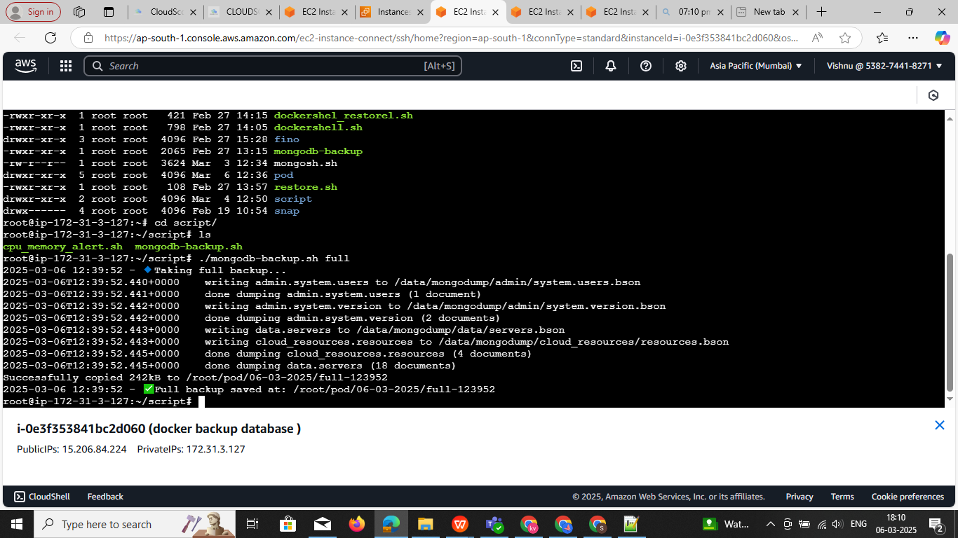C

* check the dir is dump data is available are not

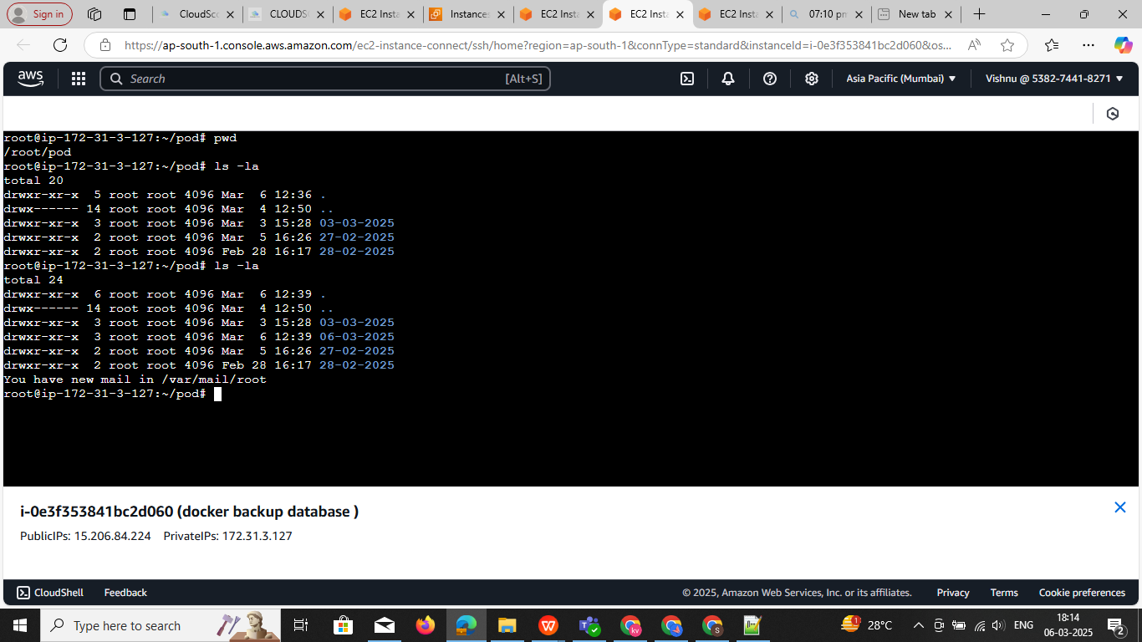

Delete the one of id I have 4 tables one of then delete it   
db.resources.deleteOne({ _id: ObjectId('67b87d6ae67cfeef59544ca8') })

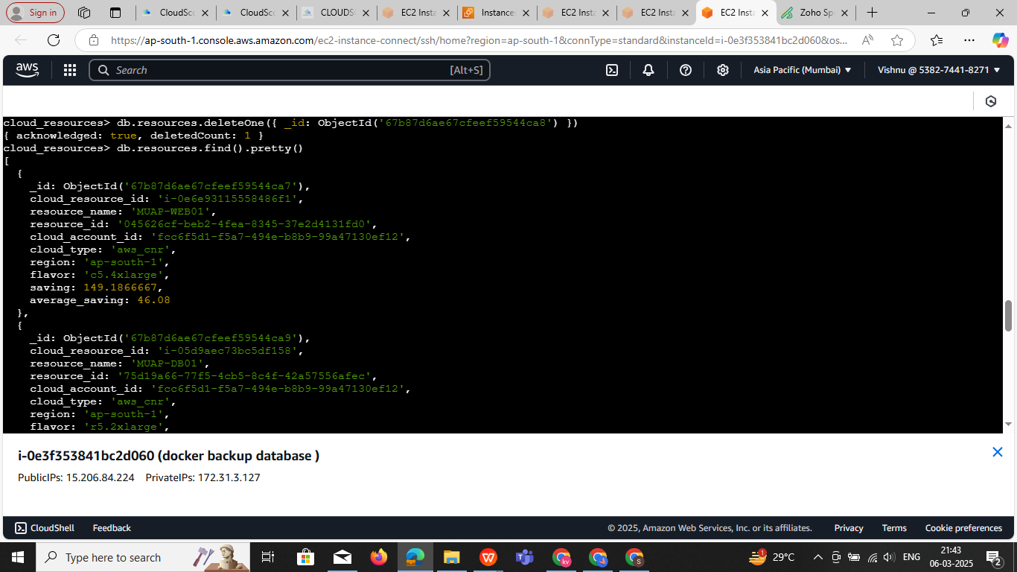

**step5.2** ./mongodb-backup.sh restore Now we need to restore the data

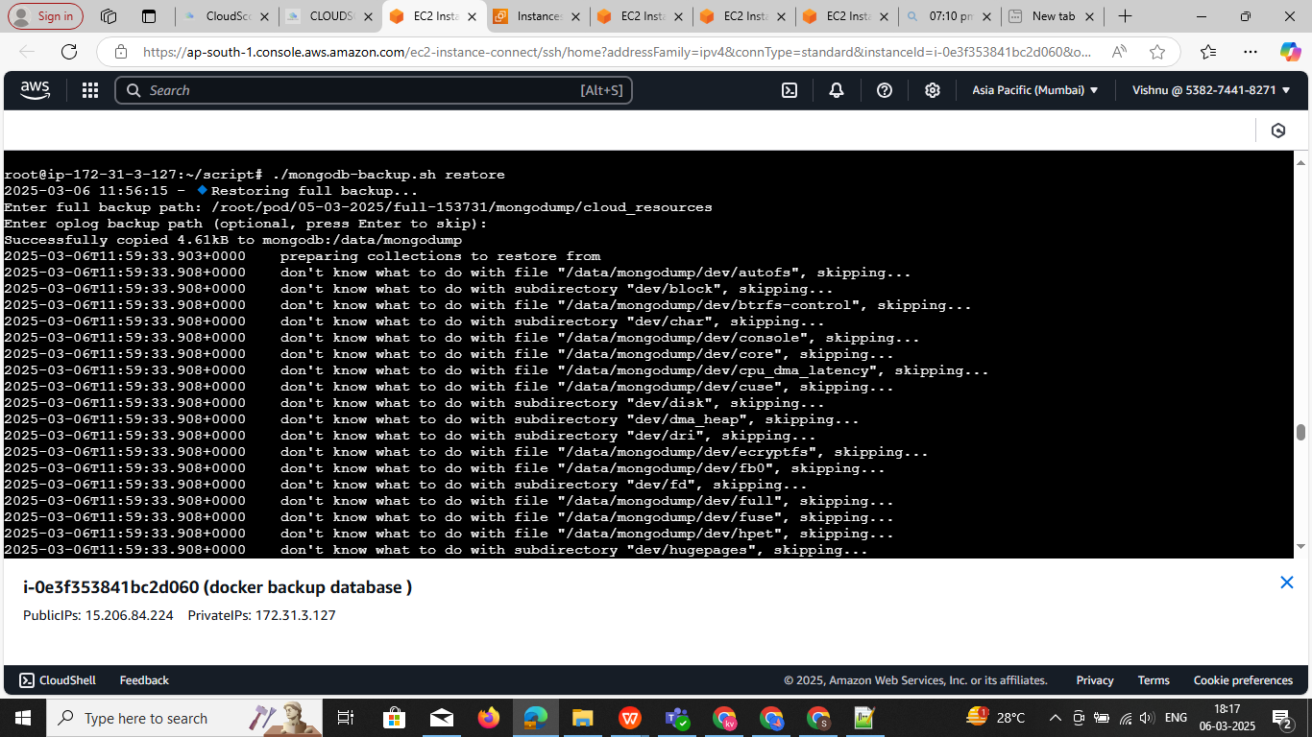

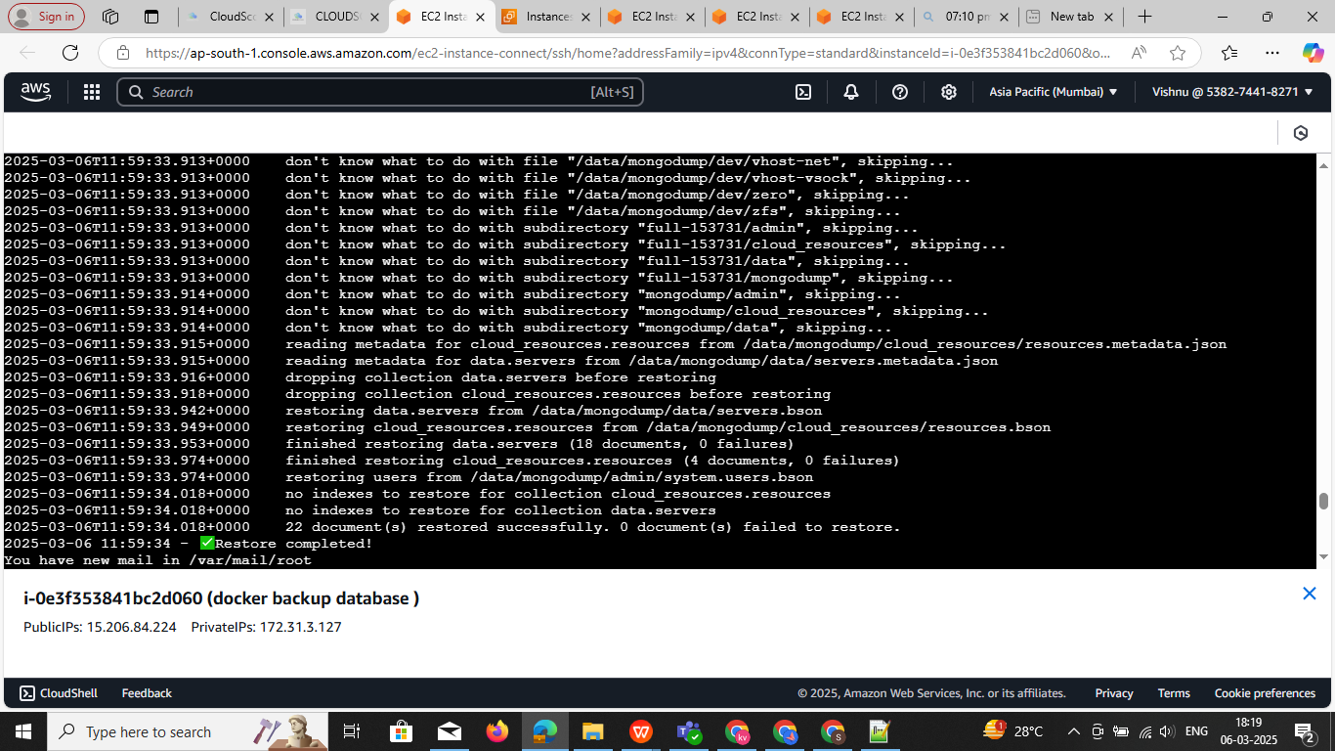

**Note:** now we need to check the database output how many restore

**Sep6:** now we need the check all To see the data inside your collection: I deleted recode db.resources.deleteOne({ _id: ObjectId('67b87d6ae67cfeef59544ca8') }) to check the collection is restore

**db.servers.find().pretty()**

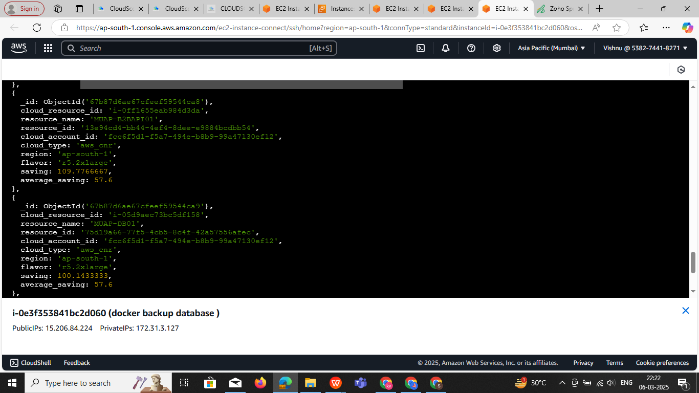

**Install the all Database set up**

**requirements t3x.large**

**30 gb storgare select AMI :Ubuntu**

**vi dockerdatabase-compose.yml**

Docker file

version: '3.8'

services:

mysql:

image: mysql:latest

restart: always

environment:

MYSQL_ROOT_PASSWORD: root

MYSQL_DATABASE: mydb

MYSQL_USER: myuser

MYSQL_PASSWORD: mypassword

ports:

- "3306:3306"

mongodb:

image: mongo:latest

restart: always

environment:

MONGO_INITDB_ROOT_USERNAME: admin

MONGO_INITDB_ROOT_PASSWORD: admin

ports:

- "27017:27017"

influxdb:

image: influxdb:latest

restart: always

environment:

INFLUXDB_ADMIN_USER: admin

INFLUXDB_ADMIN_PASSWORD: admin

ports:

- "8086:8086"

minio:

image: minio/minio

restart: always

environment:

MINIO_ROOT_USER: admin

MINIO_ROOT_PASSWORD: admin123

ports:

- "9000:9000"

- "9001:9001"

command: server /data --console-address ":9001"

clickhouse:

image: clickhouse/clickhouse-server:latest

restart: always

ports:

- "8123:8123"

- "9000:9000"

redis:

image: redis:latest

restart: always

ports:

- "6379:6379"

### ****Run Docker Compose****

Since your file is not named docker-compose.yml, you must specify it using the -f flag:

**docker-compose -f dockerdatabase-compose.yml up -d**

**Explanation:**

* -f dockerdatabase-compose.yml → Specifies the file to use.
* up → Starts the services.
* -d → Runs in **detached mode** (in the background).