Task 2

1. 10059

|  |  |  |
| --- | --- | --- |
| Division | Quotient | Remainder |
| 10059/2 | 5029 | 1 |
| 5029/2 | 2514 | 1 |
| 2514/2 | 1257 | 0 |
| 1257/2 | 628 | 1 |
| 628/2 | 314 | 0 |
| 314/2 | 157 | 0 |
| 157/2 | 78 | 1 |
| 78/2 | 39 | 0 |
| 39/2 | 19 | 1 |
| 19/2 | 9 | 1 |
| 9/2 | 4 | 1 |
| 4/2 | 2 | 0 |
| 2/2 | 1 | 0 |
| 1/2 | 0 | 1 |

10011101001011 – is the binary value of 10059

|  |  |  |
| --- | --- | --- |
| Division | Quotient | Remainder |
| 10059/16 | 628 | 11 - B |
| 628/16 | 39 | 4 |
| 39/16 | 2 | 7 |
| 2/16 | 0 | 2 |

274B – is the hexadecimal value of 10059

1. 99999 – 11000011010011111 + 10011101001011 = 11010110111101010

11000011010011111 – 10011101001011 = 10101111101010100

1. Hexadecimal numbers are widely used nowadays. For example, in representation of Media Access Control or MAC address. In naming of colors, especially in web pages.

Task 3

Orif&Feruza

|  |  |  |  |  |  |  |  |  |  |
| --- | --- | --- | --- | --- | --- | --- | --- | --- | --- |
| a | & | O | i | r | f | F | e | u | z |
| 1 | 1 | 1 | 1 | 2 | 1 | 1 | 1 | 1 | 1 |
| 000 | 001 | 010 | 011 | 100 | 101 | 1100 | 1101 | 1110 | 1111 |

1*3 + 1*3 + 1*3 +1*3 +1*3 +1*3 + 1*4 + 1*4 + 1*4 + 1*4 = 18 + 16 = 34 bits

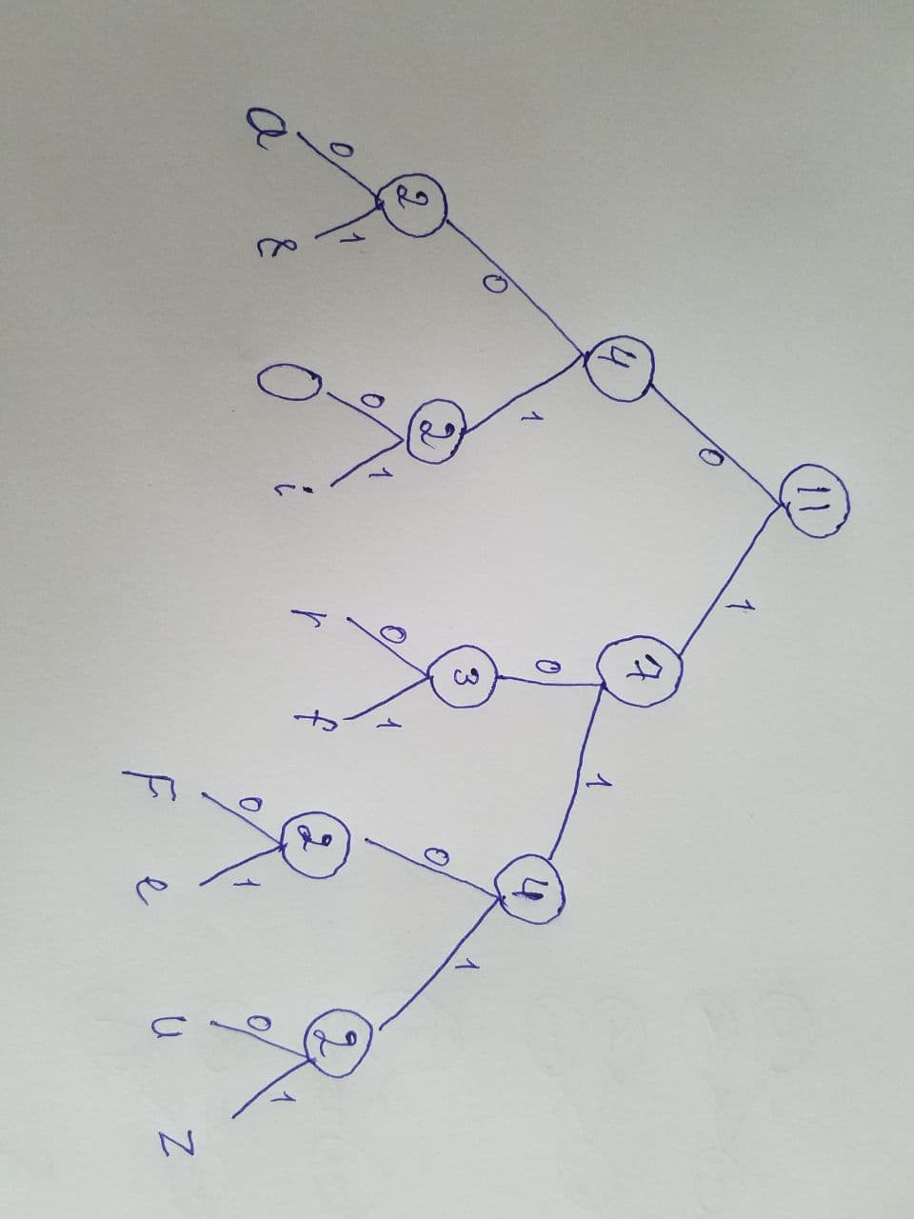Task 4

1005945237

Search for 7

1. Put in ascending order – 0, 0, 1, 2, 3, 4, 5, 5, 7, 9
2. 10/2 = 5, midpoint is 3
3. X > 3, so leave only right side
4. 5/2 = 2.5, rounded 3. Midpoint is 5
5. X > 5, so leave only right side
6. 2/2 = 1, midpoint is 7
7. X is 7, 7 = 7, number is found

Task 5

In single contiguous memory management, memory is divided into two, in partitions memory is divided into more then two parts and in paged memory management, process is divided into pages and stored in memory frames.

1. In page 2 the frame is 5, so we multiply 5 to frame size which is 1024, then add offset.

5*1024 + 85 = 5,205‬

1. It is illegal address due to the offset is bigger than frame size. 1026 > 1024

Task 6

|  |  |
| --- | --- |
| Agile | Spiral |
| The primary rule of the Agile model is to accomplish readiness by eliminating superfluous exercises that sit around and exertion. | The primary standard of the Spiral model is handling with risks. |
| Agile does not depend on documentations | Spiral model requires proper documentation |
| Agile is more suitable for bigger projects that can easily divide into smaller parts | Using the Spiral model is reasonable for risky and difficult projects |

Software Engineering | Comparison between Agile model and other models. (2018). GeeksforGeeks. Available from https://www.geeksforgeeks.org/software-engineering-comparison-between-agile-model-and-other-models/#:~:text=The%20main%20principle%20of%20the%20Spiral%20model%20is%20risk%20handling [Accessed 14 January 2021].

Task 7

The difference between ring and star topology is that in star topology every device is connected to one central device which of the form looks like a star. In ring topology, device is connected to two another devices which looks like a ring.

|  |  |
| --- | --- |
| Star topology | Ring topology |
| A network where each device is connected to one central node | A network where connections create circular data path |
| If central node fails, affects every device. If one device fails, won’t affect to others | If one device fails, all of them fail |
| All devices connected to one central | Each device connected to two other devices |
| Easy to troubleshoot | Difficult to troubleshoot |
| Expensive | Cheaper |

Lithmee. (2019). What is the Difference Between Star and Ring Topology. Pediaa.com. Available from https://pediaa.com/what-is-the-difference-between-star-and-ring-topology/#:~:text=The%20main%20difference%20between%20star [Accessed 14 January 2021].

Task 8

# void functions does not have return keyword  
def hello():  
 print("hello world")  
  
hello()  
  
# value returning functions have return keyword  
# and they return certain value  
def sqrt_(a):  
 return print(a*a)  
  
sqrt_(3)