COURSEWORK SUBMISSION FORM
STUDENT USE |  | STAFF USE
Module Name | Web Technology | First Marker’s  (acts as signature) | Bunyod Khoshimkhujaev
Module Code | 4BUIS011C-n | Second Marker’s  (acts as signature)
Lecturer Name |  | Agreed Mark
UoW Student IDs |  | For Registrar’s office use only (hard copy submission)
WIUT Student IDs | 00010209
Deadline date | December 9
Assignment Type | GroupIndividual
Word Count | 997

SUBMISSION INSTRUCTIONS

COURSEWORKS must be submitted in both HARD COPY (to the Registrar’s Office) and ELECTRONIC unless instructed otherwise.
For hardcopy submission instructions refer to: http://intranet.wiut.uz/Shared%20Documents/Forms/AllItems.aspx - Coursework hard copy submission instructions.doc
For online submission instructions refer to: http://intranet.wiut.uz/Shared%20Documents/Forms/AllItems.aspx - Coursework online submission instructions.doc

MARKERS FEEDBACK (Continued on the next page)

Table of Contents
Table of Contents 2
Audience Profile 3
Functions and Features 3
References 6

Audience Profile
The established company is a travel agency and it is called “Travel4Fun”. The main goal of Travel4Fun is to make travelling and tourism as much easier, cheaper and simpler as possible, so all the people despite of their income and social status can afford and appreciate the wonders of travelling without any problem and considerable effort. There is no denying that there are plenty of competitors on the market who have been in this area of business noticeably longer than us and have more experience. But rest assured that Travel4Fun has few competitive advantages, for example we aim to improve our customer experience by reducing as much bureaucracy and paperwork as possible so that customers do not have to worry about time and just focus on what is important. As for the audience profile, first of all since men and women are fond of traveling, both genders can be considered as our target audience, because they usually travel as a couple or even individually speaking females travel slightly less than males. The age range is between 20 and 50, the younger people are more inclined to travel than the elderly for reasons such as shopping, entertainment, vacations and so on. Regarding the country, our main target is not only people from Uzbekistan, but also people from foreign countries who are willing to visit Uzbekistan.

Functions and Features
Regarding the structure of the website created for Travel4Fun, basically, it consists of 6 different pages namely Home, News, Places To Visit, Pricing, Things To Do and Contact Us pages. First of all, the matter that must be highlighted and resolved is the utilization of multiple different CSS files for each separate HTML page of the website. While many people consider this method as a bad approach, there are also people who disagree with this idea. For instance, Blansit (2008) states that splitting style sheets into multiple files has its own merits especially for beginners, such as it makes updating and keeping track of your CSS codes dramatically easier and straightforward, because if you use only one CSS file with hundreds of lines of codes it is only a matter of time for anyone without much experience in coding before they become overwhelmed by the sheer amount of code lines. It is true that browsers make numerous requests if they have many CSS files which potentially slows down reloading time, but this problem is no longer an issue due to the introduction of HTTP2 which is an improved version of HTTP1.1. For example, almost all browsers now support HTTP2 that allows the browser to download multiple resources simultaneously as well as being able to push resources pre-emptively (Ramadan and Abdulwaheb, 2016). As for the pages themselves, homepage introduces relevant information about Travel4Fun and has texts and a couple of images, because too much content would just confuse the reader. Noteworthy features are each page contains the company logo which is animated with CSS to rotate non-stop to give customers a figurative experience of traveling. All animations are done using CSS animations feature, such as the homepage welcome message that flips up when hovered. News page contains more items especially links to outside sources and 2 YouTube videos, however its distinctive feature is the CSS animated heading that moves when the page loads. The next is Places To Visit page that gives detailed information about 6 countries with 3 corresponding images for each country. The images were modified with “border-radius” property into the round shape which makes them pleasing to the eyes and they also move up when hovered. Also, page’s heading is animated to change its color and move when hovered. On the other hand, the table was chosen as the best way to display prices in Pricing page and its background-color is white and text is black. The table was given a nice CSS visual effect with “transform: scale(1.02)” which makes it bigger by 1.02 and “box-shadow” properties that make it more interactive when hovered. Things To Do page gives information with texts and 3 corresponding images about things and events that people can do in particular countries. As it was done in other pages, the special CSS animation effect was also applied to the heading, which makes the heading something like container filled with water. The water inside moves continuously and it is perfect for grabbing people’s attention and encourage them to travel.

The whole animation was done with only CSS “clip-path” property which was used to create a custom polygon
(“clip-path: polygon (custom coordinates)). It shows only specified parts of the shape, while the outer parts are hidden and gives the illusion of moving water. The last Contact Us page contains Form that was also animated using CSS codes only, for example when the user chooses “email” to write, email immediately rises up and instead it will have a green background. The mainly following codes were used:
.inputbox input:focus + .text, input:valid + .text{top:-35px, left:-10px} choosing and making the element rise when user focuses on it.
input:focus ~ .line, input:valid ~ .line {height:100%}- when user focuses make the height of the line 100%
The form email was validated using a simple JS file, its logic is pretty simple declaring the variables and the correct email pattern:
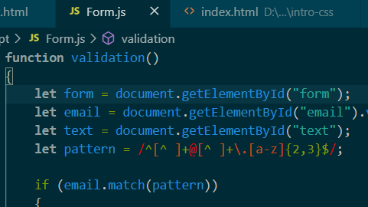
Then using If conditions to check the input against that pattern:
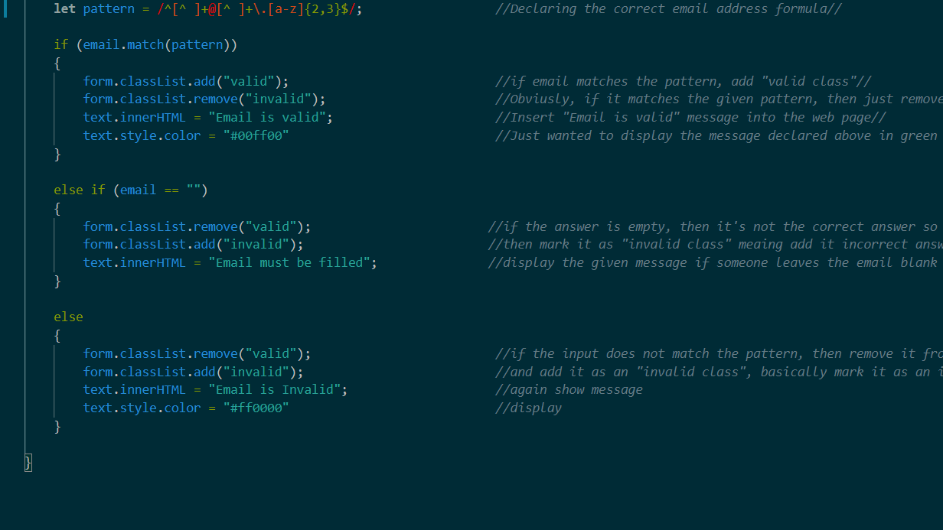
If the input matches then it marks it correct by adding it as “valid” class and if the email is empty then the error message is shown. If it does not match then input is removed from “valid” class and added as “invalid” class.
Regarding other functions, a variety of methods were implemented throughout the whole development to make the website as responsive as possible. For instance, each page has its own unique media queries to make it look the same on smaller screens such as not displaying the logo on smaller screens. Additionally, flex and grid properties were also used many times to make website more responsive.

Links
https://github.com/00010209/Web-Technologies -Report link
https://id00010209.netlify.app/ - Website Link

References
Al-Jazeera (2020). Will the global tourism industry survive the pandemic? I Inside Story. YouTube. Available from: https://www.youtube.com/watch?v=gpsinlvDs7A&feature=emb_title [Accessed November 25 2020].
amzonaws.com (2020). Australia [image]. Available from https://s3.amazonaws.com/crowdriff-media/mirror/208da8f0fbda6212486832229474677ce7c6ffb92f923e7e9a2a935ccdcb450e.jpg [Accessed 26 November 2020].
BBC (2020). Coronavirus: the impact on the Travel and Tourism industry - BBC News. YouTube. Available from: https://www.youtube.com/watch?v=BhzdU7yNvsc&feature=emb_title [Accessed November 26 2020].
Blansit, B. (2008). An introduction to Cascading Style Sheets (CSS). Journal of Electronic Resources in Medical Libraries, 5 (4), 395-409. Available from: https://www.researchgate.net/publication/244887062_An_introduction_to_Cascading_Style_Sheets_CSS [Accessed November 15 2020].
Pinterest (2020). Australia [image]. Available from https://i.pinimg.com/1200x/fa/59/f2/fa59f2aacf8d795a4e9d6909d77a9037.jpg [Accessed November 29 2020].
Pinterest (2020). Spain [image]. Available from https://i.pinimg.com/originals/de/c3/d3/dec3d322f02013497affc82da4d1fdda.jpg [Accessed 29 November 2020].
Pinterest (2020). Spain [image]. Available from https://i.pinimg.com/736x/28/bf/5a/28bf5a48a0695b23973df1ba4a175d66.jpg [Accessed 26 November 2020].
Pinterest (2020). Spain [image]. Available from https://i.pinimg.com/736x/70/e4/e8/70e4e8f5f6214f4423baa696ea1eca11.jpg [Accessed 25 November 2020].
Pinterest (2020). Turkey [image]. Available from https://i.pinimg.com/originals/2e/e2/38/2ee238b52e7f66cb4ad9596a4c4b5854.jpg [Accessed 27 November 2020].
Pinterest (2020). Turkey [image]. Available from https://i.pinimg.com/originals/cf/97/02/cf9702d631011685706724e01dd780ee.jpg [Accessed 26 November 2020].
Pinterest (2020). Turkey [image]. Available from https://i.pinimg.com/originals/39/11/b9/3911b9b476f98134a982417d63aef132.jpg [Accessed 27 November 2020].

Ramadan, N. and Abdelwahab, I. (2016). Impact of Implementing HTTP/2 in Web Services. International Journal of Computer Applications, 147 (9), 27-32. Available from: https://www.researchgate.net/publication/307906792_Impact_of_Implementing_HTTP2_in_Web_Services [Accessed December 3 2020].
Unsplash.com (2020). Australia [image]. Available from https://images.unsplash.com/photo-1560748952-1d2d768c2337?ixlib=rb1.2.1&ixid=MXwxMjA3fDB8MHxwaG90by1wYWdlfHx8fGVufDB8fHw%3D&auto=format&fit=crop&w=800&q=80 [Accessed 26 November 2020].
Unsplash.com (2020). Arctic Journey [image]. Available from: https://images.unsplash.com/photo-1518780091305-f380b9470931?ixlib=rb-1.2.1&auto=format&fit=crop&w=1952&q=80 [Accessed 30 November 2020].
Unsplash.com (2020). Fireworks [image]. Available from https://images.unsplash.com/photo-1523630389663-56a52388ddd4?ixlib=rb1.2.1&ixid=MXwxMjA3fDB8MHxwaG90by1wYWdlfHx8fGVufDB8fHw%3D&auto=format&fit=crop&w=1050&q=80 [Accessed 28 November 2020].
Unsplash.com (2020). Fireworks [image]. Available from https://images.unsplash.com/photo-1502214722586-9c0a74759710?ixlib=rb1.2.1&ixid=MXwxMjA3fDB8MHxwaG90by1wYWdlfHx8fGVufDB8fHw%3D&auto=format&fit=crop&w=1052&q=80 [Accessed 25 November 2020].
Unsplash.com (2020). Fireworks [image]. Available from https://images.unsplash.com/photo-1530196505398-de21716ddd79?ixlib=rb1.2.1&ixid=MXwxMjA3fDB8MHxwaG90by1wYWdlfHx8fGVufDB8fHw%3D&auto=format&fit=crop&w=1950&q=80 [Accessed 29 November 2020].
Unsplash.com (2020). Fishing [image]. Available from: https://images.unsplash.com/photo-1493787039806-2edcbe808750?ixlib=rb-1.2.1&ixid=eyJhcHBfaWQiOjEyMDd9&auto=format&fit=crop&w=1050&q=80 [Accessed 1 December 2020].
Unsplash.com (2020). Hiking [image]. Available from https://images.unsplash.com/photo-1578592391689-0e3d1a1b52b9?ixlib=rb1.2.1&ixid=MXwxMjA3fDB8MHxwaG90by1wYWdlfHx8fGVufDB8fHw%3D&auto=format&fit=crop&w=1189&q=80 [Accessed 27 November 2020].
Unsplash.com (2020). Hiking [image]. Available from https://images.unsplash.com/photo-1587502537147-2ba64a62e3d3?ixlib=rb1.2.1&ixid=MXwxMjA3fDF8MHxwaG90by1wYWdlfHx8fGVufDB8fHw%3D&auto=format&fit=crop&w=2017&q=80 [Accessed 26 November 2020].
Unsplash.com (2020). Hiking [image]. Available from https://images.unsplash.com/photo-1518419530812-e4cc91c95162?ixlib=rb1.2.1&ixid=MXwxMjA3fDB8MHxwaG90by1wYWdlfHx8fGVufDB8fHw%3D&auto=format&fit=crop&w=1050&q=80 [Accessed 29 November 2020].
Unsplash.com (2020). Iceland [image]. Available from https://images.unsplash.com/photo-1545317616-d8c166de6c7d?ixlib=rb1.2.1&ixid=MXwxMjA3fDB8MHxwaG90by1wYWdlfHx8fGVufDB8fHw%3D&auto=format&fit=crop&w=800&q=80 [Accessed 27 November 2020].
Unsplash.com (2020). Iceland [image]. Available from https://images.unsplash.com/photo-1498866363999-1afe374cb87f?ixlib=rb1.2.1&ixid=MXwxMjA3fDB8MHxwaG90by1wYWdlfHx8fGVufDB8fHw%3D&auto=format&fit=crop&w=800&q=80 [Accessed 24 November 2020].
Unsplash.com (2020). Iceland [image]. Available from https://images.unsplash.com/photo-1543840980-2fa72c525e9b?ixlib=rb1.2.1&ixid=MXwxMjA3fDB8MHxwaG90by1wYWdlfHx8fGVufDB8fHw%3D&auto=format&fit=crop&w=813&q=80 [Accessed 28 November 2020].
Unsplash.com (2020). Italy [image]. Available from https://images.unsplash.com/photo-1602532769631-f27de70308ae?ixlib=rb1.2.1&ixid=MXwxMjA3fDB8MHxwaG90by1wYWdlfHx8fGVufDB8fHw%3D&auto=format&fit=crop&w=800&q=80 [Accessed 26 November 2020].
Unsplash.com (2020). Italy [image]. Available from https://images.unsplash.com/photo-1508162942367-e4dd4cd67513?ixlib=rb1.2.1&ixid=MXwxMjA3fDB8MHxwaG90by1wYWdlfHx8fGVufDB8fHw%3D&auto=format&fit=crop&w=800&q=80 [Accessed 26 November 2020].
Unsplash.com (2020). Italy [image]. Available from https://images.unsplash.com/photo-1570025796121-87d2d9b69ca9?ixlib=rb1.2.1&ixid=MXwxMjA3fDB8MHxwaG90by1wYWdlfHx8fGVufDB8fHw%3D&auto=format&fit=crop&w=800&q=80 [Accessed 30 November 020].
Unsplash.com (2020). Japan [image]. Available from https://images.unsplash.com/photo-1589451907357-2f03122fe218?ixlib=rb1.2.1&ixid=MXwxMjA3fDB8MHxwaG90by1wYWdlfHx8fGVufDB8fHw%3D&auto=format&fit=crop&w=800&q=80 [Accessed 23 November 2020].
Unsplash.com (2020). Japan [image]. Available from https://images.unsplash.com/photo-1601374260222-384060af3db8?ixlib=rb1.2.1&ixid=MXwxMjA3fDB8MHxwaG90by1wYWdlfHx8fGVufDB8fHw%3D&auto=format&fit=crop&w=813&q=80 [Accessed 1 December 2020].
Unsplash.com (2020). Japan [image]. Available from https://images.unsplash.com/photo-1581552801758 ccba6e259090?ixlib=rb1.2.1&ixid=MXwxMjA3fDB8MHxwaG90by1wYWdlfHx8fGVufDB8fHw%3D&auto=format&fit=crop&w=800&q=80 [Accessed 30 November 2020].
Unsplash.com (2020). Journey [image]. Available from: https://live-production.wcms.abc-cdn.net.au/322b36b1e1f99ff89977c7cca19280b0?impolicy=wcms_crop_resize&cropH=1125&cropW=1998&xPos=1&yPos=0&width=862&height=485 [Accessed 2 December 2020].
Unsplash.com (2020). Shopping [image]. Available from https://images.unsplash.com/photo-1585202505656-c6b17753db12?ixlib=rb1.2.1&ixid=MXwxMjA3fDB8MHxwaG90by1wYWdlfHx8fGVufDB8fHw%3D&auto=format&fit=crop&w=967&q=80 [Accessed 29 November 2020].
Unsplash.com (2020). Shopping [image]. Available from https://images.unsplash.com/photo-1579792389177-ae25b2c86d4b?ixlib=rb1.2.1&ixid=MXwxMjA3fDB8MHxwaG90by1wYWdlfHx8fGVufDB8fHw%3D&auto=format&fit=crop&w=967&q=80 [Accessed 30 November 2020].
Unsplash.com (2020). Shopping [image]. Available from https://images.unsplash.com/photo-1591563757054-b5721b6e0c1b?ixlib=rb1.2.1&ixid=MXwxMjA3fDB8MHxwaG90by1wYWdlfHx8fGVufDB8fHw%3D&auto=format&fit=crop&w=1055&q=80 [Accessed 27 November 2020].
Unsplash.com (2020). Skiing [image]. Available from https://images.unsplash.com/photo-1551524559-8af4e6624178?ixlib=rb1.2.1&ixid=MXwxMjA3fDB8MHxwaG90by1wYWdlfHx8fGVufDB8fHw%3D&auto=format&fit=crop&w=926&q=80 [Accessed 28 November 2020].
Unsplash.com (2020). Skiing [image]. Available from https://images.unsplash.com/photo-1551698618-1dfe5d97d256?ixlib=rb1.2.1&ixid=MXwxMjA3fDB8MHxwaG90by1wYWdlfHx8fGVufDB8fHw%3D&auto=format&fit=crop&w=1050&q=80 [Accessed 25 November 2020].
Unsplash.com (2020). Skiing [image]. Available from https://images.unsplash.com/photo-1596473536124-397c469c8506?ixlib=rb1.2.1&ixid=MXwxMjA3fDB8MHxwaG90by1wYWdlfHx8fGVufDB8fHw%3D&auto=format&fit=crop&w=1050&q=80 [Accessed 28 November 2020].
Unsplash.com (2020). Tour [image]. Available from https://images.unsplash.com/photo-1600454021970-351eff4a6554?ixlib=rb1.2.1&ixid=MXwxMjA3fDB8MHxwaG90by1wYWdlfHx8fGVufDB8fHw%3D&auto=format&fit=crop&w=1049&q=80 [Accessed 25 November 2020].
Unsplash.com (2020). Tour [image]. Available from https://images.unsplash.com/photo-1582076197883-14c89e0d1a46?ixlib=rb1.2.1&ixid=MXwxMjA3fDB8MHxwaG90by1wYWdlfHx8fGVufDB8fHw%3D&auto=format&fit=crop&w=1050&q=80 [Accessed 2 December 2020].
Unsplash.com (2020). Tour [image]. Available from https://images.unsplash.com/photo-1549693578-d683be217e58?ixlib=rb1.2.1&ixid=MXwxMjA3fDB8MHxwaG90by1wYWdlfHx8fGVufDB8fHw%3D&auto=format&fit=crop&w=1056&q=80 [Accessed 30 November 2020].

