Module Title: | Machine Larning
Module Code: | 6COSC017C
Assessment: | Coursework 1
Student ID: | 00015986
Submission Deadline: | 05.12.2025
Module Marker’s Name:
Feedback

Content Pages:

Introduction…………………………………………………………………………………………………….2
Exploratory Data Analysis………………………………………………………………………………….3
Data Preparation…………………………………………………………………………………………….11
Justification for Machine Learning Algorithms………………………………………………………13
Conclusion…………………………………………………………………………………………………….15
References………………………………………………………………………………….………………….17

Introduction
The goal of this project is to forecast university students' academic performance, specifically whether they will remain enrolled, drop out, or successfully graduate. The dataset includes comprehensive academic, demographic, and socioeconomic characteristics and was obtained from a Portuguese higher education institution in 2021. The dataset is accessible to the public on the UCI Machine Learning Repository under an open license. Previous grades, admission scores, socioeconomic circumstances, course type, family history, and semester-based academic performance are just a few of the many characteristics that are included.
Dataset link: https://archive.ics.uci.edu/dataset/697/predict+students+dropout+and+academic+success
Digital Object Identifier (DOI): 10.24432/C5MC89
This study is intended to analyse the factors associated with student success or dropout rates and create predictive models that can assist colleges in identifying at-risk students early on. Reducing dropout rates benefits both institutions and students from a business standpoint. It enhances financial stability and performance metrics for organisations. Early risk identification helps students with specific areas, which improves their chances of academic success.
Additionally, I made my projects publicly accessible by deploying them in the GitHub repository and the Streamlit Cloud.
Streamlit UI app link: https://mlda-cw1-15986-predict-student-dropout-academic-success.streamlit.app
GitHub Repository Link: https://github.com/00015986/MLDA_CW1_15986

Exploratory Data Analysis
The dataset has 37 mixed-type columns and 4424 rows. Apart from the Target column, which contains information of the "string" data type, almost all of the columns are integer types. Age, gender, nationality, and marital status are among the demographic details included in the data. Academic characteristics include the number of credits, approved units, admission grade, prior qualification grade, semester performance, and absences. The unemployment rate, GDP, inflation, and the occupations and qualifications of parents are examples of socioeconomic variables.

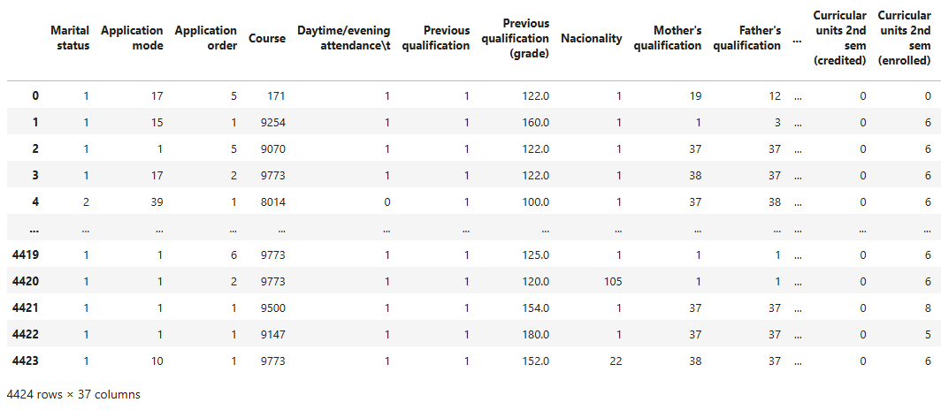
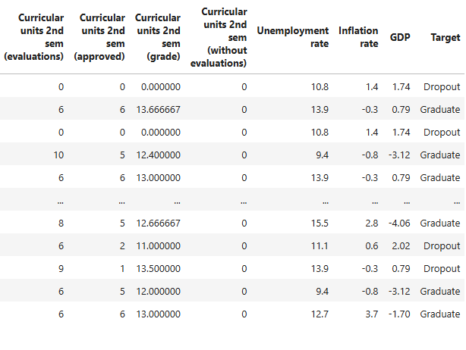
To comprehend the central tendency and distribution of features, summary statistics like mean, median, variance, and standard deviation were computed. This made it easier to identify variables that might have abnormal distributions or outliers.
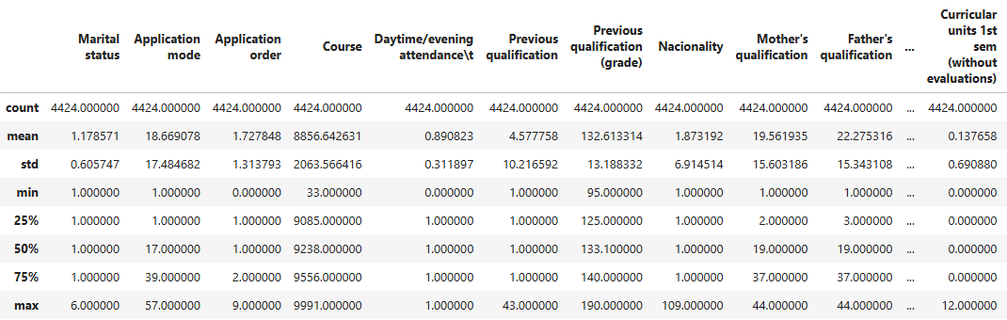
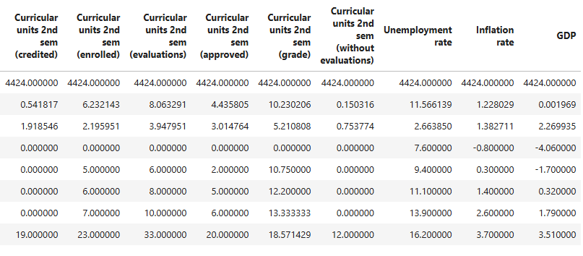
Academic-related factors showed the strongest correlations. For instance, there was a correlation of roughly 0.84 between the average grades from the first and second semesters, indicating that students who do well in the first semester are likely to continue doing well later. Approved units showed a similar pattern, with a correlation of roughly 0.79 between first semester and second semester approved units. This implies that one of the most obvious markers of student success is steady academic achievement.
The admission grade and the prior qualification grade had a moderate correlation of 0.58, which was another noteworthy relationship. This suggests that students who excelled academically prior to enrolling in college typically continue to do so.
The majority of demographic factors, including gender, nationality, and parental occupation, demonstrated very low correlations with academic performance, typically near 0.0, indicating that these factors do not have a strong direct linear relationship with success or dropout. This made it easier for me to focus on characteristics related to academic performance when choosing features for modelling.
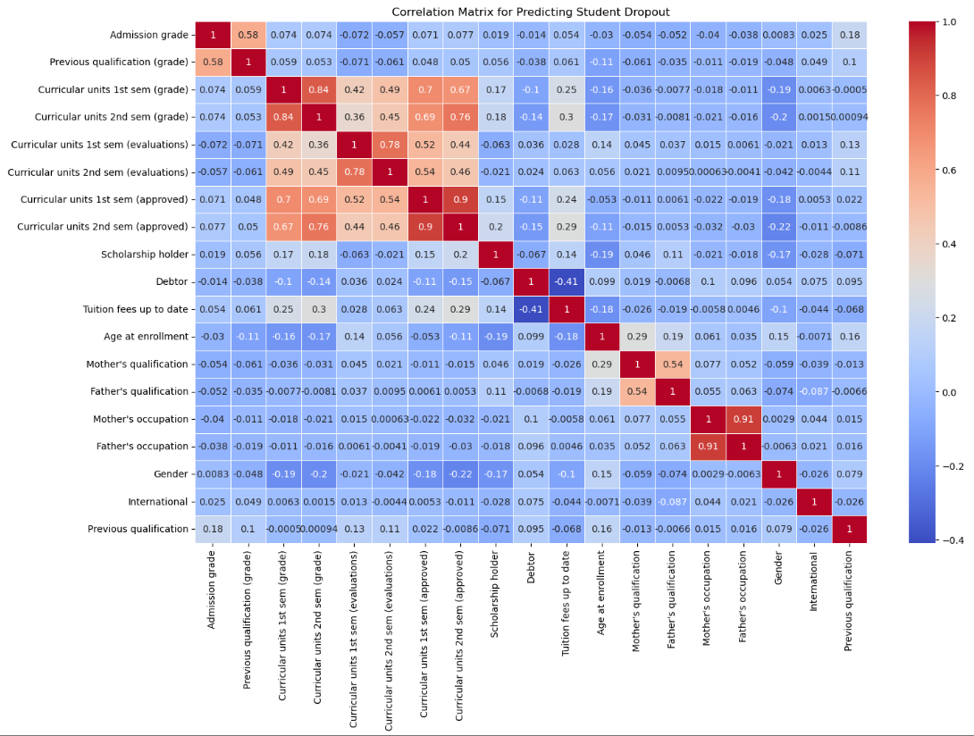

I used histograms as the primary visual aid to gain a better understanding of the distribution of the most significant academic and demographic characteristics. Because they display the frequency of various values and highlight significant patterns like value concentration and outliers, histograms are appropriate for this dataset. Histograms are more effective than earlier techniques because they can identify smaller droplets that were overlooked in earlier research Unnikrishnan, S., Donovan, J., Macpherson, R. and Tormey, D. (2020).
Before creating machine-learning models, this information is crucial because metrics, model stability, and feature utility are all directly impacted by the data's shape.
According to the histograms, the majority of numerical academic characteristics, including admission grade, prior qualification grade, and semester grades, have a roughly normal distribution, which means that the majority of students fall within a central range with fewer extreme values. This aids in verifying the validity and consistency of these academic indicators throughout the dataset.
There was clear skewness in other features, such as age at enrolment, approved units, and evaluations. For instance, while smaller groups of students have significantly higher or lower values, the majority of students complete roughly the same number of assessments or approved units. This aids in the early identification of students who may be at risk. Younger students predominate in the dataset, according to the age at enrolment histogram, which is crucial for determining how representative the population is, (Arthurs, C. 2019).
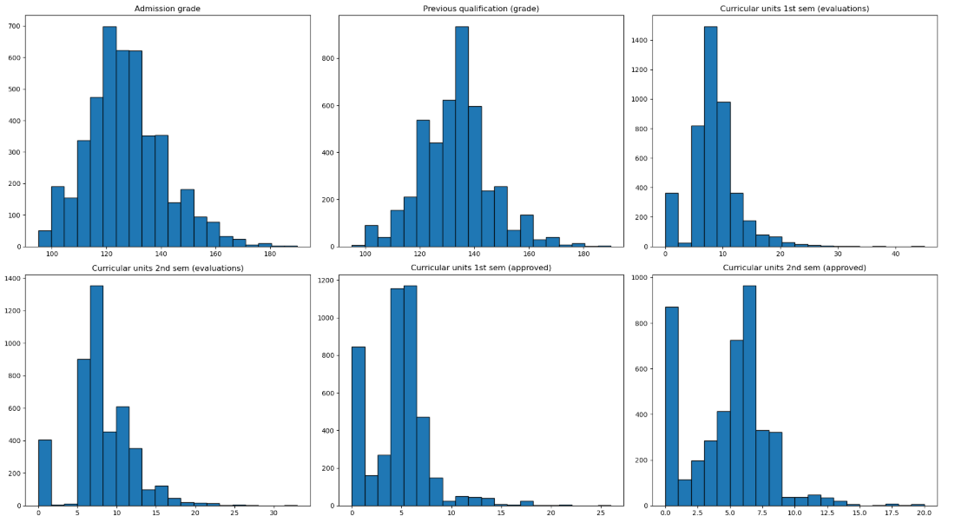
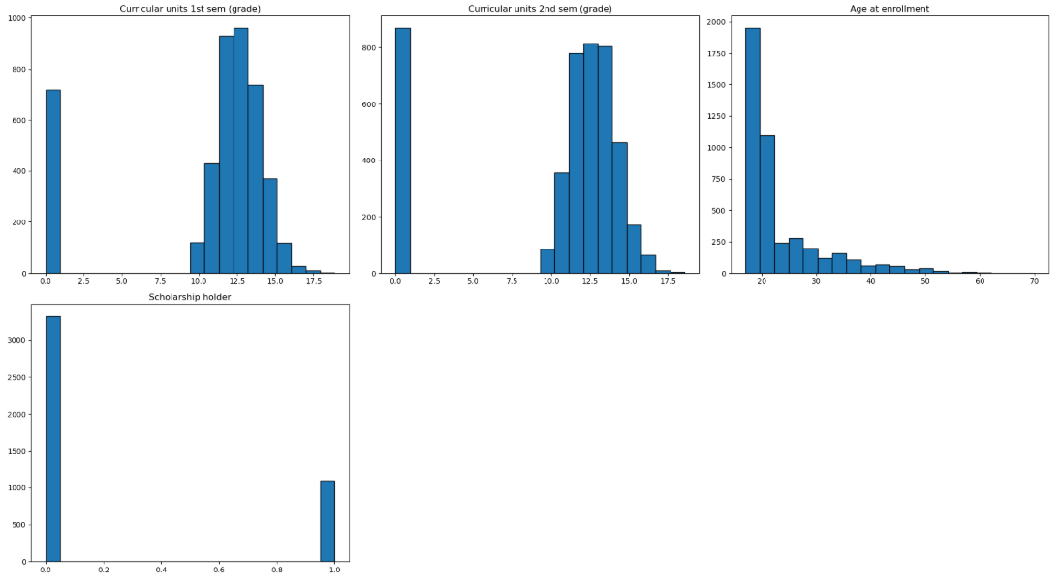
Students with higher prior grades 140 - 180 also tended to have higher admission grades 130 - 170, according to the scatter plot between prior qualification grade and admission grade. This demonstrates that one of the best measures of university readiness is past academic achievement (Unnikrishnan 2020). Features like the quantity of evaluations and authorized units, on the other hand, demonstrated weaker but still discernible correlations. For instance, admission grades above 130 were more common for students with 10–15 approved units per semester than for those with few or no approved units. Students with average semester grades between 12 and 16 typically had higher admission grades, while those with scores below 10 tended to cluster around lower admission grades. Semester grade values also revealed a significant pattern.
The majority of younger students 18 - 25 tended to fall within the common admission grade range of 110 - 150, although age at enrolment showed a widespread and weak correlation. Scholarship holders were more likely to appear in the higher admission-grade range, while debtors tended to appear slightly lower, according to financial variables like debtor status and scholarship status (Berlanga 2025).

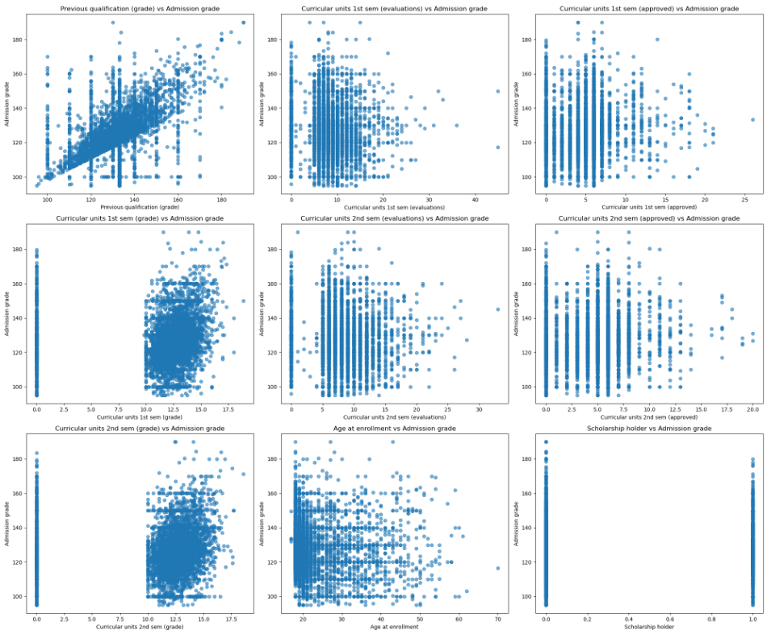

The plots demonstrated the disparity in parental occupations and qualifications. Higher education levels and advanced occupations were much less common, while most values were centered around the lowest categories, such as level 1 or level 2. The majority of students appear to come from families with low levels of education, which could have an impact on their academic achievement (Nelson, 2009).
Financial factors that were highly skewed included scholarship holders, debtors, and current tuition fees. Only about 1,000 students had scholarships, compared to over 3,000 who did not. Similar disparities were seen in debtor status, with most people having no debt. These trends contribute to the explanation of why academic behaviors are compared to financial factors, which are weaker predictors in the model.
Additionally, gender and international status were displayed. There were very few international students in comparison to domestic students, and gender was balanced but slightly skewed towards male students. Due to their highly skewed distributions, these visualizations supported the choice to handle financial and demographic features with caution during modelling.

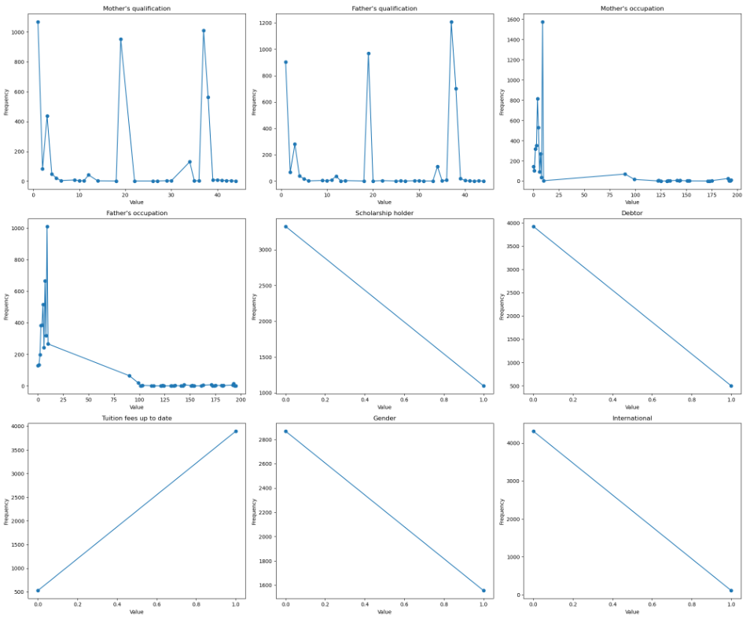

To determine how the dataset's primary continuous features are disrupted, KDE plots were utilised. The majority of students enter university with mid-level academic performance, as evidenced by the admission grade and prior qualification grade both show strong peaks around 120 - 140. Grades above 170 were uncommon. Grades from the first and second semesters also formed dense peaks around 11 - 14, indicating consistent performance throughout the semesters. There was a small, distinct cluster of students with extremely low semester grades, which is associated with a higher risk of dropout.
Because the dataset spans many years, economic variables like the unemployment rate and inflation rate showed multiple peaks. For instance, inflation ranges from slightly negative values to about 3%, while unemployment exhibits multiple peaks between roughly 8% and 14%. These differences are important because students' ability to continue their education may be impacted by outside financial pressure.
The age at enrolment KDE plot revealed a long tail that extended into older ages after a strong peak at about 18 or 19 years old. This suggests that while mature students are fewer and more dispersed, most students start their studies right after high school. Different academic behaviours and dropout rates are frequently correlated with these age group differences.
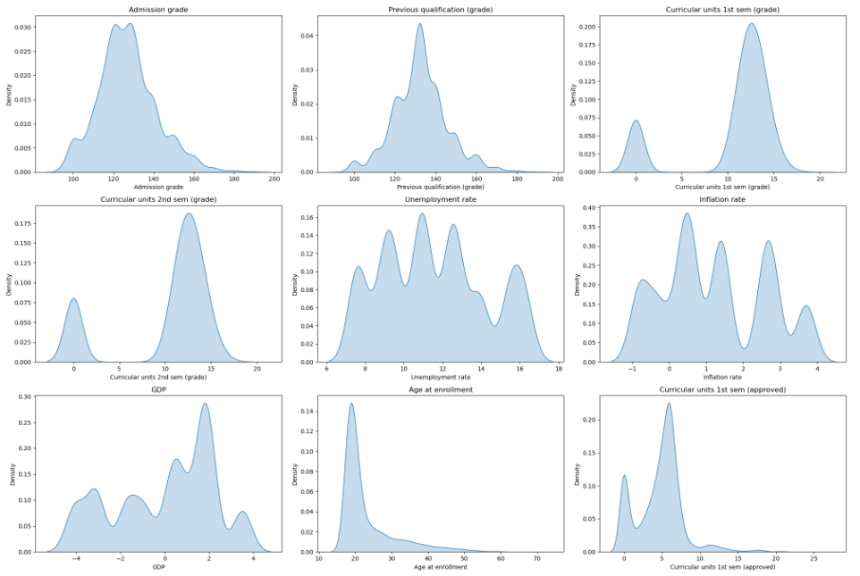

Data Preparation:
I worked on making sure the data was accurate, clean, and appropriate for machine learning model training during the dataset preparation phase. Since the original labels were text values like Dropout, Enrolled, and Graduate, the first step was to encode the target variable. I mapped Dropout = 0, Enrolled = 1, and Graduate = 2 after using LabelEncoder to transform them into numerical classes. Because machine learning models need numerical input to identify patterns and cannot operate with text categories, this conversion was necessary.
I examined the dataset's general structure after encoding the target column. Thirty integer-type variables and seven floating-point variables made up the dataset's 4424 rows and 37 columns. My preprocessing was aided by the dataset's lack of string-type columns following encoding. To learn more about the characteristics of the variables, I also looked at each column's unique values. For instance, there were 620 unique values for admission grade, 101 unique values for prior qualification grade, 46 unique values for age at enrolment, and only two unique values for categorical variables like scholarship holder, gender, debtor, and international. This made it easier to determine which features were binary or categorical and which represented continuous values.
I then confirmed the accuracy of the data. All 37 columns displayed zero missing values when the null value check was used, indicating that the dataset was already complete and did not need to be clarified or have any rows removed. I looked for duplicate entries, but there were none in the dataset. This eliminated any bias resulting from repeated data by confirming that every student record was distinct.
I then conducted outlier analysis on the continuous variables, particularly those pertaining to academic performance, economic indicators, and grades. Using the IQR method, I discovered that there were 86 outliers in the admission grade, 179 outliers in the previous qualification grade, 726 outliers in the curricular units first semester grade, and 877 outliers in the curricular units second semester grade. There were no outliers found for the GDP, unemployment rate, or inflation rate. Because extreme academic values can affect how some machine learning models behave, it was crucial to identify these outliers. Nevertheless, the values were retained in the dataset because tree-based models like Decision Tree, Random Forest, and KNN are comparatively resilient to outliers (Kern, Klausch, and Kreuter 2019).
After cleaning and analysing the dataset, I divided the feature matrix X from the target variable y. I then separated the dataset into training and testing sets using an 80% and 20% ratio. This split was essential to ensure that model performance could be fairly evaluated on data that the model had never seen before.

Justification for the Machine Learning Algorithms
Because the problem in this project is a classification with multiple classes task where each student belongs to one of three outcomes-dropout, enrolled, or graduate-supervised machine learning was employed (Shetty, 2022). In addition to offering more control during training, supervised learning enables direct learning from labelled examples, which is appropriate for forecasting academic results. Three algorithms-Decision Tree, Random Forest, and KNN were chosen for modelling. These were selected because they enable the problem to be examined from multiple angles and perform well with structured datasets that include both numerical and categorical features. After scaling, KNN provides a distance-based view, Random Forest offers strong generalization by combining numerous trees, and Decision Tree provides an explained structure (Pavan 2021).
Because Random Forest and KNN are sensitive to parameter choices, hyperparameter tuning was done for these models (Justus 2024). The optimal settings were found using GridSearchCV and five-fold cross-validation. The number of decision trees, or n_estimators, was the primary hyperparameter adjusted for Random Forest. Three hundred trees produced the highest cross-validated accuracy 0.7731, according to the research. The optimal neighbor count for KNN was eleven after the value of K was adjusted, yielding a cross-validated accuracy of 0.7120. Because the objective was to observe how the model behaves without tuning and to compare its natural performance with the more optimized methods, Decision Tree was largely left at its default settings.
Each model was subjected to feature selection independently. The top half of the strongest predictors were chosen for Random Forest using the embedded method of feature importance. After the threshold was applied, eighteen features were left. Thirty-five variables were chosen for the Decision Tree using the embedded method, which retained all features with non-zero importance (Blackeel, 2021). KNN retained thirty-six significant predictors by using chi-square feature selection on non-negative scaled values. Because KNN's calculations rely on distances and unscaled values would make some features dominate the model, scaling was only used for KNN .
All models were evaluated using three metrics: accuracy, macro precision, macro recall, and macro F1-score. Macro-averaged metrics were selected because they treat all outcomes equally and prevent the majority class Graduate from controlling the overall performance due to the dataset's three unevenly distributed classes. Using macro-based scores ensured that the evaluation reflected performance across all groups, including minority categories like dropouts, since accuracy alone would not demonstrate model fairness.
With an accuracy of 0.76, macro precision of 0.71, macro recall of 0.67, and macro F1-score of 0.68, the Random Forest model yielded the best results after all models were trained and tested. With an accuracy of 0.71 and a macro F1-score of 0.60, the KNN model demonstrated mediocre performance. With an accuracy of 0.67 and a macro F1-score of 0.62, the Decision Tree demonstrated the poorest generalization. These findings demonstrate that Random Forest has a distinct advantage because it handles many features well, minimizes overfitting by combining multiple trees, and maintains stability even when certain features have low predictive power. These factors led to Random Forest being selected as the final suggested model for forecasting academic achievement and student dropout (Salman, Kalakech and Steiti, 2024).
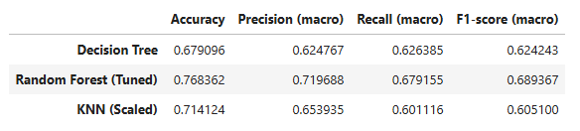

Conclusion
The results of this project show that student academic outcomes can be predicted reasonably well using their previous academic results, socio-economic factors, and enrolment-related information. Like findings from earlier educational data mining research, the strongest predictors were the semester grades, the number of approved units, and the admission grade, which confirms that early academic performance plays an important role in determining whether a student continues, drops out, or graduates. The models tested in this work achieved accuracies ranging from 68% to 77%, with the Random Forest model producing the most reliable performance.
A limitation of this project is that many of the features have non-linear relationships, but only two of the models used, Random Forest and Decision Tree, fully capture these interactions. The KNN model required feature scaling and still struggled with the high number of categorical variables, showing that distance-based methods may not be ideal for this dataset. Another limitation is the imbalance between student outcome classes, particularly the dropout class, which may have reduced the ability of models to generalize equally across all categories.
Future work can explore more advanced non-linear models such as Gradient Boosting, XGBoost or Neural Networks, which might handle complex interactions more effectively and potentially increase accuracy. Additional feature engineering, especially focusing on temporal patterns across semesters, could also improve performance. Techniques such as SMOTE or class-weight adjustments can help address class imbalance to ensure fairer predictions for dropout students. Scaling methods can be extended to all numerical variables, so that models sensitive to feature ranges benefit from more stable inputs.
The project demonstrates that supervised machine learning can be used to support early identification of students at risk of dropping out, and it provides a foundation for developing more refined predictive tools in the future.

References
Arthurs, N. et al. (2019). Grades are not Normal: Improving Exam Score Models Using the Logit-Normal Distribution. Available from https://stanford.edu/~cpiech/bio/papers/gradesAreNotNormal.pdf? [Accessed 1 December 2025].
Berlanga, V. and Corti, F. (2025). Impact of scholarships on university academic performance: a comparative analysis of students with and without scholarships. Frontiers in Education, 10. Available from https://doi.org/10.3389/feduc.2025.1554073 [Accessed 28 Novermber 2025].
Blockeel, H. et al. (2023). Decision trees: from efficient prediction to responsible AI. Frontiers in artificial intelligence, 6. Available from https://doi.org/10.3389/frai.2023.1124553 [Accessed 23 November 2025].
developers, S. (2025). KNeighborsClassifier. scikit-learn. Available from https://scikit-learn.org/stable/modules/generated/sklearn.neighbors.KNeighborsClassifier.html? [Accessed 23 November 2025].
Justus, A.I. et al. (2024). Hyperparameter Tuning in Machine Learning: A Comprehensive Review - Archive Science. Journals4promo.com. Available from http://catalog.journals4promo.com/id/eprint/1476/1/Durodola2662024JERR118312.pdf [Accessed 21 November 2025].
Kern, C., Klausch, T. and Kreuter, F. (2019). Tree-based Machine Learning Methods for Survey Research. Survey research methods, 13 (1), 73. Available from https://pmc.ncbi.nlm.nih.gov/articles/PMC7425836/ [Accessed 28 November 2025].
Nelson, J. (2019). IMPACT OF PARENT EDUCATION ON STUDENT SUCCESS 1 IMPACT OF PARENT EDUCATION ON STUDENT SUCCESS 2. Available from https://files.eric.ed.gov/fulltext/ED507263.pdf? [Accessed 17 November 2025].
Pavan, U. et al. (2021). Usage of KNN, Decision Tree and Random Forest Algorithms in Machine Learning and Performance Analysis with a Comparative Measure. Advances in intelligent systems and computing, 473–479. Available from https://doi.org/10.1007/978-981-15-9516-5_39 [Accessed 19 November 2025].
Salman, H.A., Kalakech, A. and Steiti, A. (2024). Random Forest Algorithm Overview. Babylonian Journal of Machine Learning, 2024, 69–79. Available from https://doi.org/10.58496/bjml/2024/007 [Accessed 19 November 2025].
Shetty, S.H. et al. (2022). Supervised Machine Learning: Algorithms and Applications. Fundamentals and Methods of Machine and Deep Learning, 1–16. Available from https://doi.org/10.1002/9781119821908.ch1 [Accessed 23 November 2025].
Tsiakmaki, M. et al. (2018). Predicting University Students’ Grades Based on Previous Academic Achievements. IEEE Xplore. Available from https://doi.org/10.1109/IISA.2018.8633618 [Accessed 25 November 2025].
Unnikrishnan, S. et al. (2020). An Integrated Histogram-Based Vision and Machine-Learning Classification Model for Industrial Emulsion Processing. IEEE Transactions on Industrial Informatics, 16 (9), 5948–5955. Available from https://doi.org/10.1109/tii.2019.2959021 [Accessed 27 November 2025].

