Module Title: | Machine Learning
Module Code: | 6COSC017C
Assessment: | Coursework 1
Student ID: | 00016014
Submission Deadline: | 05.12.2025
Module Marker’s Name:

Content Pages:

Introduction___________________________________________________________________2
Exploratory Data Analysis_______________________________________________________3
Data Preparation_______________________________________________________________9
Modelling and Justification of choosing____________________________________________10
Conclusion__________________________________________________________________11
References__________________________________________________________________12

Introduction
Predicting whether an online customer will finish a purchase while visiting an e-commerce website is the main goal of this project. The Online Shoppers Purchasing Intention Dataset, which was gathered over a one-year period from an actual Turkish online retail store, was used in this study. It is made available to the general public for educational and research purposes through the UCI Machine Learning Repository.
Dataset Link: https://archive.ics.uci.edu/dataset/468/online+shoppers+purchasing+intention+dataset
DOI: 10.24432/C5F88Q
The dataset includes technical and behavioural data about online sessions, including page values, operating systems, browsers, traffic types, visitor categories, time spent on various types of pages, bounce and exit rates, and special days. Additionally, it has a binary target variable called Revenue that shows whether or not a purchase was made at the end of the session.
This project's goal is to examine user behaviour trends and pinpoint the key elements that influence consumers' decisions to make purchases online. E-commerce companies can benefit greatly from this type of analysis since it can enhance website design, customise marketing tactics, and boost conversion rates. Additionally, businesses can lower marketing expenses, make more targeted recommendations, and allocate resources more efficiently by predicting purchase intention. To find the algorithm that can most accurately predict whether a visitor will make a purchase, a number of machine learning models were trained and assessed for this project. Data exploration, preprocessing, feature engineering, model training with hyperparameter tuning, and performance assessment are all included in the analysis. The top-performing model was implemented in a straightforward Streamlit web application that lets users enter session attributes and get predictions in real time.
Streamlit UI App Link: https://mlda-cw1-16014-online-shoppers-intention.streamlit.app
GitHub Repository Link: https://github.com/00016014/MLDA_CW1_16014/

Exploratory Data Analysis
There are 12,330 rows and 18 columns in the Online Shoppers Purchasing Intention dataset. Both numerical and categorical features are present in the dataset. There are two binary, two categorical, and fourteen numerical columns. Since none of the variables have any reported missing values, every entry in the dataset is complete. The dataset primarily describes how users browse an e-commerce website, including the number of administrative, informational, and product-related pages they interacted with, the length of time they spent on each type of page, and whether or not they made a purchase at the end of the session.
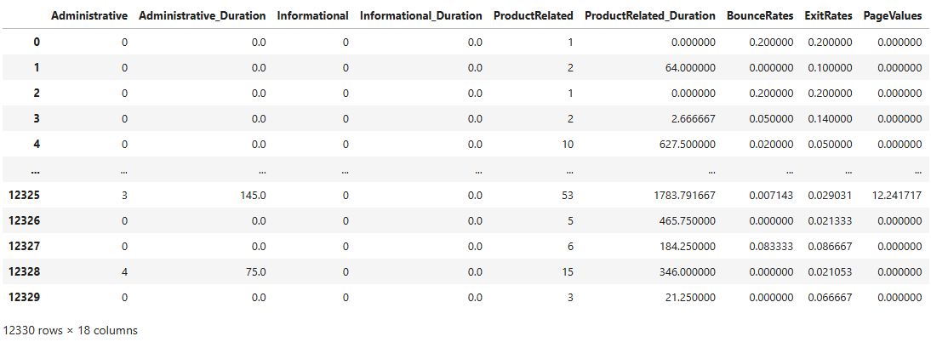
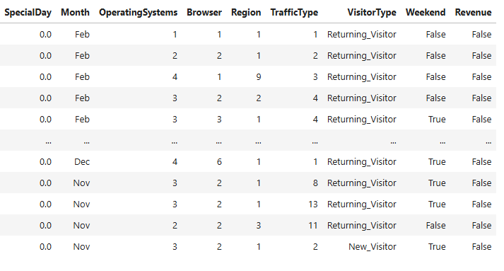
The dataset's numerical columns display a wide range of user behaviour. The majority of page-related counts—Administrative, Informational, and ProductRelated—have long upper ranges but are generally low. For instance, visitors typically open two administrative pages, but the maximum is 27, indicating that some users browse far more thoroughly than others. Similar trends can be seen in ProductRelated pages, where some sessions reach over 700, but the median is 18.
Additionally, the spread of duration-based features is extremely high. Administrative_Duration ranges from 80 seconds on average to 3398 seconds. With a very large maximum of 63973 seconds, ProductRelated_Duration has the largest spread, indicating that some visitors spend a lot of time on product pages. Certain columns, like Special Day, only rise during certain times and stay close to zero for the majority of observations. System-related columns with multiple distinct categories, such as OperatingSystems, Browser, Region, and TrafficType, exhibit a respectable degree of numerical diversity.

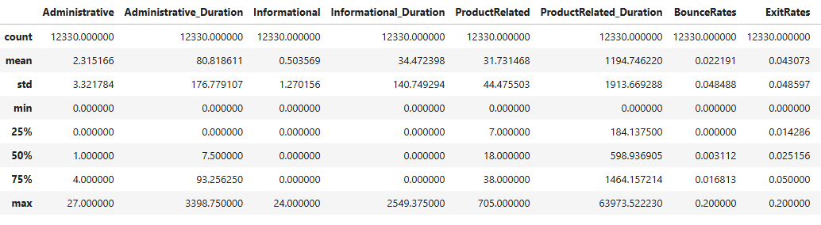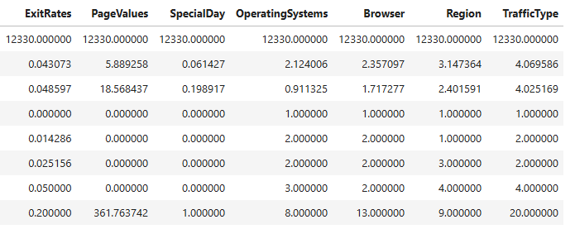

The majority of the variables in the dataset have weak to moderate relationships with one another, according to the correlation analysis. ProductRelated and ProductRelated_Duration show the strongest positive correlations (about 0.86), which is to be expected since more product-related pages typically indicate more time spent on them. Since both BounceRates and ExitRates describe visitor behaviour related to leaving the website, they show a similar pattern (around 0.91).
PageValues has the strongest correlation (about 0.49) with the target Revenue. This makes sense because a higher page value frequently signifies that a visitor is getting closer to making a purchase. While BounceRates and ExitRates exhibit slight negative correlations with Revenue, other behavioural variables like ProductRelated, ProductRelated_Duration, and Administrative_Duration exhibit slight positive correlations.
The majority of demographic and categorical characteristics (such as browser, region, and operating systems) have correlations that are nearly zero, indicating that they do not exhibit a strong linear relationship with consumer behaviour. In general, behavioural page-level metrics have the greatest impact on forecasting a customer's likelihood of making a purchase.
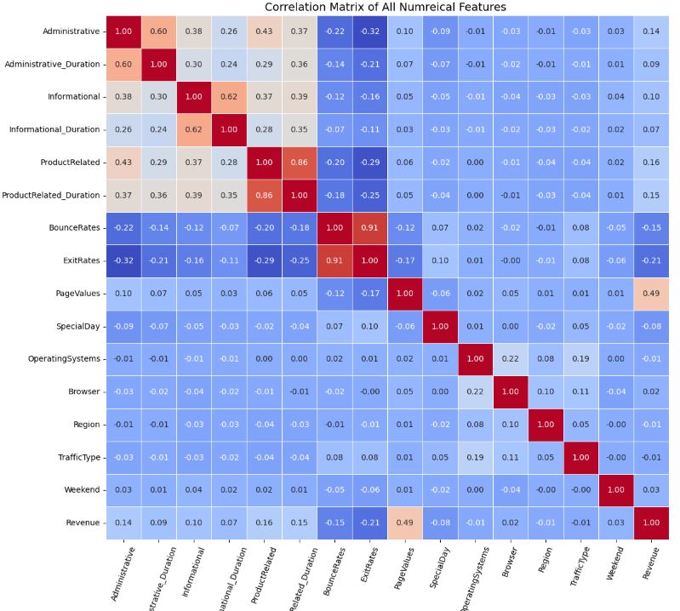

A class distribution plot illustrates the target variable's degree of imbalance or balance.
Determining whether there are significantly more "No Purchase" cases than "Purchase" cases in the dataset is helpful. This is crucial because unbalanced data may need special handling and have an impact on model performance.

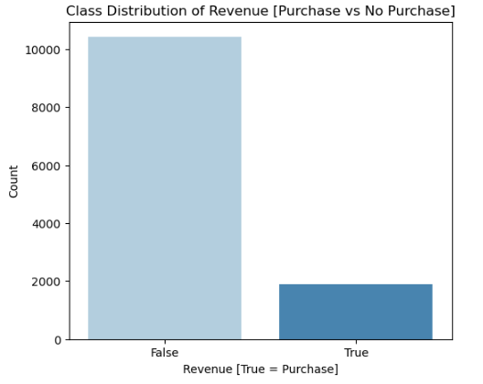
The model's most important features for prediction are highlighted in the feature importance plot. It supports the final feature selection for model deployment and aids in understanding the factors influencing purchase behaviour in the dataset.

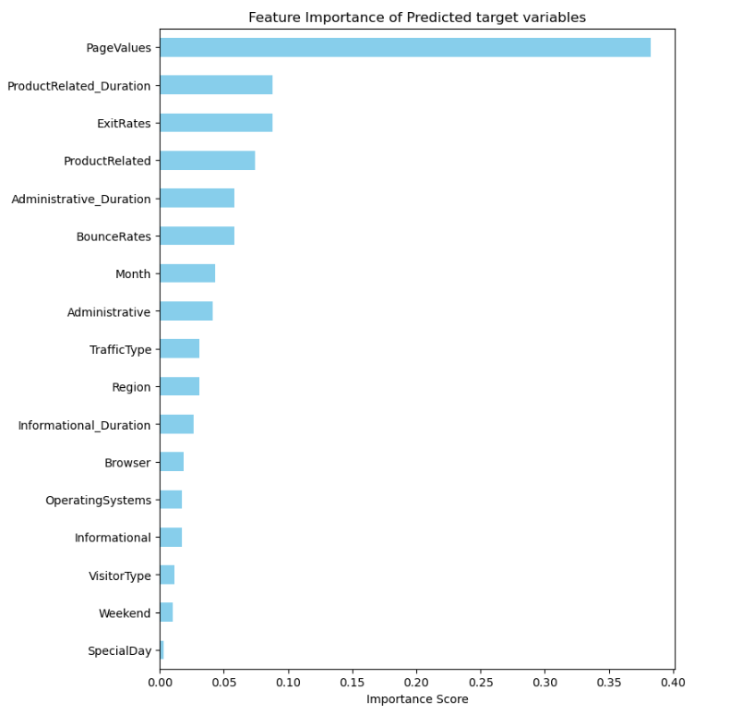

Histograms of frequency distribution make it easier to comprehend how a numerical feature is distributed throughout the dataset. It displays whether values are widely dispersed or concentrated in a small range. This is helpful for identifying anomalous patterns or skewed distributions prior to modelling.
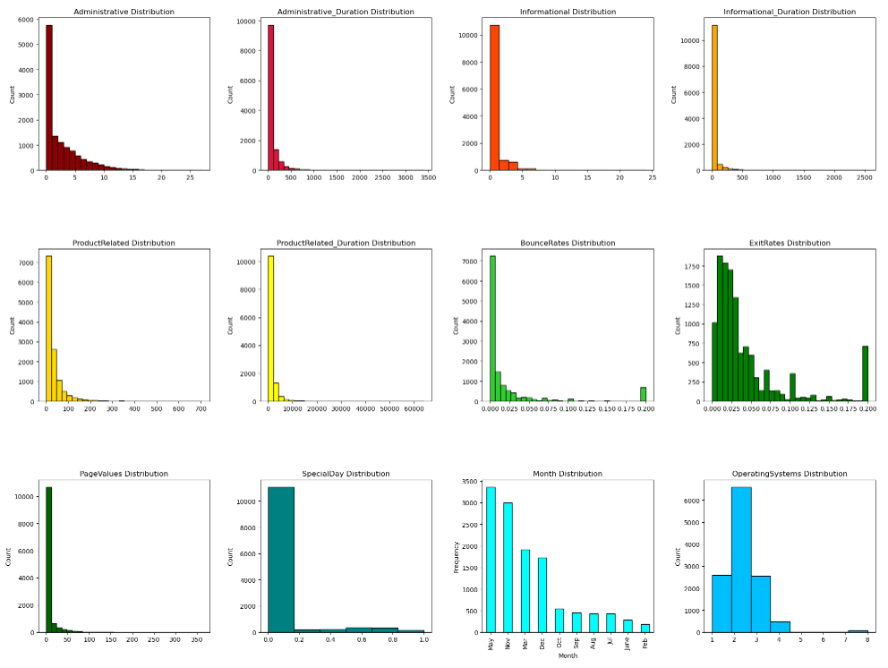
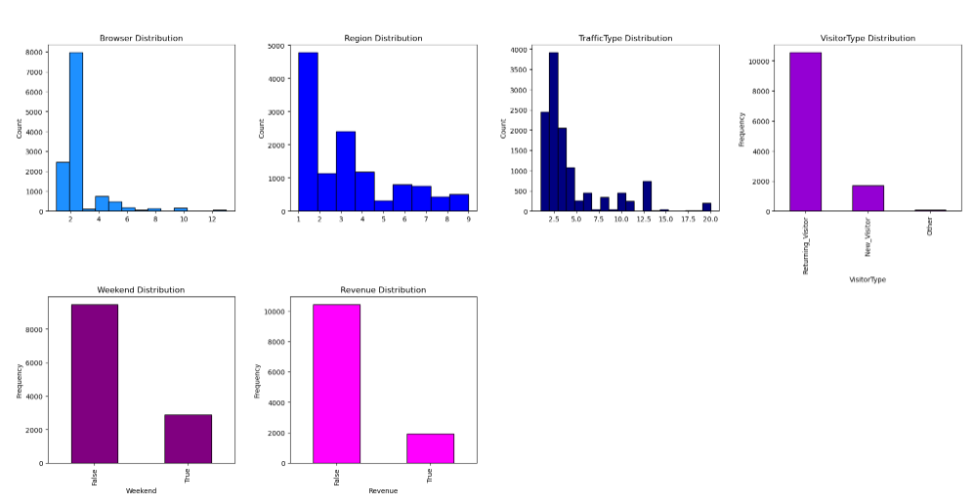

Dataset Preparation
This step involved cleaning and transforming the dataset to make it machine learning ready. I started by using the isnull() function to look for missing values. The results showed that there were no missing entries in the entire dataset. This meant that neither imputation nor row removal were required. I then checked to see if any numerical columns had negative values. No additional adjustments were required because all duration and count-based features displayed only non-negative values. In order to ensure that the values were consistent and free of unexpected labels, I also examined the distinct categories in the variables, such as VisitorType, Month, Weekend, and Revenue.
The Interquartile Range (IQR) method was used to detect outliers. The findings showed that statistical outliers were present in numerous columns. However, these extreme values were regarded as legitimate observations rather than mistakes since the dataset reflects actual user behaviour on an e-commerce platform. The dataset was left unaltered because eliminating them might have reduced the amount of useful information. After that, I started encoding categorical variables. In order for the machine learning algorithms to use the boolean columns Weekend and Revenue, they had to be converted to integers. One-hot encoding was used to transform the Month and VisitorType columns, resulting in binary variables for each category and preventing multicollinearity by eliminating the first category.
After encoding was finished, I verified that all features were appropriately interpreted as numerical by looking at the data types. All numerical columns were standardised by applying feature scaling with StandardScaler. This was done to improve the consistency of algorithms like K-Nearest Neighbours that rely on numerical distance (Ahsan, 2021). Every numerical column was scaled to have a mean of zero and a standard deviation of one. The final prepared dataset was created by reattaching the target variable Revenue after scaling. Next, an 80% and 20% ratio was used to divide the data into training and testing sets. The testing portion was set aside for assessing the models' performance, while the training portion was utilised for model learning.

Modelling and Justification of choosing
In order to forecast whether an online customer would make a purchase, three distinct machine-learning models were created and compared. Random Forest, XGBoost, and K-Nearest Neighbours were the models selected. These models were chosen because they perform well with tabular datasets; however, because each model learns patterns differently, a fair comparison can be made at the end (Martin and Chai, 2022). In order to provide a different learning behaviour that depends on feature similarity after scaling, KNN was added as a distance-based model in addition to Random Forest and XGBoost, which are tree-based models. To enhance performance, each algorithm underwent hyperparameter tuning prior to training. The optimal "n_estimators" values for Random Forest and XGBoost, as well as the optimal "k" value for KNN, were found using GridSearchCV. At 100 trees, Random Forest outperformed the others with a cross-validated accuracy of 0.905 (Robinson, 2019). With 100 estimators and an accuracy of 0.897, XGBoost likewise demonstrated strong performance (Zhang and Shang, 2022). As would be expected given that KNN is more impacted by scaling and high-dimensional data (Uddin, 2022), it attained its highest score at k=11 with an accuracy of 0.876. To ensure that each model only trained on the most crucial characteristics, feature selection was done independently for each model. While KNN employed a filter-based chi-square technique, Random Forest and XGBoost both selected features above the median threshold using their embedded feature-importance scores. This prevented needless noise and guaranteed that each model was trained using the variables that contributed most to prediction performance. Accuracy, Precision, Recall, and F1-score were used to assess each model's performance after it was trained on the same processed dataset. This allowed for a fair comparison of each model's strengths (Yacouby and Axman, 2020). Random Forest demonstrated the best overall performance across all metrics and the highest accuracy after reviewing all evaluation results (Nguyen, 2021):
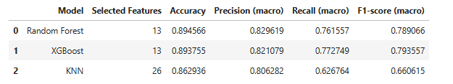

Conclusion
The analysis revealed that a visitor's browsing habits are a significant predictor of whether or not they will finish a purchase. It was discovered that characteristics like PageValues, ProductRelated duration, bounce rates, and exit rates had the biggest impact on the ultimate choice. However, there were less significant correlations between the target variable and demographic-type characteristics like region, operating system, and browser. Random Forest showed the best overall performance during cross-validation and testing after the dataset was prepared and multiple models were run. Its ability to capture non-linear interactions and its stability across different subsets of data made it the most suitable choice. While Random Forest produced somewhat better results and more consistent behaviour, XGBoost was nearly as accurate. Although KNN was less accurate and more susceptible to feature scaling, it still performed fairly well. Overall, the modelling experiment demonstrated that machine learning techniques can accurately forecast purchase intention based solely on session-level behaviour. In order to provide a useful tool that can estimate the amount of a purchase based on user activity on an e-commerce website, the final Random Forest model was chosen and implemented in a Streamlit application.

References:
Ahsan, M.M. et al. (2021). Effect of Data Scaling Methods on Machine Learning Algorithms and Model Performance. Technologies, 9 (3), 52. Available from https://doi.org/10.3390/technologies9030052 [Accessed 21 November 2025].
Marchese Robinson, R.L. et al. (2019). Comparison of the Predictive Performance and Interpretability of Random Forest and Linear Models on Benchmark Data Sets. Journal of Chemical Information and Modeling, 57 (8), 1773–1792. Available from https://doi.org/10.1021/acs.jcim.6b00753 [Accessed 23 November 2025].
Martin, D. and Chai, S.S. (2022). A Study on Performance Comparisons between KNN, Random Forest and XGBoost in Prediction of Landslide Susceptibility in Kota Kinabalu, Malaysia. A Study on Performance Comparisons between KNN, Random Forest and XGBoost in Prediction of Landslide Susceptibility in Kota Kinabalu, Malaysia, 159–164. Available from https://doi.org/10.1109/icsgrc55096.2022.9845146 [Accessed 26 November 2025].
Nguyen, J.-M. et al. (2021). Random forest of perfect trees: concept, performance, applications and perspectives. Bioinformatics, 37 (15), 2165–2174. Available from https://doi.org/10.1093/bioinformatics/btab074 [Accessed 19 November 2025].
Uddin, S. et al. (2022). Comparative performance analysis of K-nearest neighbour (KNN) algorithm and its different variants for disease prediction. Scientific Reports, 12 (1). Available from https://doi.org/10.1038/s41598-022-10358-x [Accessed 23 November 2025].
Yacouby, R. and Axman, D. (2020). Probabilistic Extension of Precision, Recall, and F1 Score for More Thorough Evaluation of Classification Models. ACLWeb. Available from https://doi.org/10.18653/v1/2020.eval4nlp-1.9 [Accessed 19 November 2025].
Zhang, P., Jia, Y. and Shang, Y. (2022). Research and application of XGBoost in imbalanced data. International Journal of Distributed Sensor Networks, 18 (6), 155013292211069. Available from https://doi.org/10.1177/15501329221106935 [Accessed 17 November 2025].

