

Module name and code | 6COSC017C-n, Machine Learning and Data Analytics
CW weighting | 50%
Lecturer setting the task with contact details and office hours | Mukhammadmuso Abduzhabbarov,  mabduzhabbarov@wiut.uz,  Office hours: TBA
Submission deadline | Dec 5, 2025
Results date and type of feedback | Dec 22, 2025, Written
The CW checks the following learning outcomes:
- Critically justify the use of data mining and machine learning techniques for Data Science applications.
- Critically reflect on how different data mining and machine learning algorithms operate and their underlying design assumptions and biases to select and apply an appropriate algorithm to solve a given problem.
- Implement, encode and test data mining/machine learning projects, focused on problem analysis, data pre-processing, data post-processing by choosing/implementing appropriate algorithms.
- Critically analyze the output of data mining and machine learning algorithms by drawing technically appropriate and justifiable conclusions resulting from the application of data mining and machine learning algorithms to real-world data sets.
- Perform critical evaluation of performance metrics for data mining and machine learning algorithms for a given domain/application.

Table of contents
Introduction 3
Description of EDA analysis 4
Data preparation 10
Justification of the choice of Machine Learning algorithms 11
Appendix 15

Introduction
To begin with the coursework description is designed to deliver machine learning solutions and also an end-to-end data analysis for the chosen dataset on Jupyter. I started the process by choosing dataset from recommended websites and for the given task I have chosen dataset regarding the “Absenteeism hours in workplace”(“https://archive.ics.uci.edu/dataset/445/absenteeism+at+work”).
The dataset were collected records of absenteeism in a work place through the period of July 2007 to July 2010 in a Courier company which is located in Brazil.Absenteeism among employees results in decreased production, higher expenses, and disruptions to workflow. In order to help a business identify high-risk instances, create interventions (wellness, scheduling, training), and enhance workforce planning, the project's goal was to develop and analyze prediction models for absence time in hours. Because it includes a range of numerical and categorical factors pertaining to individuals' personal, lifestyle, and workplace characteristics, the Absenteeism at Work dataset is appropriate for several forms of data analysis. Because of these characteristics, the dataset is very helpful for statistical analysis, predictive modeling, and supervised machine learning. Regression analysis is the main type of analysis that works best with this dataset since the goal variable, "Absenteeism time in hours," is a continuous numerical value. The dependent variable (hours of absenteeism) and independent factors (age, distance from work, body mass index, workload, and cause for absence) can be compared using regression techniques.
Additionally after choosing the dataset I had to change some columns into categorical for meaningful and concise results due to the reason that reason for absence written down in numbers which is useless accordingly to provided attribute documents inside dataset there are some attributes which must be changed so I created the copy of my csv file and make them categorical data which helps to do some manipulations on the dataset when doing the next tasks.
Description of EDA analysis
After doing Exploratory data analysis on the dataset it is clear that dataset consist of 740 rows and 21 columns. These columns are mix of numerical and categorical variables. Numeric columns: ID,Age, Transportation expense, Distance from Residence to Work, Service time, Work load average/day, Weight, Height, Body mass index, Absenteeism time in hours (target). Categorical columns: Reason for absence, Month of absence, Day of the week, Season, Education level, Social Drinker, Social Smoker. The target column is Absenteeism time in hours which is a continuous variable. After the analyzing the shape, columns,rows and data types we can say that The dataset is suitable for regression analysis, contingent upon the application of proper preprocessing techniques (encoding for categorical variables and scaling for numeric variables). To understand the data’s central tendency, dispersion and outliers we do some analysis as well in the picture below you can see it
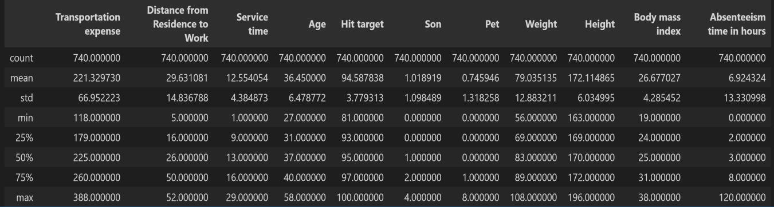

Transportation expense is the cost each employee pays to commute. On average, this cost is 221.33, but it ranges from 118 to 388. The standard deviation is 66.95, showing that commuting costs vary a lot between employees. Some employees pay much more to commute, which could affect how often they are absent. The distance between an employee's home and place of employment is measured by the distance from residence to work. With a minimum of 5 km and a maximum of 52 km, the average distance is 29.63 km. The wide range indicates that although some workers live close to their place of employment, others have a lengthy commute, which may lead to increased weariness or tardiness and, ultimately, absenteeism.The average service time is 12.55 years, with a range of 1 to 29 years. Nine years (25%), thirteen years (50%), and sixteen years (75%) are the quartiles. Employee ages range from 27 to 58 years, with an average age of 36.45 years. This implies that the majority of employees have between 9 and 16 years of experience, indicating a somewhat steady workforce. 31 is the first quartile, 37 is the median, and 40 is the third quartile. This indicates that the workforce is relatively youthful to middle-aged, with the bulk of employees being between the ages of 31 and 40.
The hit target values have a mean of 94.58% and range from 81% to 100%. The median is 95%, the 75th percentile is 97%, and the 25th percentile is 93%. This suggests that the majority of workers regularly attain high performance levels.
With a mean of 1.02, the number of boys varies from 0 to 4. 25% of workers have no children, 50% have at least one, and 75% have two or less, according to the quartiles (0, 1, 2). There are anything from 0 and 8 pets. The majority of employees do not own pets, as indicated by the 25th and 50th percentiles being both 0. Only a small percentage of employees own more than one pet, as indicated by the 75th percentile of 1.The average weight of employees is 79.03 kg, with a range of 56 kg to 108 kg. 69 kg is the first quartile, 83 kg is the median, and 89 kg is the third quartile. This suggests that the majority of workers weigh between 69 and 89 kg. The average height is 172.11 cm, with a range of 163 to 196 cm. 169 cm is the 25th percentile, 170 cm is the median, and 172 cm is the 75th percentile. This indicates that the distribution of heights among employees is rather uniform.BMI measurements have a mean of 26.68 and range from 19 to 38. At least 50% of workers fall into the overweight or obese category, with the first quartile being 24, the median being 25, and the third quartile being 31. This suggests that there may be health issues related to absence.With a mean of 6.92 hours, absenteeism ranges greatly from 0 to 120 hours. According to the quartiles, 25% of workers miss work for two hours or less, the median is three hours, and 75% miss work for eight hours or less. On the other hand, extreme outliers and a strongly skewed distribution are indicated by the maximum of 120 hours and a large standard deviation (13.33). This implies that a significant percentage of absence is caused by a small number of employees.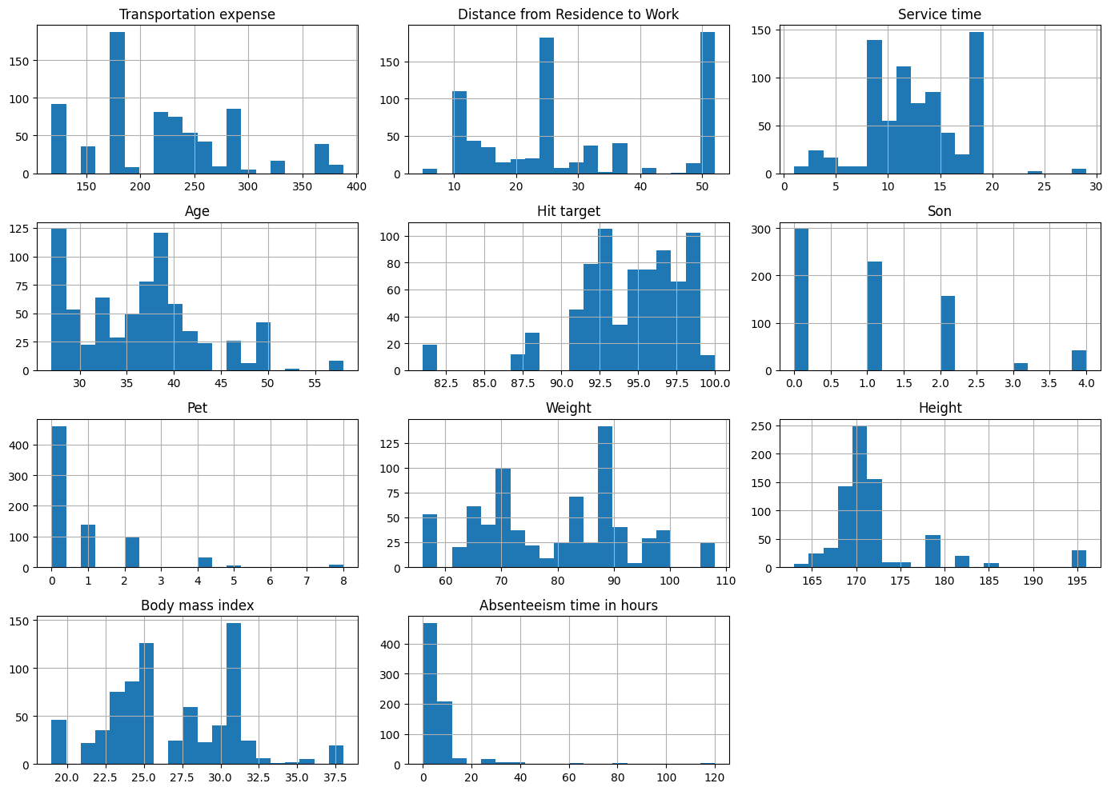
Hours of absenteeism are strongly skewed to the right.
A small percentage of workers have very high absences (up to 120 hours), while the majority have modest absences (0–10 hours). This indicates that the data contains multiple extreme values and is not regularly distributed. The age distribution is roughly normal, with the majority of workers being middle-aged people between the ages of 30 and 45. The distance between home and work varies widely (5–52 km), however the majority of values are concentrated in the 10–30 km range. Employees use various modes of transportation (bus, vehicle, etc.) with varying costs, as evidenced by the wide variation in transportation expenses. The majority of employees fall into the normal to overweight range, as shown by their BMI (body mass index), which is primarily between 22 and 32. In order to detect the outliers and data spread box-plot were generated. As it demonstrates in the columns of height,weight, absenteeism in hours there are more outliers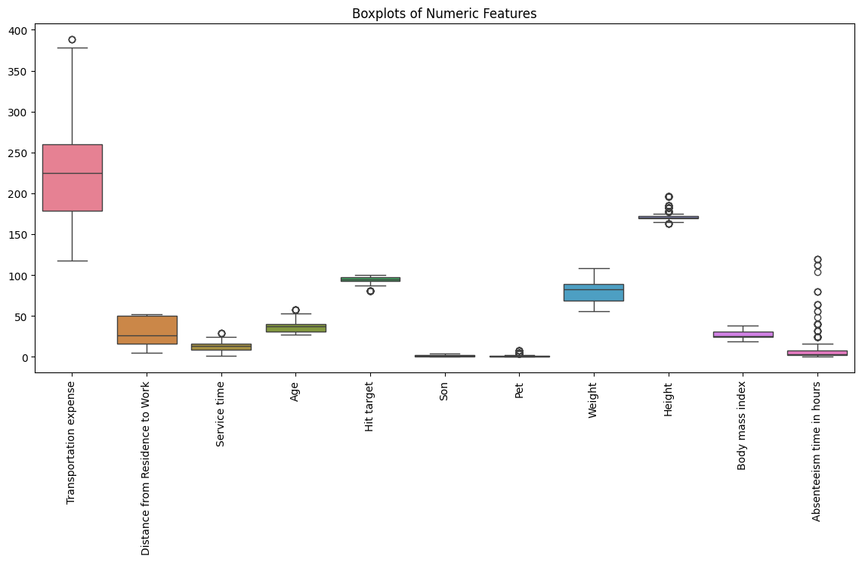
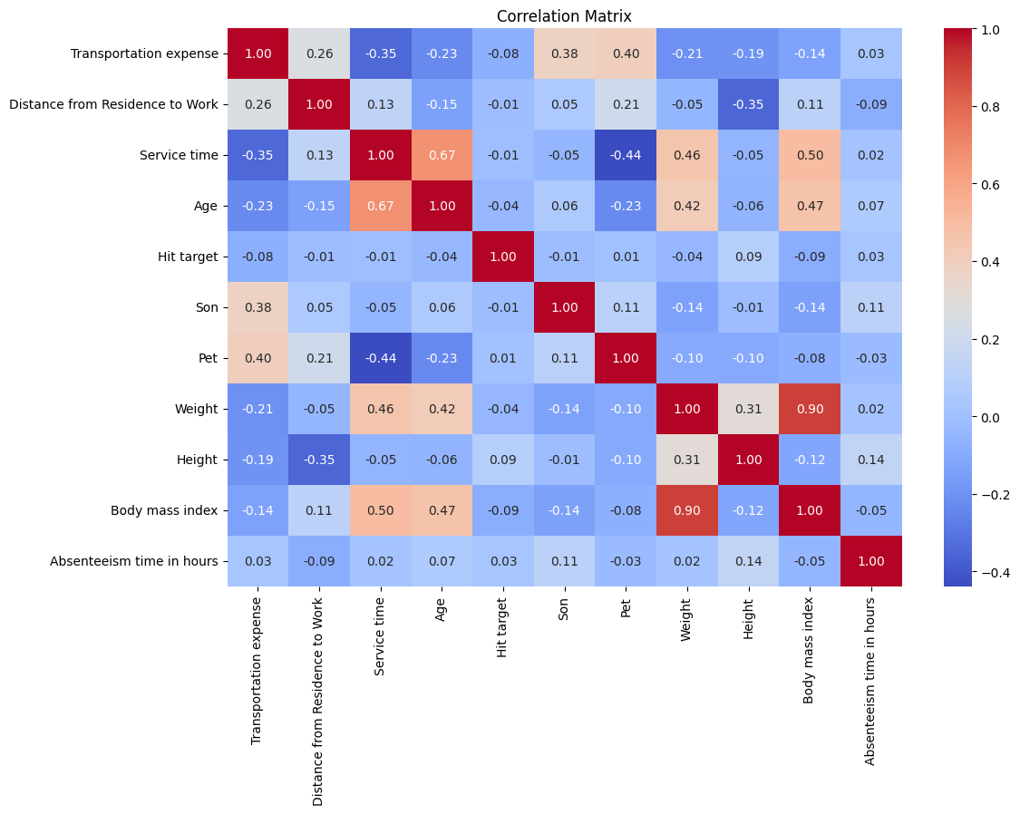
A correlation matrix was utilized to examine the relationship, among variables. Age and service time showed r = 0.67 → positive correlation. (Generally older employees tend to possess work experience.) BMI and weight are closely linked (r = 0.90 →) showing that weight greatly influences BMI. Age and BMI show a positive correlation (r = 0.47). Absenteeism compared to Residence-to-Work Distance: r = -0.09 indicates a weak correlation. The link, between Absenteeism and BMI is also very weak (r = -0.05).

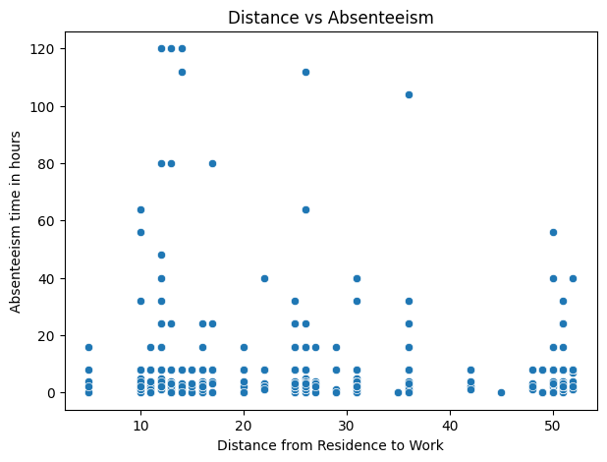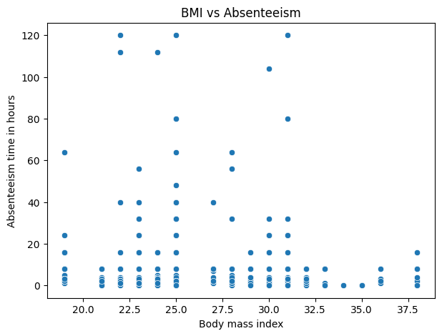

Examining the scatter plots two primary associations were identified: one between distance and absenteeism and another between BMI and absenteeism. In the distance versus absenteeism plot points are spread out broadly with no linear pattern. Notably there are instances of high absenteeism, at moderate distances (10–35 km) indicating that distance alone is not a strong predictor of absenteeism. The subsequent plot shows that elevated absenteeism appears across a range of BMI values with both low and high BMI individuals exhibiting significant absenteeism. To sum up this plot is also not so enough to for prediction
Data preparation
Proceeding to the phase of the evaluation involved cleaning the dataset identifying absent values and outliers as well as performing encoding and feature engineering. After examining for missing data we found 3 missing entries in the "Month of absence" column. Replaced them with "Unknown" to denote the absent data rather than deleting them. Regarding the data there were no missing values but to retain all records and preserve the dataset size—especially when missing values might reflect unrecorded measurements—we kept all values intact. Subsequently we conducted another check for missing data to ensure the dataset was clean, for analysis. Following that duplicated rows were detected as they can impact model accuracy and generalisation; additionally duplicate entries can cause bias by representing specific instances. During the check, for duplicated rows 34 were. Subsequently removed. Next to eliminate outliers the IQR and outlier methods were applied. Moreover rows containing invalid or implausible values were discarded. For instance entries showing absenteeism durations were removed, since having negative hours of absence is impossible. For feature engineering the BMI_Category was generated from the -existing Body Mass Index attribute and classified into categories such, as "Underweight, Normal, Overweight, Obese." This adjustment improves clarity. Helps the model recognize non-linear health trends that could influence absenteeism. Subsequently I also performed label encoding to transform data into numeric form as required by machine learning algorithms. This approach was selected due to its straightforwardness, effectiveness and suitability for columns containing a set of unique categories like days of the week, seasons or BMI groups. The dataset was split into three parts: 70% for training 15% for validation and 15%, for testing. This ensures the model is trained, tuned and evaluated on data sets preventing data leakage. To ensure reproducibility a fixed random state was used.
Justification of the choice of Machine Learning algorithms
This study aims to forecast a numeric target variable "Absenteeism time, in hours " utilizing a collection of independent variables that describe employees personal, health and job-related attributes. This constitutes a regression problem. Since the dataset contains labeled instances—meaning each input feature set is paired with a known output value representing the hours of absence—supervised learning was chosen.
To tackle this regression issue three different machine learning techniques were. Implemented: Support Vector Regressor (SVR) Random Forest Regressor and Linear Regression. These algorithms corresponded to three modeling strategies: a non-linear kernel-driven model, a tree ensemble model and a basic linear model. This diverse selection of models ensured that both linear and non-linear patterns, within the data were explored and allowed for a comparison. The train_test_split function was utilized to divide the dataset into training and testing portions before training the model allocating 80% of the data for training and 20%, for testing. To ensure the data partition remains consistent and reproducible across experiment iterations the random_state parameter was fixed at 42. This phase is vital, for machine learning as it allows the model to be trained using a portion of the data and evaluated on data offering an authentic indication of how the model could perform in real-world scenarios.
The initial algorithm implemented on the dataset was Linear Regression. This technique employs an equation to depict the relationship between the input features and the target variable. It assumes a linear association between the predictors and the outcome. This model was selected as a benchmark due to its simplicity, interpretability and frequent use, in regression tasks. Once the Linear Regression model was trained predictions were made on the test set and evaluated using Mean Squared Error (MSE) and R² Score. The model produced an MSE close to 100.94. An R² score of 0.016. The R² score being quite low indicates that the model managed to account for 1.6% of the variation in absenteeism duration. This suggests that the relationship, between the variables and absenteeism is not strictly linear. The next approach applied was the Random Forest Regressor. Random Forest is a learning method that builds multiple decision trees and merges their forecasts to achieve a more precise and reliable result. It is especially useful for complicated and non-linear datasets because it can detect relationships between characteristics that a standard linear model cannot. This model was chosen because the absenteeism dataset comprises a variety of human, health, and environmental variables that are anticipated to interact in complicated ways. Using the same test data, the Random Forest model produced a mean squared error of 71.42 and a R² score of 0.304.
This outcome indicates that the model accounts for 30.4% of the variation in absenteeism duration marking a significant enhancement compared to Linear Regression. This validated that the relationship, between the variables and absenteeism is predominantly nonlinear and intricate.
GridSearchCV was employed to optimize the Random Forest models hyperparameters greatly enhancing its effectiveness. Multiple hyperparameter configurations were tested, such as the number of trees (n_estimators) the maximum tree depth (max_depth) the minimum samples needed to divide a node (min_samples_split) and the minimum samples, at a leaf node. GridSearchCV identified the best parameter set as n_estimators = 300, max_depth = 10, min_samples_leaf = 4 and min_samples_split = 2. The Random Forest model underwent. Assessment with the recently adjusted parameters. The adjusted model presents an MSE of 76.27 and an R² value of 0.257. Although the R² metric dropped slightly compared to the model the tuned version demonstrates greater stability and reduced susceptibility, to overfitting enhancing its practical applicability. The third method implemented was Support Vector Regression (SVR). SVR is a regression technique that utilizes kernel functions to capture intricate nonlinear relationships. Initially the Radial Basis Function (RBF) kernel was utilized in this research. The SVR model produced initial outcomes yielding an R² value close to -0.02. A negative R² score implies that the model performed worse than forecasting the mean of the target variable. This indicated that the default hyperparameters were not appropriate, for this dataset. Since SVR is especially affected by the scale of data feature scaling was applied using StandardScaler to enhance the model’s effectiveness. The hyperparameters C, gamma and kernel were subsequently optimized using RandomizedSearchCV. The optimal values identified were C = 11.2, gamma = "auto" and kernel = "rbf". Following parameter tuning the SVR model was re-evaluated resulting in an MSE of 99.86 and an R² score of 0.027. Although this marked an improvement over the negative R² the performance remained significantly inferior, to that of the Random Forest model.
All models underwent assessment via two metrics: mean squared error (MSE) and R² score. MSE measures the squared deviation between predicted and real values, where smaller numbers signify superior performance. The R² Score represents the extent to which the model accounts for the variance in the target variable with values denoting a better fit. These metrics were selected due to their prevalence and appropriateness for assessing regression models. The Random Forest Regressor surpassed the three models, in both MSE and R² score metrics. It outperformed Linear Regression and Support Vector Regression in terms of capturing the dataset's complicated relationships. As a result, the Random Forest model was chosen as the final and most appropriate model for forecasting absence in hours. This choice is justified by its superior predictive accuracy, capacity to handle non-linear patterns, and robustness when dealing with real-world data containing variability and noise.

Appendix
https://archive.ics.uci.edu/dataset/445/absenteeism+at+work
https://github.com/00017159/MachineLearning_CW
https://machinelearningcw-00017159.streamlit.app/

