

Module name and code | 6COSC017C-n, Machine Learning and Data Analytics
CW weighting | 50%
Lecturer setting the task with contact details and office hours | Mukhammadmuso Abduzhabbarov,  mabduzhabbarov@wiut.uz,  Office hours: TBA
Submission deadline | Dec 5, 2025
Results date and type of feedback | Dec 22, 2025, Written
The CW checks the following learning outcomes:
- Critically justify the use of data mining and machine learning techniques for Data Science applications.
- Critically reflect on how different data mining and machine learning algorithms operate and their underlying design assumptions and biases to select and apply an appropriate algorithm to solve a given problem.
- Implement, encode and test data mining/machine learning projects, focused on problem analysis, data pre-processing, data post-processing by choosing/implementing appropriate algorithms.
- Critically analyze the output of data mining and machine learning algorithms by drawing technically appropriate and justifiable conclusions resulting from the application of data mining and machine learning algorithms to real-world data sets.
- Perform critical evaluation of performance metrics for data mining and machine learning algorithms for a given domain/application.

Table of contents
Introduction 3
Description of EDA analysis 4
Data preparation 10
Justification of the choice of Machine Learning algorithms 11
Conclusion 5
Appendix 6

Introduction
To begin with the coursework description is designed to deliver machine learning solutions and also an end-to-end data analysis for the chosen dataset on Jupyter. I started the process by choosing dataset from recommended websites and for the given task I have chosen dataset regarding the “Absenteeism hours in workplace”(“https://archive.ics.uci.edu/dataset/445/absenteeism+at+work”).
The dataset were collected records of absenteeism in a work place through the period of July 2007 to July 2010 in a Courier company which is located in Brazil.Absenteeism among employees results in decreased production, higher expenses, and disruptions to workflow. In order to help a business identify high-risk instances, create interventions (wellness, scheduling, training), and enhance workforce planning, the project's goal was to develop and analyze prediction models for absence time in hours. Because it includes a range of numerical and categorical factors pertaining to individuals' personal, lifestyle, and workplace characteristics, the Absenteeism at Work dataset is appropriate for several forms of data analysis. Because of these characteristics, the dataset is very helpful for statistical analysis, predictive modeling, and supervised machine learning. Regression analysis is the main type of analysis that works best with this dataset since the goal variable, "Absenteeism time in hours," is a continuous numerical value. The dependent variable (hours of absenteeism) and independent factors (age, distance from work, body mass index, workload, and cause for absence) can be compared using regression techniques.
Additionally after choosing the dataset I had to change some columns into categorical for meaningful and concise results due to the reason that reason for absence written down in numbers which is useless accordingly to provided attribute documents inside dataset there are some attributes which must be changed so I created the copy of my csv file and make them categorical data which helps to do some manipulations on the dataset when doing the next tasks.
Description of EDA analysis
After doing Exploratory data analysis on the dataset it is clear that dataset consist of 740 rows and 21 columns. These columns are mix of numerical and categorical variables. Numeric columns: ID,Age, Transportation expense, Distance from Residence to Work, Service time, Work load average/day, Weight, Height, Body mass index, Absenteeism time in hours (target). Categorical columns: Reason for absence, Month of absence, Day of the week, Season, Education level, Social Drinker, Social Smoker. The target column is Absenteeism time in hours which is a continuous variable. After the analyzing the shape, columns,rows and data types we can say that The dataset is suitable for regression analysis, contingent upon the application of proper preprocessing techniques (encoding for categorical variables and scaling for numeric variables). To understand the data’s central tendency, dispersion and outliers we do some analysis as well in the picture below you can see it
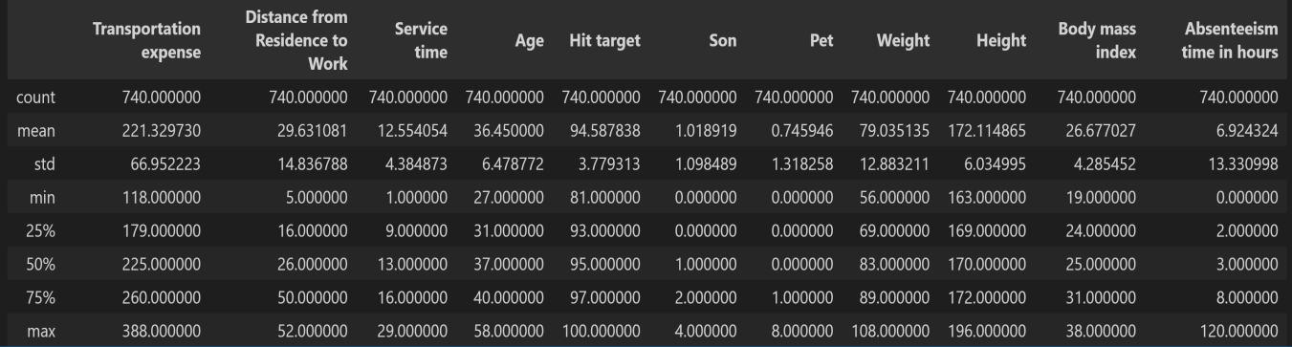

Transportation expense is the cost each employee pays to commute. On average, this cost is 221.33, but it ranges from 118 to 388. The standard deviation is 66.95, showing that commuting costs vary a lot between employees. Some employees pay much more to commute, which could affect how often they are absent. The distance between an employee's home and place of employment is measured by the distance from residence to work. With a minimum of 5 km and a maximum of 52 km, the average distance is 29.63 km. The wide range indicates that although some workers live close to their place of employment, others have a lengthy commute, which may lead to increased weariness or tardiness and, ultimately, absenteeism.The average service time is 12.55 years, with a range of 1 to 29 years. Nine years (25%), thirteen years (50%), and sixteen years (75%) are the quartiles. Employee ages range from 27 to 58 years, with an average age of 36.45 years. This implies that the majority of employees have between 9 and 16 years of experience, indicating a somewhat steady workforce. 31 is the first quartile, 37 is the median, and 40 is the third quartile. This indicates that the workforce is relatively youthful to middle-aged, with the bulk of employees being between the ages of 31 and 40.
The hit target values have a mean of 94.58% and range from 81% to 100%. The median is 95%, the 75th percentile is 97%, and the 25th percentile is 93%. This suggests that the majority of workers regularly attain high performance levels.
With a mean of 1.02, the number of boys varies from 0 to 4. 25% of workers have no children, 50% have at least one, and 75% have two or less, according to the quartiles (0, 1, 2). There are anything from 0 and 8 pets. The majority of employees do not own pets, as indicated by the 25th and 50th percentiles being both 0. Only a small percentage of employees own more than one pet, as indicated by the 75th percentile of 1.The average weight of employees is 79.03 kg, with a range of 56 kg to 108 kg. 69 kg is the first quartile, 83 kg is the median, and 89 kg is the third quartile. This suggests that the majority of workers weigh between 69 and 89 kg. The average height is 172.11 cm, with a range of 163 to 196 cm. 169 cm is the 25th percentile, 170 cm is the median, and 172 cm is the 75th percentile. This indicates that the distribution of heights among employees is rather uniform.BMI measurements have a mean of 26.68 and range from 19 to 38. At least 50% of workers fall into the overweight or obese category, with the first quartile being 24, the median being 25, and the third quartile being 31. This suggests that there may be health issues related to absence.With a mean of 6.92 hours, absenteeism ranges greatly from 0 to 120 hours. According to the quartiles, 25% of workers miss work for two hours or less, the median is three hours, and 75% miss work for eight hours or less. On the other hand, extreme outliers and a strongly skewed distribution are indicated by the maximum of 120 hours and a large standard deviation (13.33). This implies that a significant percentage of absence is caused by a small number of employees.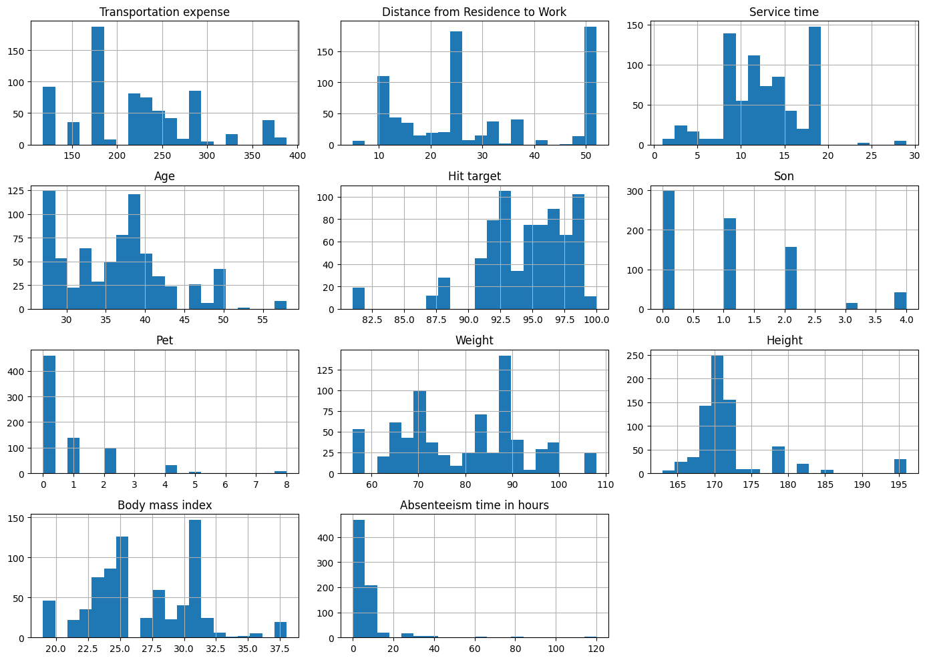
Hours of absenteeism are strongly skewed to the right.
A small percentage of workers have very high absences (up to 120 hours), while the majority have modest absences (0–10 hours). This indicates that the data contains multiple extreme values and is not regularly distributed. The age distribution is roughly normal, with the majority of workers being middle-aged people between the ages of 30 and 45. The distance between home and work varies widely (5–52 km), however the majority of values are concentrated in the 10–30 km range. Employees use various modes of transportation (bus, vehicle, etc.) with varying costs, as evidenced by the wide variation in transportation expenses. The majority of employees fall into the normal to overweight range, as shown by their BMI (body mass index), which is primarily between 22 and 32. In order to detect the outliers and data spread box-plot were generated. As it demonstrates in the columns of height,weight, absenteeism in hours there are more outliers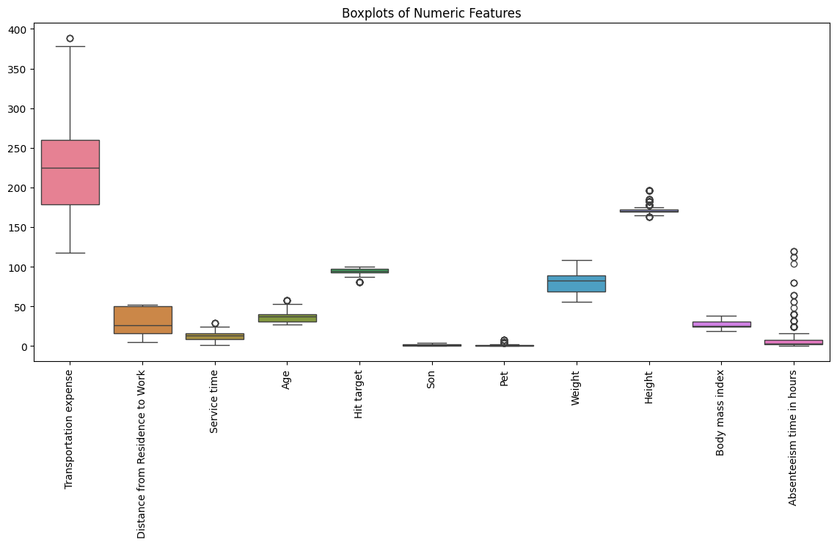
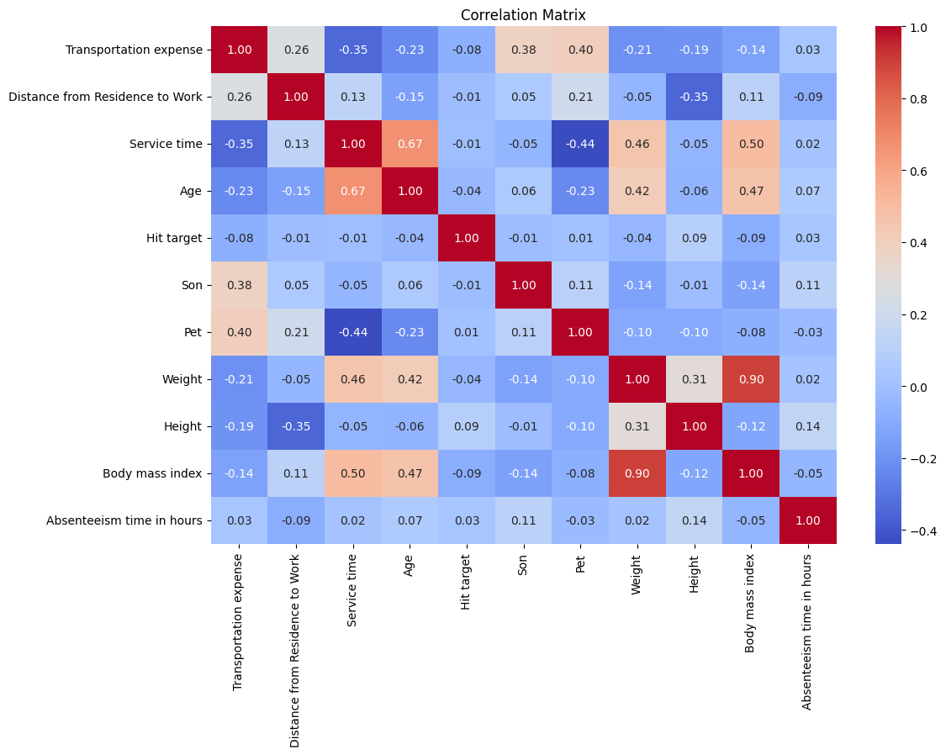
To study the connection between variables correlation matrix was used.Age and service time: r = 0.67 → solid, favorable relationship.(Older workers typically have more years of experience.)
BMI and weight have a very strong connection (r = 0.90 →), indicating that weight has a significant impact on BMI.
Age and BMI have a moderately favorable connection (r = 0.47).
Absenteeism versus. Residence-to-Work Distance: r = -0.09 extremely shaky relationship. Absenteeism and BMI have a very poor connection (r = -0.05).

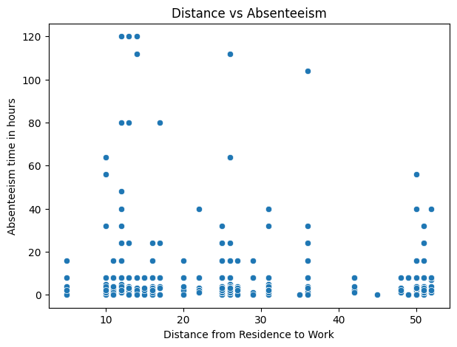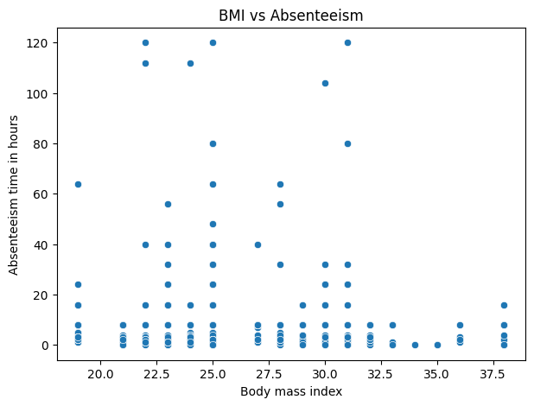

Moving to the scatter plots mainly two relationships were found between distance and absenteeism and also BMI with absenteeism. In the plot distance and absenteeism · Points are widely scattered. No clear linear trend. Some very high absenteeism occurs at medium distances (10–35 km) so to conclude that only distance is not strong predictor of absenteeism. In the next plot it visualizes that high absenteeism occurs at many different BMI values. Both low and high BMI employees show large absenteeism. To sum up this plot is also not so enough to for prediction
Data preparation
Moving to the next step of the assessment it was to cleaning dateset, finding missing values and outliers, additionally encoding and feature engineering. After checking for missing values we revealed that there is 3 missing variables for the column of “Month of absence” and we filled them with “Unknown” for indicating the missing values instead of removing them coming to the numerical values there was no any missing values but for the purpose of preserve all entries and maintain dataset size, especially in cases where missing values may indicate an absence of collected measurements. After that one more time missing values were checked in order to have a clean dataset to work with. After that duplicated rows also identified because it may affect model performance and generalisation and also duplicate data can introduce bias into the model by over-representing certain cases. While checking for the duplicated rows we find out 34 row and dropped them. Next, in order remove outliers IQR and oultlier method created. Besides this, rows with invalid or impossible values were removed. For example, rows exhibiting negative absenteeism time were eliminated, as it is inconceivable to possess negative hours of absence. For the feature engineering BMI_Category was created by already existing Body Mass Index feature and divided into groups like “Underweight, Normal,Overweight, Obese”. This modification enhances interpretability and enables the model to identify non-linear health patterns that may affect absenteeism. After that I did some label encodings as well in order to convert categorical values into numeric format as machine learning modules require. The reason for choosing this method is its simplicity, efficiency, and appropriateness for columns with a restricted number of distinct categories, such as days of the week, seasons, or BMI classifications.The dataset was divided into three categories: 70% training, 15% validation, and 15% test sets. This guarantees that the model is trained, modified, and assessed on independent data sets, avoiding data leaking. To assure repeatability, we employed a fixed random state.
Justification of the choice of Machine Learning algorithms
The goal of this study is to predict a continuous numerical target variable, "Absenteeism time in hours," using a set of independent variables that characterize employees' personal, health, and work-related characteristics. This is a supervised regression issue. Because the dataset includes labeled examples—that is, each set of input features has a known output value that represents the number of absence hours—supervised learning was selected.
Three distinct machine learning methods were chosen and put into practice to address this regression problem: Support Vector Regressor (SVR), Random Forest Regressor, and Linear Regression. Three distinct modeling approaches were represented by these algorithms: a non-linear kernel-based model, a tree-based ensemble model, and a straightforward linear model. This wide variety of models guaranteed that both linear and non-linear trends in the data were investigated and enabled a fair comparison. The train_test_split function was used to separate the data into training and testing sets prior to model training, with 80% of the data being used for training and 20% for testing. To guarantee that the data split is repeatable and stable during several experiment runs, the random_state option was set to 42. This stage is crucial to machine learning because it enables the model to be trained on a subset of the data and assessed on data that has not yet been seen, providing a realistic representation of how the model might function in actual situations.
Linear Regression was the first algorithm applied on the dataset. Linear regression uses a straight-line equation to represent the connection between the input and target variables. It presupposes a linear relationship between the characteristics and the result. This model was chosen as a baseline because it is basic, easy to read, and commonly utilized in regression situations. After training the Linear Regression model, predictions were performed on the test dataset and assessed using Mean Squared Error (MSE) and R² Score. The model yielded an MSE of around 100.94 and a R² value of 0.016. The R² value is relatively low, which means that the model could only explain around 1.6% of the differences in absenteeism time. This demonstrates that the correlations between the variables and absenteeism are not fully linear.The second method used was the Random Forest Regressor. Random Forest is an ensemble learning technique that creates many decision trees and combines their predictions to get a more accurate and stable outcome. It is especially useful for complicated and non-linear datasets because it can detect relationships between characteristics that a standard linear model cannot. This model was chosen because the absenteeism dataset comprises a variety of human, health, and environmental variables that are anticipated to interact in complicated ways. Using the same test data, the Random Forest model produced a mean squared error of 71.42 and a R² score of 0.304.
This result reveals that the model can explain around 30.4% of the variance in absenteeism time, representing a considerable improvement above Linear Regression. This confirmed that the link between the factors and absenteeism is largely nonlinear and complex.
GridSearchCV was used to tune the Random Forest model's hyperparameters, significantly improving its performance. Several hyperparameter combinations were evaluated, including the number of trees (n_estimators), the maximum depth of the trees (max_depth), the minimum samples necessary to split a node (min_samples_split), and the minimum samples required at a leaf node. GridSearchCV selected the optimal combination as n_estimators = 300, max_depth = 10, min_samples_leaf = 4, and min_samples_split = 2. The Random Forest model was retrained and evaluated using the newly tweaked parameters. The tweaked model has an MSE of 76.27 and a R² of 0.257. While the R² score declined somewhat from the untuned model, the tuned model is more stable and less prone to overfitting, making it more usable for real world application.The third approach used was the Support Vector Regression (SVR). SVR is a strong regression approach that employs kernel functions to model complex nonlinear connections. The Radial Basis Function (RBF) kernel was employed in the beginning of this study. The SVR model showed dismal first results, with a R² value of around -0.02. A negative R² score indicates the model did worse than predicting the target variable's average value. This suggested that the default hyperparameters were unsuitable for this dataset.As SVR is particularly sensitive to data scale, feature scaling was used with the StandardScaler to boost the model's performance. The hyperparameters C, gamma, and kernel were then tuned using RandomizedSearchCV. C = 11.2, gamma = "auto", and kernel = "rbf" were the best parameters discovered. After optimizing the parameters, the SVR model was assessed again, yielding an MSE of 99.86 and a R² value of 0.027. Despite an improvement from the initial negative R², it still performed much worse than the Random Forest model.
All models were evaluated using two key metrics: mean squared error (MSE) and R² score. MSE calculates the average squared difference between anticipated and actual values, with lower values indicating better performance. The R² Score reflects the model's ability to explain the target variable's variance, with higher values indicating better fit. These two measures were chosen because they are common and suitable for evaluating regression models.The Random Forest Regressor outperformed all three models in terms of MSE and R² scores. It outperformed Linear Regression and Support Vector Regression in terms of capturing the dataset's complicated relationships. As a result, the Random Forest model was chosen as the final and most appropriate model for forecasting absence in hours. This choice is justified by its superior predictive accuracy, capacity to handle non-linear patterns, and robustness when dealing with real-world data containing variability and noise.
Conclusion

Appendix
https://archive.ics.uci.edu/dataset/445/absenteeism+at+work
https://github.com/00017159/MachineLearning_CW
https://machinelearningcw-00017159.streamlit.app/

