Module code: 5COSC017C
Module name: Full Stack Web Development
Lecturer’s name: Shoxruh Sultanov
Student’s ID: 00017636
Word count: 2189 words

Content page
Introduction 3
Business Case Analysis 3
Requirements gathering 5
Functional requirements 5
Non-functional requirements 6
Security 6
Reliability and Availability 6
Data integrity 7
Usability 7
Proposed technical solution 7
MVT architecture 7
Proposed system components 8
Database design considerations 8
Security considerations 9
User stories and User flow 9
Implementation plan 12
Conclusion 14
Reference list 15

Introduction

In the 21st century, people cannot imagine their lives without modern technologies. For example, we use the internet for numerous purposes, like entertainment, education, communication, and work. Most of the enterprises tend to reduce traditional costs, automate services, and simplify business data management using web applications besides, referring to Dzhangarov, Pakhaev, and Potapova (2021), no matter what kind of company is established, whether a state-owned enterprise, a privately held company, or an online diary, having its own website or a web application is considered a strong business card and leads to efficiency improvement and increased customer satisfaction. The learning centers are not an exception.

Business Case Analysis

Currently, in the Chen Chun Study Center, the registration and course management process, assignments, and attendance are handled manually through Telegram by the administration or on paper by teachers. However, it leads to class overbooking, the loss of important data, work overload, and inconsistent communication between the tutors and students. At the same time, the main communication is conducted through Telegram, and students send online homework in either private messages to the tutor or the main chat. This leads to teachers’ frustration as they have to access homework in multiple places, write the feedback directly to the student who sent it, which creates too many chats, and mixes personal and academic communication. Additionally, the administration of the learning center wants to create a new recognition system for the students who attended most of the seminars, diligently did the homework, and successfully passed the exam. It is inconvenient to track homework deadlines and attendance, as tutors currently do so in a traditional manner by writing them down in a paper journal. Consequently, this unstructured system negatively affects both teaching effectiveness and overall center productivity.
The objective of this project is to create a web-based application that will ease and digitalize the core academic processes and perform as a Student Record System. As an example, the interested user can create a profile and register for the course with confirmation within 2 minutes, and his/her typed personal information will be securely saved in the database. Additionally, the teacher will be able to track attendance, create homework, and review students' work in the same place. Overall, the application will ensure an easy learning flow and sustainable communication between teachers and students.
The system will include functions like modifications for the users’ profiles and courses, course registration, an admin dashboard to monitor all activities, a feedback section in the homework page, a grading system, an attendance tracker, and a system to calculate students’ performance overall.
On the other hand, the project will not include but is planned to be developed in a future phase, a mobile application, notifications, a Telegram bot, and the online payments, because they will be performed by the administration, who will contact registered users through email left in the form, because they believe that human interaction is still required.
After the deployment of this Student Record System, all the stakeholders will experience the benefits. For instance, the teachers will be able to quickly access the platform where they can manage attendance, communication, and homework. So they do not have to mess with paperwork and can check the given homework anywhere with their laptop or phone. Moreover, the students will get a professional and understandable learning scheme, user-friendly access to the course materials, more visible deadlines, and a personal approach from the tutors. The research made by Aljiraiwi (2017) has shown that the web-application-based learning environment promoted discussions during the lessons and effectively improved students’ performance. The administration side will get a faster way to receive data for data-driven decision-making, an accurate record-tracking, and eliminate class overbooking. As a result, the company will achieve a higher customer satisfaction level, boost organizational efficiency and engagement, reduce administrative work overload, and increase the number of clients.
On the other hand, the web development plan must include potential risks and their solutions because any online application is vulnerable to cyber-attacks and other business-related threats. According to Kumar et al. (2021), research indicates that server downtime, users' resistance to transitioning to online tools, and data privacy issues have become the most common threats to the peaceful application usage. To mitigate them, I will choose a cloud provider with at least 99.9% uptime to ensure that the application is available and accessible to users at any time and will be unavailable for less than 9 hours per year. To help users get used to the new system, the interface will be made as minimalistic as it could be, and the developer will follow the laws of good user experience to achieve a user-friendly interface. Finally, the last risk can be mitigated through role-based access, so the users can access only the data dedicated to them.

Requirements gathering

Functional requirements

All users will have functions like registering a new account or logging in to an already existing one with their password and login, and editing personal information or deleting their profile if they have no assigned courses.
The students will be able to perform the functions such as applying to courses, getting the lists of courses and teachers, and pinning the file to the homework section only if the deadline has not passed. To measure their performance and check if they are suitable for the successful completion certificate, I will make a special system that will find the suitable candidates who attended at least 80% of seminars, passed all homework, and got no less than 70% mark for the final exam.
Teachers can oversee lists of students who enrolled in their course, put attendance in the checkboxes on a dedicated page, have CRUD operations for the homework, extend deadlines, put the “PASS” or “FAILED” marks, and add short feedback on assignments with an explanation.
Admins will have CRUD operations for courses, teachers, and students. They will ensure that the course is set up correctly and monitor the learning process.

Non-functional requirements

Security
I will include the own security system with the user’s input validation to avoid SQL injection, so the database will not be affected by the outside world. In addition, to securely store the passwords, they will be hashed. To accept only the real user’s actions, the CSRF token will be used. The HTTPS protocol will establish a safe connection between a server and a client.

Reliability and Availability
Moreover, I will manage the performance of the web application to respond faster in under 2-3 seconds and provide reliability and stability for 99% of the time. For example, the main pages like home, login, and dashboard must be loaded within 3 seconds.

Data integrity
The system will use a MySQL database to ensure that the information about new and existing users and courses will be stored persistently and reliably.

Usability
The system will provide a simple and intuitive UI by following the UX rules like Jacob’s law, Fitt’s law, and Hick’s law. In the research of Lytvynenko, Skliarenko, and Kolodinska (2020), these laws were concluded as the most useful ways to present online information to people. Therefore, the design will be similar to other web applications, have big clickable buttons for a smooth user journey, and give fewer choices to the user.

Proposed technical solution

MVT architecture
After the analysis of this case, it was decided to build an application using the Django framework that follows the (Model-View-Template) MVT architecture.
The Model means the data layer and interacts with the database, managing data operations with the assistance of an Object-Relational Mapper. The database will have tables like teachers, students, courses, enrollments, attendance, homework, and submitted homework.
View is a logic layer that serves as a bridge between the Model and Template. In this case, it will perform operations like input validation, reading and editing data in the database, and returning a valid response.
Whereas the Template stage is referred to presentation layer. Its responsibility is to render the data into HTML pages for the user and style it with CSS or Bootstrap. It will determine the layout and design of pages such as users’ profiles, courses, attendance, homework, and login.

Proposed system components
The proposed system will have the following components: frontend, backend, database, and APIs. For the frontend, the HTML, CSS, and JavaScript will be used in order to create responsive pages with intuitive navigation, sending understandable messages to the user, and a minimalistic user interface for pages. The backend will be done in the Python Django framework. Its responsibility is to perform authentication, authorization, CRUD operations, performance tracking, and data validation. The database will be built in MySQL because it is popular for its flexibility in settings and features, which allows broad customization, fast data extraction, and security level with built-in mechanisms for encrypting data. Django’s ORM will be useful for managing the connection between the application and the database. Furthermore, ORM enables writing the request to the database using Python code instead of using raw SQL. The API is a connector for the client and server, which enables secure data exchange and prevents direct access to the database. Its endpoints get the request, process the data, and return a response.

Database design considerations
Now moving on to the database considerations. It will be based on relational models. I will have 7 types of entities: teacher, student, attendance, course, enrollment, homework and submitted homework. All these entities will have either many-to-many or one-to-many relationships.
ER diagram with approximate database design
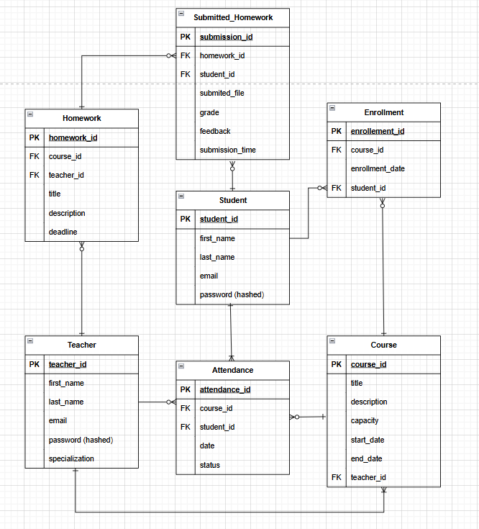

Security considerations
For any company the privacy and security are one of the most sensitive parts. For this reason, the different stages of security systems will be applied. The ORM and input validation will be implemented to prevent SQL injection attacks by checking if all the users’ inputs are valid before entering the database. The passwords will be hashed and encrypted to protect the user’s personal information and credentials from intruders. Django’s built-in authorization and authentication mechanisms will be used to restrict access to pages from unauthorized users. The HTTPS protocol will ensure a safe connection between client and server to protect data during transmission by encrypting it. Finally, the forms will contain a CSRF token and be checked in the views. Therefore, only the requests made by authorized users will be processed.

User stories and User flow

To understand the view of different users better, the user stories and flow are used.
As a teacher, I want to be able to update my profile so that I can show my new achievements or changed personal information. As a teacher, I want to see the list of my students so that I can familiarize myself with their names and create a strong bond with them. As a teacher, I want to be able to track student attendance so I know who will need additional explanation in the next lesson. As a teacher, I want to manage online homework so that I can have my own teaching plan and check students’ understanding of the material. As a teacher, I want to add feedback and put a mark on student’s work because I want to motivate them to work and give personal advice to everyone.
As a student, I want to be able to delete my account so that I can leave the center if I am not interested in any courses. As a student, I want to see the available courses and register for them online so that I can choose the suitable ones based on my level and interests. As a student, I want to submit my homework assignment and see the teacher’s feedback on it because I want to check my knowledge and get useful insights from the tutor. As a student, I want to see my attendance rate to support my motivation to study steadily.
As an admin, I want to monitor all course registrations, so that I keep a record of the course demand. As an admin, I want to add new users so that people who have trouble with registration can still join our learning center community. As an admin, I want to manage users’ accounts so that in emergencies, I can modify and delete their profiles. As an admin, I want to manage course operations like adding, modifying, and deleting so that the teachers will focus only on the teaching environment. As an admin, I want to have access to homework and attendance so that I can track the quality of education and help the teacher in case of technical problems.
User flow
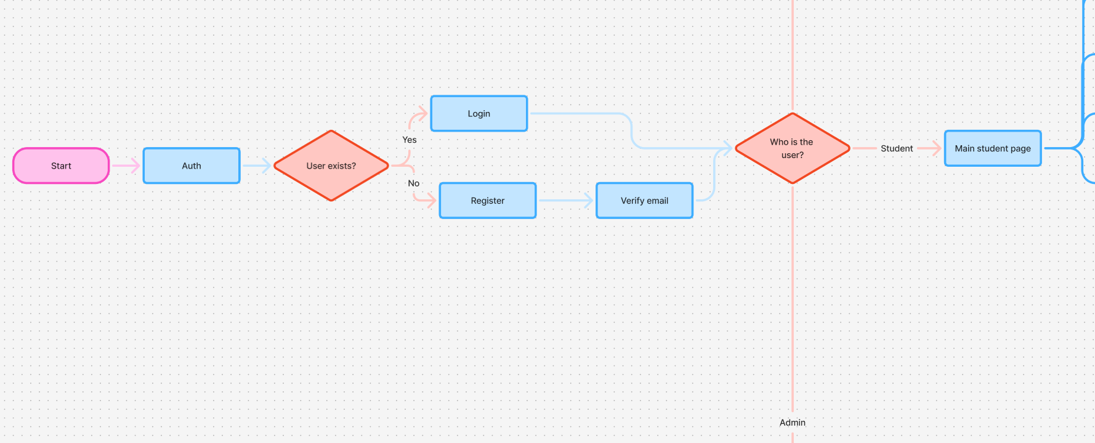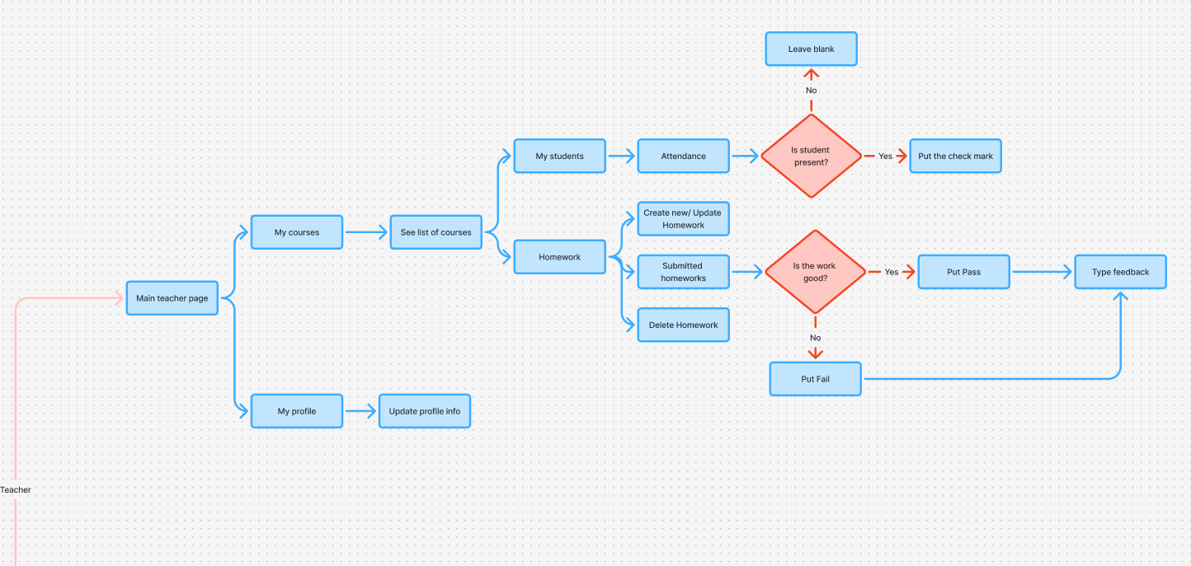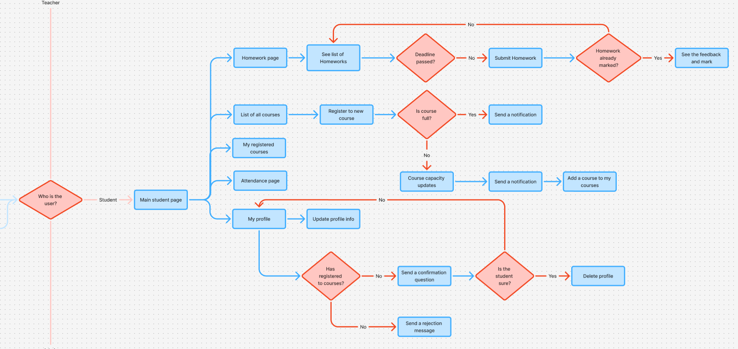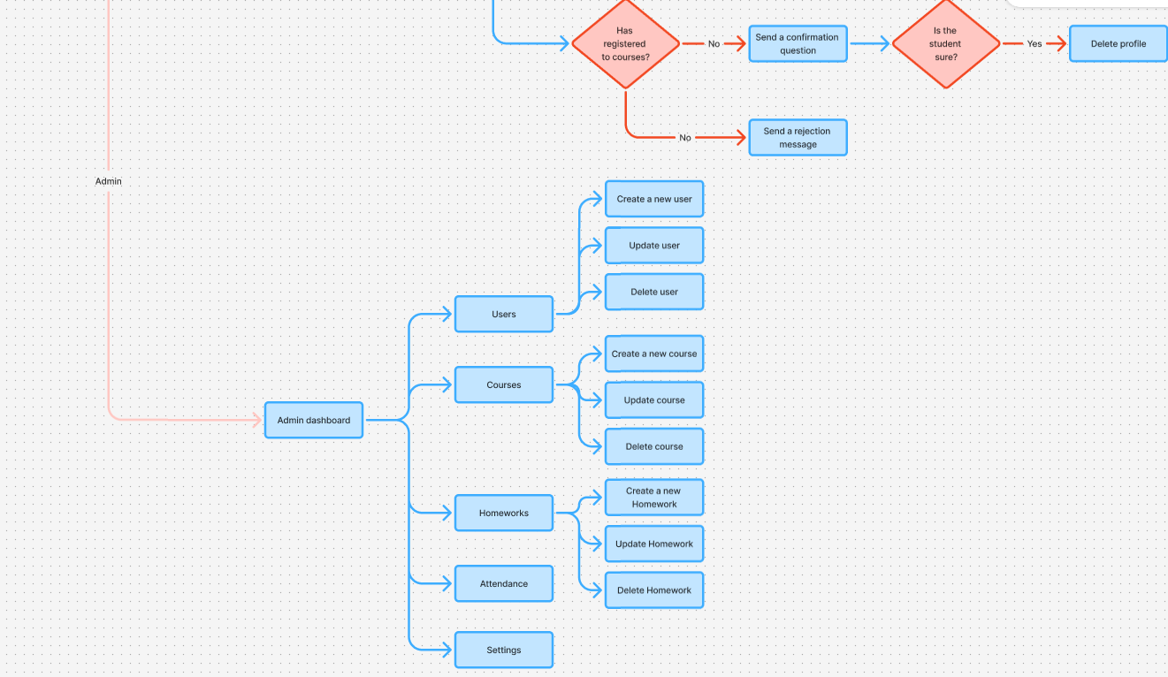

Implementation plan

Due to the structured system of the coursework project and knowledge of the expected outcome, it was decided to use the waterfall methodology and finish the web application in 6 weeks.
Week 1: Setup project, create base folder structure, connect MySQL, come up with entities and relationships
Week 2: Migrate database models, populate data, test relationships
Week 3: Build views for registration, login and profile pages, create templates, connect
Week 4: Develop the main functionality of the learning center application
Week 5: Add CSRF protection, hashed passwords, role-based access, create input validation logic
Week 6: Final testing, bug fixing, implement UX laws, write Readme, deploy to cloud server
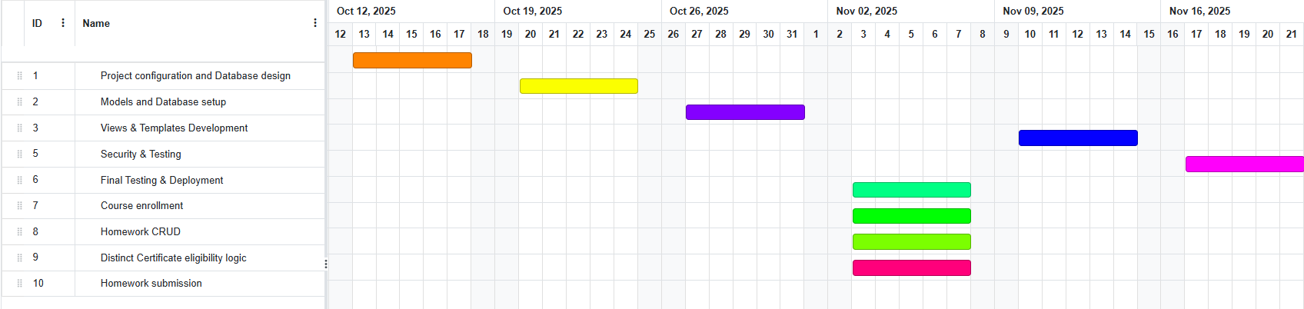
Gantt chart

Budget Breakdown
Cost category | Details | Estimate | Customer-friendly explanation
Development Hours | 60 hours in 6 weeks, $10 per hour (as a student) | $600 | Time spent coding, designing, testing and deploying
Cloud Hosting | Heroku/Render ($7 per month, need for 12 months) | $84 | System will be available 24/7
Database service | MySQL cloud ($5 per month, in 12 months) | $60 | Safe storage for teachers’ and students’ data
Domain name | Learning center domain (e.g., chen-chun-study.com) | $12 | Students can more easily remember the web address
Maintenance and Support | 3 hours per month, $10 per hour for 12 months | $360 | Bug fixes, updates, user support

Overall first-year cost is $1116

Conclusion

In conclusion, the web technologies highly support the development in the education sphere and this project serves as an example. The main objective of this business case analysis was to propose a plan for the development of the web-based application for the Chen-Chun Study learning center, adapting to the needs of the customer and time boundaries. Its main purpose will be to automate the learning processes, improve efficiency, and boost the effectiveness of the teaching methods with the implementation of functionalities such as course registration, attendance tracking, homework submission, and marking, and at the same time emphasizing data integrity, security, and user adaptation.

Reference list

Aljraiwi, S.S. (2017). The Effect of Classroom Web Applications on Teaching, Learning and Academic Performance among College of Education Female Students. Journal of Education and Learning, 6 (2), 132. Available from https://doi.org/10.5539/jel.v6n2p132 [Accessed 9 October 2025].
Dzhangarov, A.I., Pakhaev, K.K. and Potapova, N.V. (2021). Modern web application development technologies. IOP Conference Series: Materials Science and Engineering, 1155 (1), 012100. Available from https://doi.org/10.1088/1757-899x/1155/1/012100 [Accessed 3 October 2025].
Kumar, Y. et al. (2021). Risks and Threats to Web Applications and Their Preventions : A Theoretical Study on Vital Risks and Threats. International Journal of Scientific Research in Computer Science, Engineering and Information Technology, 7 (2), 432–438. Available from https://doi.org/10.32628/cseit217281 [Accessed 6 October 2025].
Lytvynenko, L., Skliarenko, O. and Kolodinska, Y. (2020). Logic of building interfaces in the software. Bulletin of the National Technical University ‘KhPI’ Series: New solutions in modern technologies, 0 (1(3)), 54–59. Available from https://doi.org/10.20998/2413-4295.2020.03.07 [Accessed 7 October 2025].

