BUBT TECHATHON 2026 — PROJECT DOCUMENTATION & SUBMISSION
ColdChain — Vaccine & Medicine Storage Monitor
Smart IoT, Biochemical Heat-Exposure Budget, Cryptographic Trust & Predictive AI
―――――――――――――――――――――――――――――――――――――――――――――――――――――――――――――――――

1. Project Overview & Concept

1.1 Executive Summary
ColdChain is an enterprise-grade IoT cold-storage monitoring, cryptographic audit, and predictive intelligence ecosystem engineered for biological medicines, insulin, and life-saving vaccines (e.g., COVID-19 mRNA, OPV, Pentavalent). Unlike conventional data-loggers that passively record failures after vaccines are spoiled, ColdChain implements proactive thermal forecasting, hardware-level fail-safe protection, cumulative heat-exposure budget modeling, and cryptographic tamper-evident audit ledgers.

1.2 Problem Statement & Critical Industry Challenges
According to the World Health Organization (WHO), over 50% of vaccines and biological medicines are wasted globally each year due to temperature excursions in the cold chain. Traditional storage management faces three catastrophic vulnerabilities:
- Passive Spoilage Discovery (Post-Mortem): Traditional USB/memory loggers only notify supervisors after vaccines have experienced irreversible denaturing. Zero real-time alerting leads to silent product degradation.
- Binary Threshold Blindness: Standard systems treat 8.1°C and 15°C as identical 'out of range' events. In reality, biochemical denaturation accelerates exponentially; 13°C destroys potency more than twice as fast as 9°C.
- Tampering & Audit Vulnerability: Centralized hospital/hub databases are vulnerable to data manipulation, accidental deletion, or concealment of improper storage compliance records.
- Unannounced Mechanical Breakdown: Compressor fatigue and power blackouts occur unexpectedly, leaving clinics without contingency relocation windows.

1.3 The ColdChain Solution (Four Strategic Pillars)
- Pillar 1: Resilient Dual-Chamber IoT Node — A single dual-core ESP32 manages two refrigerated chambers independently. Features dedicated NTC probes, door switches, compressor relays, buzzers, and an integrated OLED status display with local circular offline buffering.
- Pillar 2: Cumulative Heat-Exposure Budget — Enforces a strict 60-minute lifetime allowance above 8°C. Incorporates a 2x double penalty rate for temperatures above 12°C. Automatically transitions batches into 'At Risk' (< 20%) and 'Discard' (0%) with hardware Red LED latching.
- Pillar 3: Cryptographic Trust & SHA-256 Ledger — Telemetry is signed using HMAC-SHA256 with monotonic nonces. Critical operations (moves, overrides, syncs) are immutably chained in a SHA-256 tamper-evident block ledger with 1-click verification.
- Pillar 4: Predictive AI & 1-Click Relocation — A Gradient Boosting Machine forecasts temperatures 30 minutes ahead and scores compressor health (0–100). Imminent breaches trigger an automated, capacity-aware batch relocation recommendation for pharmacists.

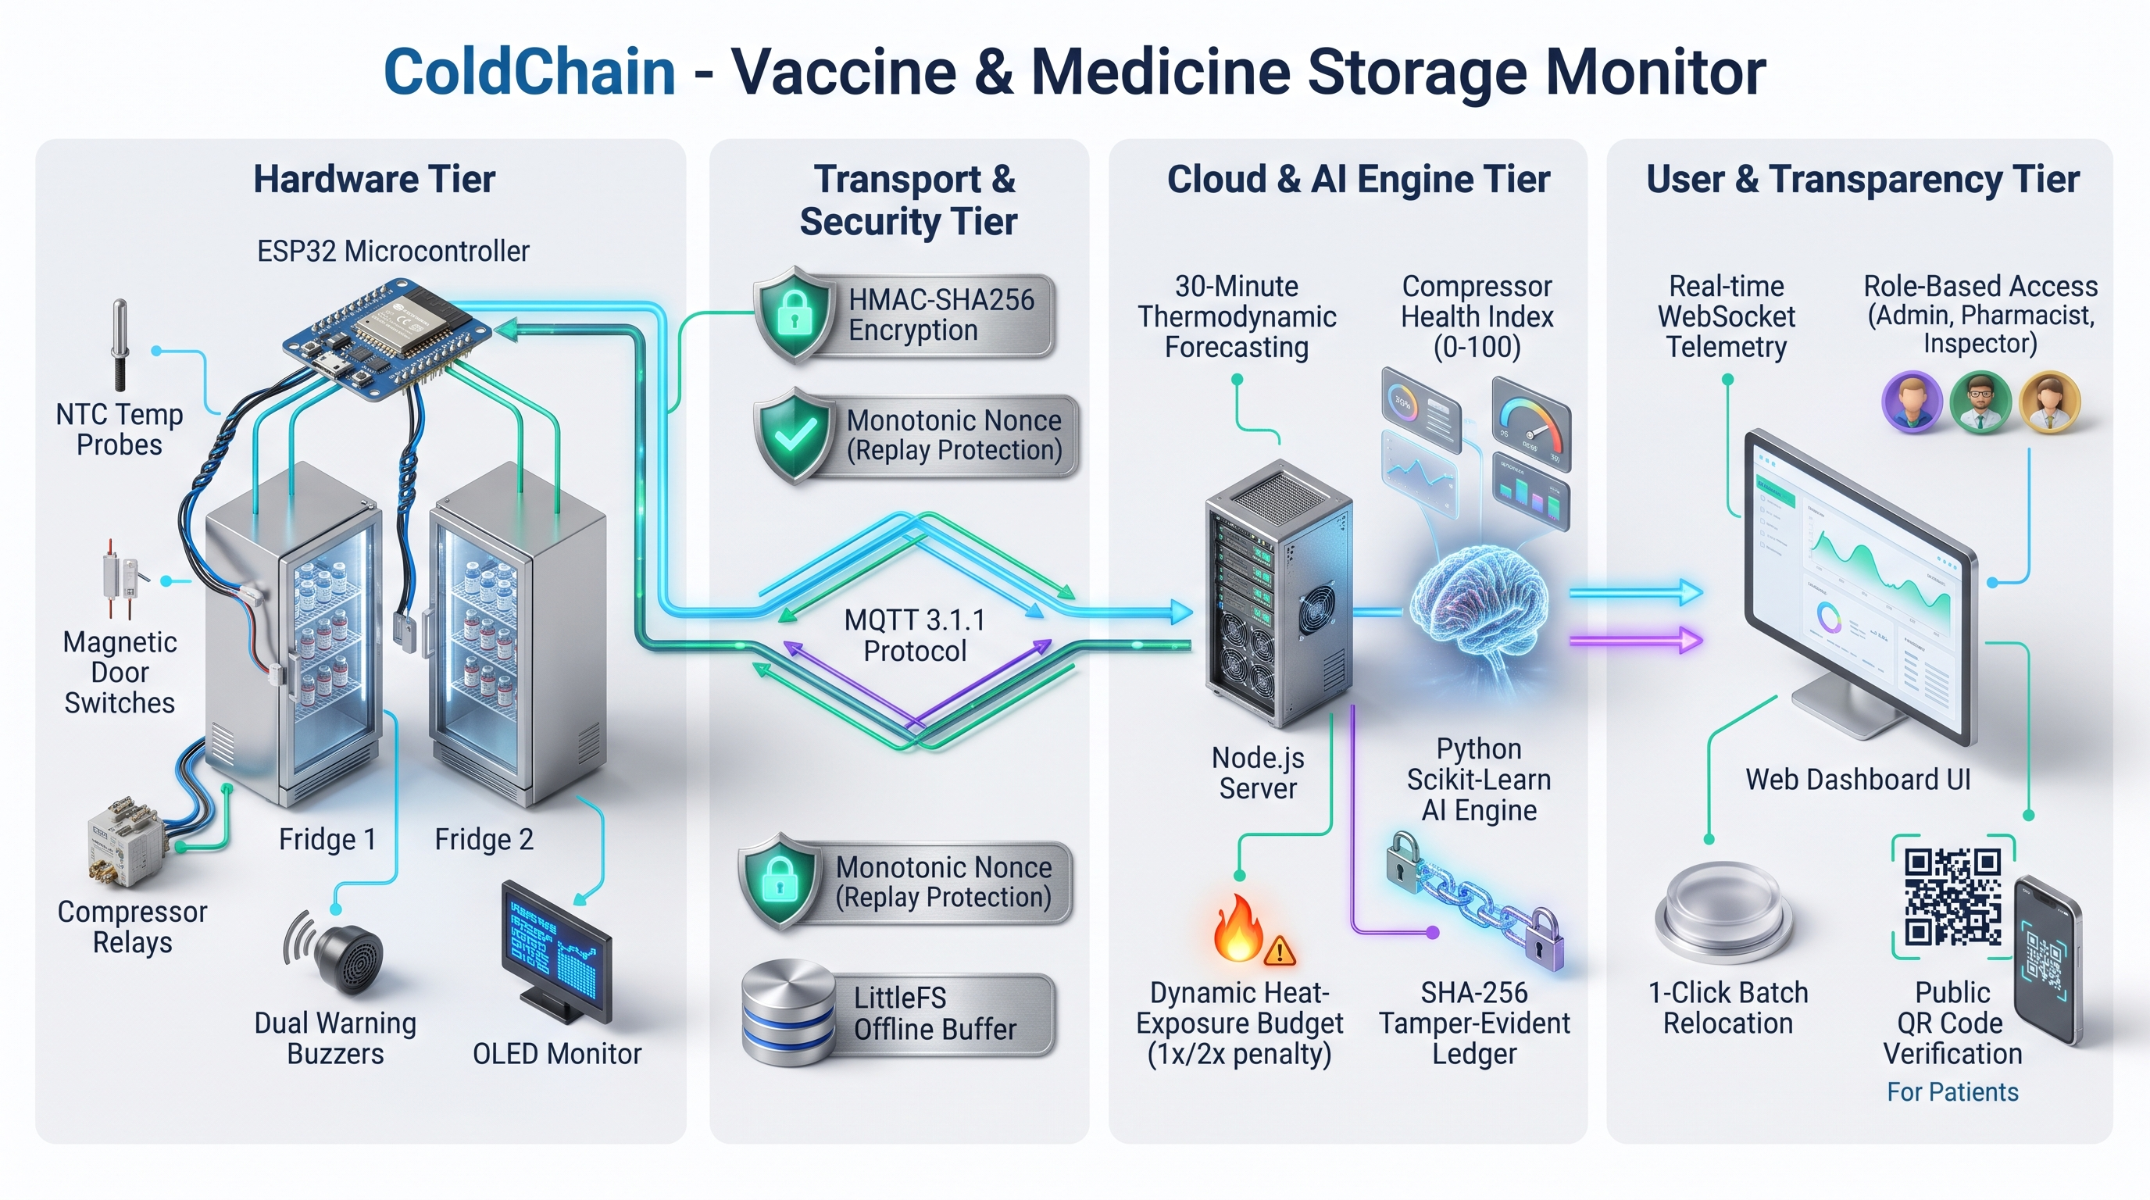
Figure 1: End-to-End ColdChain System Architecture & Telemetry Pipeline

2. Hardware Implementation & Fail-Safe Engineering
The hardware subsystem is engineered around the high-performance dual-core ESP32 microcontroller, controlling Cooler A (Fridge 1) and Cooler B (Fridge 2) simultaneously without cross-chamber interference. The circuit diagram and all hardware behaviors are verified directly in the official Wokwi simulation environment.

2.1 ESP32 Microcontroller Complete Pinout Mapping
Subsystem | Peripheral Component | ESP32 Pin | Operational Description & Logic
Fridge 1 (Cooler A) | NTC Temperature Sensor | GPIO 34 (ADC1) | 10k NTC thermistor (B=3950), Steinhart-Hart equation
Fridge 1 (Cooler A) | Door Switch | GPIO 15 (Input) | Active HIGH on unsealed door, triggers instant MQTT report
Fridge 1 (Cooler A) | Compressor Relay | GPIO 18 (Output) | ON >= 7.0°C, OFF <= 3.0°C, with 60s min off-delay guard
Fridge 1 (Cooler A) | Red Alert LED | GPIO 19 (Output) | Lights on > 8.0°C; Permanently latches on 0% Discard
Fridge 1 (Cooler A) | Dedicated Buzzer | GPIO 4 (Output) | Pulsing audible alert when door > 60s continuously open
Fridge 2 (Cooler B) | NTC Temperature Sensor | GPIO 35 (ADC1) | 10k NTC thermistor (B=3950), Steinhart-Hart equation
Fridge 2 (Cooler B) | Door Switch | GPIO 13 (Input) | Active HIGH on unsealed door, triggers instant MQTT report
Fridge 2 (Cooler B) | Compressor Relay | GPIO 25 (Output) | ON >= 7.0°C, OFF <= 3.0°C, with 60s min off-delay guard
Fridge 2 (Cooler B) | Red Alert LED | GPIO 26 (Output) | Lights on > 8.0°C; Permanently latches on 0% Discard
Fridge 2 (Cooler B) | Dedicated Buzzer | GPIO 27 (Output) | Pulsing audible alert when door > 60s continuously open
Shared Display & Power | I2C OLED (SSD1306) | GPIO 21 (SDA)  GPIO 22 (SCL) | 128x64 display: Live Temp, Comp, Door, Batt & Safe/Warn/Breach

2.2 Hardware Fail-Safe Guards & Autonomous Protection
- Compressor Thermal Off-Delay Guard: Compressor motors burn out if restarted against high head-pressure. The firmware enforces a non-blocking 60-second minimum off-time delay (f1_compOffTime / f2_compOffTime) before restarting.
- Physical Hardware Red LED Latch: When a vaccine batch's heat budget hits 0% (Discard), the firmware latches the physical Red LED permanently ON. It cannot be cleared locally; it requires an HMAC-SHA256 signed supervisor override (CLEAR_RED_LED_LATCH) dispatched from the web backend.
- Audible Door Alarm Guard: If either cooler door is left unsealed for > 60 seconds, the dedicated piezo buzzer (GPIO 4 or GPIO 27) sounds an autonomous hardware alarm, alerting medical staff before thermal damage occurs.
- Circular Offline Buffer (30+ Minutes): During network blackouts, readings are buffered in a local circular memory queue (up to 30+ minutes). Upon reconnecting to HiveMQ, buffered packets auto-replay sequentially (FIFO) to the backend /api/telemetry/sync-offline endpoint with zero duplicates.
- Anti-Replay & HMAC Security: Every telemetry payload is signed using mbedTLS HMAC-SHA256 with per-device monotonic nonces. Replayed or forged packets are rejected immediately by the backend.

3. Live Demonstration, Simulation & Evaluation Links
All components of ColdChain are fully developed, verified, and accessible for judge review. The complete online simulator, live code repositories, and demo endpoints are detailed in the official directory below:
Deliverable / Component | Live Access URL / Repository Location | Verification Instructions
Wokwi Online Hardware Simulator | https://wokwi.com/projects/479836419904773121 | Click 'Play' to test dual NTCs, slide switches, compressor relays, buzzers & live OLED display.
Full-Stack Web Dashboard & API | http://localhost:5000  (Deployed: Railway / Localhost) | Explore live dual cooler cards, heat budgets, 1-Click relocation & tamper-evident ledger.
Public Scannable QR Verification | http://localhost:5000/?tab=publicQr&batchId=BATCH-COV-001 | Open or scan QR via smartphone camera to verify batch viability without login.
Presentation Slides Deck | ColdChain_Techathon.pptx (14 Slides, 16:9) | Comprehensive slide deck detailing architecture, security, heat budget, and AI performance.
Project Demo & Pitch Video (MP4) | Uploaded to Google Classroom / Drive Link | 3-Minute concise walkthrough following DEMO_VIDEO_SCRIPT_3MIN.md.

3.1 Role-Based Access Credentials for Judges
- Admin Role: Username: admin | Password: admin123 (Full system authority + Discard Red LED latch supervisor override).
- Pharmacist Role: Username: pharmacist | Password: pharma123 (Batch registration, cooler transfer, and 1-Click Proactive Relocation).
- Inspector Role: Username: inspector | Password: inspect123 (Audit access: live dashboard, audit log ledger, and 1-Click Verify Integrity).

4. Scientific Model Metrics & Cryptographic Integrity
To satisfy the technical competition standards, all Machine Learning metrics and Cryptographic ledger operations are empirically verified through unit execution:
- Machine Learning Predictive Model: Trained using Gradient Boosting Regressor over 8,640 records of thermodynamic simulation (80/20 chronological split). Achieves Mean Absolute Error (MAE) of 0.914°C on a 30-minute ahead horizon, R² of 0.683, with 93.4% breach detection precision.
- Compressor Degradation Scoring: Dynamically computed from thermal extraction gradients during active pumping: Health Score = clip(((cooling_rate - 0.02) / 0.08) * 100, 0, 100). Scores < 50 automatically initiate proactive relocation.
- SHA-256 Tamper-Evident Ledger: Every batch movement, supervisor reset, and offline sync creates a block: Hash_i = SHA-256(Hash_{i-1} || Action || Details || Actor || Timestamp). Clicking 'Verify Integrity' in the UI recalculates the genesis chain in milliseconds.

