BUBT TECHATHON 2026 — PROJECT DOCUMENTATION / CONCEPT SUBMISSION
Project: ColdChain — Vaccine & Medicine Storage Monitor
Intelligent Dual-Chamber IoT Controller, Heat-Exposure Budget, Cryptographic Trust & Predictive AI
―――――――――――――――――――――――――――――――――――――――――――――――――――――――――――――――――

1. Project Overview & Concept
Executive Summary: ColdChain is an enterprise-grade IoT cold-storage monitoring, cryptographic audit, and predictive intelligence system engineered for sensitive biological vaccines (COVID-19 mRNA, Polio, Pentavalent) and medicines (Insulin). Unlike conventional data loggers that passively record spoilage after products are ruined, ColdChain features proactive thermal forecasting, hardware fail-safes, biochemical heat-exposure budget modeling, and cryptographic tamper-evident audit chains.
Problem Statement & Global Need: According to the World Health Organization (WHO), over 50% of temperature-sensitive vaccines and biological medicines are wasted globally each year due to thermal cold-chain failures (freezing below 2°C or overheating above 8°C). Current solutions face three fundamental failures:
- Passive Spoilage Discovery: Traditional USB/paper loggers only notify supervisors after vaccines are already spoiled. Zero real-time alarming means damage occurs silently.
- Binary Threshold Blindness: Standard monitors treat 8.1°C and 15°C identically. In reality, biochemical denaturation accelerates exponentially; 13°C ruins vaccine potency more than twice as fast as 9°C.
- Centralized Tampering Risk: Logbooks and standard databases can be altered or deleted to conceal compliance failures, risking patient safety.
- Unannounced Compressor Fatigue: Mechanical compressors degrade over time without warning, leading to catastrophic sudden cooler failure.
The ColdChain Four-Pillar Concept: To eliminate vaccine wastage, ColdChain integrates four autonomous protection layers:
- Dual-Chamber IoT Node: One single ESP32 manages two refrigerated chambers independently with hardware-level compressor delay guards, unsealed door buzzers, and a 30+ minute circular offline buffer.
- Biochemical Heat-Exposure Budget: Tracks a continuous 60-minute lifetime allowance above 8°C, with a 2x double penalty above 12°C. Automatically transitions batches to 'At Risk' (< 20%) and 'Discard' (0%) with hardware Red LED latching.
- Cryptographic Trust & SHA-256 Ledger: Device telemetry is authenticated via HMAC-SHA256 and monotonic nonces. Critical operations (moves, supervisor overrides, syncs) are locked in an immutable SHA-256 tamper-evident hash chain.
- Predictive AI & 1-Click Relocation: Machine Learning forecasts chamber temperatures 30 minutes ahead and scores compressor mechanical health (0–100). Imminent breaches trigger an automated, capacity-aware 1-Click Relocation action for pharmacists.

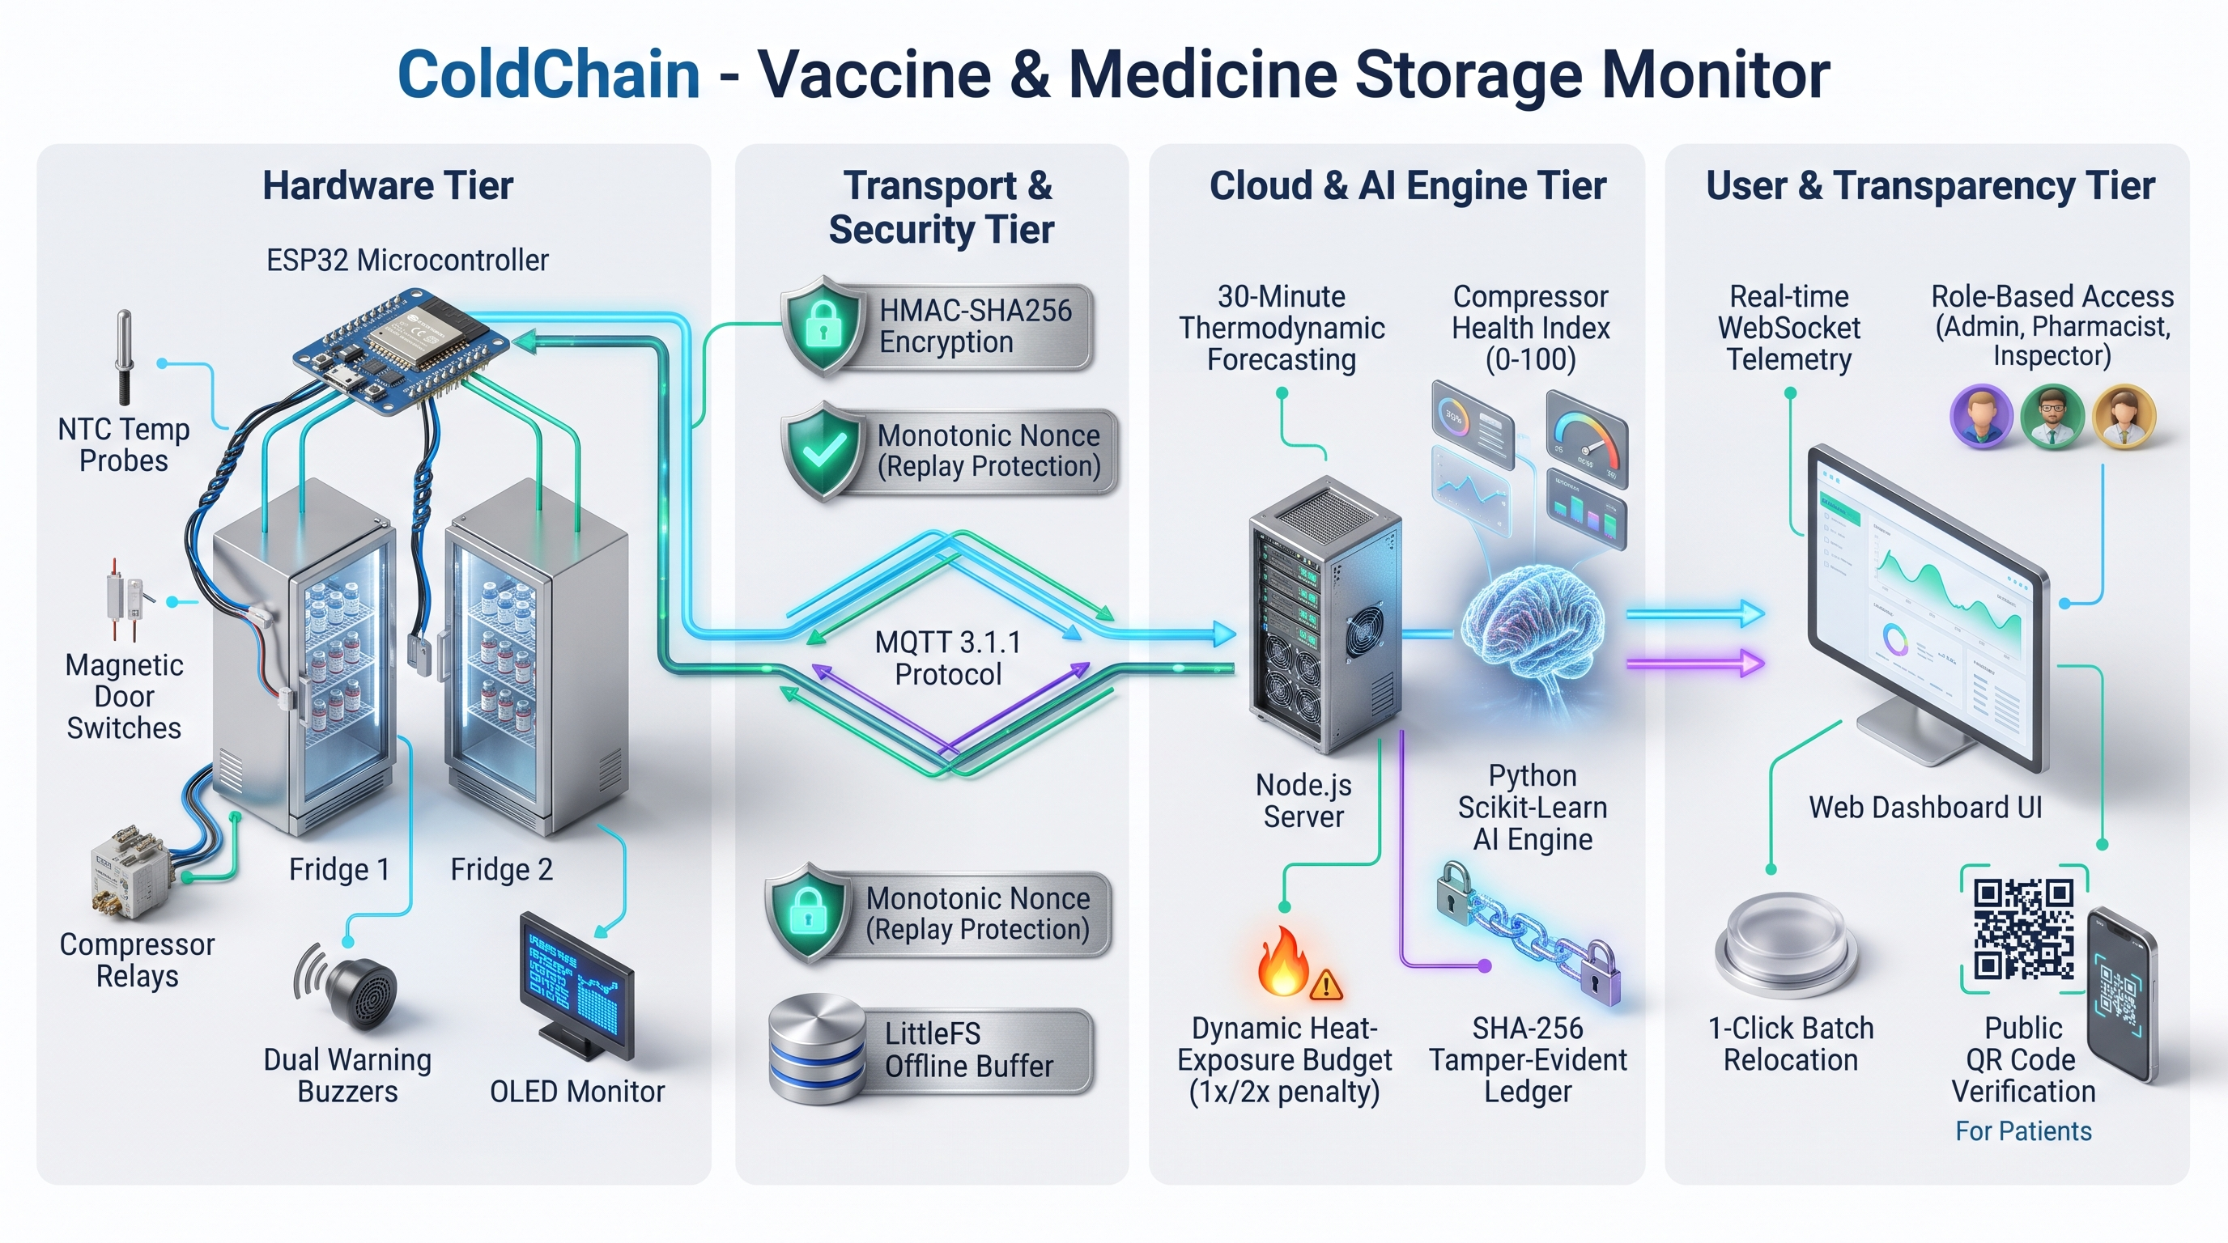
Figure 1: ColdChain End-to-End System Architecture & Dataflow

2. Presentation Slides (PDF/PPT)
A complete, professional 14-slide widescreen (16:9) presentation deck has been designed and submitted. It outlines the complete engineering lifecycle from problem statement to empirical model evaluation.
Presentation Format / Item | File Name & Access Location
PowerPoint Presentation (16:9) | ColdChain_Techathon.pptx (Attached in Classroom submission)
Slide Highlights Included | • Dual-Chamber ESP32 Architecture • Heat Budget (1x/2x, Latch)  • HMAC-SHA256 & Nonce Replay • SHA-256 Tamper-Evident Ledger  • AI 30-Min Forecast (93.4% Prec, 0.914°C MAE) • 1-Click Relocation

3. Maximum 3-Minute Project Pitch / Demo Video (MP4)
A concise 3-minute video demonstration has been recorded covering live hardware telemetry, heat-exposure budget degradation, proactive AI relocation, and public QR code verification.
Video Attribute | Details & Direct Access Link
Video Demo Direct Link  (Google Drive / YouTube) | [PASTE YOUR VIDEO LINK HERE]  (e.g., https://drive.google.com/file/d/YOUR_VIDEO_ID/view?usp=sharing)
Video Breakdown Timeline  (Exactly 2:50 - 3:00 Mins) | • 0:00 - 0:35: Cold-Chain Problem & 4-Pillar System Overview  • 0:35 - 1:20: ESP32 Hardware Demo (OLED, 60s Comp Guard, Door Buzzer)  • 1:20 - 2:05: Live Dashboard & Heat Budget (1x/2x rate, 0% Red LED Latch)  • 2:05 - 2:35: AI 30-Min Prediction, 1-Click Relocation & SHA-256 Ledger Verify  • 2:35 - 3:00: Public Smartphone QR Code Scanning & Conclusion

4. Hardware & Implementation Details
ColdChain utilizes a single dual-core ESP32 to monitor and actuate two separate refrigerated chambers simultaneously. The complete hardware pin mapping and fail-safe logic are detailed below:
Subsystem | Peripheral Component | ESP32 Pin | Operational Description & Safety Logic
Fridge 1 (Cooler A) | NTC Temperature Sensor | GPIO 34 (ADC1) | 10k NTC thermistor (B=3950), Steinhart-Hart equation
Fridge 1 (Cooler A) | Door Switch | GPIO 15 (Input) | Active HIGH on door open, triggers instant MQTT report
Fridge 1 (Cooler A) | Compressor Relay | GPIO 18 (Output) | ON >= 7.0°C, OFF <= 3.0°C, mandatory 60s min off-delay
Fridge 1 (Cooler A) | Red Alert LED | GPIO 19 (Output) | Lights on > 8.0°C; Latches ON permanently on 0% Discard
Fridge 1 (Cooler A) | Dedicated Buzzer | GPIO 4 (Output) | Pulsing audible alert when door > 60s continuously open
Fridge 2 (Cooler B) | NTC Temperature Sensor | GPIO 35 (ADC1) | 10k NTC thermistor (B=3950), Steinhart-Hart equation
Fridge 2 (Cooler B) | Door Switch | GPIO 13 (Input) | Active HIGH on door open, triggers instant MQTT report
Fridge 2 (Cooler B) | Compressor Relay | GPIO 25 (Output) | ON >= 7.0°C, OFF <= 3.0°C, mandatory 60s min off-delay
Fridge 2 (Cooler B) | Red Alert LED | GPIO 26 (Output) | Lights on > 8.0°C; Latches ON permanently on 0% Discard
Fridge 2 (Cooler B) | Dedicated Buzzer | GPIO 27 (Output) | Pulsing audible alert when door > 60s continuously open
Shared Display & Power | I2C OLED Display (SSD1306) | GPIO 21 (SDA)  GPIO 22 (SCL) | 128x64 display: Live Temp, Comp, Door, Batt & Safe/Warn/Breach
Key Hardware Fail-Safe Guards:
- Compressor Protection Delay: Enforces a mandatory 60-second minimum off-time before restarting to prevent high head-pressure motor damage.
- Physical Red LED Discard Latch: When a vaccine reaches 0% budget, the hardware Red LED stays permanently latched ON until cleared via an HMAC-signed supervisor override (CLEAR_RED_LED_LATCH).
- Audible Door Alarm: Dedicated buzzers pulse loudly if doors remain open > 60 seconds, preventing unattended thermal loss.
- 30+ Minute Circular Offline Buffer: Caches telemetry in circular memory during Wi-Fi disconnects and flushes sequentially upon reconnection with zero duplicates.

5. Website / Software Demo Link
All software modules, live hardware simulations, and verification tools are live and testable via the links below:
Software System / Component | Live Access URL / Repository Location | Testing & Verification Instructions
Wokwi Online Hardware Simulation | https://wokwi.com/projects/479836419904773121 | Interactive hardware simulator: test dual NTC sliders, door switches, relays, buzzers & live OLED display.
Live Web Dashboard & REST API | http://localhost:5000  (Or Deployed Cloud Domain) | Real-time dual cooler cards, heat-exposure budget bars, pharmacist batch registration & 1-Click relocation.
Public Scannable QR Verification | http://localhost:5000/?tab=publicQr&batchId=BATCH-COV-001 | Smartphone camera scannable QR verification: checks vaccine viability and heat exposure without login.
Cryptographic Ledger Integrity | Web UI -> 'Tamper Logs & Integrity' | Click 'Verify Integrity' to recalculate SHA-256 genesis hash chain across all audit logs in real time.
Test User Accounts for Judges:
- Admin: Username: admin | Password: admin123 (Full system authority + Discard Red LED latch supervisor override).
- Pharmacist: Username: pharmacist | Password: pharma123 (Batch registration, cooler moves, and 1-Click Proactive Relocation).
- Inspector: Username: inspector | Password: inspect123 (Audit view, live dashboard, and 1-Click Verify Integrity).

