
School of Computing, Electrical, and Applied Technology
COMP8811
Data Analytics and Intelligence
Customer Churn Prediction in Telecommunications
Assignment 2 – Technical Report

Prepared by:
Rehaan
Date of Submission: 30 October 2026

Table of Contents
Telecommunications Customer Churn Prediction Using Random Forest: A Business Intelligence Approach 3
ABSTRACT 3
1. INTRODUCTION 3
1.1 Background 3
1.2 Problem Statement 4
1.3 Project Objectives 4
1.4 Scope of the Project 5
2. DATASET DESCRIPTION AND DATA PREPARATION 5
2.1 Dataset Description 5
2.2 Data Cleaning and Preprocessing 5
3. REVIEW OF RANDOM FOREST AND RELATED TECHNIQUE 6
3.1 Random Forest Classification 6
3.2 Customer Churn and Class Imbalance 6
3.3 Model Evaluation and Alternative Techniques 6
4. SOLUTION DESIGN AND DEVELOPMENT 7
4.1 System Architecture 7
4.2 Model Development 9
4.3 Application Workflow 9
4.4 Business Intelligence Dashboard 11
5. MODEL EVALUATION AND RESULTS 11
5.1 Evaluation Method 11
5.2 Model performance Comparison 11
5.3 Confusion Matrix Analysis 12
5.4 Business Implications 12
6. CONCLUSION AND FUTURE IMPROVEMENTS 12
Works Cited 14

Telecommunications Customer Churn Prediction Using Random Forest: A Business Intelligence Approach

ABSTRACT
Customer churn is a significant challenge in the telecommunications industry as loosing customers affects revenue, profitability, and long term business growth. Targeted customer retention strategies are used for identifying customers, which have a higher chance of churn. This project gives a business Intelligence solution for the same problem. The solution uses Random Forest Machine Learning Model to predict customer churn.
The solution uses the IBM Telco customer churn dataset, which originally contained 7043 customer records. After cleaning the data, 7032 records were retained for analysis. Two random forest models were used i.e. baseline model and improved model using hyperparameter tuning. Different matrices were used to evaluate these models such as accuracy, precision, recall, F1 score, ROC-AUC, and confusion.
The improved model scored 78.07% recall with 82 missed churners and on the other hand baseline model scored 48.40% in recall with 193 missed churners in the test dataset. A Streamlit based BI dashboard was also developed to visualize churn patterns, compare model performance, and generate individual customer churn risk predictions with illustrative retention recommendations.
The project demonstrates how predictive analytics can support data driven customer retention decisions.

1. INTRODUCTION

1.1 Background
The telecommunications industry operates in a competitive environment where customers have multiple choices between different service providers with different pricing, contracts, internet services, contracts, features, etc. Customer churn occurs when an existing customer discontinues their relationship with a service provider. High churn rates can reduce recurring revenue and create additional pressure on organizations to attract replacement customers.
Business Intelligence helps organizations transform customer information into meaningful insights that support business decisions. Traditional BI technique, including reports, and dashboards, help organizations understand historical business performance. Predictive analytics extends these capabilities by using historical data to estimate future outcomes.
Machine learning algorithms can identify patterns across customer characteristics which include contract type, service usage, monthly charges, tenure, and payment methods. This help the organisation to identify customers who may be at the risk of leaving before they discontinue their services. Besides that, developing the customer churn prediction models provides understandable results with predictive performance. (Verbeke, Martens, Mues, & Baesens, 2011)

1.2 Problem Statement
Telecommunication companies have a large amount of data on their hands and to manually analyse information of that scale is difficult as well as time consuming. That’s why companies need a automated system which can preidict the customers at the risk of churning saving the company hassle and struggle to implement appropriate retention strategies.
The project addresses the following problem: How can random forest machine learning and business intelligence visualization be combined to identify customer who are at the risk of churning and form a retention strategy for the same?
This project gives the solution for the same by combining historical data, machine learning prediction, model evaluation, and an interactive BI dashboard.

1.3 Project Objectives
The main objective of this project is to design and implement a BI solution for problem stated above which can predict customer churn using machine learning (random forest).
The specific objectives are:
- Prepare and analyse a telecommunications customer dataset to identify churn related problems.
- Develop a baseline machine learning classification model (random forest).
- Improve this model using hyperparameter tuning with giving special emphasis on finding the customers who actually churn.
- Evaluate and compare all the models described and used.
- Develop a BI dashboard to present the insights, model results and predictions.
- Give a solution for retaining the customer based on the risk of churning.

1.4 Scope of the Project
The project focuses on identifying and separating the customers into churned or not churned. For this IBM Telco Churn Dataset provides the historical information required. Python is used for data preparation and cleaning, machine learning and application development. The sicklit learn library supports random forest modelling and evaluation. Streamlit provides the dashboard interface for viewing.
The system has descriptive churn analysis, baseline and improved model comparisons, individual customer churn risk prediction with retention recommendations as well.
This project is more of a prototype rather than a production ready system as it uses a historical data and the recommendation provided have not been independently tested for business effectiveness.

2. DATASET DESCRIPTION AND DATA PREPARATION

2.1 Dataset Description
The project uses the IBM Telco Customer Churn Dataset, which contains 7,043 customer records and 21 attributes. This dataset provides information about customer demographics, subscription services, account details, and churn status. IBM provides the dataset as a fictional telecommunications customer sample. (IBM, n.d.)
The Attributes include customer tenure, contract type, monthly charges, total charges, internet service, payment method, and additional services such as online security and technical support.

2.2 Data Cleaning and Preprocessing
For preparing the data Python was used along pandas library. The customer ID column was removed because works as an identifier instead of working as a predictive customer characteristic. The TotalCharges column was converted to numerical format and due to this ,11 records which had missing values in that column were removed.
After cleaning the dataset had 7032 customer records left, which included 1869 churned customers representing a churn rate of 26.6%.
Categorial variables encoded using one hot coding encoding, while numerical records were retained for model training. 80% of data was used for training and remaining was used as testing data, using stratified sampling to preserve the proportion of churned and non-churned customers. The cleaned data provided the foundation for training and evaluating the random forest models.

3. REVIEW OF RANDOM FOREST AND RELATED TECHNIQUE

3.1 Random Forest Classification
Random forest uses multiple decision trees which help them in performing regression and classification. It is a machine learning algorithm. For training a single tree a random sample of training data. The final classification is presented after combining the all the predictions from the individual trees. This approach can improve generalization and reduces the instability which comes with single decision tree. (Breiman, 2001)
One of the benefits of Random forest is that it can identify complex relationships between customer characteristics and churn behavior. One more thing is that it can analyse multiple features all at once such as tenure, monthly charges, service subscriptions etc.

3.2 Customer Churn and Class Imbalance
Predicting customer churn is a difficult job as the number of customers who may leave are considerably less than the customer who stays. (Burez & Van den Poel, 2009) This indicates the importance of class imbalance and why it should be considered when making a predictive model.
Taking an example from this project, approximately 26.6% of customers were found to be churned. So, accuracy alone cannot be evaluating factor, for this very reason Recall was used as it measures the proportion of actual churners correctly identified.

3.3 Model Evaluation and Alternative Techniques
For evaluating different models’ accuracy, precision, F1 score and ROC-AUC were used. ROC analysis helps assess how well a classifier distinguishes between classes across different decision thresholds. (Fawcett, 2006) Precision and Recall are also valuable when evaluating models on imbalanced datasets. (Saito & Rehmsmeier, 2015)
Alternative approaches include Logistic regression, Decision tress, and resampling techniques such as SMOTE, etc. (Chawla, Bowyer, Hall, & Kegelmeyer, 2002) SMOTE uses synthetic minority class example to address class imbalance. However, SMOTE was not implemented in this project. Moreover, additional research has explored incorporating customer communication data and comparing different classification techniques to improve customer attrition prediction. (Coussement & Van den Poel, 2009)

4. SOLUTION DESIGN AND DEVELOPMENT

4.1 System Architecture
The solution proposed for this problem was developed using technologies like Python, scikit learn, pandas, and streamlit. It is made up of five main processes i.e. data collection, data processing, machine learning model development, model evaluation and dashboard visualization.
The IBM Telco Customer Churn Dataset was cleansed properly and made ready to be used in our model. Then it was used to train random forest classifiers. The trained files were saved as .pkl files using Joblib, allowing the Streamlit application to load them without retraining every time the dashboard runs.
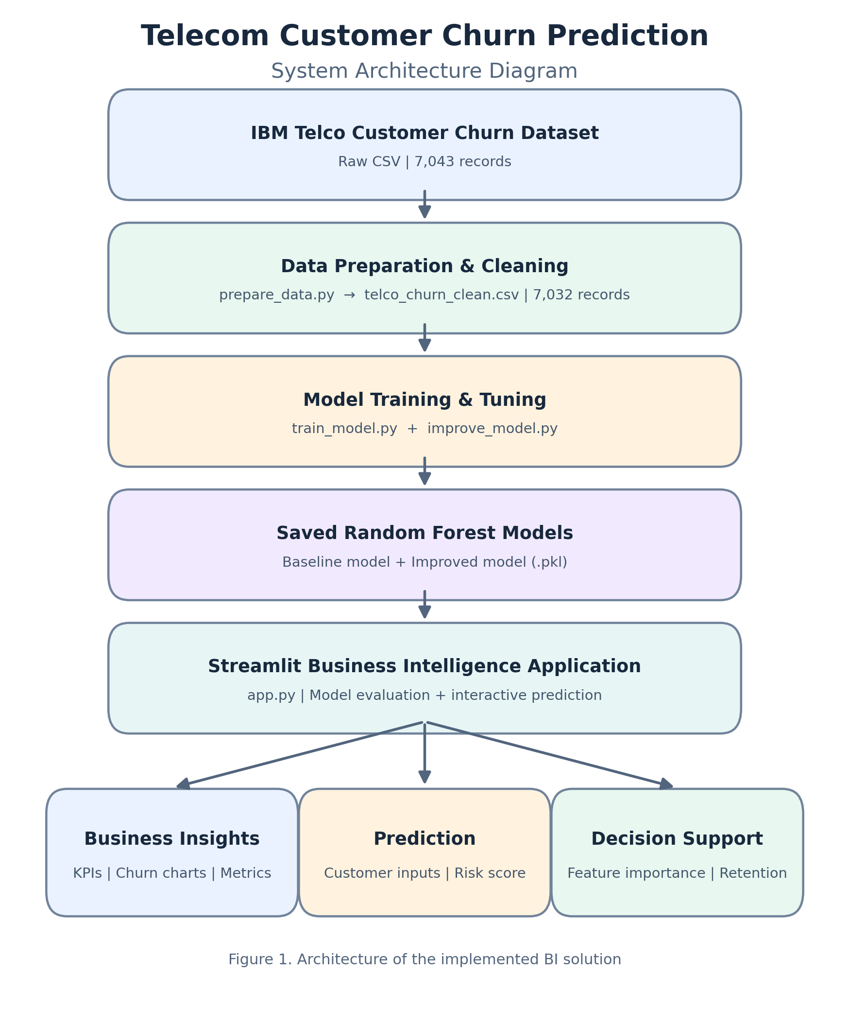
Figure 1. System architecture of the telecommunications customer churn prediction solution.

4.2 Model Development
For the solution two random forest models were developed using sickit learn. (Pedregosa, et al., 2011) The baseline model used 200 Decision trees and balanced class weights. An improved model was developed using RandomizedSearchCV with fivefold cross validation which majorly focused to recall to improve detection of customers that are likely to churn.
The hyperparameters used for the improved models consisted of 500 Decision trees with a maximum tree depth of 5. It had a minimum sample split of 5 and minimum leaf size of 2. These values were not selected randomly rather main reason for selecting these values were hyperparameter optimization.
Categorical customer attributes were transformed using one hot encoded within a preprocessing pipeline. Both models were evaluated using the same 80/20 training and testing split to support a consistent comparison.

4.3 Application Workflow
The system workflow starts after dataset preparation is done and model is trained.Once this process is over models are save and loaded into the streamlit application.
Users can enter different type of fields in the application which include customer characteristics such as contract tenure, contract type, internet service, payment method, monthly charges, etc. The application processes and validates combinations put in the system before giving a churn probability using the Improved random forest model.
Predictions are classified into three illustrative risk categories that is Low Risk (below 30%), Medium Risk (30% to 60% ) and High Risk (60% or above).
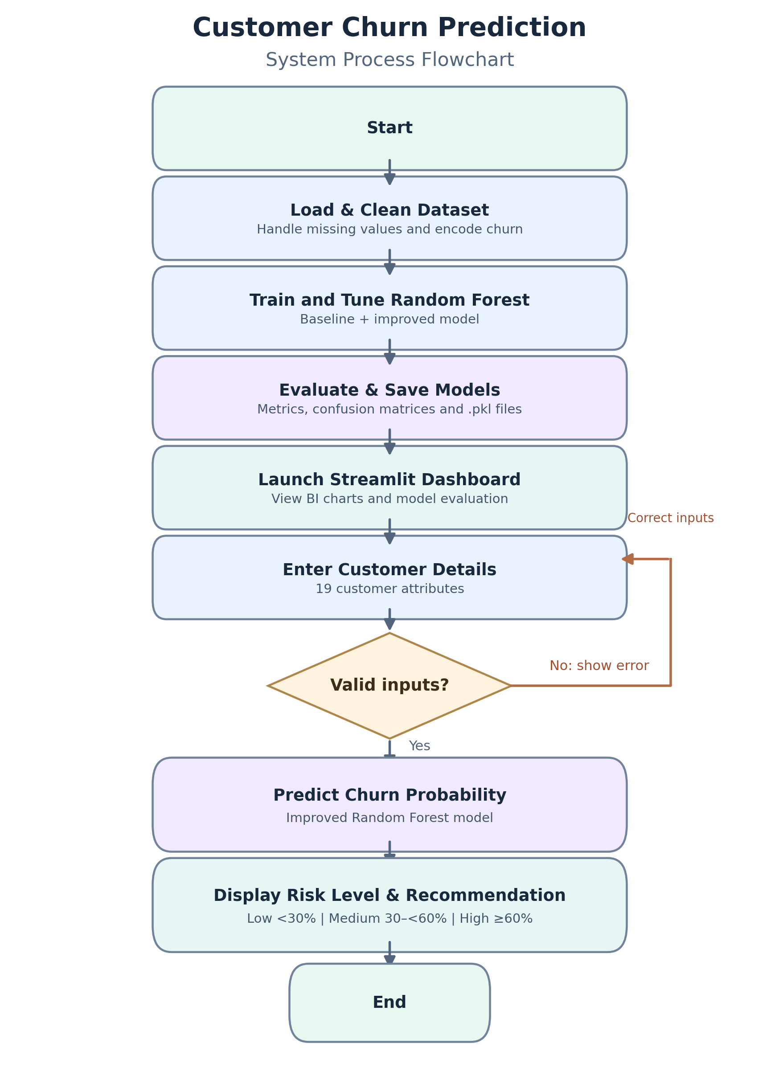
Figure 2. Flowchart of the customer churn prediction process.

4.4 Business Intelligence Dashboard
The dashboard was developed using Streamlit (Streamlit, n.d.) to provide an interactive interface. It displays key performance indicators such as total customers, churned customers, churn rate, and average monthly charges.
Other visualization includes churn distribution, churn rate by contract type, model performance comparisons, confusion matrices, etc. The application also contains individual customer churn risk prediction and retention actions as well.
By combining descriptive an predictive analytics it supports in customer retention and planning.

5. MODEL EVALUATION AND RESULTS

5.1 Evaluation Method
Both Random Forest models were evaluated using the same test dataset, representing 20% of the cleaned customer records. The classification metrics used were accuracy, precision, recall, F1 score and ROC-AUC.
Accuracy measures correctness of the overall prediction while precision tells us the proportion of predicted churners who churned. Recall measures number of actual churners correctly identified and F1 score balances precision and recall. On the other hand, ROC-AUC evaluates the model’s ability to differentiate between actual churners and non-churners across classification thresholds. (Fawcett, 2006) (Saito & Rehmsmeier, 2015)

5.2 Model performance Comparison
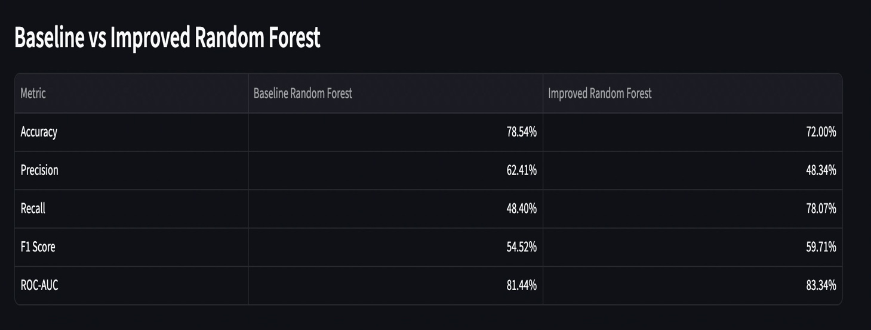
Table 1. Baseline and Improved Random Forest Performance
The improved model achieved a higher recall of 78.07% compared to 48.40% for baseline model which is improvement of almost 30 percentage points, indicating that improved gave improved performance.
However, accuracy decreased from 78.54% to 72.00% while precision also declined. This demonstrates the tradeoff for detecting more churners and identifying customers who would remain.

5.3 Confusion Matrix Analysis
The baseline model correctly identified 181 but missed 193. In comparison, the improved model correctly identified 292 churners and missed only 82.
However, false predictions also increased from 109 to 312. Because of this the company may have to spend more on additional customers who might not be churners increasing the overall retention cost.
Despite this limitation, the improved model was selected as identifying more customers was prioritized overachieving more accuracy.

5.4 Business Implications
The results show how predictive analysis can support customer retention and planning. By identifying customers with elevated churn probabilities, this helps the telecom companies to prioritize more attention on the risked customers and potential dissatisfaction.
However, the model’s predictions are for support not to replace business judgement as dashboard’s visualization are illustrative and are not validated for deployment. So, the dashboard’s risk thresholds and retention recommendations should not be used unless validated.

6. CONCLUSION AND FUTURE IMPROVEMENTS
The project successfully developed a BI solution for predicting telecommunications customer churn with the help of random forest machine learning. The solution contains predictive modelling, model evaluation, and a streamlit dashboard to support customer retention planning.
There were two models used for the solution. The later model (improved) achieved almost 30% better recall than baseline model but to achieve that it had to trade off accuracy and precision. Even with low accuracy and precision the improved model was chosen for the project.
The dashboard provides customer churn statistics, model comparisons, feature importance, individual churn risk predictions, and retention recommendations.
Future improvements could include evaluating alternative classification algorithms, exploring SMOTE to address class imbalance (Chawla, Bowyer, Hall, & Kegelmeyer, 2002) and testing different thresholds to balance recall so that the extra cost of retention on non-churner customers can be cut off. Also, validation form the recent customer data should be done before deployment.
Overall, the project demonstrates how machine learning and business intelligence can support telecommunication companies to make retention decisions.

Works Cited
Breiman, L. (2001). Random forests. Machine Learning, 45, 5-32.
Burez, J., & Van den Poel, D. (2009, January). Handling class imbalance in customer churn prediction. Expert Systems with Applications, 36(3).
Chawla, N. V., Bowyer, K. W., Hall, L. O., & Kegelmeyer, W. P. (2002). SMOTE: Synthetic minority over-sampling technique. Journal of Artificial Intelligence Research, 16.
Coussement, K., & Van den Poel, D. (2009, April). Improving customer attrition prediction by integrating emotions from client/company interaction emails and evaluating multiple classifiers. Expert Systems with Applications, 36(3), 6127-6134.
Fawcett, T. (2006). An introduction to ROC analysis. Pattern Recognition Letters, 27(8).
IBM. (n.d.). Telco customer churn. Retrieved from IBM Documentation: https://www.ibm.com/docs/en/cognos-analytics/12.0.x?topic=samples-telco-customer-churn
Pedregosa, F., Varoquaux, G., Gramfort, A., Michel, V., Thirion, B., Grisel, O., . . . Brucher, M. (2011). Scikit-learn: Machine learning in Python. Journal of Machine Learning Research, 12(85).
Saito, T., & Rehmsmeier, M. (2015). The precision-recall plot is more informative than the ROC plot when evaluating binary classifiers on imbalanced datasets. PLOS ONE, 10(3).
Streamlit. (n.d.). Streamlit documentation. Retrieved from Streamlit: https://docs.streamlit.io/
Verbeke, W., Martens, D., Mues, C., & Baesens, B. (2011, March). Building comprehensible customer churn prediction models with advanced rule induction techniques. Expert Systems with Applications, 38(3).

