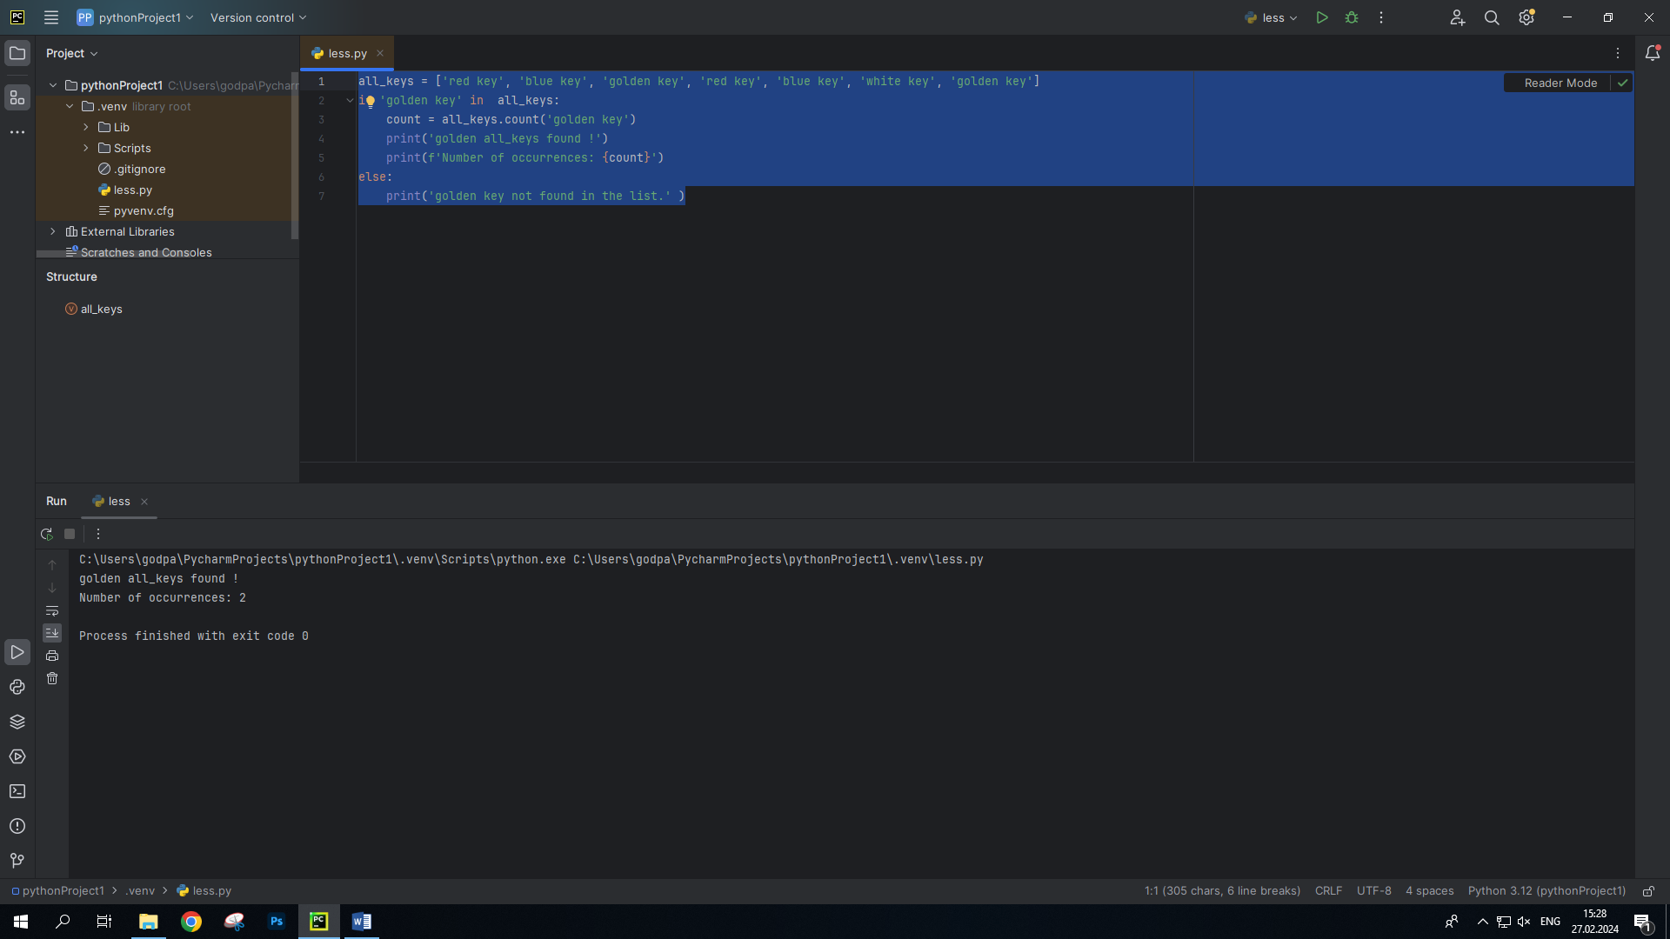

all_keys = ['red key', 'blue key', 'golden key', 'red key', 'blue key', 'white key', 'golden key']  
if 'golden key' in all_keys:  
 count = all_keys.count('golden key')  
 print('golden all_keys found !')  
 print(f'Number of occurrences: {count}')  
else:  
 print('golden key not found in the list.' )

2 задание

message = '6_185+_7*/#4i/*(@n'  
  
decryptrd_message = ''  
for char in message:  
 if char == '7':  
 decryptrd_message += 'П'  
 elif char == '1':  
 decryptrd_message += 'T'  
 elif char == 'i':  
 decryptrd_message += 'И'  
 elif char == 'Я':  
 decryptrd_message += 'И'  
 elif char == '/':  
 decryptrd_message += 'Л'  
 elif char == '(':  
 decryptrd_message += 'С'  
 elif char == '5':  
 decryptrd_message += 'Б'  
 elif char == '6':  
 decryptrd_message += 'У'  
 elif char == '_':  
 decryptrd_message += ' '  
 elif char == '*':  
 decryptrd_message += '0'  
 elif char == '8':  
 decryptrd_message += 'Е'  
 elif char == '#':  
 decryptrd_message += 'У'  
 elif char == '4':  
 decryptrd_message += 'Ч'  
 elif char == '@':  
 decryptrd_message += 'Ь'  
 elif char == 'n':  
 decryptrd_message += '!'  
 elif char == '+':  
 decryptrd_message += 'Я'  
 else:  
 decryptrd_message += char  
print(decryptrd_message)

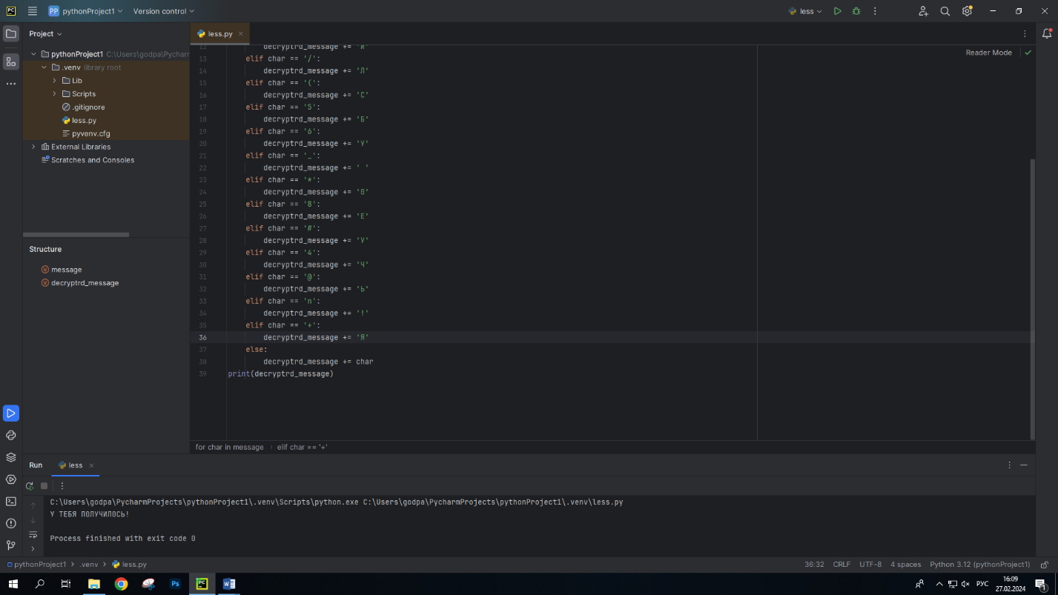

3)

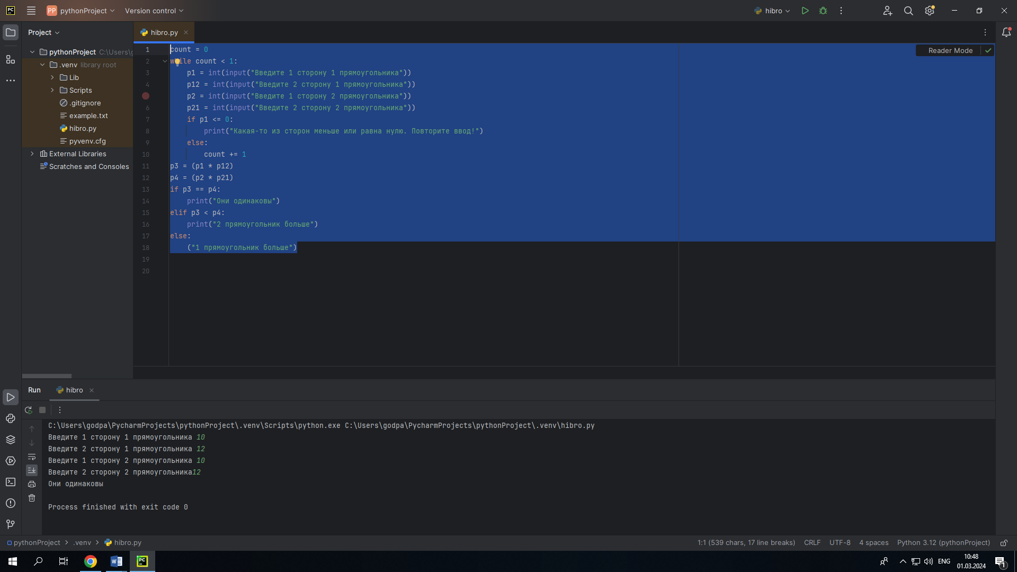

count = 0  
while count < 1:  
 p1 = int(input("Введите 1 сторону 1 прямоугольника"))  
 p12 = int(input("Введите 2 сторону 1 прямоугольника"))  
 p2 = int(input("Введите 1 сторону 2 прямоугольника"))  
 p21 = int(input("Введите 2 сторону 2 прямоугольника"))  
 if p1 <= 0:  
 print("Какая-то из сторон меньше или равна нулю. Повторите ввод!")  
 else:  
 count += 1  
p3 = (p1 * p12)  
p4 = (p2 * p21)  
if p3 == p4:  
 print("Они одинаковы")  
elif p3 < p4:  
 print("2 прямоугольник больше")  
else:  
 ("1 прямоугольник больше")